Clouds Second Report

Harrison Lien

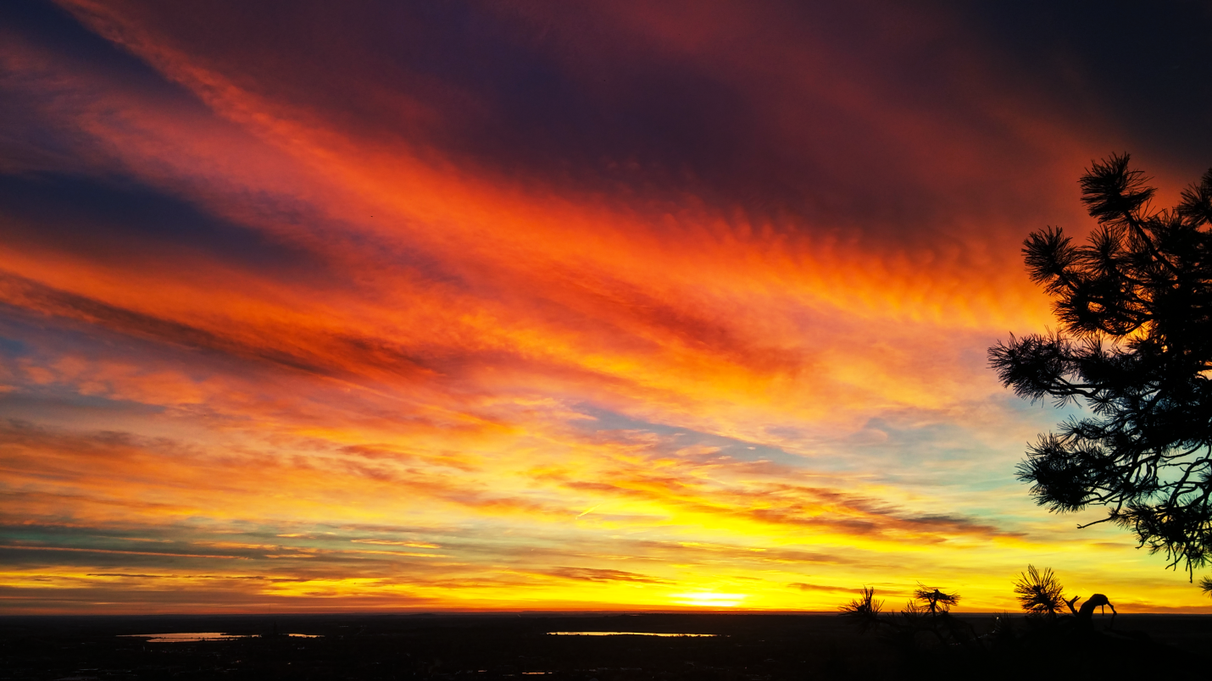
Figure 1: Sunrise over Boulder, Colorado

The image depicted in figure 1 is of a sunrise taken on October 21st, 2016. The photo was taken on the first main viewpoint on Flagstaff road, where it overlooks Boulder and the surrounding area toward the east of the mountains. The photo was taken at 7:07 AM, with an aperture of 2.4, a shutter speed of 1/140 s, and an ISO of 50, using a camera on a phone. In the photo: a magnificent sunrise, over an arrangement of clouds in a stable atmosphere. On the ground, the weather was fairly pleasant, there was not really any wind, the temperature was pretty nice for a morning in October, and there was no rain anywhere nearby, both in time and space. The cloud at the top of the image shall be the one in discussion.
The cloud at the top of figure 1 is an Altocumulus Undulatus cloud, which are considered a mid-cloud, appearing around 2,200 – 6,000 m above ground level. The Skew-T diagram for this weather data suggests clouds likely formed around 7,500 m and up, however that data was collected in Denver, and is more accurate for clouds toward the lower portion of the image, and the cloud over Boulder has more of the details of an Altocumulus than it does of a Cirrocumulus. The Skew-T in figure 2 also has fairly consistent wind coming from the west (behind the perspective of the photograph), and a Cape of 0.00, suggesting a stable and predictable atmosphere.
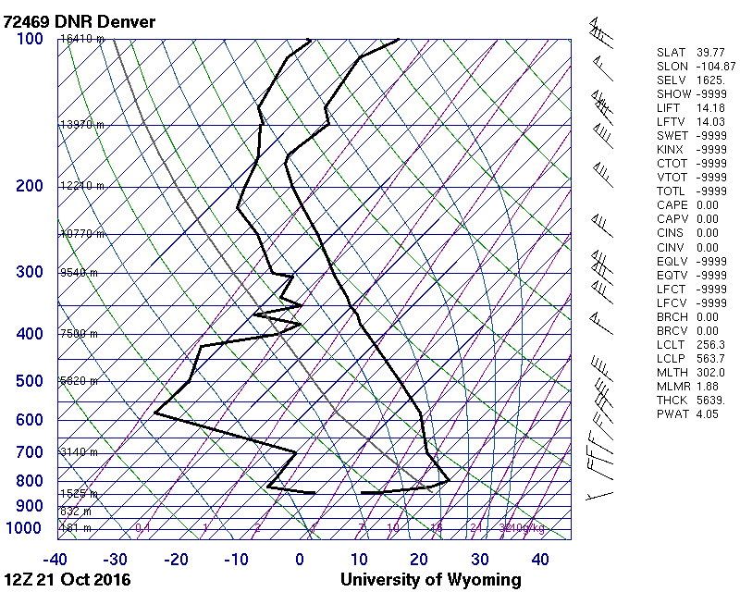
Figure 2: Skew-T
The original image can be seen in figure 3. In post processing, there were some adjustments to the RGB, the Red, and the Blue curves, a slight increase in Brightness, and subtle Vibrance and Saturation enhancements. These adjustments were made to try to maintain cloud detail while enhancing the aesthetic of the sunrise.
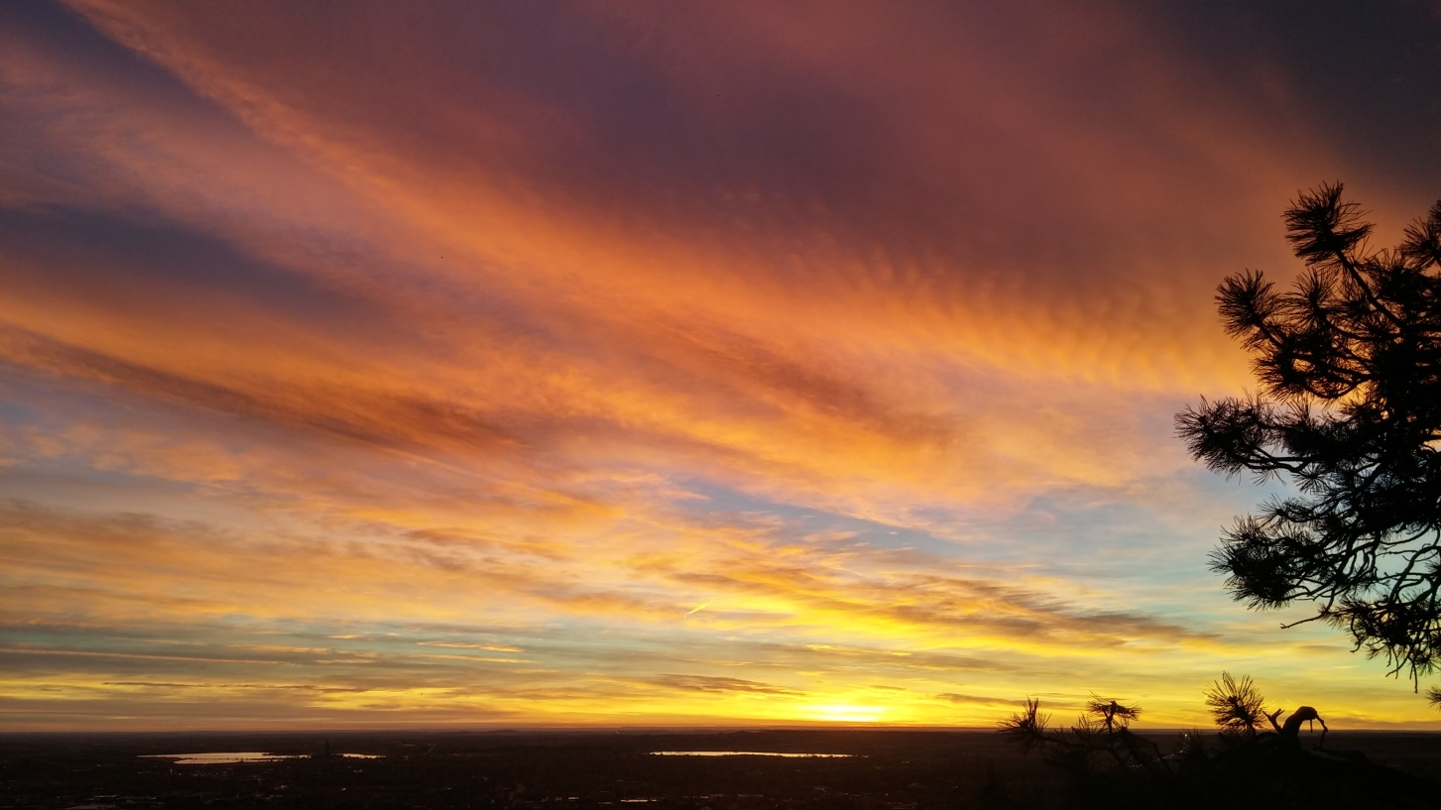
Figure 3: Original Image

