team First Image – fog flow around cylinder

J. Julian¹

¹The University of Colorado Mechanical Engineering-Master’s Program, Boulder, Colorado, USA

Abstract
In this paper we shall look at how the use of a fog machine was used in conjunction with a cylinder made from cardboard. The overall desired result was to successfully capture the flow of the fog cloud around the cylinder. There were several conditions that improved the overall quality of the picture including the low levels of air flow that would’ve disrupted the flowing process of the fog as well as the use of diffused light in the background.

Flow Visualization
The use of dynamic motion in photographs has always been interesting to people. This could possibly be due to the fact that the inherent qualities of a still image of a flowing process lends to the imagination of the viewer in such a manner as to make him or her feel like the picture is moving. Flow visualization is the process of making the physics of fluid flows (gases, liquids) visible [1]. In this paper we will explore how a still image of a fog layer flowing over a hollow cylinder can be represented in such a way as to display the flowing inherent dynamic nature of condensed water vapor.

Fog Machine
Fog machines are commonly used in a variety of situations ranging from Halloween decorating to professional production shows. The typical commercial grade fog machine uses a precise combination of water vapor and a glycol, glycerin or mineral oil based fluid. There are two main methods of creating fog that are typically utilized by fog machines, which are either heated or chilled. The most common type of fog machine is heated fog machines with electric pumps.

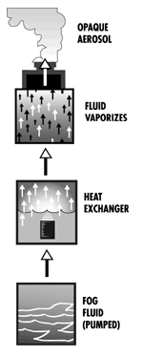
Figure 1: Heated Fog Machine

The general process that is required for heated fog machines to create fog can clearly be seen in Figure 1 above. Heated fog machines use either a pump or an inert gas to propel a mixture of water and mineral oil, glycol or glycerin into a heat exchanger. The most common type of heated fog machines operates using an electric pump as shown in Figure 1. The use of a mixture of water and an oil means that the resulting fog will float in the air for a significant amount of time longer than if the vapor was just water. The pump pushes the fluid into the heat exchanger. In the heat exchanger the fluid is vaporized and the resulting vapor mixture creates a fog. At this point the fog can be propelled out of the machine faster by a fan or in some cases cooled further before being output of the machine.

The second method for creating fog is the chilled technique. This technique is typically created using either dry ice or less commonly liquid nitrogen. The dry ice process is typically done by heating a large quantity of water to or near boiling, and then dropping dry ice into the water. Due to the large difference in temperature and pressure between the ice and the boiling water the carbon dioxide in the dry ice sublimates and instantly produces a gas. The resulting fog is a thicker white fog that usually low lying, meaning that it usually flows and remains near the floor. This effect makes it especially good for special effects on stages for performances.

For this picture a heated fog machine with a cooled pocket outlet was used. The inherent nature of this machine made it difficult to capture the desired result of an impinging jet on a cylinder. Due to the fact that the glycerin mixture resulted in a longer lingering fog made it difficult to direct the fog downward on to the lower edges of the cylinder. In addition, the fog did not continuously come out of the machine in a thick cloud as preferred but started out as thick and then became thinner over time.

Impinging Jet onto a cylinder
For this picture an impinging jet onto a cylinder is observable. If the slot jet with width of approximately 3 inches and the diameter of the cylinder is 6 inches. Than using equation 1 the cylinder-to-jet diameter ratio is equal to 1.

$\frac{D}{D_{j}}$ = 0.5 (1)

For this diameter ratio the flow behaves as if immersed in uniform free stream [4]. With this condition given the behavior of the trailing turbulent flow of the fog can be analyzed with a boundary condition of uniform flow.

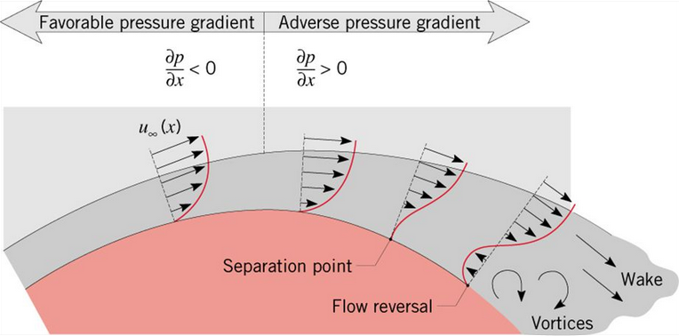
Figure 2: Cylinder in cross flow

It can clearly be seen in Figure 2 that there is a separation point along the surface of the cylinder where the flow transitions from a laminar flow to a turbulent one that includes vortices and a wake. This separation occurs when the velocity gradient becomes zero and an adverse pressure gradient occurs. This can cause a flow reversal and thus vortices are created. These properties can clearly be seen in the picture in the flow behind the cylinder where there are numerous eddies that are contained in the fog.

Set Up
To capture the picture a system was set up to establish a set of stable conditions as to which a quality picture could be captured.

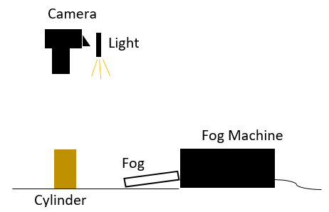
Figure 3: Picture Set Up

The camera was held in hand and an additional light source was pointed in a downward fashion at the cylinder and fog interaction. The external light that was used was a bike light that was set on the lowest setting, so as to minimize the light reflection on the black poster board background. The fog machine was set on the same level as the cylinder approximately 1 foot away from the intended target. The sides of the poster board were set in a vertical direction so as to use them as a channel to focus the fog toward the cylinder. Approximately 12 pieces of ice from an ice tray were used in the cooling chamber of the fog machine. The position of the pieces of ice were periodically adjusted in the machine as the ice melted during the experiment. Due to the slanted nature of the fog machine the fog that was produced came out at a slight angle. As a result, the machine was positioned in such a way as to produce as close to a direct flow onto the cylinder as possible.

Camera Set Up
The camera was also set up in a specific way to capture as much of the contrasting color and brightness as possible. The camera that was used in this piece was a Canon EOS Rebel T6 DSLR with an attached 18-55 mm lens. The lens attachment that was used was adequate due to the fact that the fog that was used was so close in proximity that zoom was not necessary. There were 4 main manual features on the camera that were used to maximize the quality of this picture. These features were the aperture (f stop or f/number), exposure time or shutter speed, ISO, and the exposure bias.

The aperture on a camera refers to the size of the opening in the optics which light passes through to capture an image. The size of the aperture is one of the major factors that affects the depth of field for any given image. With a small f stop the subject stands out and the background is blurred. The aperture stop is typically referred to as the f stop, which is a ratio of the attached lens’s focal length to the diameter of the aperture opening. The range of f stops for the camera used ranged from f/3.5 to f/36. For this picture an f/stop of f/4.8 was used which is not particularly small but did allow an adequate amount of light into the camera to capture the desired details.

The shutter speed, also referred to as the exposure time, is the amount of time that the shutter is open when taking a given picture. This is important when considering whether the desired target is moving at a fast or slow pace. For a relatively slow moving object like a fog cloud moving across a cylinder a relatively fast shutter speed isn’t necessary but it is quite helpful when trying to capture as much of the flowing cloud detail as possible. The range of shutter speeds on the camera used went from 1/4000 to 30 seconds. However, one drawback of utilizing a faster shutter speed is that it lets less amount of light into the camera. For this reason, a shutter speed of 1/50 of a second was used to balance the levels of light as well as the desired detail of the fog.

The ISO sensitivity refers to how sensitive the camera film or in the case of a DSLR how sensitive the sensor is to the incoming light. ISO stands for International Standards Organization and this value just refers to how sensitive the sensor is to a given value of incoming light. For the camera that was used the range of the ISO sensitivity went from 100 to 6400. This value is extremely important when taking pictures at relatively low level light conditions that the source light is not direct but being reflected off of surrounding background. To balance the amount of light that was coming in with the details in the fog an ISO of 3200 was used. One drawback of using such a high ISO is that it can sometimes be too grainy and doesn’t capture so much detail in the picture. But for this piece the ISO level that was used allowed enough light to come in to be able to capture as much detail as possible.

The final manual feature that was used was the exposure bias, which refers to the feature that allows the user to manually adjust the exposure that is measured by the camera’s light meter. On the camera that was used to take the picture this ranged from -3 to 3, but an automatic setting was used. This is because on an artistic approach I as the artist didn’t like what the over exposure and underexposure results were.

After the desired picture was taken a post processing software named Photoshop was used to enhance the picture. For this piece the brightness of the overall picture was increased 50%. While the contrast between the black background and the white fog cloud was also increased.

discussion & CONCLUsion
The desired result of capturing a full array of detail of fog flowing around a cylinder. While the sharpness of the fog cloud is what I as the artist would have desired, the blurriness of the flowing fog cloud with a dark background made for a drastic contrast between the background and the fog. In future iterations of this work one improvement that could be made is to use higher quality lighting over just a bike light because some of the blurriness in the image is due to the low light on the fog with such a high ISO. Another possible improvement would be to explore in more depth with using dry ice instead of ice made from tap water. As mentioned earlier the temperature of the cooling chamber plays a very important role in the thickness and color of the fog cloud.

REFERENCES
[1] Hertzberg, Jean. Flow Visualization. Web. 23 Sept. 2016. <http://www.flowvis.org/>.

[2] Brain, Marshall. "How Do Fog Machines Work?" HowStuffWorks. 01 Apr. 2000. Web. 30 Oct. 2016. <http://entertainment.howstuffworks.com/arts/theater/question240.htm>.

[3] Rosco. "How Fog Machines Work - Rosco.com." How Fog Machines Work - Rosco.com. Web. 29 Oct. 2016. <https://www.rosco.com/fog/how_mach_work.cfm>

[4] Wang, X.L., D. Motala, T.J. Lu, S.J. Song, and T. Kim. "International Journal of Thermal Sciences and ScienceDirect." International Journal of Thermal Sciences 78.1 (2014): 1-8. ScienceDirect. Web. 30 Oct. 2016. <http://www.sciencedirect.com.colorado.idm.oclc.org/science/article/pii/S1290072913002731>.

