Report-Team First Image
11/08/2016
Flow Visualization: The Physics and Art of Fluid Flow
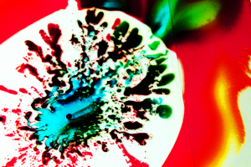
The image shows the phenomenon of Hele-Shaw cell which was took on October 16, 2016 in ECME lab 165 about 9pm. The team members include Matt Blackmailer, Yadira Valadez and Stephanie.
The experiment steps are shown following: There are two pieces of transparent sheets. The mixed fluid include oil and red dye is squeezed between two pieces of sheets. The pure fluid-blue dye is injected from the hole of upper sheet by injector. Thus the above phenomenon so called “Hele-Shaw cell” is generated, which because of the viscous difference of oil and dye. The white part in the image is the oil which is at the bottom and the outer background is the dye with different colors that is overflow from the gap of sheets. Different colors of dye were tried to carry out the experiments with different method, while the above image is selected because of great distribution of dyes and distinct contrast of color. (The straight line shown in the image is the edge of the sheet).
The principle of “Hele-Shaw cell” is depicted in detail as following. When a viscous fluid filling the voids in a porous medium is driven forwards by the pressure of another driving fluid, the interface between them is liable to be unstable if the driving fluid is the less viscous of the two. In 1958, P. G. Saffman and Geoffrey Taylor firstly carried out the experiments in which a viscous fluid confined between closely spaced parallel sheets of glass, a Hele-Shaw cell, is driven out by a less viscous one reveal a similar state. The motion in a Hele-Shaw cell is mathematically analogous to two-dimensional flow in a porous medium [1].
The stability of the interface between two fluids in a porous medium is firstly theoretically researched by Taylor in and experimentally verified by Lewis in 1950. The formulas that decide the stability are shown following:

If stable interface
$\left(\frac{μ_{2}}{k_{2}}-\frac{μ_{1}}{k_{1}}\right)V+\left(ρ_{2}-ρ_{1}\right)g>0$ (1)
If unstable interface
$\left(\frac{μ_{2}}{k_{2}}-\frac{μ_{1}}{k_{1}}\right)V+\left(ρ_{2}-ρ_{1}\right)g>0$ (2)
Where $μ$ denotes the viscosity, $ρ$ the density and $k$ is the permeability of the medium to the fluid. $V$ means the upward velocity and $g$ means the gravity acceleration. In 1898, Hele-Shaw given an analogue study for two-dimensional flow in a porous medium. The mean velocity across the stratum of fluid 1 ahead of the interface is given by:
$u_{1}=-\left(\frac{b^{2}}{12μ_{1}}\right)grad(p+ρ_{1}gx)$ (3)
$u_{2}=-\left(\frac{b^{2}}{12μ_{1}}\right)grad(p+ρ_{2}gx)$ (4)
Where b denotes the distance between two sheets. The following picture shows the finger moving into a channel.
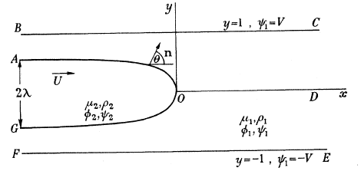
The mean velocity across the stratum is given by equations (3) and (4) and the equation of continuity takes the form:
$\frac{∂u}{∂x}+\frac{∂v}{∂y}=0$ (5)
Where $u$ and $v$ are the components mean velocity parallel to the axes. A stream function ψ can be defined by
$u=\frac{∂∅}{∂x}=\frac{∂ψ}{∂y}$ $v=-\frac{∂∅}{∂y}=\frac{∂ψ}{∂x}$ (6)
Using the method of stream function and potential function, the maximum velocity of propagation could be calculated as following, (The detailed processes are omitted).
$U_{max}=\frac{μ_{1}}{μ_{2}}V+\frac{b^{2}g}{12μ_{2}}(ρ_{1}-ρ_{2})$ (7)
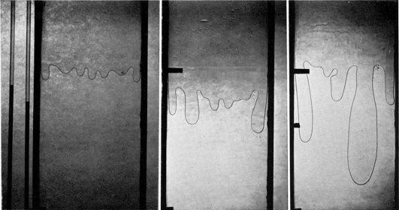
Viscous fingering experiments carried out by P. G. Saffman and Sir Geoffrey Taylor
For other applications of Saffman-Taylor instability. William Mather also research the stream instability in growing cell population [2]. The Canon EOS REBEL T5 is applied to took the image. For the parameters, the focus length 49mm, the exposure time is 1/60 sec and ISO is about 800. For the processing, the image contrast has been adjusted. The image pixels after treatment is 5184*3456.
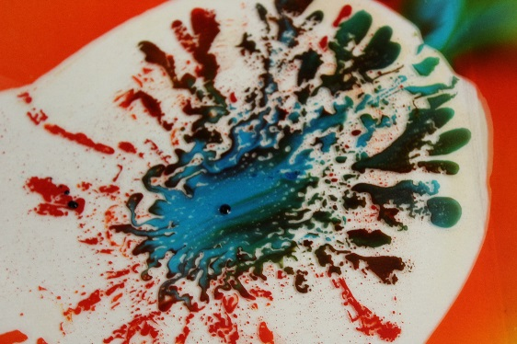
Original image After processing
For the potential improvement, the shape of Hele Shaw cell should be more symmetrical. The actual asymmetry is probably because of the pressure difference when injecting blue dye.

[1] “The penetration of fluid into a porous medium or Hele-Shaw cell containing a more viscous liquid” P. G. Saffman and Sir Geoffrey Taylor, The Royal Society, Mathematical and Physical Sciences.
[2] “Streaming Instability in Growing Cell Populations” William Mather, etc. Physical Review Letter 104, 208101(2010).

