Team Third Image: Paint Diffusion in Water
Jeremiah Chen
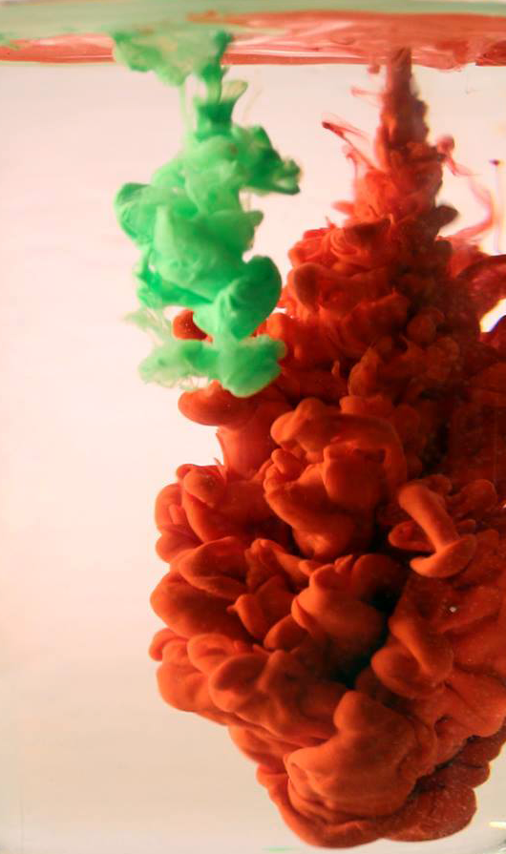
December 6, 2016
MCEN 4151 – Flow Visualization
Professor Jean Hertzberg

Purpose/Introduction

The purpose of this assignment, titled “Team Photo #3”, was to work in a team to create a display of fluid phenomenon for the MCEN 4151 Flow Visualization course held by Professor Hertzberg. The image captured should be both visually appealing and show fluid dynamics.
This image was chosen due to the interest in diffusion of fluids in water and their visual appeal.

Materials

- Clear glass filled with water
- Acrylic paint (various colors)
- Turkey baster
- DSLR Camera

Team
- Jeremiah Chen
- Daniel Bateman
- Jason Savath
- Mark Noel

Procedure

The procedure for this image was to first mix acrylic paint with water. Varying concentrations of paint and water yielded different results for the final image. For this particular image, about three (3) parts of red paint was mixed with one (1) part room temperature water. The same was done with green paint. Then, the turkey baster was filled with the green mixture. Holding the container of red mixture and baster of green mixture at about 6 inches above the surface of the water, the red mixture was first poured into the glass. The green mixture was injected about half a second after the red mixture had started pouring. Back lighting was used from a regular tungsten light with a piece of white paper placed behind the glass in order to distribute the light. One more tungsten light was placed to the left of the glass, aimed directly at the glass as well.
Red
Green

6 inches

Glass of Water

Figure 1. Flow apparatus set up.

Fluid Physics

According to an article on Gizmodo, the effects of the paint mixture as it falls through the water is a result of Rayleigh-Taylor instabilities [1]. This instability occurs two fluids of different densities interact with each other. It is seen often with nuclear bomb explosions as well as supernovae. In the case of this image, it is the denser paint mixture colliding with the water due to the force of gravity. This fluid phenomenon is quite complicated in nature but essentially, the instability occurs due to shear, gravity, and the rolling of fluid. However, this phenomenon does not last long as the two fluids will quickly mix together and the beautiful distortions will no longer be seen.

Figure 2 below outlines a single stream of fluid entering another body of fluid and the result effects. It also shows how the Rayleigh-Taylor instabilities cause the mushroom like form to appear.

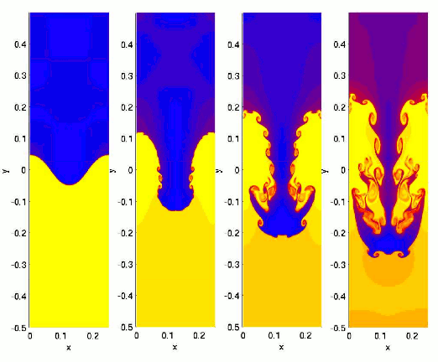
Figure 2. Visual of Rayleigh-Taylor instability [2].

Photographic Technique

This image was shot on a Canon 70D DSLR with a 17-50 mm lens placed half a meter away from the glass. Shutter speed was at 1/195 s with ISO and aperture at 800 and f/4.0. The focal length was set to 35 mm. Depth of field was approximately 15 cm, and the original image had a resolution of 5472 x 3678. Very minimal post processing was done as the set up and lighting for this assignment provided a very clear visual of the flow. Therefore, the only post-processing done to this image was to crop the image in order to get rid of any distracting elements. The final resolution of the image was 530 x 895.

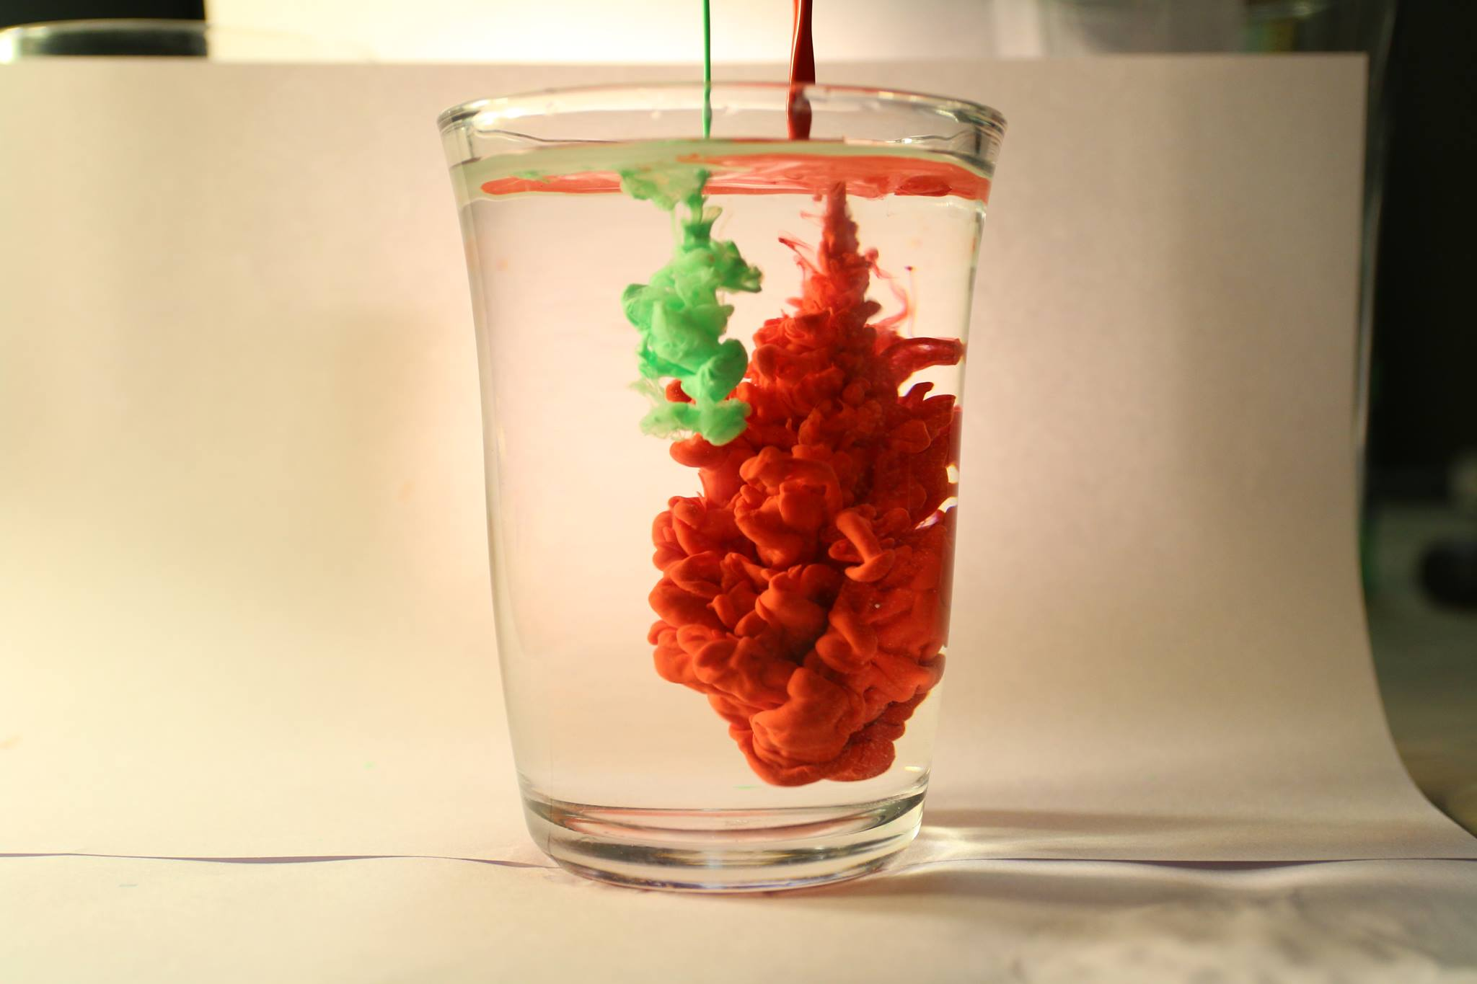
Figure 3. Original image.

Figure 4. Final, edited image.

Conclusion

Overall, this image produced good results as the flow, and aesthetic are all of high quality. The use of green and red paint contributes well to the holiday spirit. If this assignment was to be repeated, more variety of colors would be used to generate an even more visually appealing image. Additionally, the concentrations of the paint mixture could be varied to see how the density of the mixture will affect diffusion.

Works Cited

- Stone, Maddie. “There’s Some Complex Physics In These Photos of Ink Falling Through Water.” Gizmodo. [Online, Accessed December 6, 2016].
- Li, Shengtai & Hui Li. “Parallel AMR Code for Compressible MHD or HD Equations.” Los Alamos National Laboratory. [Online, Accessed December 6, 2016].

