Flow Visualization Jason Savath

Clouds 2
The Physics and Art of Fluid Flow

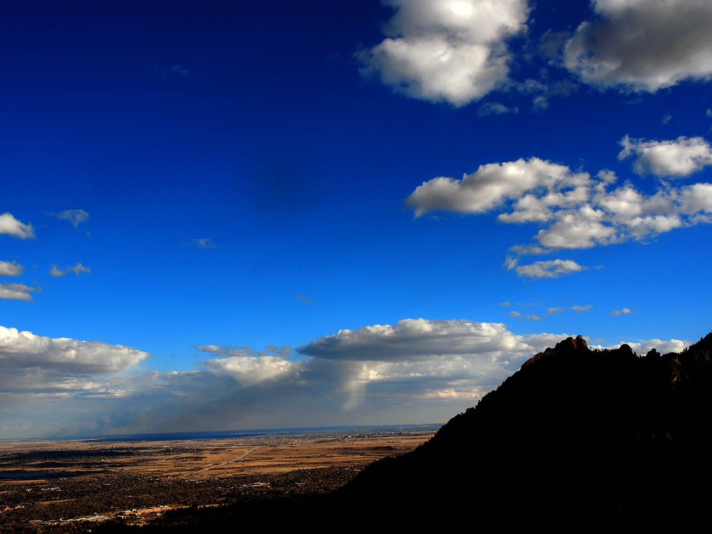

Introduction
This project, “Clouds 2,” is designed to get students to take beautiful cloud images while understand the fluid flow. The photo was taken near the Flagstaff amphitheater in Boulder, Colorado. The purpose of this image was to capture different types of clouds against the beautiful silhouette of the Flatirons. The clouds in this image appear to be nimbostratus and stratocumulus in stable atmosphere. This image was captured facing due south using a Nikon camera.

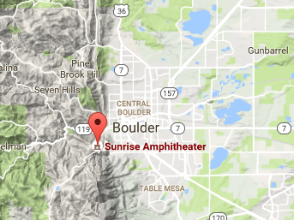
Image Circumstances
The direction of the camera was facing due east, and the wind was blowing from the south to the north. The camera was held at an angle about 10 to 15 degrees above the horizontal at no visible tilt. The image was taken late in the evening around at 5:15 pm on November 13th 2016. The location was Flagstaff amphitheater in Boulder, Colorado with the GPS coordinates of 40.00 Latitude, -105.3 Longitude, and 2086 m above sea level (Map Coordinates)

Cloud Description
There are two visible types of clouds shown in the image. The two clouds are nimbostratus and stratocumulus clouds. This can be confirmed visually with the cloud type diagrams shown in class lecture (Lecture 14). This means that the atmosphere at this time is fairly stable. Both the nimbostratus and stratocumulus clouds appear around 1,500m to 2,000m respectively above the surface. The altitude difference can be clearly seen in the image from the different level of clouds. The stratocumulus clouds can be seen closer to the mountains and the nimbostratus clouds are spread out in the distance. By looking at the skewed-t diagram (University of Wyoming), the clouds forming at those altitudes seem to be appearing correctly. This also proves that the atmosphere was stable around that time as the CAPE value from the skewed-t diagram is zero. The wind was blowing the clouds from the mountains at about the speed of 8mph. This can be seen throughout the evening as the clouds traveled and spread out across the sky as shown in the image.

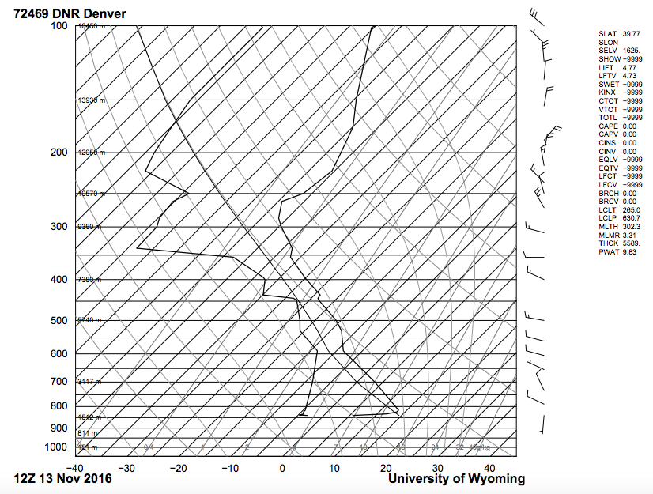

The Photography
Capturing the image proved to be difficult because the clouds are at different distances away from the camera. By setting the ISO to 200, it is possible to capture the depth of the clouds while making the image crisp and focused. The f-stop was f/10.0 and exposure time of 1/400 seconds. The image came out with a bright background and a dark foreground. To accentuate this contrast, Photoshop was used to further darken the foreground while bringing out the colors of everything else. To decrease the blue discolor of the image, a color balance filter was also applied. The sunlight comes in from behind the mountains shining from west to east. This image also contains crepuscular rays in the background. This set of crepuscular ray is caused in the same direction as the sunlight creating a streak in the sky.

Conclusion
The image turned out to be quite beautiful. The clouds are well contrasted along with the mountain silhouette that gives the image an aesthetically pleasing effect. Two different set of clouds can easily be seen. They then slowly drift towards the camera, which adds visual effects to the direction that the wind is blowing. The crepuscular rays gives the image a sense of uniqueness.
The final image definitely has revealed both the physics and the art. However, some improvements can be made. The contrast of the picture can be further increased to thoroughly define the cloud shape and depth. The blue smudge at the top left is a distraction and should be removed by cleaning the lenses better.
Setting up the camera to take pictures of the clouds, mountains, and city scape was difficult. In order to perfectly achieve an artistic image, Photoshop had to be used. Overall, this was a another experience that allowed me to take interesting pictures of clouds. Upon completion of this project, I have learned more behind the physics of how clouds form and what different types of clouds look like.

References
Lecture 14. Clouds 1. http://www.flowvis.org/media/course/Lecture2016/14.Clouds1.pdf

Map Coordinates. http://www.mapcoordinates.net/en

University of Wyoming. Atmospheric Sounding.
http://weather.uwyo.edu/upperair/sounding.html

