Cloud First Report
Jacob Chapin
Flow Visualization
3/15/18

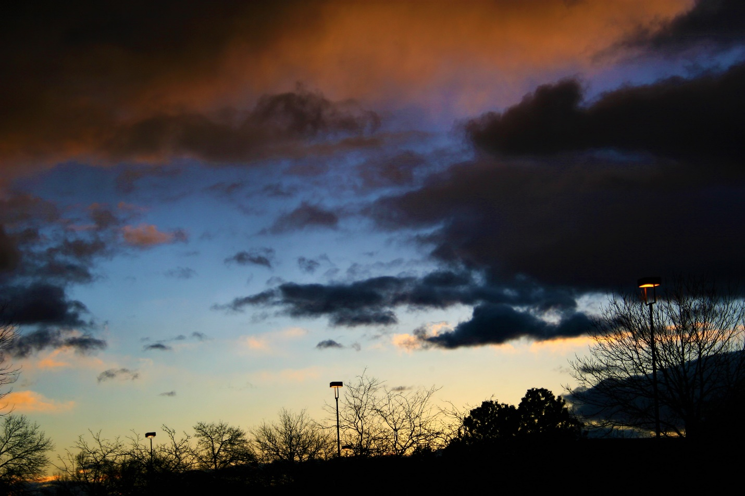

When I was envisioning how I wanted my cloud image to look I was originally focused on trying to capture a lot of color. After shooting some sunsets with nice colors, I decided I wanted a cloud image that had color and was beautiful but was also dark and ominous at the same time.
This image was taken on February 5th at approximately 7am in Boulder, Colorado. After waking up on this morning, I checked the weather radar and it showed a storm was approaching Boulder. I quickly went outside and began to shoot, hoping to get an image I was happy with. Once the storm neared Boulder, a large wall of dark cloud was met the relatively clear sky and created an interesting composition of clouds. This image was taken facing east at some point while the sun was rising. I took this image standing on the ground outside of Petco on Arapahoe Avenue. The sun’s rays were hitting the fronts of the clouds, while the backs, which were facing me, were much darker. The storm clouds which were the ones most directly overhead or at the top of the image were colored orange.
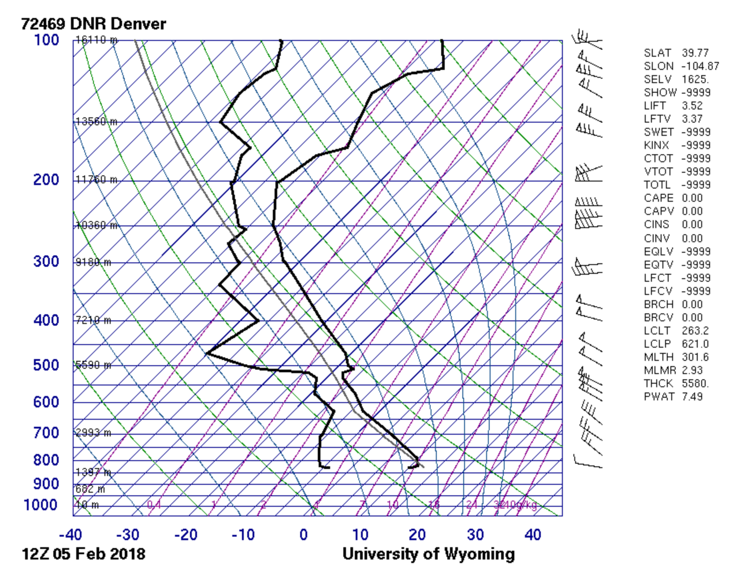
Figure 1: Skew T
Based on observation of the weather, the Skew-T diagram from this day, and other factors, a few things can be said about the clouds in the image. The clouds in this image are most likely Stratocumulus or Nimbostratus. This is because of how low they were in elevation and how much moisture the were holding. This is typical and was consistent with what I was expecting. After this image was taken it started to become windy and rainy. This was caused by the weather system being unstable. The warm air in Boulder caused the moist mass of cloud to rise and cool until it eventually condenses into rain. Prior to this rainstorm, it was a clear morning. This can be seen by the clear sky in the distance of the image.
I shot this image with a Canon 30D DSLR. I was standing on the ground when I took this image and was shooting at approximately 10 degrees above the horizon. While I was shooting the clouds, I was playing around with some different settings. I was still not very familiar with my camera at this point, so I was shooting in the preset landscape setting. I also darkened the image slightly to make it more unsettling.
Personally, I think this image reveals a connection between the upper atmosphere and the earth’s surface. When viewing a cloud from the ground, it seems like it is out of reach or disconnected from people and things on the ground. This image makes the cloud seem like it is very low and close to the trees. The fluids of the cloud are shown clearly. This image fulfilled my intent to capture a unique cloud image. In terms of editing, I would like to do some darkening to the street lamp on the far right.

