Jacob Chapin
Team First
Flow Visualization
3/5/18
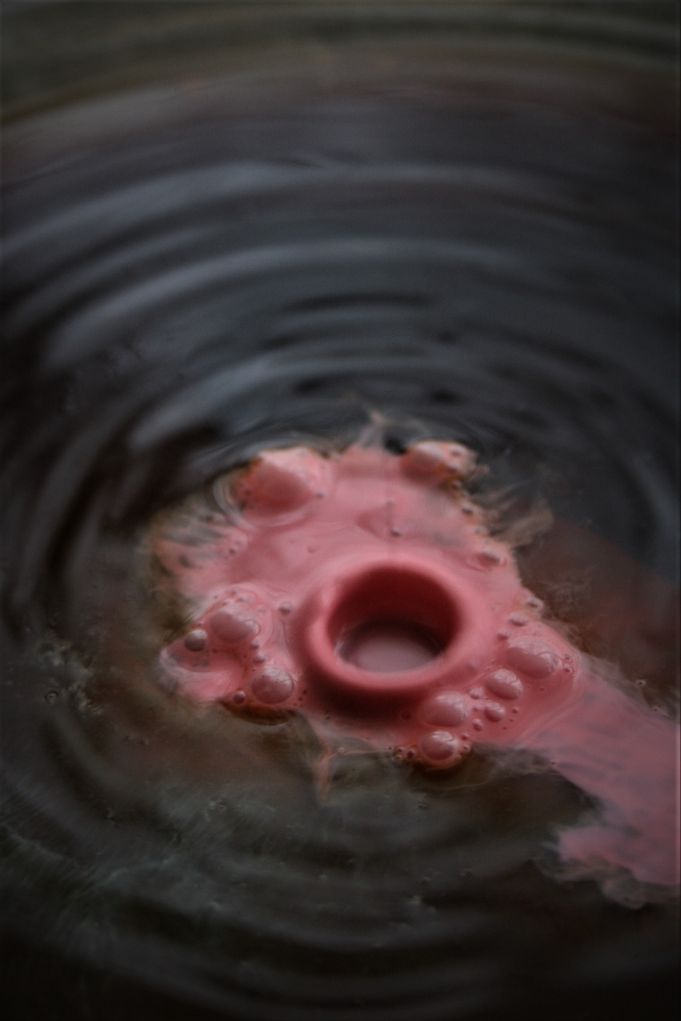
When I was envisioning an interesting image the thought of photographing creamer entering coffee immediately popped into my head. I had a vision of creating an image where different colored cream was violently poured into coffee. I was interested in seeing how the creamer would spread in the coffee based on different pour heights, durations, and colors
When considering the physics that govern the flow it important to try and understand some concepts. Given that the coffee was stationary, we can assume that it was initially at rest. The creamer that is poured into the coffee does impact the coffee at a certain velocity. Given that the creamer was poured at about 10 inches from the surface of the coffee, we can calculate the velocity at impact.
If we set the potential energy equal to the kinetic energy we can solve for the impact velocity. Then we can use the impact velocity to solve for the Reynolds number.

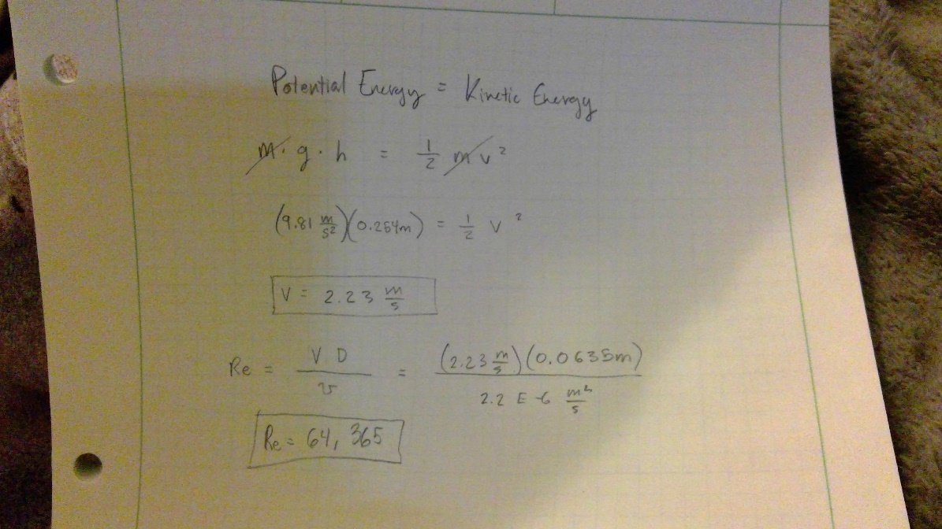

When we do this, we find the Reynolds number is approximately 64,000. This means that our flow is turbulent as it hits the coffee. This would make sense because there is clearly some trapped air in the stream that we can see in the form of bubbles on the surface. This tends to occur when flow is turbulent. The lighting for this photo was normal outdoor lighting coming through an open door.
The setup of the image consisted of a large dinner plate filled with approximately one cup of coffee. I brewed this pot of coffee especially strong with the hopes to have some more dramatic contrast. The depth of the coffee was only about one centimeter. The creamer was made with approximately 2 ounces of half and half cream with two drops of red food coloring added to it. Both were generic Safeway brand.
I did not complete this image with a partner, so I knew it would take a lot of trials to get the image I was hoping for. I set up the shot and had one hand fixed on the camera and one hand holding the creamer above the coffee. I then set my camera to the action setting so it would take multiple continuous images and began shooting. After about 5 shots were taken, I poured the creamer blindly, hoping for an interesting image. After approximately 10 setups of pouring creamer into coffee I got this image with the impact but no stream. The camera was positioned about 12 inches from the fluid. The final image was edited and darkened slightly to improve the contrast.
This image reveals some of the intermolecular forces that are occurring when a turbulent fluid impacts a stationary fluid. It also has the effect of puzzling the audience as they are not sure how the image was generated. I like how the pink fluid is centered in the image with the ripples of the coffee framing it. I also like the pattern that is made in the coffee, it appears to look like a distorted face. I dislike the blurriness of the impact hole itself but I like how the bubbles are in focus.

