Cloud Second Assignment

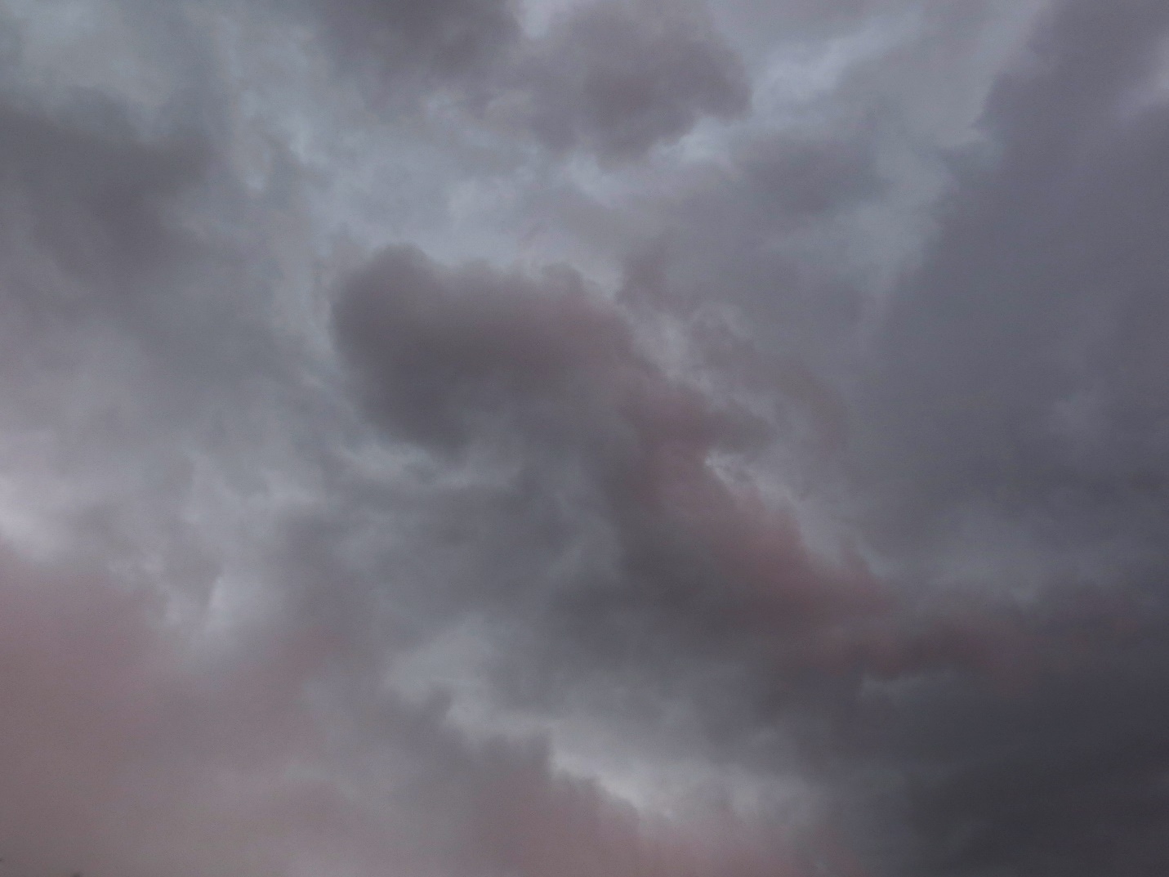

By: Casey Cooter
Team Eta
MCEN 4151
Professor Hertzberg
4/23/2018

Introduction
This image was taken for the “Clouds Second” assignment for the 2018 spring semester course of “Flow Visualization” at the University of Colorado at Boulder. The assignment was to photograph an intriguing cloud, and then to evaluate the cloud to learn more about the type and conditions which produced it. This report will contain information pertaining to the circumstances of which the cloud was taken, a deeper analysis on the environment of the cloud, and the details of how the photo was taken.

Cloud Information
The cloud was taken on March 18th, 2018 at 2:09 PM. This photo was taken at Whole Foods Ideal Market, located on 1275 Alpine Avenue in Boulder, Colorado, on the adjacent street. The city of Boulder is located 5430 feet above sea level. In this photo, the camera was pointed straight up at the sky, as the intention was to capture the details of the clouds, as none of the surrounding scenery would have complimented the photo, and the sky was completely overcast. In this photo, it had just started to rain.
On the day the photo was taken, it had just started to rain. As was mentioned above, the entire sky was overcast with grey rain clouds. The rainfall was long, but never heavy. Because of these factors, the cloud most likely falls under the classification of nimbostratus. Looking deeper, the temperature of the day was 42 °F with a max of 54 °F, and experienced only 0.48 inches of precipitation. After a few hours, the rain began to turn to snow as the temperature began to cool later towards the evening. [1] This storm had been coming on the horizon for a few days before it hit Boulder. The Skew-T diagram for Denver on April 18th, 6:00 PM can be found in Figure 1.
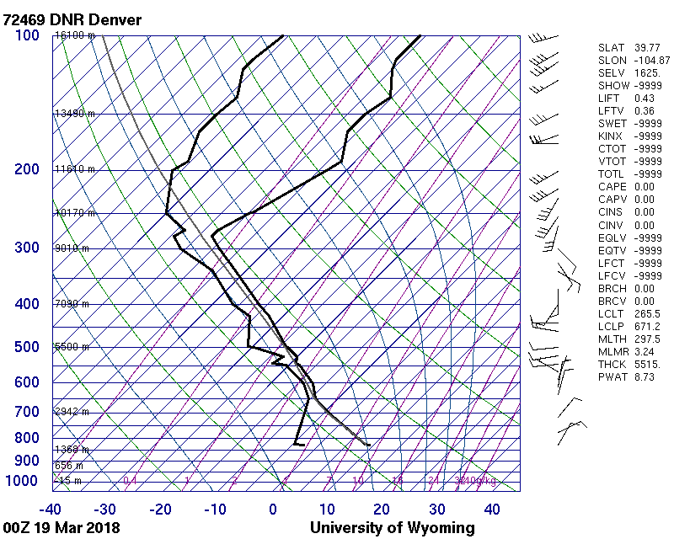
Figure 1: SKEW-T diagram from an observatory in Denver, Colorado at 6:00 PM MST, the closest time and location available. [2]
From the SKEW-T diagram, we note that the CAPE is 0.00, which implies the atmosphere is stable. This helps to affirm that the cloud is a nimbostratus, as nimbostratus clouds generally occur only in stable atmosphere. We also note that the dew point only ranges from -20 °C to 0 °C, which is sensible as it was just starting to rain in the photo 4 hours prior. The skywatch data for this day can be seen in Figure 2.
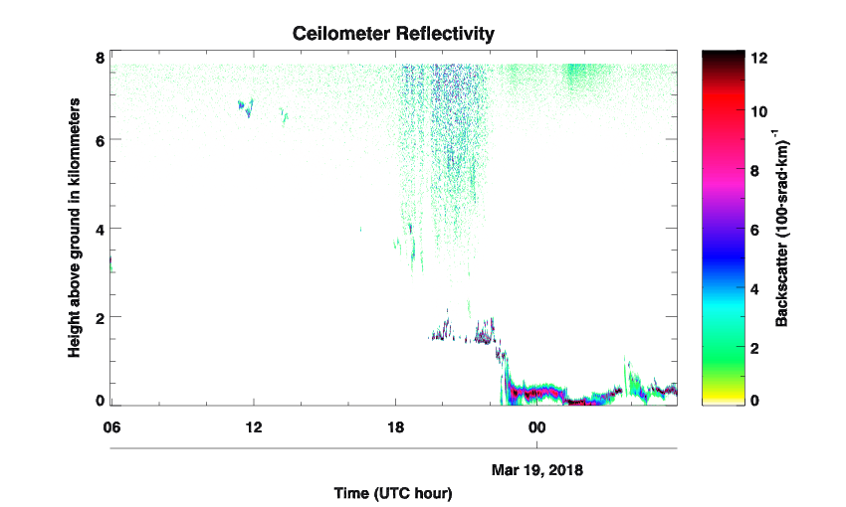
Figure 2: Ceilometer data from CU Boulder's Skywatch Observatory, illustrating the height of clouds. Notice how much of the cloud activity occurs between 18:00 and 23:59, corresponding to 12:00 PM and 5:59 PM in MST.
The rain clouds began to appear around Boulder in the exact times the Ceilometer shows activity around the 2000-meter mark. As nimbostratus clouds occur around 2000 meters, this final piece of evidence strongly affirms that the clouds in the photo is a nimbostratus cloud.

Photo Information
This image was taken with a Canon SX260HS digital camera, producing a JPEG of 4000 x 3000 pixels, and had an F-stop of f/3.5. The exposure time was 1/40th of a second with an ISO speed of ISO-100. The focal length was 6 mm, and flash was not used in this photo. The ceilometer suggests that the cloud is approximately 2000 meters away from the ground. Without any physical references, it is difficult to properly estimate the distance being viewed, but 3000 x 4000 meters is a reasonable approximation. The original image can be seen in Figure 3. This image captures the details of the sky well, but the contrast is quite low which can pose a problem for those with lower quality screens. Furthermore, there is a hint of a powerline in the bottom left corner. To edit this photo, I used the photo editing software package GIMP. First, the image had this
Figure 3: Original cloud image before post-processing.
powerline edited out with the clone tool, as I wanted to preserve the aspect ratio and size of the image. Following this, I stretched the contrast using exposure curves so that I could preserve the stormy image without making it look too dramatic. If contrast was stretched too much, then the image would look unnatural and be highly unpleasing to look at. The final image can be seen on the cover page. The powerline was edited out and looks much better in the image. Furthermore, by stretching the contrast, the dull blues in the image were brought out while the greys were darkened. It still provides an effect of being stormy without being too dramatic.

Conclusion
As the semester has been relatively dry, I used this as an excellent opportunity to photograph a rain cloud, as I saw it as a rare opportunity. What I did learn however is that capturing rain clouds is extremely difficult. The nimbocumulus cloud had nothing that could quite serve as a reference point since it stretched the entire sky. However, this photo was taken in just the right way, and was the perfect subject for post-processing. Therefore, I feel that this photograph is an excellent example of a nimbocumulus cloud.

References
[1] “Weather History for KBDU - Weather Underground (10.226.243.89), 18 Mar. 2018,
www.wunderground.com/history/airport/KBDU/2017/12/2/DailyHistory.html.
[2] University of Wyoming. “Atmospheric Soundings.” UNWO Weather, University of
Wyoming, 18 Mar. 2018.
[3] “Skywatch Observatory.” Skywatch Observatory, skywatch.colorado.edu/, 18 Mar. 2018

Image Assessment Form
Flow Visualization
Spring 2013

Name(s): Casey Cooter

Assignment: Cloud Second Date: 23 April 2018
Scale: +, ! = excellent √ = meets expectations; good. ~ = Ok, could be better. X = needs work. NA = not applicable
Art | Your assessment | Comments
Intent was realized | +
Effective | +
Impact | +
Interesting | +
Beautiful | +
Dramatic | +
Feel/texture | +
No distracting elements | +
Framing/cropping enhances image | +

Flow | Your assessment | Comments
Clearly illustrates phenomena | !
Flow is understandable | !
Physics revealed | √ | No frame of reference ruins photo slightly
Details visible | !
Flow is reproducible | N/A
Flow is controlled | N/A
Creative flow or technique | N/A
Publishable quality | √

Photographic/video technique | Your assessment | Comments
Exposure: highlights detailed | !
Exposure: shadows detailed | !
Full contrast range | !
Focus | !
Depth of field | !
Time resolved | !
Spatially resolved | !
Photoshop/ post-processing enhances intent | !
Photoshop/ post-processing does not decrease important information | !

Report |  |  | Your assessment | Comments
Collaborators acknowledged |  |  | N/A
Describes intent | Artistic |  | !
 | Scientific |  | √
Describes fluid phenomena |  |  | √
Estimates appropriate scales | Reynolds number etc. |  | √
Calculation of time resolution etc. | How far did flow move during exposure? |  | NA
References: | Web level |  | !
 | Refereed journal level |  | !
Clearly written |  |  | !
Information is organized |  |  | !
Good spelling and grammar |  |  | !
Professional language (publishable) |  |  | !
Provides information needed for reproducing flow |  | Fluid data, flow rates | N/A
 |  | geometry | NA
 |  | timing | NA
Provides information needed for reproducing vis technique |  | Method | NA
 |  | dilution | NA
 |  | injection speed | NA
 |  | settings | !
lighting type |  | (strobe/tungsten, watts, number) | !
 |  | light position, distance | !
Provides information for reproducing image |  | Camera type and model | !
 |  | Camera-subject distance | !
 |  | Field of view | !
 |  | Focal length | !
 |  | aperture | !
 |  | shutter speed | !
 |  | Frame rate, playback rate | NA
 |  | ISO setting | !
 |  | # pixels (width X ht) | !
 |  | Photoshop and post-processing techniques | !
 |  | "before" Photoshop image | !

