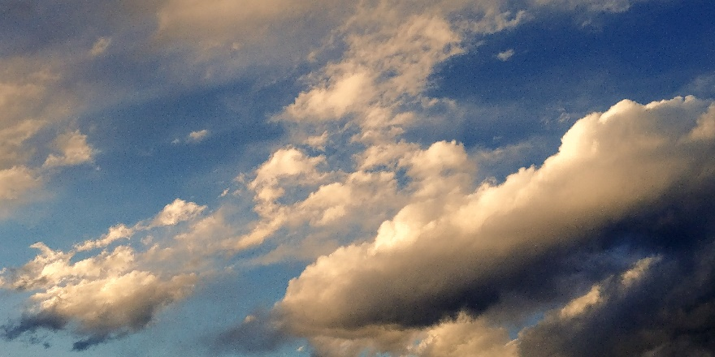

Mountain Wave Clouds over Chautauqua Park
  - Clouds Second
Cyron Completo | ATLS 4151 | April 23, 2018
Photograph taken: March 4, 2018

Context
This image was taken for the Clouds Second project and was taken by Cyron Completo on March 4, 2018 at 5:32 PM. The intention was to capture mountain wave clouds during a relatively stable atmosphere while accurately reproducing the textures and colors that I saw in person. The photograph was taken at the base of the Chautauqua trailhead at Baseline Rd & 9th St, Boulder, CO 80302. The intent of this image was to show the varying shapes and sizes of mountain wave clouds, showing that they can take on the appearance and texture of various cloud types. For example, the cloud structure on the bottom right could be a cumulus cloud, while the clouds on the top left could be cirrus clouds. All the clouds in the scene are mountain wave clouds.
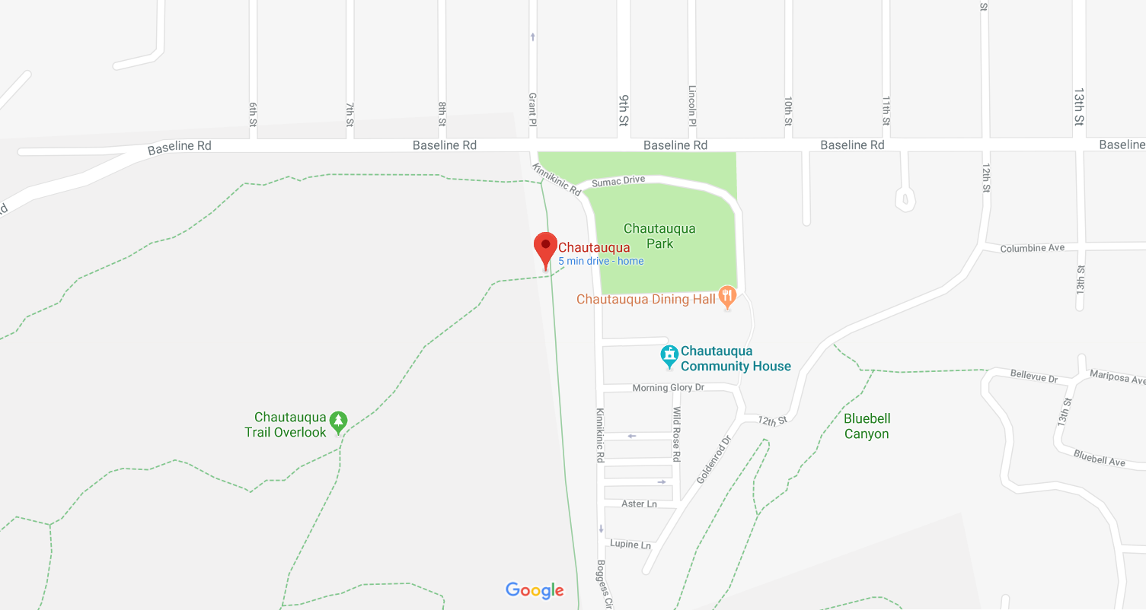
Figure 1: Location of Photograph

Flow Discussion
These clouds appear in such a way due to the stability of the atmosphere, time of day, the direction of the wind, and the height of the clouds. Slightly above the bottom right cloud are some clouds that are slightly dissipating. When referencing the Skew-T diagram below, it is clear to see that these clouds were hovering around 5700 meters, due to the large spike around that y-value. Furthermore, since the CAPE value of the day was at 0 when the skew-T diagram was recorded, that is proof that the atmosphere that day was stable.
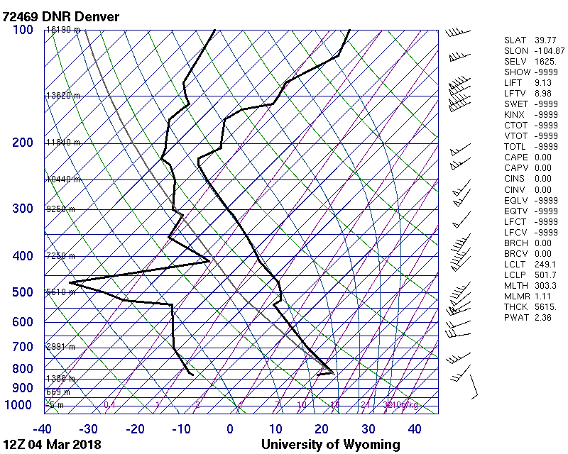
Figure 2: Skew-T Diagram of March 4, 2018

Visualization Technique
I used natural sunlight as the main source of lighting for this photograph. I did not use any physical filters to capture this photograph. Also, I purposely avoided including any foreground elements that did were not clouds to focus on the cloud shapes and textures.

Photographic Technique
I used my LG G6 camera phone to take this photograph. The original photograph had a resolution of 4160 x 2080. The final image had the same resolution as the original. The cloud captured was about 5700 meters in the air. I used an aperture of f/1.8 in order to capture as much light as possible (my phone also limited the adjustment of my aperture), a shutter speed of 1/950 seconds in order to eliminate any motion blur, a focal length of 4.03 mm so that I could eliminate any distracting elements in the scene while focusing on capturing as much of the cloud as possible, an ISO speed rating of ISO 50 in order to reduce graininess while anticipating a degree of image noise. In addition, I used Adobe Lightroom as my source of post-processing in order to accurately display the colors I was seeing at the time and to adjust for lighting and contrast. In Lightroom, I increased the temperature of the white balance to give off a “sunset” sort of feel, made the tint of the white balance lean towards magenta in order to amplify the blue tones as well, decreased the exposure and contrast so that the image had a slightly blurrier, dreamier effect. In terms of lighting in the scene, I bumped up the shadows, whites, and highlights while making the blacks darker in order to provide a greater range of lighting while keeping the contrast relatively loose in comparison to the exposure. I also gave all the colors in the scene more presence in terms of clarity, vibrance, and saturation so that it felt a little bit more ethereal.
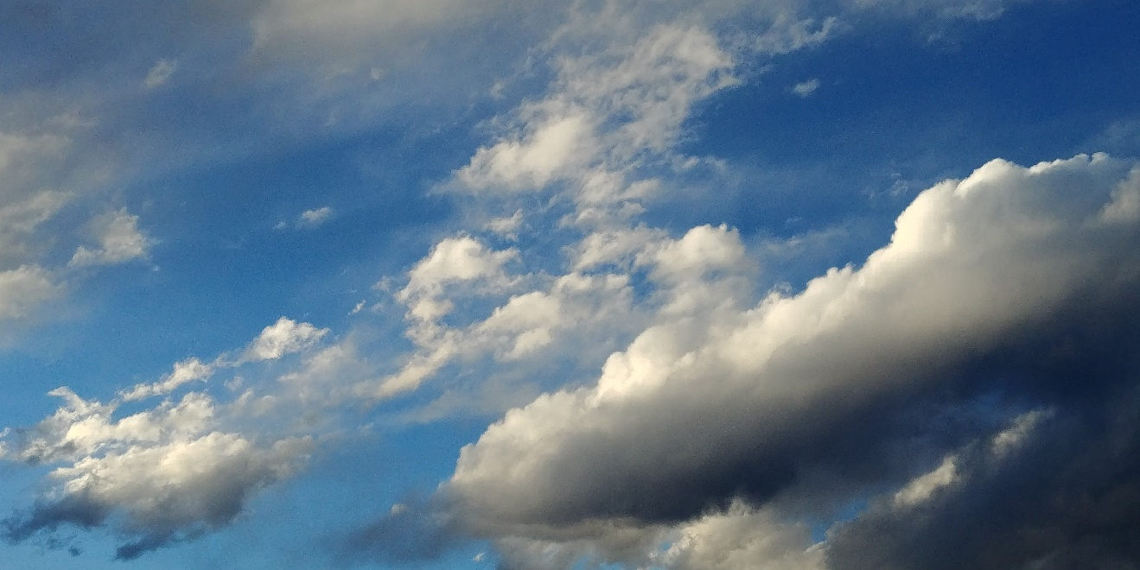
Figure 3: Original image

Closing remarks
I accomplished my intention of capturing the various characteristics of mountain wave clouds in the final image. By framing a subsection which comprised a wide variety of the clouds’ characteristics, choosing to not include any foreground elements, making use of a high shutter speed to reduce motion blur in tandem with a wide aperture to capture as much light as possible, and carefully adjusting the white balance, exposure, contrast, highlights, and shadows, I was able to craft an image that effectively portrayed the various personalities of mountain wave clouds. I am satisfied with the final image. However, if I could go back and change my process, I would have liked to have spent more time in the area taking pictures of the same cloud formations so that I could discover a series of images that describe the mountain wave phenomena well.

