First Team Image Report

Brent Eckles

MCEN 4151-001

8-Oct-18
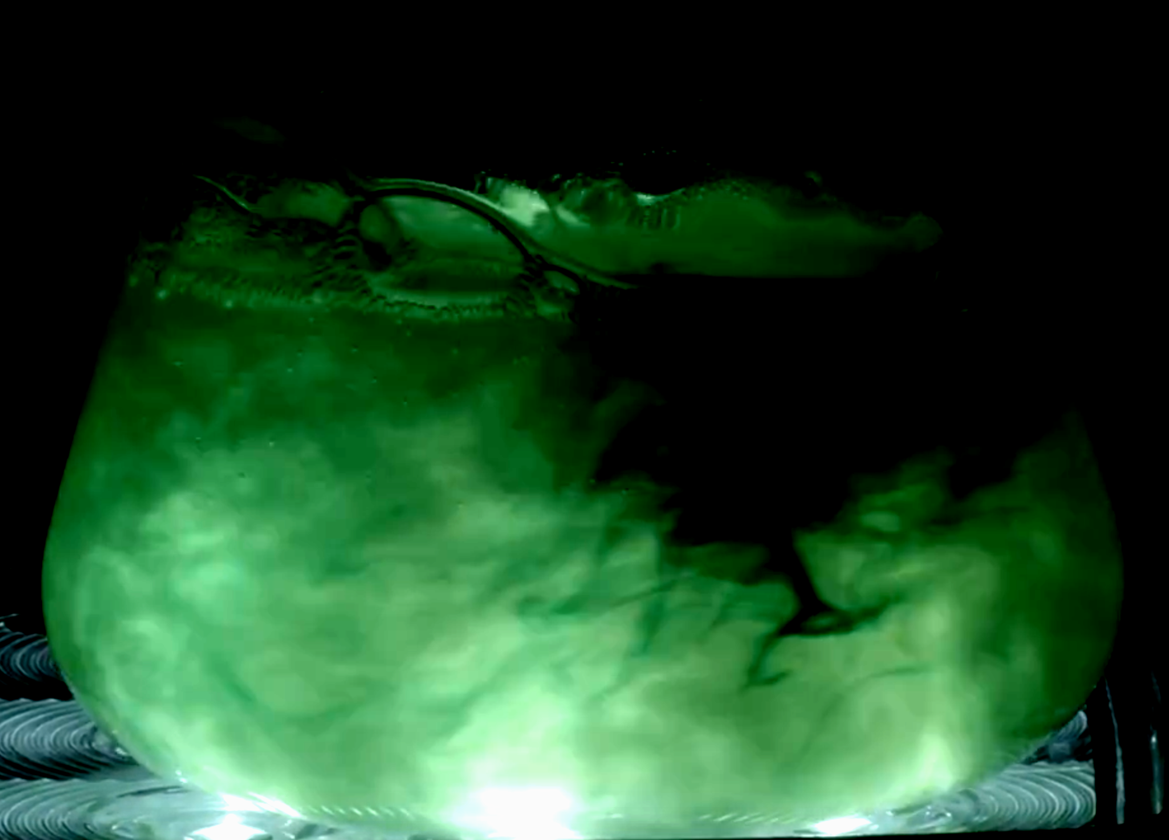

Introduction:
This image was produced in response to the first team project assignment for Flow Visualization as the initial opportunity to work as a team to produce a shot. The idea for this image came from the experience one team member had working with fluids, which have far more visible flows than others. The fluid in particular was a mixture of water and shaving cream, the white and thicker shaving cream makes the flow of the water far more visible but has a negligible effect on the flow of the water. After brain storming several ideas on which scenario to test the fluid flow, we decided to try a few options. The first was generating a fluid channel which would create a situation of both turbulent and laminar flow, and the second, which is captured in this photo, testing the visual output of adding heavy light and swirling the fluid. This project gave the opportunity to further practice the teams staging abilities, as well as dealing with adversity when attempting to capture the perfect shot.

Experimental Setup:
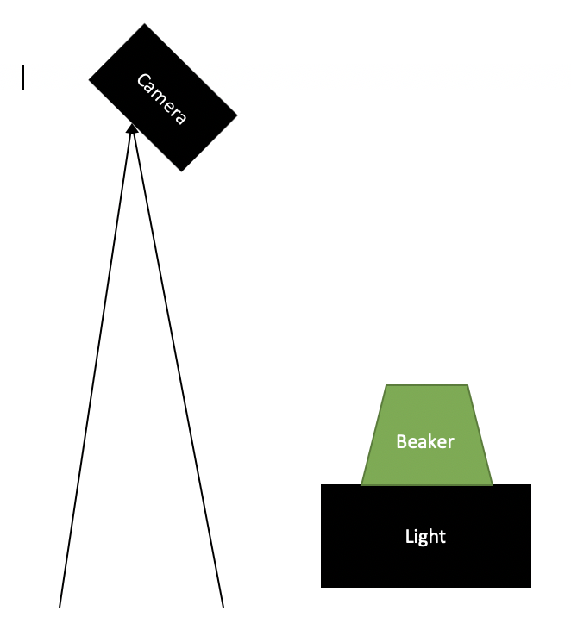
The materials used in the capturing of this image were shaving cream, green food dye, water, a light generator, and a beaker (Figure1). First the mixture of shaving cream and water had to be produced. The two were mixed together and the ratio between the two was played with until the optimal properties were discovered. These properties were a very visible mixture of fluids while still having a low viscosity. Next the fluid was poured into a large beaker filling nearly half of the container. A large light was set up facing directly upwards, then the beaker was placed directly on top. The camera was set up approximately four feet above the set up, focused to give the best resolution. Two drops of the food dye were then dropped into the fluid, and the fluid was quickly swirled. This mixed the food dye and the solution together with the resulting flow captured. This process was repeated for several food dye and lighting set ups until the team was satisfied with the results.
Figure 1

Flow Analysis:
There are two main flow phenomena that were captured through this experiment and image, fluid density’s and mixing properties. The effects of differing fluid density and properties can be seen by the solution of water and shaving cream. The low density shaving cream is mixed with the higher density water to create the experimental solution. While the water dissipates much of the fluid into very small segments of shaving cream the affects of their densities can still be seen. The shaving cream rises to the top of the fluid while the water sits on the bottom. This is due to the density of the fluids. The water is made of particles and a particle arrangement which has a greater mass per unit area then the shaving cream. When the two fluids mix this greater mass per unit area pulls the fluid down and allows the lesser mass per unit area fluid to rise to the top. The second flow phenomena observed is the generation of a completely solvent aqueous solution due to the hydrophilic food dye. Due to the properties of the food dye it immediately begins to mix with the water and shaving cream solution. The swirling observed in the photo speeds up the mixing process and quickly turns the entire solution the green color. The mixing is only possible because the food dye is hydrophilic and dissolves in water.

Camera Specs & Photo Editing:
The image was originally captured while taking a video of the flow. The camera used was a Black Magic Pocket Cinema Camera with an adjustable 80-200mm lens. The exposure time was 1/96 seconds with an f-stop of f/8 and ISO800. The camera lens was located about 4.5 feet from the object in focus. The original photo was 1920 X 1080 pixels before being cropped to the image in Figure 2. Since the original media type was a video there was a plethora of still images to select from. This final picture was selected due to two major characteristics. First, the picture captured the events of the experiment very well. It can be seen that the fluid is being swirled around giving the image a dynamic element. Secondly the image was selected due to its deep and interesting color presentation. At this moment in time there is a nice dark segment of the fluid as well as a large segment presenting the green color dye that had been dropped into the fluid. Once the perfect image was selected it then had to be edited, allowing for the optimization of the photo. The image was uploaded into gimp, an editing software with multiple image altering options. There were two main alterations done to the photo. One, the image was cropped to remove the extra subject matter taking away from the main subject of the beaker. As can be seen in Figure 2 the original image included some of the background lighting and set up which took away from the picture. The cropping of the picture removed this waste and place the beaker and fluid in the center of the photo.
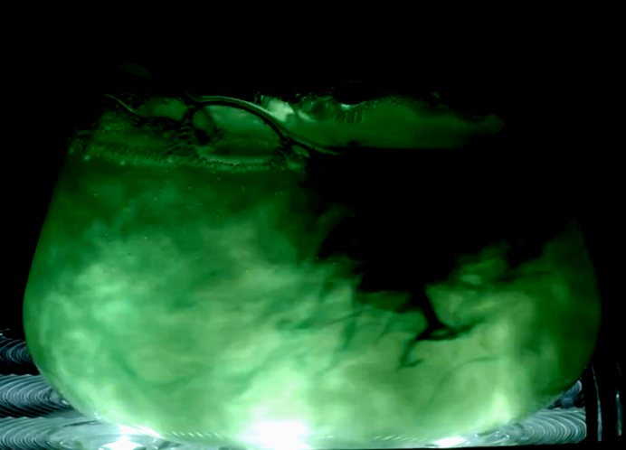
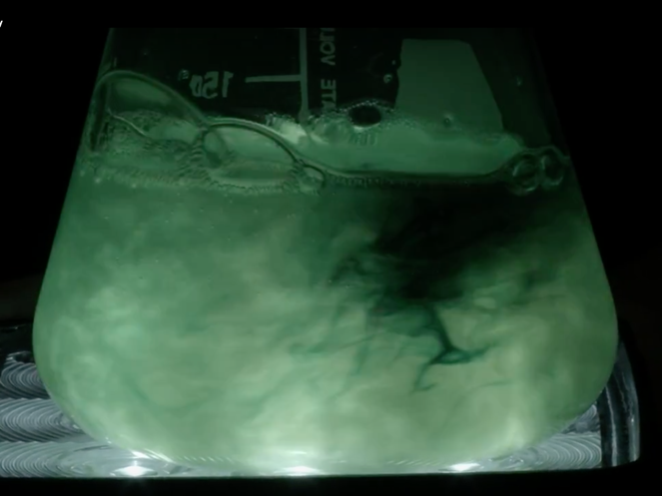

Figure 2
In addition to the cropping of the photo Figure 2 also shows the color editing. The goal of the editing was to make the lighter portion of the photo more vibrant and bright, and the darker portions to be much darker. The results of this attempt are seen above. By doing this a large contrast between the subject matter of the photo and the darker points are emphasized. The green is very vibrant a fun, with the black being very dark. The adjustment curve for the photo is contained in Figure 3.

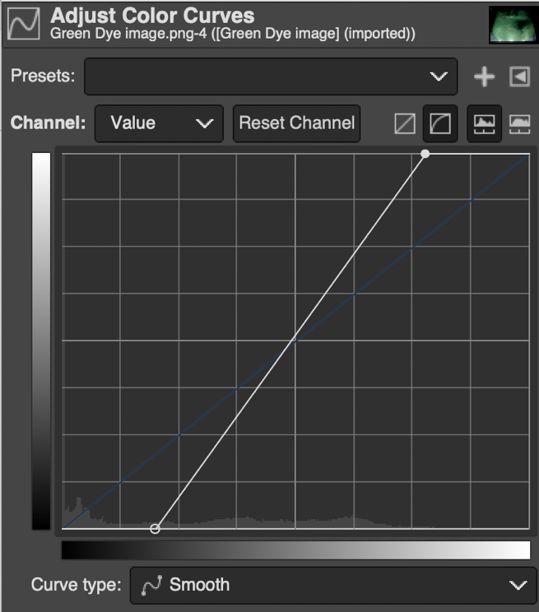

Figure 3
Conclusion:
The first team project gave a nice introduction to the process of setting up and executing a project in a group setting. This process had several benefits over that of the individual assignment. First the brainstorming process generated a wide range of ideas where when thinking individually the ideas can become quite narrow. Additionally there was a lot more help when generating the set up for the project. This group was able to utilize the expertise of one of the photography students angling and camera experience, while the engineers in the group were able to generate a great experiment and explain the flow physics involved. The final photo has several exemplary characteristics including a stark contrast and vibrant colors. This photo nicely captures the events that are taking place in the experiment, whilst also having an artistic flair. There is a stark contrast between the black background and the warm green, giving the image a dark feel.

