Jeremy Aparicio
MCEN 4151-001
October 10, 2018
Team First

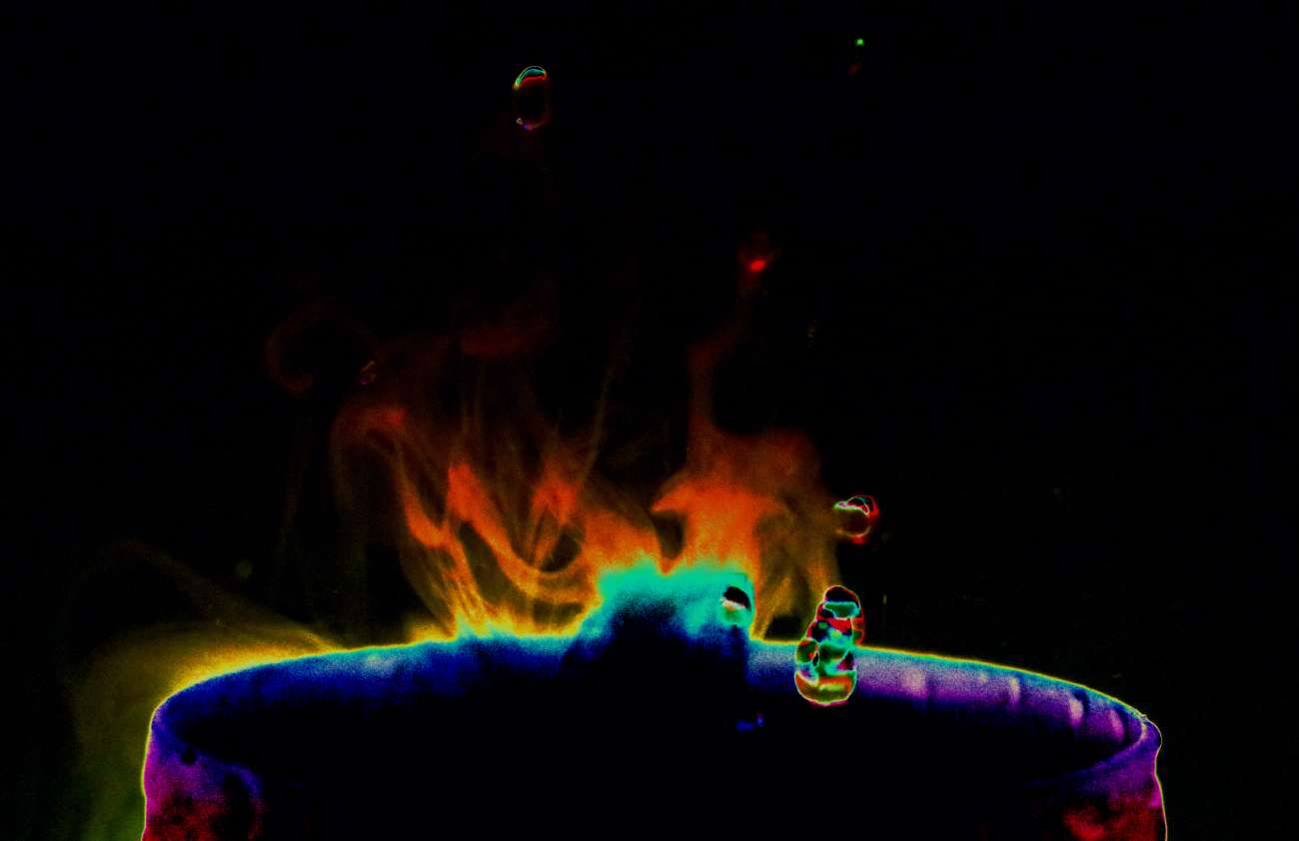

My team for Fall 2018 includes Max Rodgers, Charles Keeley, Michael Karns, and myself. Our team idea involved observing the vaporization process of a supersonic humidifier. After my Get Wet assignment, I became enthused with photographing the smoke and vaporization process because of how unique and abstract each possible picture is. After having much difficultly capturing smoke using a candle by myself, our team found a good solution through the use of Michael’s supersonic humidifier.
Ultrasonic humidifiers work by using ultrasonic waves to create mist through cavitation in the water inside. These waves are created by a piezoelectric ceramic disc with current running through it. This disc oscillates the current at ultrasonic frequencies which are outside the range of human hearing. The water tries to match the motion of the disc, but due to the weight of itself and inertia, the water slows down compared to the disc, this causes areas of extremely low pressure creating a cavity or air pocket. This cavity then implodes due to the weight of the water resulting in capillary waves forming at the surface. At the crest of the wave, small water droplets are absorbed into the air current created by a fan, becoming mist.
To capture this image a black pad was used for a background with the supersonic humidifier placed directly in front by about three to four inches. The camera is then placed in line with the humidifier with a distance of about one foot. All materials were found in Michael’s home, involving only his camera, humidifier, water, a table, and a black pad. The humidifier has colored lights which were the source of light for my image with all other lights turned off. Figure
The width of the field of view can be established when realizing that the diameter of the humidifier is 4 inches while being 1 foot in front of the camera and three to four inches in front of the background. The lens had a 49 mm focal length with a maximum aperture of 4.3. This photo was taken using the Canon EOS Rebel T6i camera. The original image has a width of 6,000 pixels and a height of 4,000 pixels. The final photo has a width of 1,300 pixels and a height of 842 pixels. The photo was shot at F-stop f/5.6 with a 1/800 second exposer time and 12,800 ISO setting. The high ISO setting allowed for a high shutter speed to capture water droplets. In photoshop, I wanted to harshly affect the curves to bring out a variety of colors other than just white. I set a curve to the RGB as shown in figure 1. A layer mask was inverted and places on top of the image and the saturation was set to 17. The exposure was also turned up by 0.012.
I really enjoyed playing with the color schemes and post-processing of this picture. Due to the face that Michael and I had similar photographs, I wanted to make mine drastically different. It doesn’t focus as much on the visualization of the flow which is a large down-side but the creative part of me was very pleased. It was much easier capturing the vapor effect using Michael’s humidifier rather than candle smoke or vape which were attempted in the Get Wet assignment. I love how the image is framed but there is a lot of light dispersion coming from the cup, perhaps redoing this experiment with my own lighting setup could produce superior images. To develop this idea further, the team could put other liquids into the humidifier (with proper research of course for the safety of the humidifier), or try creative, alternate forms of lighting other than the basic humidifier lights themselves.

Figure 1:
RGB Curve Edit

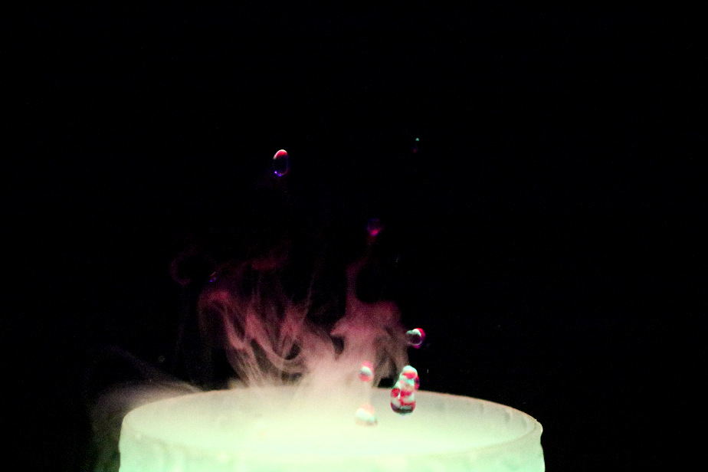

Figure 2:
Original Image

References
[1] Parashar, K. (2012, August 09). How do ultrasonic humidifiers work? Retrieved from https://www.quora.com/How-do-ultrasonic-humidifiers-work

