UNIVERSITY OF COLORADO BOULDER
Cloud 2 Report
MCEN 5151-001

Ibrahim Alhajji
12/7/2018

This purpose of this report is to provide a thorough explanation of the fifth assignment and second cloud project (Cloud 2). The intent of this assignment is to provide a picture of clouds and describe it based on the weather conditions and the cloud type. My intention for this picture was to capture a cloud where the sun light shines on it to provide a good light and color. Also, to couple the picture with a background in order to make it looks nicer.
To take this picture, I went to the rocky mountain national park. I decided that the best time was at sunset while showing the mountains at the background.
To take the picture, I used i-phone 7 camera. The focal length was 7 mm on the camera and it took the image in 4032 pixels width and 3024 pixels height. This picture was taken using the following specs: Exposure time: 1/1808 sec, ISO speed: 20, Aperture: 2.8.
This picture was taken on 10/22/2018. After looking up the weather information on (www.weather.uwyo.edu), The below skew chart was obtained.
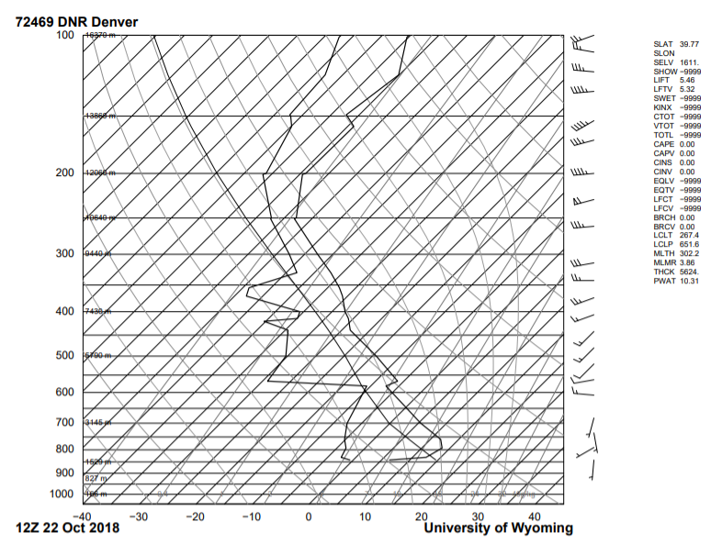
The graph above shows CAPE as being zero which indicate that the weather was stable at that day. Based on the weather condition being stable, the height of the clouds and that it was not raining, the type of the cloud is Stratocumulus.
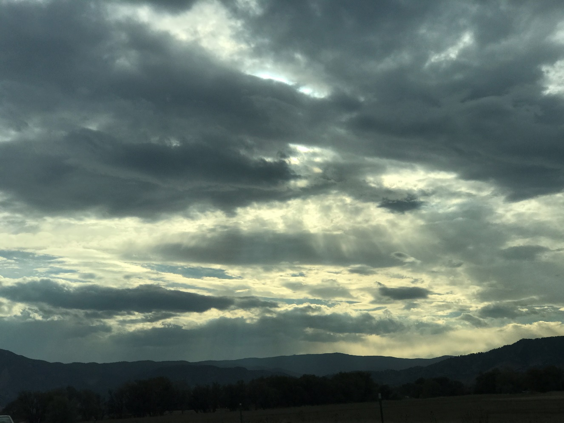
Figure1: Cloud 1 raw picture
Windows Photo application was used to crop the image and enhance the colors and contrast. Below is the image after manipulations.
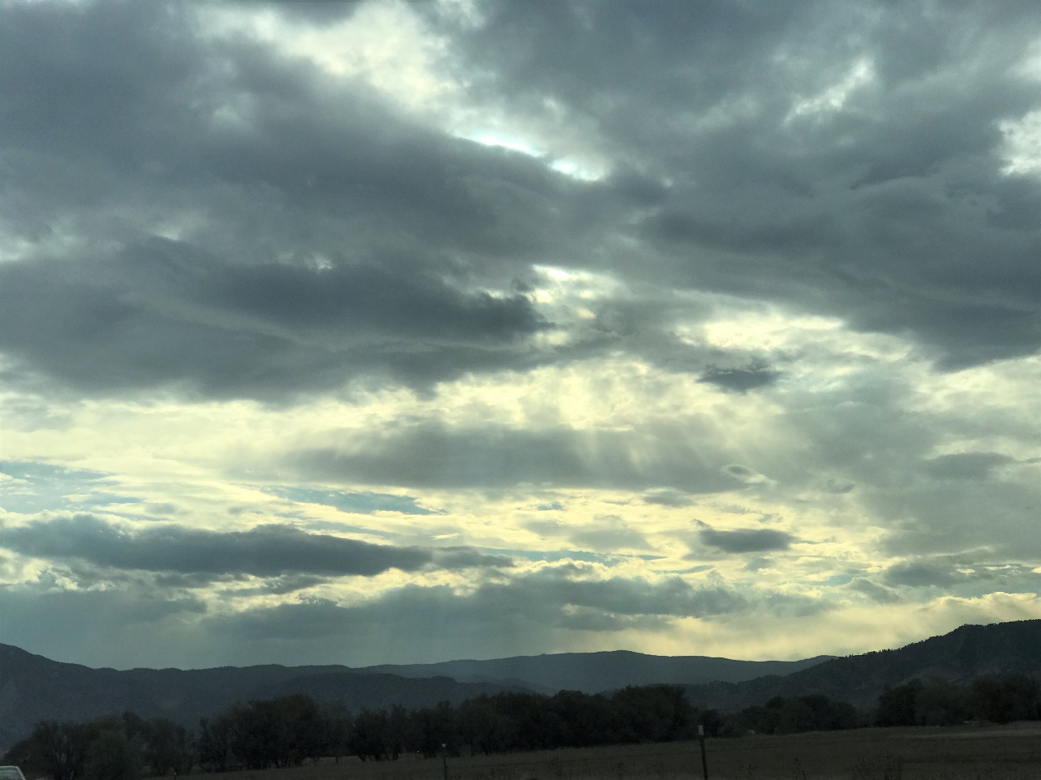
Figure2: Cloud 1 picture after manipulation
The image shows the cloud at sunset with mountains at the background which provided the picture with some interesting and beautiful colors.

