First Cloud Image Report

Brent Eckles

MCEN 4151-001

22-Oct-18

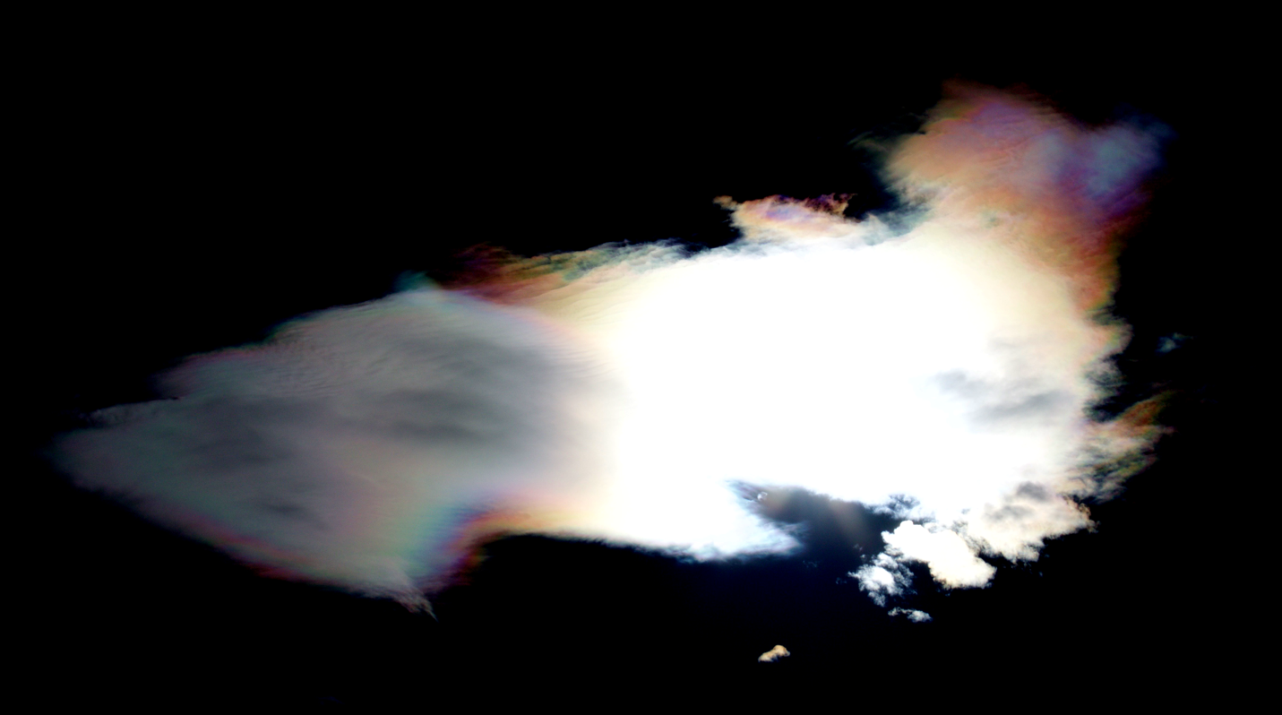

Introduction:
This picture was taken in response to the First Cloud Image assignment for the class Flow Visualization. The aim of the assignment being to observe the changes in clouds due to differing weather and seasons. The idea for this picture came from the desire to capture and display a more common cloud in a unique and artistic way, to have the viewer think of the cloud in a way they hadn’t before. This image was not captured at a planned time, but was the result of seeing a great opportunity to take a cloud picture. This image was captured on the hill in Boulder, CO at 12:30 pm on October 13th. The picture was captured from outside in the middle of the road, to eliminate the distractions from the image. The picture was captured from ground level, which is approximately 5400 ft in Boulder, CO. The sun was essentially overhead and the cloud had lined up exactly with the sun so that it was directly behind it. The camera angle was close to perpendicular to ground level with a slight angling to capture the cloud.

Conditions and Clouds:
The cloud that is captured in this photo displays the characteristics most associated with the cumulus subgenre of clouds. Cumulus clouds are often described as having flat bases and appear to be puffy or cotton-like. Cumulus clouds are found lower in the atmosphere around 2000 meters in altitude and generally do not form precipitation. However, they can grow into precipitation bearing forms of other clouds. These clouds are generally precursors to other types of clouds when influenced by weather factors such as instability, moisture, and temperature gradient. The weather was sunny and warm at the capturing of this photo and was the first day the sun had been seen in about a week. This day represented a break in two weather systems as the days before and after presented much weather. The ceilometer from the day indicated that the clouds were in the lower level, which match’s the observations recorded while taking the photo. Figure 1 presents much of the weather data collected from the day in question presented in the form of a Skew-T graph.
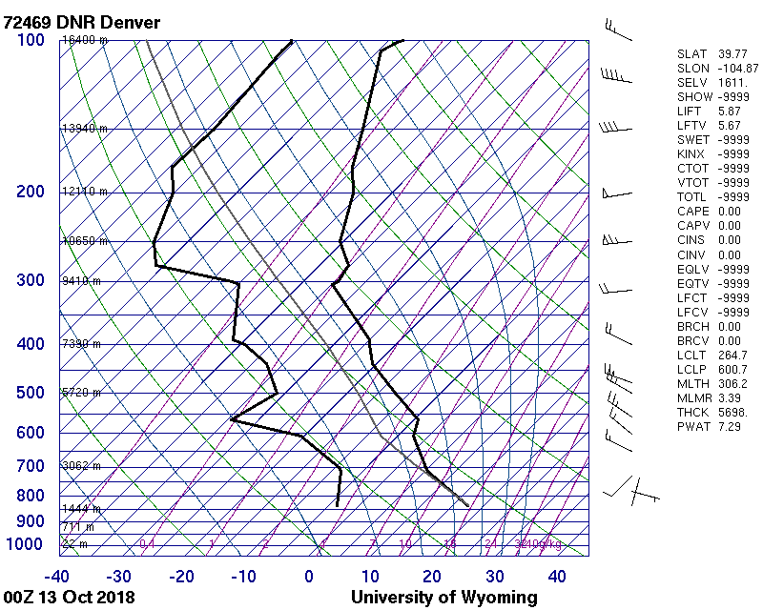

Figure 1
As can be seen from the plot the CAPE for October 13th at noon was 0 representing a stable atmosphere, which is the atmosphere cumulus clouds are most commonly found in. Cumulus clouds are formed as air warmed by the surface begins to rise, causing the air to cool and increase the relative humidity. This occurrence is most likely to occur during a stable atmosphere which matches the day in question.

Camera Specs & Photo Editing
The camera used was a Canon EOS 70D with an adjustable 18-55 mm lens set to a focal length of 43mm. The exposure time was 1/1100 seconds with an f-stop of f/22 and ISO2000. The camera lens was angled at about 85 degrees. The original photo was 5472 X 3648 pixels before being cropped to the image in Figure 2. A large quantity of photos were captured from differing angles and backgrounds, so the images had to be sorted through in order to select the perfect image. This perfect image displayed two major characteristics, one being the capturing of the cloud without interference from the background and two, the coloring of the photo optimally displaying the contents. The final image selected removed a lot of the background of the houses and trees located in the position of the picture being captured. This image also captured the sun perfectly in the background of the photo, giving the picture a unique coloring. Once this photo was selected it then had to be edited allowing for the optimization of the photo. The image was uploaded into gimp, an editing software with several image editing options. Two main things happened to the photo, one it was cropped and two the color curve was adjusted. As can be seen from Figure 2 the original photo captured a much larger area, with the main events of the picture not centered in the photo. The picture was cropped to remove the trees and houses from the background.
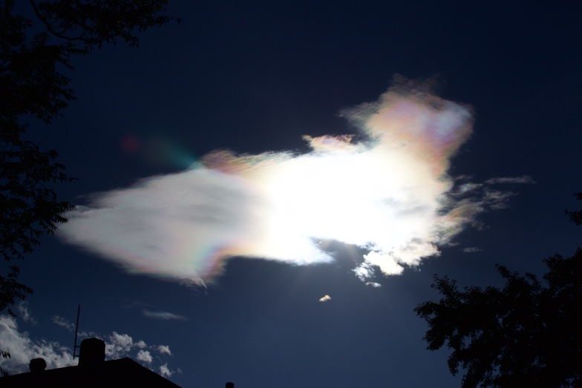
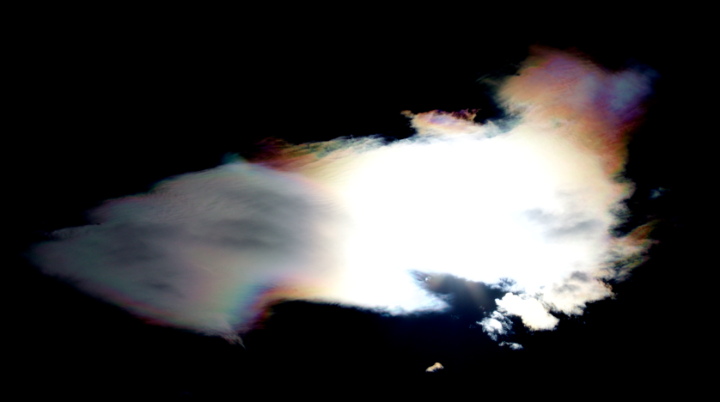
Figure 2
Figure 2 also shows the changes made to the coloring of the photo. As can be seen the original photo while being taken during the day, displays a pretty dark background. This is due to the brightness brought in from the sun. The features of the trees and house in comparison to the suns light are dark. As can also be seen the original photo contains streaks of coloring containing the full spectrum of color. The goal of the editing was to steer into the curve of the original image. The background was made much darker, while the light cloud colors were accentuated. This created a larger contrast and further brought out the spectrum of colors. The adjustment of the color curve can be seen in Figure 3.

Figure 3
Conclusion:
The first cloud assignment gets the participant to look at clouds in a new and different way. Tracking the clouds over a multitude of times and events throughout a couple of months provides much insight into the possibilities that clouds present. There is much beauty to be observed in the clouds above and this assignment provides some experience into capturing it. The final photo has a surreal feel to it as displays the cloud in a way that would not be experienced in life. The image at first glimpse is confusing as it displays a bright and shining cloud with an all black background. This all together gives the image artistic feel and makes the viewer think a little bit. This photo nicely captures the effects that the sun can have on pictures.

References:

Cumulus cloud. (2018, October 16). Retrieved from https://en.wikipedia.org/wiki/Cumuluscloud

