Second Cloud Image Report

Brent Eckles

MCEN 4151-001

3-Dec-18
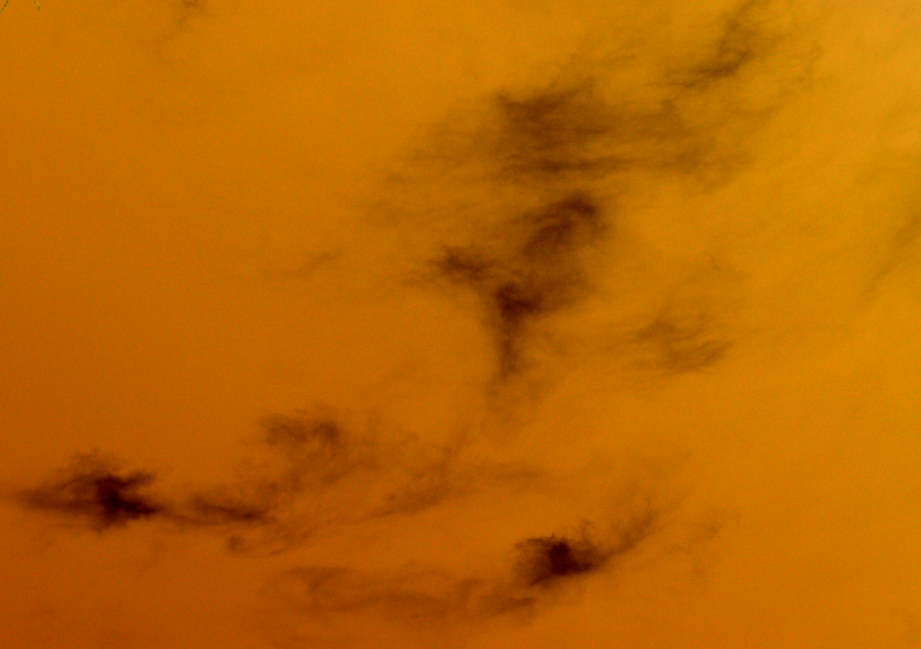

Introduction:
This picture was taken in response to the Second Cloud Image assignment for the class Flow Visualization. The aim of the assignment being to observe the changes in clouds due to differing weather and seasons. The goal of this picture was to capture the beauty in smaller and less prominent clouds, as people tend to disregard clouds on less cloudy days. The picture was not captured at a specific event or time period but arose out of opportunity. A unique and interesting cloud formation was visible and the picture was taken. This image was captured on the hill in Boulder, CO at 11:30 pm on November 16th. The picture was captured from a backyard outside, with the aim of eliminating distracting elements from the photo. The photo was captured from ground level, which is approximately 5400 ft in Boulder, CO. The sun was essentially overhead and was unblocked by clouds giving good lighting for a picture to be taken. The camera angle was close to perpendicular to ground level with a slight angling to capture the cloud.

Conditions and Clouds:
The cloud that is captured in this photo displays the characteristics most associated with the Cirrus subgenre of clouds. Cirrus clouds are often described as looking like thin wispy strands. Cirrus clouds are found higher in the atmosphere typically from 16500 ft and 45000 ft. Cirrus clouds are composed of ice crystals that originate from the freezing of supercooled water droplets. This weather was sunny and cold at the capturing of this photo the weather had been similar to this for several days prior with very little change. The ceilometer from the day indicated that the clouds were in the upper level of the atmosphere, which matches the observations recorded while taking the photo. Figure 1 presents much of the weather data collected from the day in question presented in the form of a Skew-T graph.
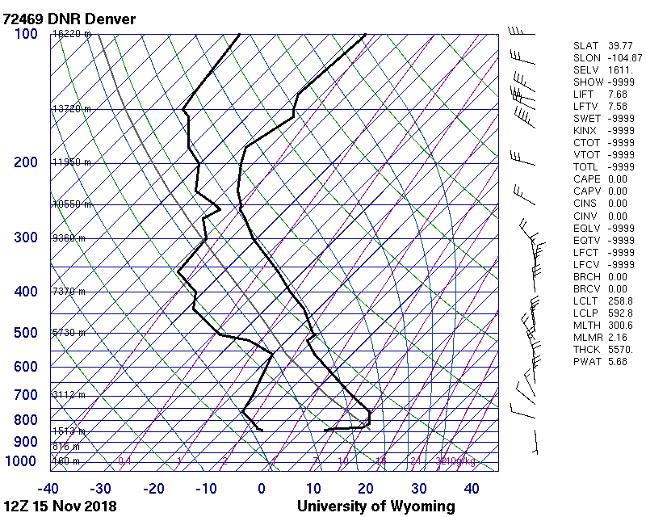

Figure 1
As can be seen from the plot the CAPE for November 15th at noon was 0 representing a stable atmosphere, which is the atmosphere Cirrus clouds are most commonly found in. Cirrus clouds form from any cloud that has undergone glaciation and are observed in a variety of shapes and point towards the direction of airflow at their elevation. Cirrus clouds are generally present if fair weather as was the case for the day in question.

Camera Specs & Photo Editing
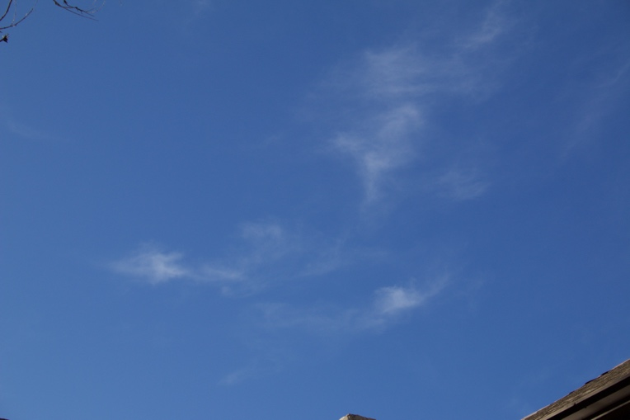
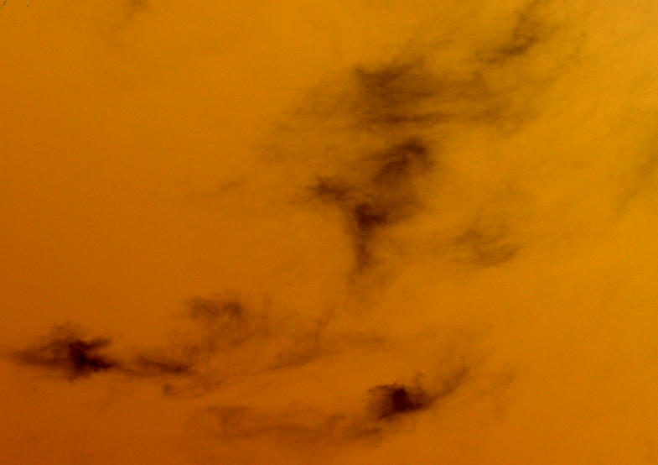
The camera used was a Canon EOS 70D with an adjustable 18-55 mm lens set to a focal length of 55mm. The exposure time was 1/250 seconds with an f-stop of f/10 and ISO2000. The camera lens was angled at about 80 degrees. The original photo was 5472 X 3648 pixels before being cropped to the image in Figure 2. A large quantity of photos were captured from differing angles and backgrounds, so the images had to be sorted through in order to select the perfect image. This perfect image displayed two major characteristics, one being the capturing of the cloud without interference from the background and two, the coloring of the photo optimally displaying the contents. The final image selected removed a lot of the sky which did not picture the cloud. This image also utilized the natural lighting generated by the sun making the contents nicely illuminated. Once this photo was selected it then had to be edited allowing for the optimization of the photo. The image was uploaded into gimp, an editing software with several image editing options. Two main things happened to the photo, one it was cropped and two the color curve was adjusted. As can be seen from Figure 2 the original photo captured a much larger area, with the main events of the picture not centered in the photo. The picture was cropped to center in on the cloud and remove the unnecessary sky.
Figure 2
Figure 2 also shows the changes made to the coloring of the photo. As can be seen in the original photo the light blue and the white cloud do not stand out very well. In order to make the contents more visible as well as put an artistic spin on the photo the colors were inverted. This made the cloud color change to black and the sky to turn to a yellow/orange. This made the cloud almost look like a sandstorm which was the desired effect. The darker colors where then made darker and the lighter colors lighter to increase the contrast of the photo. The adjustment of the color curve can be seen in Figure 3.

Figure 3
Conclusion:
The first cloud assignment gets the participant to look at clouds in a new and different way. Tracking the clouds over a multitude of times and events throughout a couple of months provides much insight into the possibilities that clouds present. There is much beauty to be observed in the clouds above and this assignment provides some experience into capturing it. The final photo is a bit confusing due to the inversion of the colors and makes the viewer to question what they are looking at. This is the desired effect as the picture is not just a boring every day cloud to see.

References:
Cirrus Clouds. (n.d.). Retrieved December 3, 2018, from http://ww2010.atmos.uiuc.edu/(Gh)/guides/mtr/cld/cldtyp/hgh/crs.rxml

