Background
This image was the first photo assignment of the semester. The purpose was to introduce students to taking photographs of fluids and editing techniques. The intent behind this image was to photograph the movement of carbon dioxide gas produced from a tablet through two fluid mediums, water with red dye and canola oil. It was determined after a test setup that a round bowl worked better than a drinking glass and that lots of light was needed to take a photo that captured the phenomena adequately. The image was inspired by experiments performed by Steven Spangler¹.
Flow Apparatus
Initial setup of the apparatus entailed filling an 8.9cm x 10.9cm glass fishbowl with ½ cup tap water and 15 drops of red liquid food dye, avoiding liquid touching the edges of the bowl above the final level of liquid. The dye was completely mixed into the water using a spoon. Next, ¾ cup of refined canola oil was slowly added to the bowl over the water, avoiding liquid touching the edges of the bowl to prevent residue appearing on the glass in the final image. The liquids were allowed to settle back into their respective layers until there was clean separation. The inside edges of the bowl above the liquid as well as the outside of the bowl were wiped down with a microfiber cloth to remove liquid residues and fingerprints that would affect image quality. A whole tablet of Alka Seltzer was carefully dropped into the bowl near the center. Photos were taken until the reaction was complete.
The water in the apparatus has a density of 1.00 g/mL⁴, which is greater than that of the canola oil at around 0.92 g/mL on average¹. Since the water is denser than the oil, it forms the bottom layer as a result of buoyant force. The oil is less dense than water, so buoyant force causes it to be the top layer. In addition to density, the water and oil repel each other, instead of mixing, as a result of polarity and inter-molecular forces. Water is a polar molecule because there is unequal sharing of electrons between the hydrogen and oxygen atoms in the molecule. In contrast, oil a is non-polar molecule composed of long chains of hydrocarbons with equal electron sharing between atoms. The contrast of polar and non-polar between the molecules result in the two liquids being immiscible. The red food coloring mixes with the water because it is composed of polar molecules, which makes it miscible in water³.
The Alka Seltzer tablet used consists of citric acid and sodium bicarbonate. When the two compounds come in contact with water, they react to form carbon dioxide gas. Carbon dioxide gas less dense than oil and water at 1.96 x 10⁻³ g/mL², and as a result when it forms at the bottom of the bowl, buoyant forces cause it to migrate to the surface of the oil. When the carbon dioxide bubbles form, they adhere to the colored water molecules via adhesion. The water-carbon dioxide mixture is less dense than the oil, so buoyant force pushes it to the surface of the oil, without mixing with the oil. When the mixture reaches the surface, the carbon dioxide is released into the atmosphere and the dense water remaining sinks back down to its respective layer.
Visualization Technique
For better visualization of the water compared to the oil, red, food-grade quality dye from Wilton® Color Right™ Performance Color System were added to the water before adding the oil to the apparatus. Before filling the apparatus, the bowl was placed on a drinking glass to remove the table from view in the photo. For lighting, hue lights with a diffuser for a smooth backlight and background were used along with a key light. An iPhone flashlight was placed under the apparatus for foley.
Photographic Technique
The photo was taken on a Sony a7r3 camera, which is a mirrorless DSLR. A 50mm lens was used with the camera. This lens was used because it has a wide aperture of f/1.4. The wide aperture allows for more light to hit the sensor compared to smaller apertures. The distance from the lens to the apparatus was about 50 cm, and the field of view was also about 50 cm. The shutter speed was 1/240 sec, which was fast enough to catch the movement of the flow without appearing blurry. The ISO used was 800, which is fairly high. A higher ISO was used to increase the light sensitivity because the environment where the photo was taken was not brightly lit.
Final photo processing was performed in Lightroom CC. Initial cropping of the photo was performed to increase magnification of the apparatus so that it took up more space in the image. Next the temperature of the image was decreased to decrease the yellow hue of the image. The photo was given a radial gradient that directed focus to the flow inside the bowl. Small, residual spots of water in oil were removed that distracted from the main flow near the edge of the bowl. The glare was not cropped out of the photo because cropping decreased the round vignette effect the bowl had on the image. Instead, the glare was selected, and the exposure and highlights were decreased, but the shadows were slightly increased. Exposure and contrast of the entire photo were slightly increased to sharpen the image and make the flow more visible and brighter.
Note: Images of the original and final photos can be found at the end of the report.
Image Analysis
Overall, the image reveals the lava lamp effect that Alka Seltzer can have on oil and water. The fluid physics are well shown by the main stream of water-carbon dioxide mixture flowing to the surface surrounded by sinking water droplets. Although the main stream of flow is cleanly visualized, it is unfortunate that some of the adjacent bubbles and water droplets are not well visualized. In addition, the glare on the bottom of the bowl is slightly distracting, and it would have been nice to be able to remove it from the photo. However, I really enjoy the thick appearance of the water-carbon dioxide flow and the effect that surrounding light has on the depth of the flow. Some questions I have about the image pertain to image processing: How could I remove the glare without cropping the bottom of the bowl? Additionally, I would want to know how to increase the focus on the adjacent droplets, without losing focus on the main flow stream? In the future, I would further develop the idea of this photo by adding more layers of fluids with different densities and observe any changes they cause when adding Alka Seltzer.
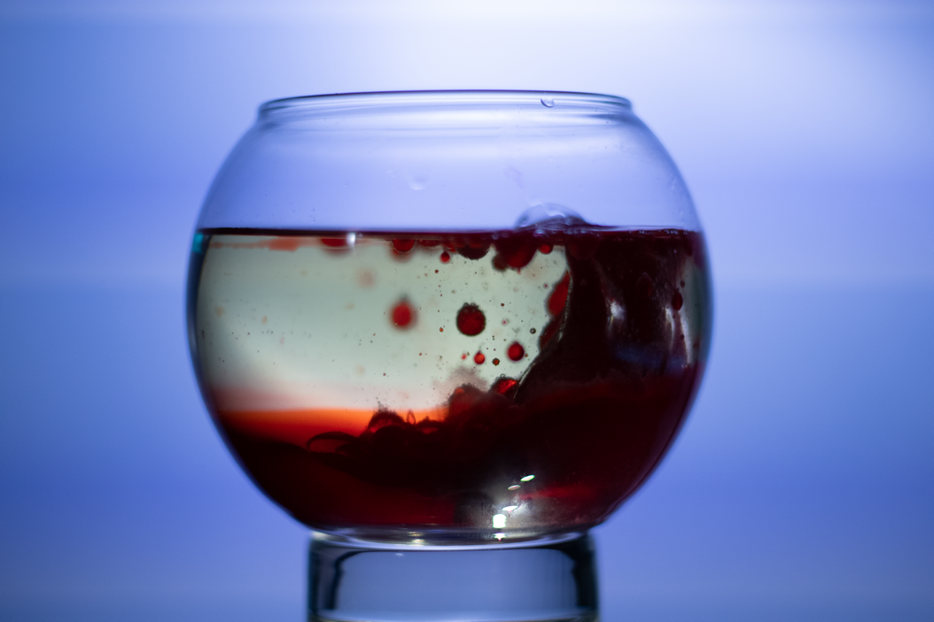
Original, Unedited Image
Dimensions: 5168 × 3448 pixels

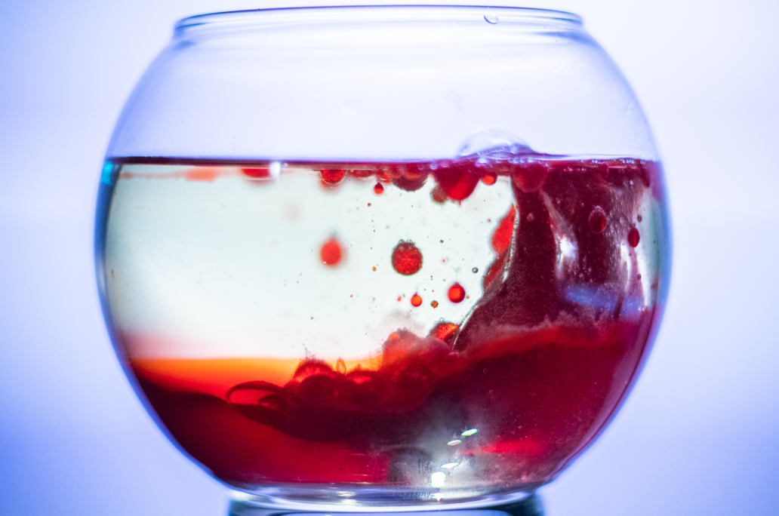
Final Processed Image
Dimensions: 3922 × 2598 pixels

References:
¹Canola oil. (2019, September 21). Retrieved October 2, 2019, from https://en.wikipedia.org/wiki/Canola_oil.
²Elmhurst College. (n.d.). DENSITY Applications with Gases. Retrieved October 2, 2019, from http://chemistry.elmhurst.edu/vchembook/imagespdb/123Adensitygas.html#table.
³Spangler, S. (n.d.). Bubbling Blob - Lava Lamp: Experiments: Steve Spangler Science. Retrieved October 2, 2019, from https://www.stevespanglerscience.com/lab/experiments/bubbling-lava-lamp/.
⁴Water Density. (n.d.). Retrieved October 2, 2019, from https://www.usgs.gov/special-topic/water-science-school/science/water-density?qt-science_center_objects=0#qt-science_center_objects.

