Jeremiah Chen
MCEN 4151
Get Wet: Report

Capturing Smoke Rings and the Physics Behind Them

Nowadays, the “vape” or e-cigarette (short for electronic cigarette) has become quite popular amongst the younger and older generation alike. Whether it is to curb nicotine addiction, or simply picked up as something new, it is common to see someone on the street holding a “vape” these days. A consequential trend that has arisen as a product of the popularity of “vaping” are smoke tricks. People use the smoke from their vape to create different shapes. One of the most basic and most often used trick is the smoke ring. Users create an “O” shape with their mouth and blow the smoke out. The result is a ring of smoke that bursts out of the mouth and travels a distance. The image for this assignment shows two smoke rings being shot out of the mouth. It was created with the help of Jason Savath and David Leng. The following report will attempt to analyze the flow and physics behind the ever popular smoke ring.

There is no particular flow apparatus for this set up as it only requires the use of a human mouth to create smoke rings. The flow is created as the smoke flows through the air partially due to the friction that exists between particles of air. According to Beaty (2000), smoke rings form due to the fact that the smoke will push the existing air apart, but the air in between the smoke is also spreading apart. “As the [smoke] moves forward, its outer layer is dragged backwards. A central stream of air starts moving forward through [the smoke], and [the smoke] swirls inside” (Beaty, 2000). What results is that the smoke is turned into a sphere, but inside this sphere is a vortex ring. The vortex ring inside the smoke is what gives the vapor its donut look. In essence, smoke rings are the result of the combination of friction in the air dragging the outside bounds back as the smoke moves forward and the existing air stirring the inside of the smoke.

Figure 1. As the cloud of vapor (shown in red) moves through the air, it is rotated by the outside layers be dragged backwards and the air stirring the inside of the cloud. (Beaty, 2000)
In terms of nondimensional scales, the Reynolds number of the smoke rings can be calculated with the equation:

$Re= \frac{UD}{ν}=\frac{(0.5\frac{m}{s})(0.01 m)}{(1.568*{10}^{-5}\frac{m^{2}}{s})}=31.89 ≈ 32$

The Reynolds number is about 32 showing that the flow is very laminar since 32 is far below the threshold of 5 x 10⁵ for the Reynolds number boundary through air. The velocity was chosen to be approximately 0.5 m/s because for a clear smoke ring to be formed, it needs to be ejected from the mouth relatively quickly. A small diameter additionally contributes to a cleaner smoke ring. The kinematic viscosity value was chosen for dry air at 300 K which is about 70ºF. Dry air was assumed due to the air conditioning unit running beforehand that dehumidified the room. The fact that the Reynolds number is so small is not surprising as the flow must be relatively slow and the environment must be still in order for smoke rings to form.

The set up for this image was relatively simple. A black table was set up with a black backdrop being held by someone. The room was in David’s living room. All fans and air conditioning systems were turned off in order to make the air as still as possible. Additionally, movement from all persons was limited to aid in the creation of still air. The lighting for this set up had direct overhead lighting above the lighting and from behind the lens. This allowed for there to be enough light to allow high visuals of the vortex rings but the light did not inhibit the image quality.

This image was taken on an Olympus OM-D E-M5 digital camera. It has a 12-50 mm telescopic lens capable of 1:3.5-6.3 ratio. For this image, the focal length was 13 mm. The photographic techniques of this image include having the aperture at f3.7 with an ISO of 6400. The shutter speed was set at 1/40 sec. The distance from the lens to the first vortex ring (seen on the background) is approximately 0.5 m with the second ring being slightly closer to the lens. Field of view was rather small at about 1 m. The original image had a resolution with 4608 x 3456 pixels. The final image was cropped slightly to make the resolution 3264 × 2522; edits such as increasing contrast a bit were made. Other edits include adding a slight black and white filter to the image.

These choices were made due to the soft edges of smoke and vapor as well as the light in the room. The f-stop was kept low to allow for more exposure as well as a high ISO to aid in a brighter picture. Shutter speed was high due to the speed at which the smoke rings are pushed out of the mouth. The goal was to capture the smoke rings while they still have a very definitive shape to provide the best image. The lens was located a short distance away from the rings for this reason as well. When editing, contrast was increased to showcase the smoke rings while limiting other distracting elements in the image. The black and white filter was chosen due to the black color of the table and backdrop being used.
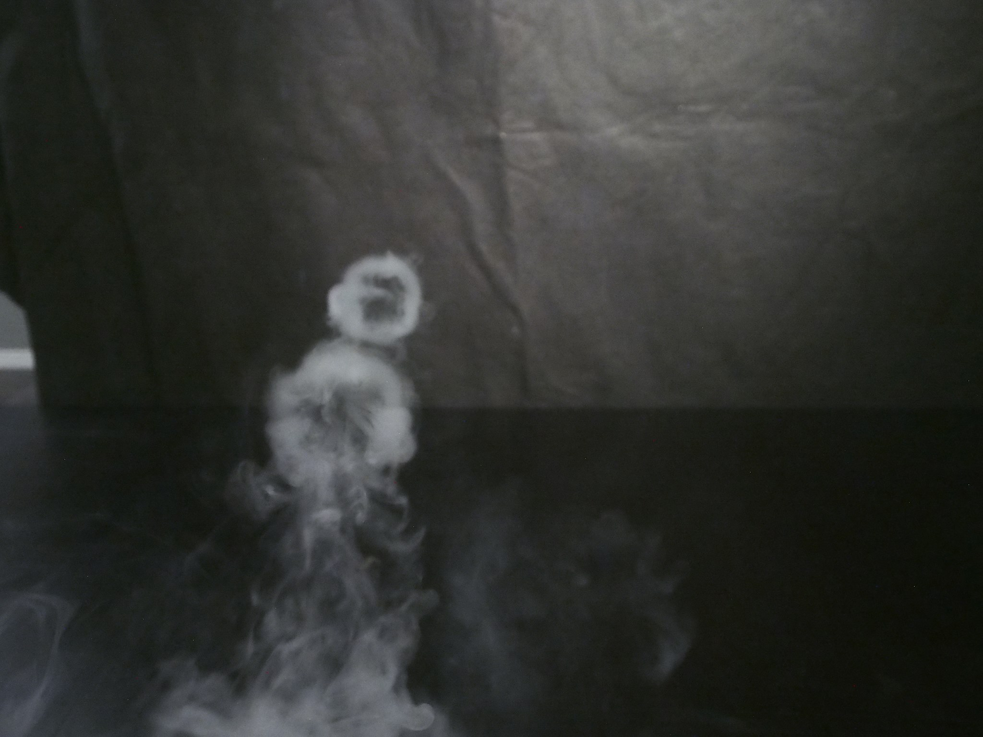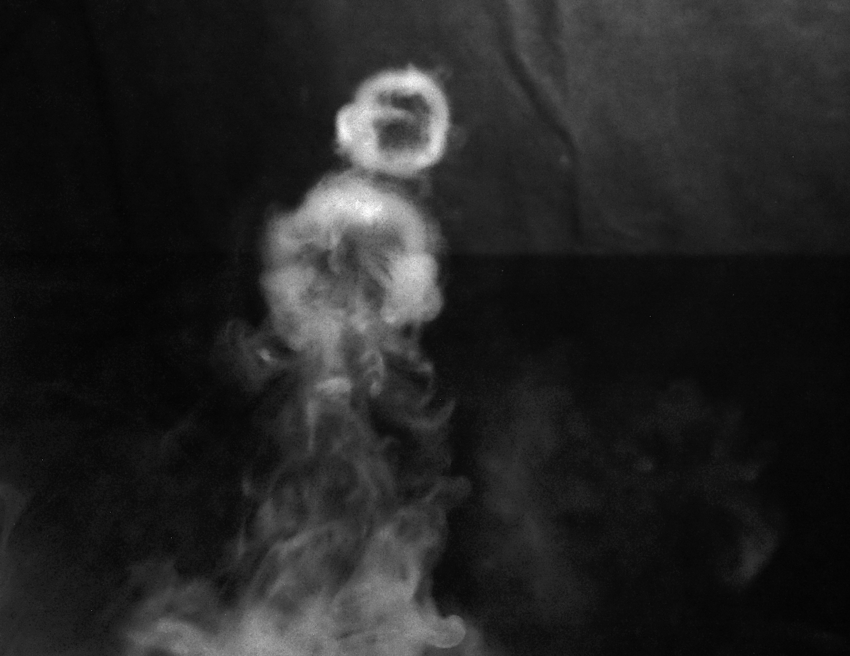
Figure 2. The original image (left) compared with the final image (right)
The final image very well revealed the fluid phenomenon. It clearly depicts the vortex rings being sent out from the mouth. Some areas that could provide more interest is being able to find equations and calculations of vortex rings to find out if there are ways to manipulate them. Possible corrections to the final image include increasing the contrast in order to smooth out the wrinkles in the backdrop. Additionally, decreasing ISO on the camera and shutter speed would reduce the noise seen in the image as well as making the vortex rings clearer. Increasing depth of field would also make both smoke rings clear. To explore this phenomenon even further, an apparatus could be built to generate smoke rings without the use of an e-cigarette. This would provide more consistency across each smoke ring.

Bibliography
Beaty, William J. (2000). Why Does Smoke 'Ring?'. Retrieved 09 14, 2016, from Sciene Hobbyist: http://amasci.com/wing/smring.html

