Flow Visualization Jason Savath

Champagne
The Physics and Art of Fluid Flow

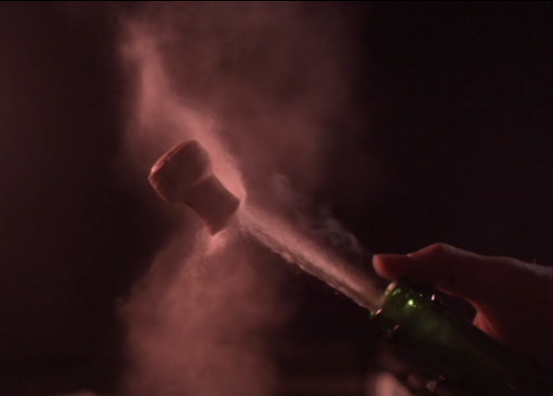

Introduction
This project, “Team 2,” is designed to get students to form teams in order to create a better set up and more complicated fluid dynamics. The fluid flow captured in this project is a champagne popping. Cheap champagne is shaken up and popped to produce amazing fluid flow. This video was captured with the assistance of Tadd Truscott, Jeremiah Chen, Mark Noel, and Daniel Bateman using a High Speed Camera, Vision Research Phantom 2512.

The Physics
The fluid used in this project was champagne. The champagne bottle was shaken vigorously while applying pressure to the cork. After shaking the champagne about 2-3 times, the bottle was then held in place. The cork was slowing nudged off with a thumb and allowed to pop across the room. This popping process is demonstrated in the video in slow motion. The cork can be seen accelerating away from the bottle as liquid champagne followed it. The champagne shot out at a higher speed than the cork, which allowed the liquid to help push and accelerate the cork even more. This happens because of carbon dioxide or CO2. CO2 is the ingredient used to make carbonated drinks. As the bottle is shaken, the CO2 builds up and expands inside of the container. This builds up high pressure and applies the force onto the cork which allows it to pop out. Only 5% of the total energy released will be transferred into kinetic energy when the bottle pops open (Becca). This is due to the fact that pressure will be applied on all surfaces inside the bottle and the cork only makes up of 5% of that area.
Smoke can also be seen rising out of the bottle as the cork flies out. This smoke is due to the sudden drop of temperature. The drop of temperature is caused by the expansion of CO2 gas to the condensation of ethanol vapor and water vapor right after. This drop of temperature is affected by the ambient temperature and the champagne temperature. This experiment was held at room temperature with room temperature champagne. If the temperature was altered, different results could have been recorded (Becca).
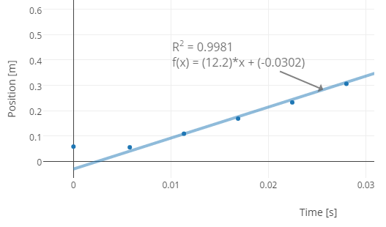
Figure 1. Linear Regression of Position vs. Time (Allain)
Linear regression of the position vs. time graph is shown above. It can be seen that the actual graph is exponential which can be verified in the video. Using the regression line, an approximation of the cork velocity is about 12.2 m/s (Allain).

The Art
The medium of the artwork is champagne with a black background. Six different light sources are being used to capture this video. 2 flood lights are pointed down from the top left and 2 flood lights are pointed upwards from the bottom right. In addition, 2 led lights are pointed upwards right below the champagne bottle.
The camera, a high speed camera, Vision Research Phantom 2512 was used in the production of this video. The first video used front lighting with 50mm lens with 8000 frames per second. The second video used back lighting with 50mm lens as well with 25000 frames per second. The music choice for this video is called “Dark Thriller Loop,” which was created by Zetauri. The choice was made because of the slow melody and the base drops with the pulse of the champagne coming out of the bottle. Little post editing was used because of no knowledge of video editing software.

Conclusion
The final image definitely has revealed both the physics and the art. However, some improvements can be made. The contrast of the video can be increased to further accentuate the champagne shooting out. The video can be cropped so that the focus can be made closer to the fluid flow action instead of having a broad blank space.
The project was easy to set up and easy to clean up. The physics and fluid flow can also be clearly seen in the video. The effects and music goes well with the video as well. I enjoyed working on this project as it was fun an pleasing to pop the champagne bottles. Overall, this was a learning experience that allowed me to work with a high speed camera. Upon completion of this project, I have learned the physics behind how champagne popping works.

References
Allain, Rhett. December 30, 2015. The Physics Behind Popping Champagne Bottles. November 11, 2016. https://www.wired.com/2015/12/the-physics-behind-popping-champagne-bottles/

Becca. April 24, 2013. The Physics of the Champagne POP! November 11, 2016. http://www.academicwino.com/2013/04/physics-champagne-pop.html/

