Report-Team Second Image
11/10/2016
Flow Visualization: The physics and Art of Fluid Flow
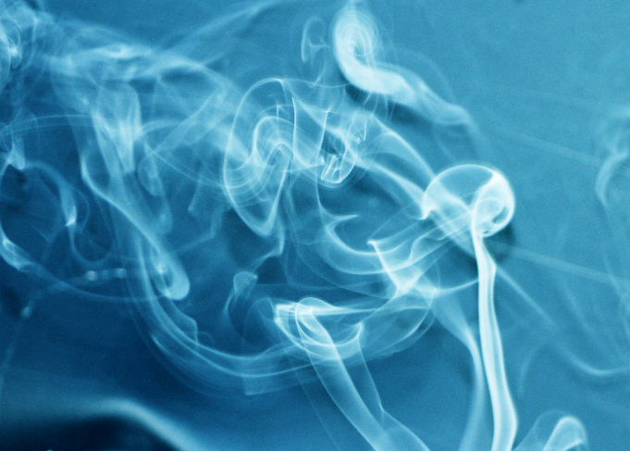
For the team second assignment, our image topic is incense smoke flow tracking. The above image is taken at ECME lab 165 on October 30. The team members include Matt Blackmailer, Yadira Valadez and Stephanie.
Beginning with the experiments set up and procedure. A piece of black sheet is applied as the background because the black color has the best contrast with the smoke color. Two incenses were almost ignited at the same time and their smoke are interacted with each other to obtain more complex and changeable smoke flow pattern. Actually, it’s not easy to catch great image because of the unpredictable change of smoke flow. More than a hundred of images has been taken and the above image is selected as the most satisfied one.
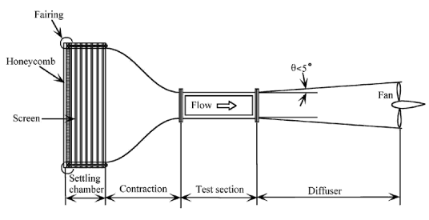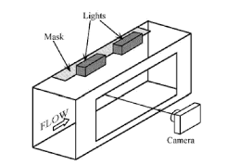
The above pictures show the structure of smoke tunnel, which is applied for professional flow visualization research [1]. The smoke tunnel includes setting chamber, contraction, test section and diffuser. And a camera is applied for photographing at the test section part. Although the above instruments are not applied for our team image, it is quite necessary to give a brief introduction to them to get people knows what is the real flow visualization and its professionalization.
When talking about the flow pattern of incense smoke, a significant concept should be given, that is turbulent flows. The turbulent flow is characterized by chaotic changes of velocity and pressure. In the contrast, turbulent flow usually has high Reynolds numbers, where inertial forces dominate viscous force. The statistical Approach-One Point Averaging method is applied to research turbulent flows laws [2]. That is, for any turbulent quantity, split the flow into a time mean quantity and turbulent fluctuation quantity. For example, letting unmarked quantities denote the total value, superposed bars denote an average, and prime denote the portion, for velocity and pressure, write
$v=\overline{v}+v^{'}$ [1]
$p=\overline{p}+p^{'}$ [2]
Taking the above equations into Naiver-Stokes equations. The Reynolds averaged Naiver-Stokes equations is obtained, as the most well-known turbulent flow control equation, is written following
$ρ\left(\frac{∂\overline{v_{i}}}{∂t}+\frac{∂\left(\overline{v_{i}}\overline{v_{j}}\right)}{∂x_{j}}\right)=-\frac{∂\overline{p}}{∂x_{i}}+\frac{∂}{∂x_{j}}(μ\frac{∂\overline{v_{i}}}{∂x_{j}}-ρ\overline{{v_{i}}^{'}{v_{j}}^{'}}$) [3]
Several models have applied to solve Reynolds averaged Naiver-Stokes equation using numerical method, which include One-equation models, Two equation models, Stress-equation models and Large eddy simulations.
Incense smoke is a kind of indoor particle. The research of indoor particle flow has given by many researchers. The comprehensive reviews on indoor particles have been given by Nazaroff (2004) and Wallace (1996). Mathematically, there are two treatments of indoor particle movements: Euler-Lagrange method and Euler-Euler method. One of the simplified Eulerian method, a drift-flux model, is used to investigate particle distribution in an enclosed environment. The drift-flux model can easily incorporate the effects of Brownian and turbulent diffusion and gravitational settling effect. The drift-flux model governing equation of the particle concentration is similar to Naiver-Stokes equations, except that it integrates the gravitational settling effect of particles into the convection term [3]:
$\frac{∂(ρC)}{∂t}+∇∙\left(ρ\left(\vec{V}+\vec{V_{S}}\right)C\right)=∇∙\left(\frac{u_{eff}}{σ_{C}}∇C\right)+S_{C}$ [4]
For the photography techniques and processing. The Canon EOS Rebel T5 is applied to take the image. The telephoto lens is used to obtain more details of incense smoke. The exposure time is 1/60 sec, ISO is 800 and focal length is 80 mm. The original picture is in black and white, while the blue is applied as the background in processing. Also, only the significant part of the incense smoke is selected as the final image.
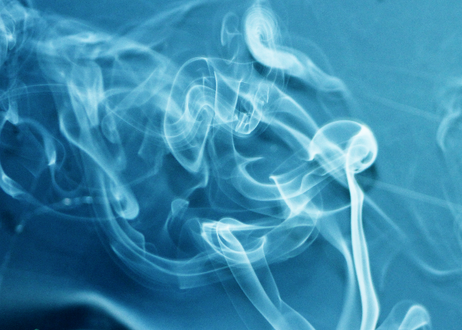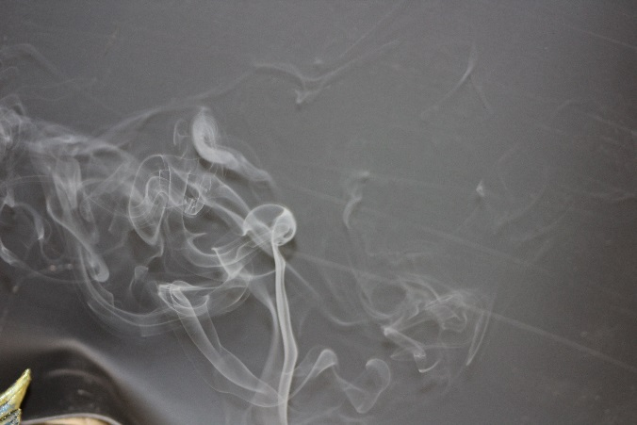
Final Image Original Image
For the potential improvement. Because the incense smoke shape is unsteady, it should be necessary for us to think about how to control the smoke shape well using some techniques. Also, the focus should be more precise to obtain more clear picture.

Reference
[1] “Flow Visualization: Techniques and Examples”, A. J. Smits and T.T. Lim, Imperial College Press
[2] “Advanced Fluid Mechanics”, W. P. Graebel, ELSEVIER
[3] “Modeling particle dispersion and deposition in indoor environments”, N. P. Gao, J. L. Niu, Atmosphere Environment 42(2007) 3862-3876

