team second Image – food coloring mixing around sphere

J. Julian¹

¹The University of Colorado Mechanical Engineering-Master’s Program, Boulder, Colorado, USA

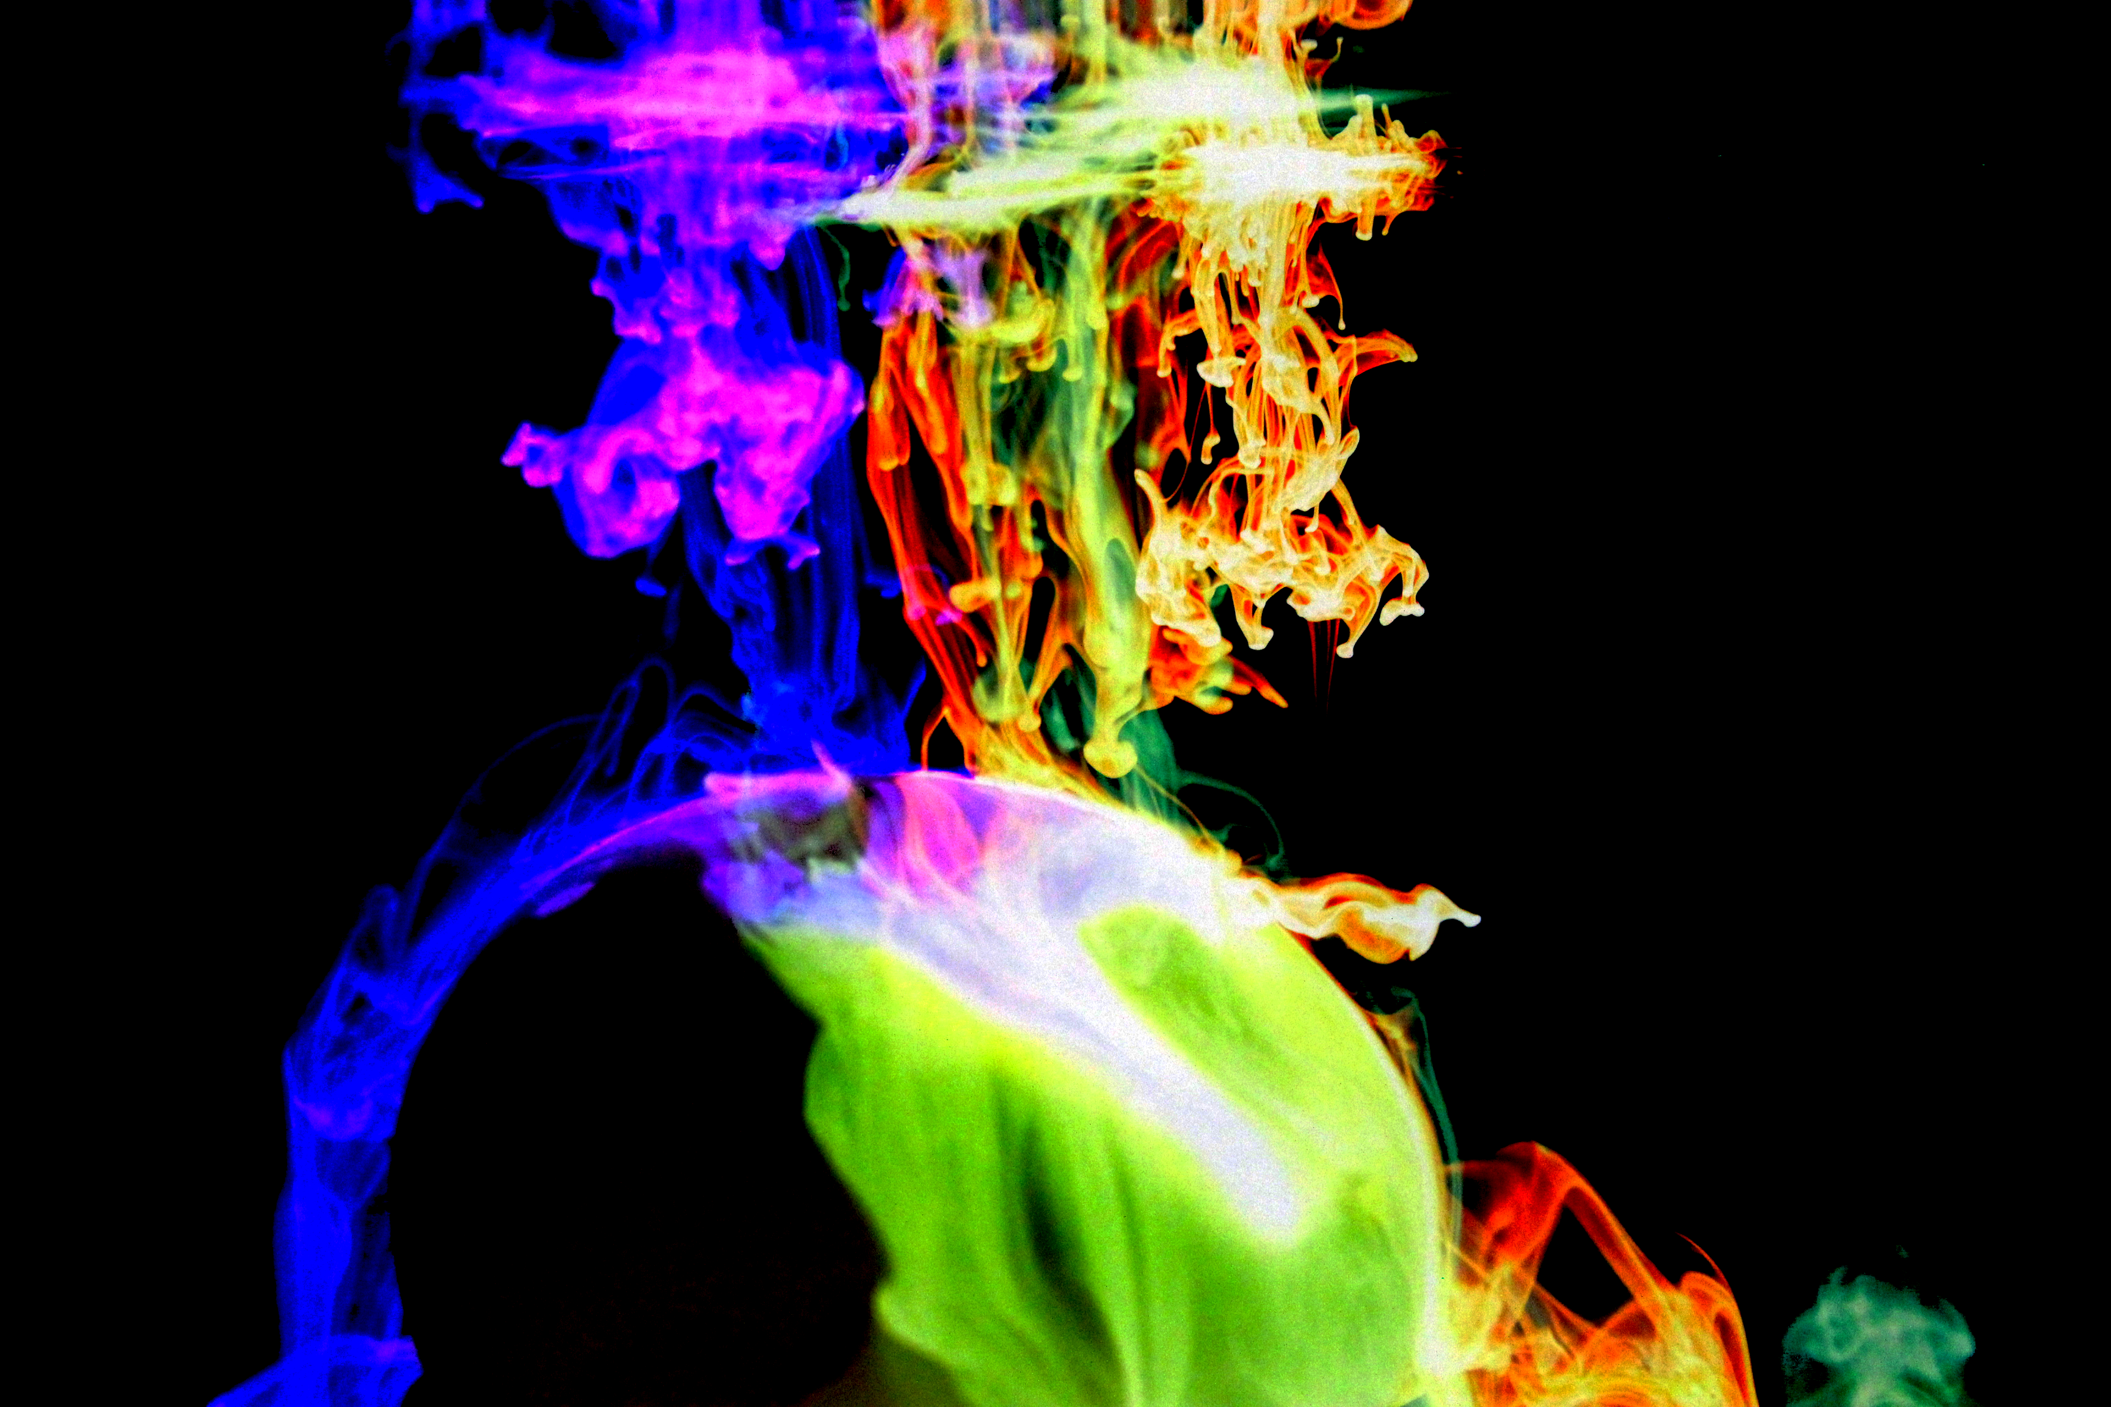

Abstract
In this paper we shall look at how the use of a food coloring and water was used in conjunction with a sphere made up of sand was used to create the image above. The overall desired result was to successfully capture the mixing of the food coloring around the sphere. There were several conditions that improved the overall quality of the picture including the low levels of fluid flow that would’ve disrupted the flowing process of the food coloring as well as the use of diffused light in the background.

Flow Visualization
The use of dynamic motion in photographs has always been interesting to people. This could possibly be due to the fact that the inherent qualities of a still image of a flowing process lends to the imagination of the viewer in such a manner as to make him or her feel like the picture is moving. Flow visualization is the process of making the physics of fluid flows (gases, liquids) visible [1]. In this paper we will explore how a still image of a food coloring mixing with water over a solid sphere can be represented in such a way as to display the flowing inherent dynamic nature of mixing fluids.

Food Coloring
Food colors are used in a large number of applications that range from changing the color of food to making your own lava lamp. With the large majority of applications being used for entertainment in the commercial market. Food colors can be made from a range of natural things from other foods, to plants, and even to insects. In addition, artificial food colors can be made in the lab. These types of colors are more suitable for when more exotic colors that can’t be found in nature are desired. The type of chemical structure of the food color determines the color that it changes food to.

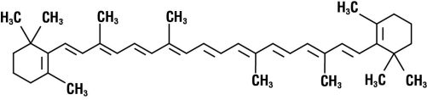
Figure 1: Beta-Carotene Molecule

The molecule similar to the one shown in Figure 1 can be used to create red, yellow, or an orange color. The beta-carotene molecule as shown above is present in sweet potatoes, pumpkins, and is soluble in fat which is why it is typically added to dairy products [2]. In high enough concentrations it can be made into a red, yellow or orange colored food coloring dye.

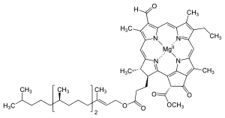
Figure 2: Chlorophyll Molecule

The chlorophyll molecule similar to the one shown in Figure 2 can be used to create a green color. The chlorophyll molecule as shown above is present in all green plants. This molecule absorbs and uses sunlight to create carbohydrates from carbon dioxide and water, this is commonly known as photosynthesis [2]. In high enough concentrations it can be made into a green colored food coloring dye.

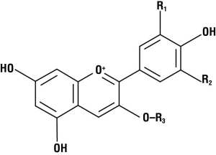
Figure 3: Anthocyanin Molecule

The anthocyanin molecule similar to the one shown in Figure 3 can be used to create a blue color. The molecule as shown above is naturally present in grapes, blueberries and cranberries. More than 500 different anthocyanins have been isolated from plants all of which are based on a single basic core structure called the flavylium ion which can make the molecule polar and water soluble [2]. In high enough concentrations it can be made into a blue colored food coloring dye.

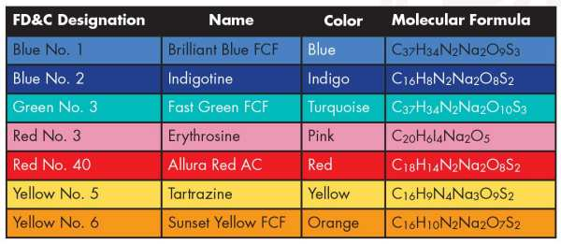
Figure 4: Chlorophyll Molecule

Figure 4 shows the various artificially created molecular formulas that create different colors. Unlike the naturally found and cultivated materials the artificial method can create colors that are otherwise much more difficult to formulate. In addition to the large array of colors another reason to utilize the artificial method is cost. The cost of gathering and processing natural ingredients versus creating artificial ones in a lab is large. With so many variations of artificial colors and combinations that are possible there are only seven synthetic food colors that are granted approval by the U.S. Food and Drug Administration for widespread use in food [2]. The seven colors that have been approved by the FDA are listed in Figure 4.

To make a successful food coloring dye it must when added to water dissolve as well as contain a significant amount of dye so as to be able to change the color of the food item as desired. The individual molecules of the food coloring are held together by relatively weak intermolecular forces and so when the dye is added to water the attractive forces between the molecules are overcome and these molecules are released into the solution [2]. After the food coloring is mixed into the water the color of the solution should be the same color as the food color. This property comes from how the food coloring interacts with the incoming light. When light interacts with an object it can either be transmitted, absorbed, or reflected. When light is absorbed the incoming light brings an electron in a molecule, atom or ion to a higher energy level [2]. When light is transmitted the incoming light passes through the material without being hindered even if it changes angles. Finally, when light is reflected the incoming light reflects off of the material at an angle.

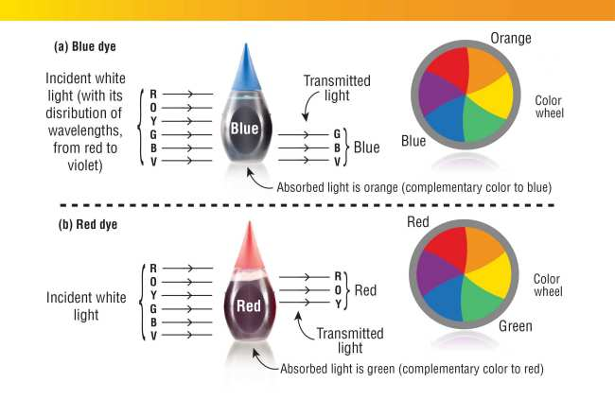
Figure 5: Light Interaction with Red and Blue Food Coloring

It can be seen in the above Figure 5 which spectrum of light are transmitted and which are absorbed for both red and blue food colors. For the blue food color it transmits a combination of green, blue, and violet rays through the coloring. This mixture allows the incoming light to scatter in such a way so as to just show a blue coloring. For the red food color it transmits a combination of red, orange, and yellow rays through the coloring. This mixture allows the incoming light to scatter in such a way so as to just show a red coloring.

Diffusion
For this picture the rate of diffusion of the food coloring into the water was critical to how fast the fluids mixed and how dramatic the lines of the mixing are. The water tank that was used in this piece was a 1 gallon tank, with only 2 drops of three different colors were used. The three colors used were green, blue and purple.

J = -D$\frac{dc}{dx}$ (1)

From equation 1 one can determine that the flux or rate of diffusion depends on the diffusivity constant D as well as the distance of diffusion. The most important variable that changes in a stable experiment like this is the concentration. The larger the difference in concentration the fast the rate of diffusion will be. There are several factors that can contribute to this with one being that the starting concentration of the food coloring in the droplet. The higher the concentration the faster the diffusion, but this has an inherent limitation. Another factor is the temperature of the fluids.

$\frac{δC}{δT}$ = $x\frac{δ^{2}C}{δx^{2}}$ (2)

From equation 2 one can determine that the flux or rate of diffusion depends on the concentration C as well as the distance of diffusion and the temperature. The concentration difference in this equation is directly affected by the temperature of the fluids that are involved in this mixing process. The higher the temperature the higher the concentration difference.

Set Up
To capture the picture a system was set up to establish a set of stable conditions as to which a quality picture could be captured.

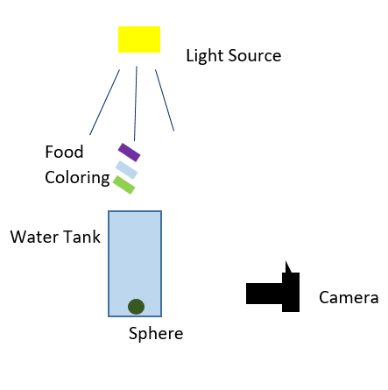
Figure 6: Picture Set Up

The camera was placed upon the table directly in front of the water tank with an overhead light source. The external light that was used was a fluorescent source, which was sufficient for this piece. The use of an overhead light source was used so as to minimize the light reflection onto the water tank. The sphere was place directly in the middle of the tank at the bottom, while the tank was filled completely with luke warm water. Behind the tank a white poster board was set up so as to minimize any possible distractions from the background. Approximately two drops of green, blue and purple were dropped consecutively into the water tank.

Camera Set Up
The camera was also set up in a specific way to capture as much of the contrasting color and brightness as possible. The camera that was used in this piece was a Canon EOS Rebel T6 DSLR with an attached 18-55 mm lens. The lens attachment that was used was adequate due to the fact that the fog that was used was so close in proximity that zoom was not necessary. There were 4 main manual features on the camera that were used to maximize the quality of this picture. These features were the aperture (f stop or f/number), exposure time or shutter speed, ISO, and the exposure bias.

The aperture on a camera refers to the size of the opening in the optics which light passes through to capture an image. The size of the aperture is one of the major factors that affects the depth of field for any given image. With a small f stop the subject stands out and the background is blurred. The aperture stop is typically referred to as the f stop, which is a ratio of the attached lens’s focal length to the diameter of the aperture opening. The range of f stops for the camera used ranged from f/3.5 to f/36. For this picture an f/stop of f/5.6 was used which is not particularly small but did allow an adequate amount of light into the camera to capture the desired details.

The shutter speed, also referred to as the exposure time, is the amount of time that the shutter is open when taking a given picture. This is important when considering whether the desired target is moving at a fast or slow pace. For a relatively slow moving object like a mixing process of food color into water over a solid sphere a relatively fast shutter speed isn’t necessary but it is quite helpful when trying to capture as much of the flowing mixing food dye detail as possible. The range of shutter speeds on the camera used went from 1/4000 to 30 seconds. However, one drawback of utilizing a faster shutter speed is that it lets less amount of light into the camera. For this reason, a shutter speed of 1/200 of a second was used to balance the levels of light as well as the desired detail of the food coloring cloud.

The ISO sensitivity refers to how sensitive the camera film or in the case of a DSLR how sensitive the sensor is to the incoming light. ISO stands for International Standards Organization and this value just refers to how sensitive the sensor is to a given value of incoming light. For the camera that was used the range of the ISO sensitivity went from 100 to 6400. This value is extremely important when taking pictures at relatively low level light conditions that the source light is not direct but being reflected off of surrounding background. To balance the amount of light that was coming in with the details in the mixing food color an ISO of 3200 was used. One drawback of using such a high ISO is that it can sometimes be too grainy and doesn’t capture so much detail in the picture. But for this piece the ISO level that was used allowed enough light to come in to be able to capture as much detail as possible.

The final manual feature that was used was the exposure bias, which refers to the feature that allows the user to manually adjust the exposure that is measured by the camera’s light meter. On the camera that was used to take the picture this ranged from -3 to 3, but an automatic setting was used. This is because on an artistic approach I as the artist didn’t like what the over exposure and underexposure results were.

After the desired picture was taken a post processing software named Photoshop was used to enhance the picture. For this piece the brightness of the overall picture was increased 50%. One important alteration from the original image that should be noted is that the coloring was inverted so as to create a more interesting image. In addition to this the background was darkened so as to prevent it from distracting from the detail of the food color mixing detail.

discussion & CONCLUsion
The desired result of capturing a full array of detail of food coloring mixing around a sphere. While the sharpness of the mixing cloud is what I as the artist would have desired, the blurriness of the bright mixing fluids with a dark background made for a dramatic contrast which was better than I could’ve asked for. In future iterations of this work one improvement that could be made is to use higher quality lighting over just fluorescent and camera light because some of the blurriness in the image is due to the low light on the mixing fluids with such a high ISO. Another possible improvement would be to explore in more depth with using another solution other than water which could freeze more of the intense lines that are present in the mixing process. As mentioned earlier the temperature of the fluids as well as the concentration of the food colors plays a very important role in the diffusion speed of the color and the water.

REFERENCES
[1] Hertzberg, Jean. Flow Visualization. Web. 12 Nov. 2016. <http://www.flowvis.org/>.

[2] Rohrig, Brian. "The Chemistry of Food Colorings - American Chemical Society." American Chemical Society. Web. 12 Nov. 2016. <https://www.acs.org/content/acs/en/education/resources/highschool/chemmatters/past-issues/2015-2016/october-2015/food-colorings.html>.

[3] Chlorophyll molecule. Digital image. Web. 14 Nov. 2016. <https://upload.wikimedia.org/wikipedia/commons/thumb/3/3a/Chlorophyll_d_structure.svg/300px-Chlorophyll_d_structure.svg.png>.

[4] "Rate of Diffusion through a Solution." Chemistry LibreTexts. 21 July 2016. Web. 15 Nov. 2016. <http://chem.libretexts.org/Core/Physical_and_Theoretical_Chemistry/Kinetics/Rate_Laws/Reaction_Mechanisms/Rate_of_Diffusion_through_a_Solution>.

