Lava Lamp

Get Wet
Seunghwa Park

MCEN-4151
Flow Visualization
A Course in the Physics and Art of Fluid Flow
2/19/2018

Projected with Sung Moon and Youngwoong Kim

Background

The purpose of the project is to clearly see the flow visualization of a phenomenon. For this video, physics and chemistry are involved to create a beautiful flow visualization. The flow visualization shows the science of buoyancy, drag, and chemical change of solvent and solute.

Experimental Setup, Physics, and Chemistry

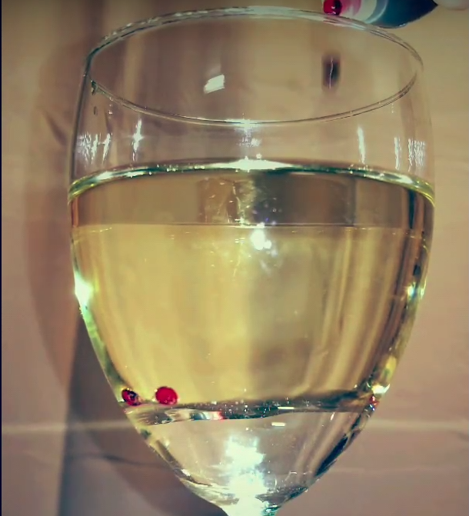
The experiment needs water, wine glass, effervescent tablets, food coloring, and vegetable oil. To start off the experiment, the wine glass must be clear and transparent. Water was poured in the wine glass, where vegetable oil was poured carefully to separate water and oil in the wine glass. Food coloring is added on top of the oil, where it stays between the boundary of water and oil. The setup is shown in Figure 1 where the food coloring stays between the boundary of water and oil.
Figure 1. Food Coloring staying between the boundary of water and oil

The effervescent tablets are added to the wine glass, where they go into water to activate a chemical reaction. When effervescent tablets dissolve in water, they create carbon dioxide, which tends to go up to the atmosphere. When the carbon dioxide passes through water and oil, it creates a beautiful flow motion with food coloring. The Figure 2 shows the flow visualization when effervescent tablets are added to the wine glass.

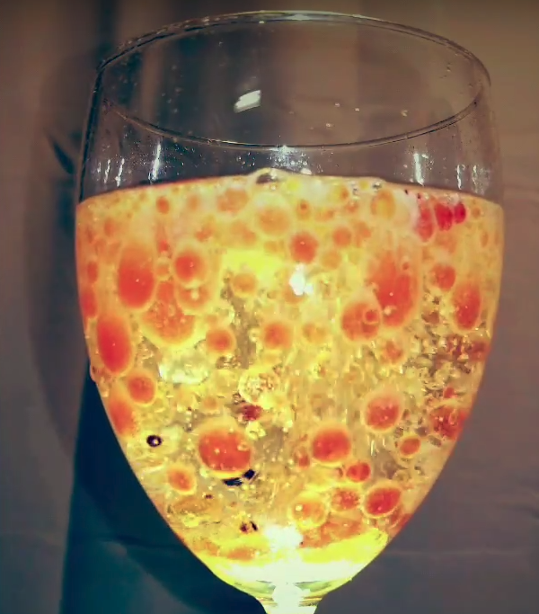
Figure 2. Flow visualization when effervescent tablets are added to the wine glass.

The effervescent tablets are medical tablets that help people to cure indigestion. When the effervescent tablets releases carbon dioxide when they are released in water, creating a chemical reaction. The Equation 1 shows how the effervescent tablet reacts with water.

C₆H₈O₇ + 3 NaHCO₃ Na₃C₆H₅O₇ + 3 H₂O + 3 CO₂ (gas bubbles)

(citric acid) (sodium bicarbonate (sodium citrate) (water) (carbon dioxide)
Equation 1. Chemical reaction when effervescent tablet is released in water

Also, the purpose of having oil on top of the water is to decrease the speed of bubbles floating to the atmosphere. By the buoyancy equation, Stokes drag for a sphere equation, Reynolds number equation, we solve for a terminal velocity of the bubble equation (shown in Equation 2), where the viscosity of the fluid changes the terminal velocity of the bubble.

$$v=\frac{2}{9}\frac{ρgR^{2}}{μ}$$
Equation 2. Terminal velocity of the sphere bubble
By making the velocity of the bubble slower, the visualization of flow was clearly shown including the beauty of art.

Visualization Technique

To create the flow visualization, there were many techniques involved in the project. The food dye was one of them, where the red food dye was the best option to create a beautiful flow visualization. Red and blue food dye were used to demonstrate the fire and ice appearance to the flow visualization. Two smartphones were used underneath the wine glass to have the best lighting effect.

Equipment and photographic technique

Galaxy S8 was used to record video of flow visualization. The resolution of the video was in 1920x1080 in 60fps. The Window Movie Maker was used to edit the video and name of the music of the video was Goody by Samsung. All these settings were used to demonstrate the flow visualization as much as it can since these settings are the maximum output from the smartphone.

Conclusion

The video shows how the carbon dioxide is generated by releasing effervescent tablet and how oil slower the speed of the carbon dioxide bubbles. The video is pleasing where the contrast between the background and the wine glass was magnificent. The lighting was good as well as the other details. There are tons of improvements that can be done to the video, but the major improvements that can be made are right cropping, more clear edges, and more editing.

The Video URL
https://www.youtube.com/watch?v=MQWk78lfgqA
Citation

Floris (https://physics.stackexchange.com/users/26969/floris), Why does the speed of an air bubble rising in a liquid increase?, URL (version: 2016-08-21): https://physics.stackexchange.com/q/275621

“Plop, Plop, Fizz, Fizz, Oh What a Reaction Is…”. Peabody Fellows Investigators. ©2013 Yale Peabody Museum of Natural History.:
http://peabody.yale.edu/sites/default/files/documents/teachers/PlopPlopFizzFizzInv%20RW%20BBH%20FINAL%20WEB%20LLF%20070413-rv.docx

