Clouds 2: Storm
Alexandra Grace Wilson
ATLS 4151
Cloud Video:
https://vimeo.com/268873801

About the cloud:
Cloud type: Nimbus
taken facing the West, Boulder CO 80303, March 18, 2018 4:37 PM
skew-T: Unstable (CAPE 32.77)

I took this image for the second cloud assignment and to capture an incoming storm in March,

Location:
taken facing the West, Boulder CO 80303, March 18, 2018 4:37 PM
Elevation roughly 5340 ft
skew-T: Unstable (CAPE 32.77)
Camera angle was almost straight towards the sky.

Third Paragraph:
The clouds in this image are nimbus “thunderclouds”. They are low and full of moisture and turbulence, and they care with them sleet and snow, which starts at the end of the video. The weather was the beginning of a full on thunder-snow storm. A front had started earlier that day, culminating in this storm. The clouds were much calmer the day before. The atmosphere was very unstable, with the CAPE reading at 32.77.
Here’s the Skew-T for the storm:
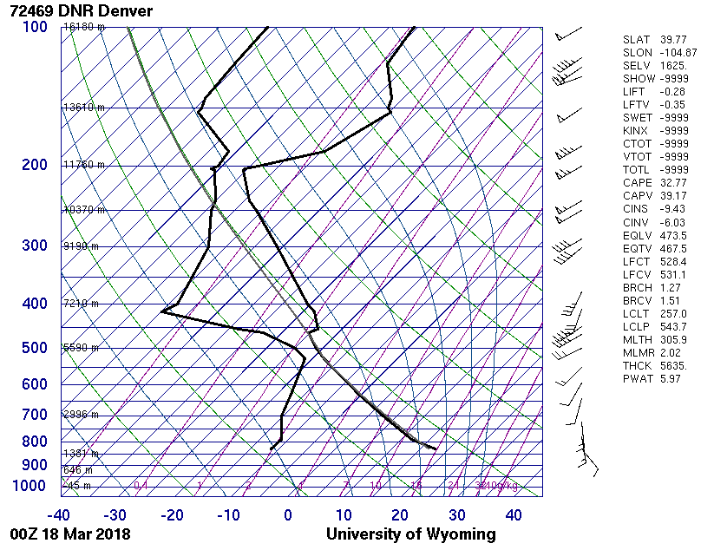
The clouds were very low, scudding over the foothills. I would estimate around 500 feet high or lower. There was a strong wind blowing. The storm was created by the intermixing of two very different atmospheres leading to the creation of sleet and snow out of the rapidly cooling atmospheric water.

I took a video with my iPhone 6 looking almost straight up, I was so worried that I would miss the start of the storm that I didn’t dare try to shoot twice, or take the time to set-up and protect my full DSLR, so I did a time-lapse using Apple’s timelapse feature.over the timespan of about a minute and a half. I don’t know exactly how much it was sped up, because I wasn’t timing the timelapse with a stopwatch as I watched the storm come in, but that was a mistake because Apple uses “dynamically selected intervals” that they have not, as a company, disclosed the ratio for. I would estimate the field of view to be extremely large. Clouds, even when they’re close, take up a lot of room.
The final timelapse video from the phone was 30 frames/second, but it is unknown how many frames were used to create the timelapse because of Apple’s proprietary interest in their timelapse feature.
Lens focal length and other lens specs are unknown because the iphone doesn’t give that info for a timelapse. The original video was 1080x720 px. but this was then rotated by Premiere pro to 720x 1080 px to make it look more professional, Exposure specs: Aperture, shutter speed, and ISO setting are unknown,
I used Premiere pro to slow the timelapse to 60% of its original speed. I also increased the contrast slightly, and converted the video to grayscale.
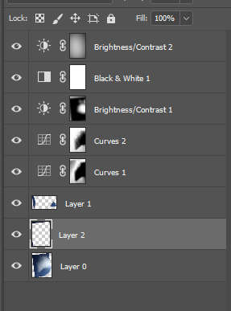
The “before” video, unedited, can be seen here: https://vimeo.com/264288046

The image reveals that when a storm comes in, it’s incredible beautiful. I hate that my hands aren’t as steady as they could be, and that there are trees and a car in the way, but I’m really glad I was able to get the actual beginning of the storm! The fluid phyiscs are shown well in that it’s a dramatic storm, but if you don’t know how storms form, this won’t tell you. I would love to film a storm starting with a full DSLR as a further step to improve the focus and hand movements!

