Acrylic Pour Video
Alexandra Grace Wilson
ATLS 4151

Introduction
I photographed pomegranate molasses dropped into a half of a liter of cold tap water in order to capture the behavior of the drop before and after if fell into the water.

Materials Used and Apparatus:
- 4 liter glass bowl with a 12 inch inner lip and 6 inch base.
- A 15” long piece of Saran-wrap attached to both sides of the large glass bowl.
- Cortas brand Pomegranate Molasses
- 1 liter of chilled tap water poured into the glass bowl
- A large envelope that functioned as a smooth background
- Camera: Rebel SL1 with 50 mm fixed lens
Setup
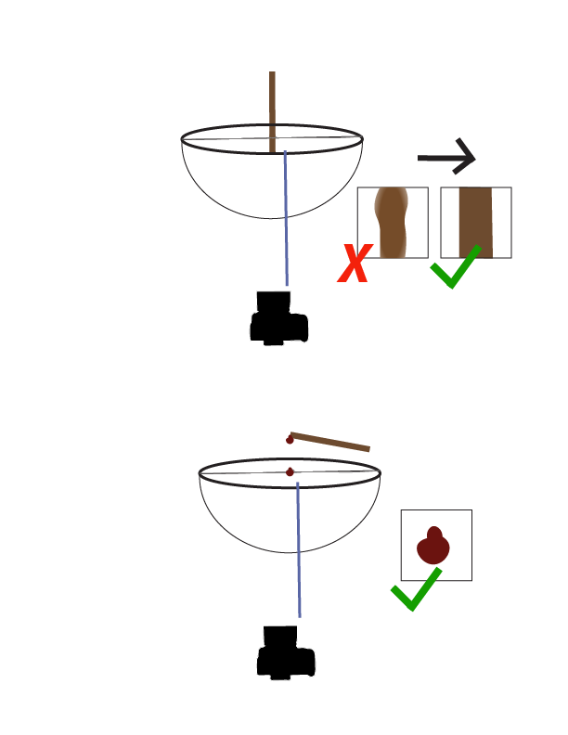

The basic flow is a drop of pomegranate molasses being dropped into cold water.

Description of the flow
The flow itself was a slow-moving flow of viscous drops of pomegranate molasses, which is concentrated pomegranate juice with added sugar, dropped into a glass bowl of chilled tap water.

Lighting and Camera:
I used natural lighting
I used a Canon EOS Rebel Sl1 with a 50mm prime lens.

Technique
The field of view was larger than the final film. It was originally roughly 10 inches wide by 8 inched, photographed at f/2.0, filmed roughly 1.5’ way from the aparatus, I trimmed the images that were most striking to the drop and heavily increased the contrast . Then I brought all images into the same frame and change the color of the last image to make it more visually appealing.
Conclusion
This image reveals the beauty of viscous drops. I wish that I had thought through the aparatus more. The capture of the drops was all done through hand button presses, and if I were to repeat this experiment I would definitely use a remote. Additionally, I wish I had gotten a video that I was pleased with. I had one on camera the first time I attempted this, but then the SD card corrupted, which was so frustrating. The original images used in this have also been lost. Only the photoshop file remains.

