Team Third
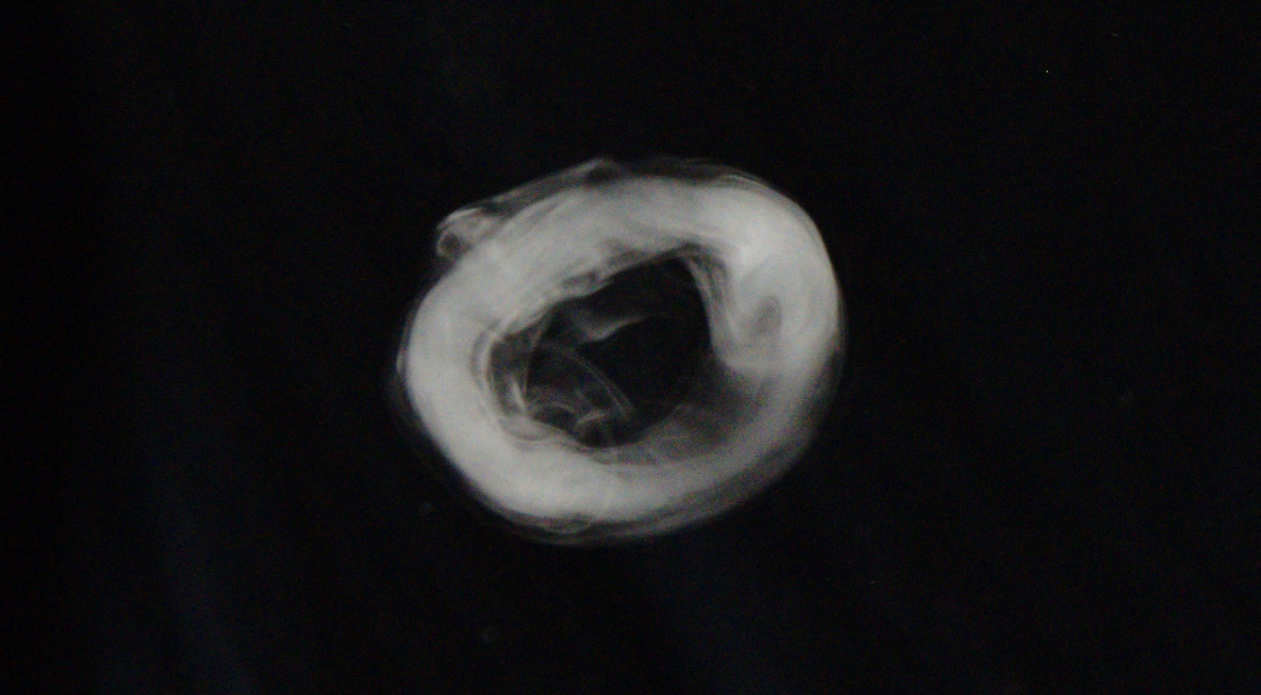
By: Casey Cooter
Team Eta
MCEN 4151
Professor Hertzberg
5/7/2018

Introduction
This image was taken for the “Team Third” assignment of the 2018 spring semester course “flow visualization” at the University of Colorado at Boulder. The experiment’s goal was to try and capture a collision of two smoke rings. However, this was difficult to capture and the tools were not capable of producing the photo, so instead our team set out to capture some great photos of smoke rings, which was achieved.
Contributors
For this team we were assigned groups. I am on team eta. The other contributors were Sam Oliver, Brent Bauer, and Jacob Chapin. We collaborated to get the best possible photo. Sam Oliver took photos while the remainder of the team held up apparatuses and shot smoke rings.
Materials
The material list for this photo is minimal, and all easily found given some preparation time. The materials are:
- Black t-shirt
- Person to hold the t-shirt
- Toy “Zero Blaster” Smoke Ring Shooter
- Nikon D5500
Procedure
The small toy smoke ring generators make smoke rings with a diameter of approximately 4 inches. The toys have a special fluid filled with them, and when the fluid is heated, it expands into a fog. When the trigger is pulled, the air is forced out in the shape of a smoke ring. As they are quite difficult to capture, the photos needed to be taken against a black background. As we did not have a black backdrop to take this on, we used a black t-shirt. For this shot, I personally held the t-shirt up against a light source while my other members shot smoke rings at the t-shirt and captured images, although many more smoke rings were shot in both ordered and unorderly fashions. The camera was approximately 3 feet away from the subject of the smoke ring when this photo was taken. The setup can be seen in Figure 1.
Natural sunlight was used as the light source, as it was during sunset and illuminated the room quite well. The window it came through was approximately 5-6 feet away from the photo. The camera was approximately 3 feet away from the smoke ring when the photo was taken, and the smoke ring was about to collide with the t-shirt, meaning it was approximately 6 inches away when it was taken. While the sun was not in line with the subject matter, the camera, ring, and t-shirt were all roughly on the same plane.
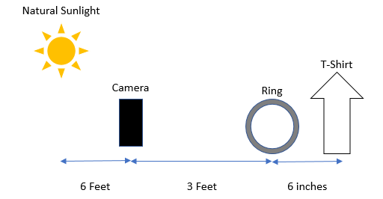
Figure 1: Diagram of Setup

Fluid Dynamics
The smoke ring has smooth lines and is not spreading out throughout the distance, which means it is extremely likely that the smoke in the ring is in the laminar region rather than the turbulent region. To confirm this, let’s consider the Reynold’s number and estimate the parameters. The density of the vapor is going to be approximately the same as a water vapor’s density (958 kg/m^3) as the fluid used in the smoke ring gun is water-based. From engineering toolbox, we find that at approximately 1 atm and room temperature, the dynamic viscosity is 1.1 centipoise, or 0.0011 Pa*s. If we apply the relation $ν=\frac{μ}{ρ}$ to find the kinematic viscosity, we find that the kinematic viscosity is 1.148e-6 m^2/s. We know the diameter of the smoke ring is approximately 4 inches, or 0.1016 meters. Finally, while the movement of the smoke ring wasn’t zero, none of the vapor was necessarily moving extremely quickly either. So, let’s approximate the velocity as 0.5 m/s, as this seems like a good approximation since it covered the distance in a few seconds. This means that the Reynolds number calculation is
$$Re=\frac{vD}{ν}=\frac{(0.5 m/s)(0.1016 m)}{1.148 ×-6 {m^{2}}/s}=432$$
This confirms that the smoke ring’s vapor is indeed in the laminar region. This explains why the smoke ring remains intact and doesn’t spread off during movement. The laminar region allows the smoke ring to contain itself and its shape, especially since the air around it is not necessarily in the laminar region either relative to the smoke ring.
Photo Technique
The photo was taken with a Nikon D5500 camera, a camera which can shoot the photos in a raw (.NEF) format. The smoke ring was quite difficult to capture, so it was captured with a fast time resolution. The exposure time was set to 1/125 seconds, used ISO-640, had a F-stop of f/4.2, and a focal length of 28 mm. While the time resolution is “okay,” it could be much better. However, shooting at a higher exposure time was difficult since the image began to become washout out and still lacked definition. This image, while blurry, is still acceptable. The original photo is 6000 x 4000. The general framing of this image is around 3 feet x 4/3 feet. It can be seen in the following figure:
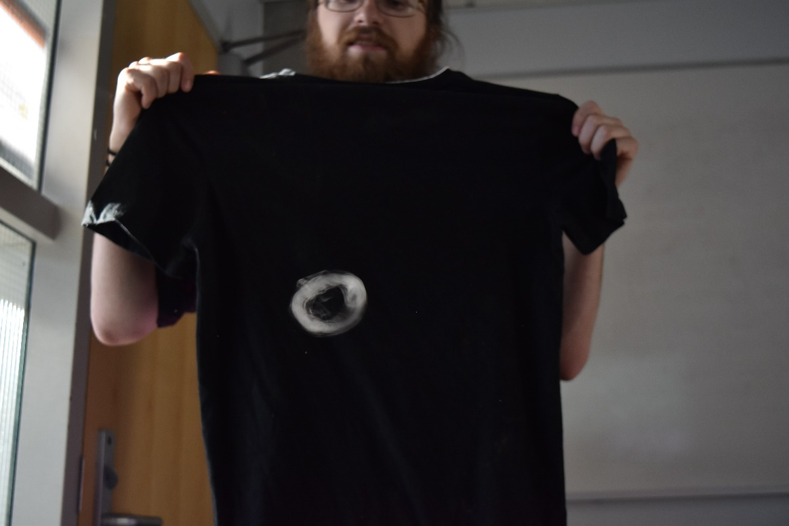
Figure 2: The way the original photo was taken, featuring the author of this paper!
The photo was imported into the photo processing photo “GIMP” using the software UFRAW, a free and open source way to process RAW files. Editing was kept to a minimum, but it was an excellent opportunity to work with a RAW format. Exposure values were tweaked slightly to bring out the smoke ring and hide some of the messiness and inconsistencies of the black shirt. Once the image was imported, it was cropped to center the smoke ring as the center focus. I tried to leave an equal amount of black on both sides to keep the image in a nice aspect ratio. The final resolution was 1664 x 918.A light sharpening was applied for a similar reason, as this helped to smooth out some of the edges that had noise due to movement of the smoke ring. The image was exported as a png, and can be seen on the cover page.
Conclusion
While I was unable to capture the image I wanted, I’m still extremely happy with the way this photo turned out. It was a difficult shot to capture and edit, so I’m glad we as a team could capture this phenomenon. Smoke rings are an excellent example of fluid dynamics in motion, as they are so simple yet demonstrate complicated fluid dynamics. There are many ways to evaluate the fluid dynamics of a smoke ring other than through the Reynold’s number, and in a more controlled experiment this would be a fantastic concept to explore. Overall, the process of obtaining the image was also unique and enjoyable. I really enjoy the shape of the smoke ring, as this one was just about to dissipate and you can see the smoke ring become less thick in extra areas. Overall, I am quite pleased with this photo and am pleased to have had the opportunity to capture this in such detail.
References
[1] https://www.engineeringtoolbox.com/steam-viscosity-d_770.html

Image Assessment Form
Flow Visualization
Spring 2013

Name(s): Casey Cooter

Assignment: Team First Date:5 March 2018
Scale: +,! = excellent √ = meets expectations; good. ~ = Ok, could be better. X = needs work. NA = not applicable
Art | Your assessment | Comments
Intent was realized | ~
Effective | !
Impact | !
Interesting | !
Beautiful | !
Dramatic | !
Feel/texture | !
No distracting elements | √
Framing/cropping enhances image | !

Flow | Your assessment | Comments
Clearly illustrates phenomena | !
Flow is understandable | !
Physics revealed | !
Details visible | !
Flow is reproducible | !
Flow is controlled | !
Creative flow or technique | !
Publishable quality | √

Photographic/video technique | Your assessment | Comments
Exposure: highlights detailed | √ | Could be better, still grainy, but not all bad since the shape is still quite interesting
Exposure: shadows detailed | !
Full contrast range | !
Focus | !
Depth of field | !
Time resolved | ~ | Still grainy, but capturing the smoke ring itself was quite difficult anyways!
Spatially resolved | !
Photoshop/ post-processing enhances intent | !
Photoshop/ post-processing does not decrease important information | !

Report |  |  | Your assessment | Comments
Collaborators acknowledged |  |  | !
Describes intent | Artistic |  | !
 | Scientific |  | !
Describes fluid phenomena |  |  | !
Estimates appropriate scales | Reynolds number etc. |  | !
Calculation of time resolution etc. | How far did flow move during exposure? |  | √
References: | Web level |  | !
 | Refereed journal level |  | x | Much of the resources I needed weren’t present in any scientific journals I found
Clearly written |  |  | !
Information is organized |  |  | !
Good spelling and grammar |  |  | !
Professional language (publishable) |  |  | !
Provides information needed for reproducing flow |  | Fluid data, flow rates | !
 |  | geometry | !
 |  | timing | !
Provides information needed for reproducing vis technique |  | Method | !
 |  | dilution | N/A
 |  | injection speed | N/A
 |  | settings | N/A
lighting type |  | (strobe/tungsten, watts, number) | !
 |  | light position, distance | !
Provides information for reproducing image |  | Camera type and model | !
 |  | Camera-subject distance | !
 |  | Field of view | !
 |  | Focal length | !
 |  | aperture | !
 |  | shutter speed | !
 |  | Frame rate, playback rate | !
 |  | ISO setting | !
 |  | # pixels (width X ht) | !
 |  | Photoshop and post-processing techniques | !
 |  | "before" Photoshop image | !

