Jeremy Aparicio
MCEN 4151-001
October 1, 2018
Get Wet

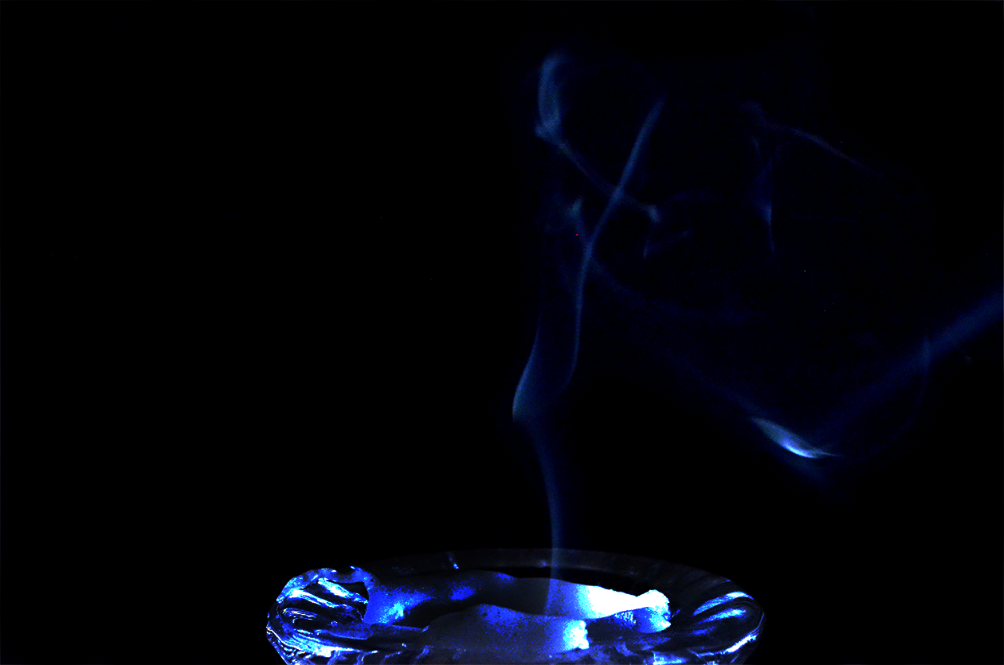

This image was meant to capture the combustion process from a single candle. My initial idea was to draw unique designs with hand-sanitizer on a marble counter. However, my lack of photography knowledge led to all my images becoming corrupted files and so I decided to do something different. Combustion has always been a phenomenon that inspires the creative side in me and tackling this photo was no easy task.
Candle smoke is produced through the vaporization of wax. There is no smoke when the candle is lit because the bonds of the saturated hydrocarbons in the wax break down at lower temperatures. When cellulose string (the wick) is burnt, a mass carbon forms at the end which acts as a catalyst in the vaporization process of the wax. When the candle is blown out, the mass of carbon in the tip is often illuminated and seen releasing smoke. This mass of carbon oxidizes the wax into smoke particles.
To capture this image, the setup was constructed in a dark bathroom with no noticeable air current. All materials were found in my apartment and consist of a large black board, a small black board, a single candle, an LED light from a Google Pixel 2, and the Nikon D5100 DSLR camera. The large blackboard was used for the background while the smaller one was used to block the light source from illuminating the background. Unfortunately, the candle I had chosen dispersed light much more than expected, ultimately illuminating the background more than I wanted. My process involved lighting the candle, blowing out the candle, then immediately taking three to five pictures with the few seconds of thin smoke.
The width of the field of view is about 2 feet and the height is about 1.5 feet for the background. The candle has a diameter of 1.5 inches for perspective. The background was placed 2.5 feet from the camera with the candle about 7 inches from the camera. The lens had a 28mm focal length with a maximum aperture of 4.3. This photo was taken using the Nikon D5100 DSLR camera. The original image has a width of 3,696 pixels and a height of 2,448 pixels. The final photo has a width of 1,260 pixels and a height of 835 pixels. The photo was shot at F-stop f/11 with a 1/60 second exposer time and 6400 ISO setting. The exposure bias was also increased to +0.3. In photoshop, I wanted to add more accent to the blues that come from the light from my camera phone. I set a curve to the RGB as shown in figure 1. I set the curves for the green and red setting as shown in figure 2. A layer mask was inverted and places on top of the image and the saturation was set to 15. The exposure was also turned down by 0.008 and painted over the candle base to lower the intensity. Figure 3 below shows the original image.
The image reveals how much I have to learn when it comes to photography. I wanted to challenge myself with manually setting all specs, even with little knowledge of how those setting would affect an image. I struggled with getting the smoke illuminated enough and the final image seems a little dull. I like the symmetry of the image and the visualization of the flow but the image can be much cleaner. To develop this idea further, it would help to have a friend work the lighting for me or have the camera on multiple picture mode as I blow out the candle. I also learned the tip of the wick has the most wax in it once it has burned long enough to reach equilibrium. Had I known this information I would have left the flame lit longer before extinguishing the flame so that smoke volume would increase.

Figure 1: Figure 2:
RGB Curve Edit Blue and Green Curve Edit

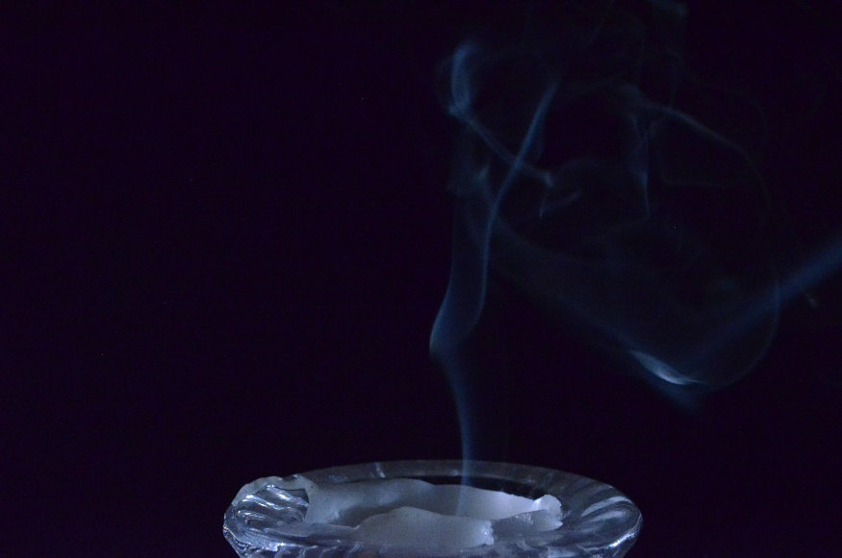

Figure 3:
Original Image Taken with the Nikon D5100

References
Hill, K. (2013, September 09). Waxbows: The Incredible Beauty of a Blown Out Candle. Retrieved from https://blogs.scientificamerican.com/but-not-simpler/waxbows-the-incredible-beauty-of-a- blown-out-candle/

