Casey Munsch
Flow Visualization
09/27/2018
Get Wet Project Report
For this first assignment, I wanted to play around with the boundary layers of liquids and how they interact when an object travels through them. Initially the plan was to layer 7 different liquids, each one colored differently with different densities, then drop a dart through the layers and watch how each layer reacted to the disturbance. This idea was simplified into the final project in which black colored rubbing alcohol was poured into a large vase of blue colored water under a large layer of canola oil. This was done to show the reaction of the fluid boundaries, miscibility properties, and varying densities.
The apparatus used in the final image is a large vase, about a foot tall and half a foot wide, with an interesting shape that is shown in Figure 1. I used this vase because I thought it has an interesting shape that would add to the aesthetics of the image and because it was large enough to display all the fluid reactions clearly. There are three basic flow phenomenon that are represented in my image: Boundary layer reactions, immiscibility properties, and density reactions.
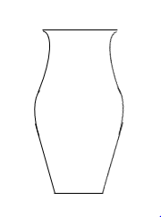
Figure 1. Vase shape
The density properties allow the water to stay at the bottom of the vase while the oil forms a layer on top. This is because the water has a specific gravity of 1 while vegetable oil has a slightly less specific gravity of 0.92. The isopropyl alcohol has an even less specific gravity of only 0.79 which is why in the image you can see isopropyl bubbles in the oil (1). These pockets were stuck in the oil as the alcohol was poured and now they are rising to the top of the container.
These pockets stay in the bubble shape and wont mix with the oil due to the properties of immiscibility between the alcohol and oil (2). This is the same reason why the oil forms a layer on top of the water instead of becoming a mixture. The rubbing alcohol that is poured with enough entering velocity will pass all the way through the oil layer and reach the water underneath. The oil and water do not share the immiscibility property and so as these fluids touch they start to mix. Because the alcohol is mixing with the water, the new mixture has a higher specific gravity than the oil and will not rise past the oil layer.
The boundary layer reactions occur at the top of the oil layer as well as between the layers of oil and water as the alcohol breaks through these surfaces. Even though this is difficult to see in the image, it is possible to make out small drops of oil forced into the water from the pouring alcohol and now rising back to the oil layer.
As an attempt to allow clearer visualization, Kroger brand food coloring dye was used to change the colors of the fluids to better differentiate them. Water was poured into the vase until it reached the neck or thinner part of the vase. This came out to about a half a gallon total. A single drop of blue food coloring dye was added to the water and then mixed. This amount produced a slight blue color to the water. A half of a cup of isopropyl alcohol was poured into a measuring cup and a drop of blue, green, and red were added. As these colors mixed, the alcohol turned black. Two cups of oil were used to form a layer above the water and were not dyed or affected in any way. The alcohol was poured from a height in witch part of the alcohol would break all the way through the oil while other section would not. I found this height to be about 6 inches from the top of the vase. This vase was rested on the back side of a phone which was placed on a wooden table. The phone light was turned on and centered under the vase. All other lights were turned off and a white paper was placed behind the vase to remove any backgrounds. This paper also reflected some of the light from the vase to form an interesting section of halo behind the vase.
The photo was taken on a mirrorless Canon camera. The shutter speed was at 1/500 of a second to clearly capture the flow without blur. To combat the low amount of light reaching the sensor, the aperture was increased to f/3.2. The picture was taken at a portrait angle with fixed 50 mm lens from about five feet. The image was cropped to center the vase and to remove unnecessary space. The contrast was turned up slightly and so was the saturation to enhance the colors of the image. Finally, a black padding was added to the sides of the image to make the image landscape.
The final image captures the miscible properties clearly as well as the varying densities of each fluid. The picture fails however to clearly show the boundary layer reactions as the alcohol passes through each layer. I like the symmetry of the vase and light except for the alcohol that is being poured at an off-set angle. I also like the way the shape of the vase traps small air bubbles in the water at the vase overhang and how the light illuminates these bubbles. To improve the image, I could use a DSLR camera to increase the clarity of the image and time the picture so that less alcohol would be poured.

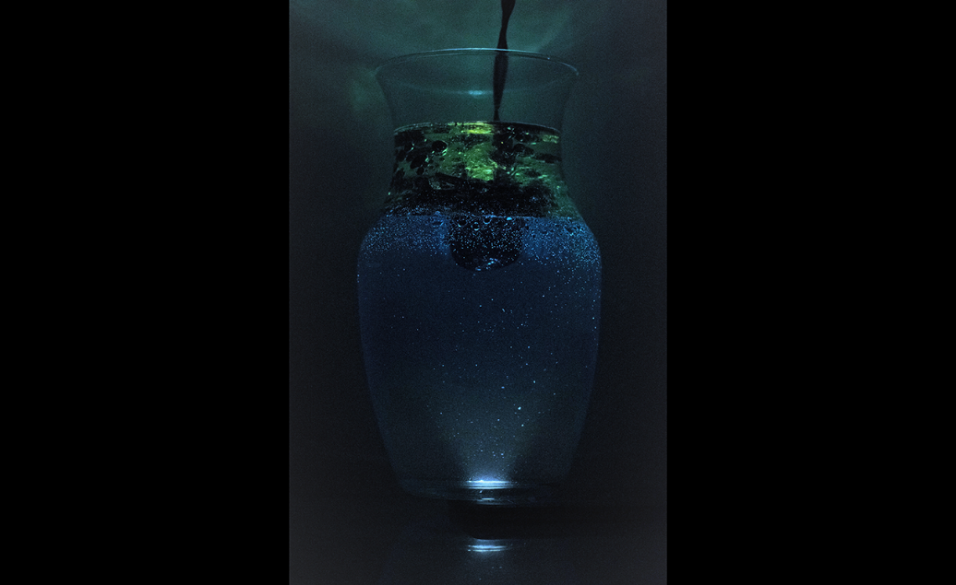

Works Cited
- Engineering ToolBox, (2003). Liquids - Specific Gravities. [online] Available at: https://www.engineeringtoolbox.com/specific-gravity-liquids-d_336.html [01/11/2018].

- Libretexts. “10.16: Miscibility.” Chemistry LibreTexts, Libretexts, 6 Sept. 2017, chem.libretexts.org/Textbook_Maps/General_Chemistry/Book%3A_ChemPRIME_(Moore_et_al.)/10Solids%2C_Liquids_and_Solutions/10.16%3A_Miscibility#title.

