Casey Munsch with Chris Davidoff, Owen Brown, Matthew Davis
Flow Visualization
MCEN 4151-001
09/27/2018

Team First
Project Report
For this first group assignment, a group member had discussed creating a contained fire whirl in a cut vase. I did some research and found an image of the fire whirl and decided it would make an interesting image. A fire whirl is a contained flame that rotates as it burns creating a vortex. I was hoping to capture a video or image that clearly shows the spinning of the flame.

Chris Davidoff, Owen Brown, and I went to Matthew Davis’ house next to the Engineering Center for the photo shoot. We used Chris’ camera for all the images. Matthew had cut a foot-tall vase vertically down the center as shown in Figure 1. A Coke can was cut in half to create a cup that was filled with 4 tablespoons of ethanol. The two sides of the vase were placed outside during a calm night and were offset one inch as shown in Figure 2 to allow air circulation. The ethanol cup was placed in the center of the two vase halves.

The ethanol was lit with a lighter and the fire was left until it was burning at a consistent height. At this height the fire started to vortex in the vase and we began to take pictures from different angles and at different distances.
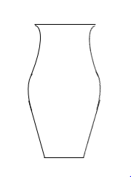

Figure 1. Vase Shape and Cut Line | Figure 2. Top View of Cut Vase

The combustion reaction, shown in equation 1, that keeps the fire lit requires both C2H5OH (ethanol) and 02 which makes up 20% of air. The reaction of the fire pulls in air from the outsides of the vase. Because this vase is offset, the air circulates around the vase. The shear force at the boundary layer of circulating air forces the rising fire to spin as well. The fire swirl is taller than a normal fire under these conditions because the air gets heated quickly causing it to rise. This causes the fire to rise as well.

 | CH₅OH +3O₂ = 2CO₂ + 3H₂O | (1)

As an attempt to allow clearer visualization, the walls of the vase were cleaned. To focus the camera at the center of the flame, before lighting the ethanol we placed the lighter right above the cup of ethanol and manually focused on the lighter. We kept the camera on a tripod and did not move it so that the focus would stay in the center of the vase after we removed the lighter and lit the flame. The only sources of light were from the flame and small porch and street lights. It was a cloudy night, so we did not have to worry about moon light. We used the setting on our camera to filter out most of the outside lighting.

The photo was taken on a DSLR camera. The shutter speed was at 1/500 of a second to clearly capture the flow without blur. The aperture was held at f/3.2 to allow the flame to be bright enough without catching light from outside of the experiment. The picture was taken at a portrait angle with fixed 50 mm lens from about two feet. The image was cropped to center the vase and to remove unnecessary space and areas of the vase were painted black to remove glare and reflection in the image. The contrast was turned up slightly and so was the saturation to enhance the colors of the image. Finally, a black padding was added to the sides of the image to make the image landscape.

The final image captures the fire whirl well and it is easy to see the spinning of the flame in the image. The final image does however have some vase reflection which appears as lines of different colors around the image. Theses reflections are distraction and were very difficult to deal with in editing. I like the symmetry of the vase and light and how the flame stays vertical. To improve this image, I could work on editing out the reflections of the vase or take more photos from different angles to find a placement that does not create glare.
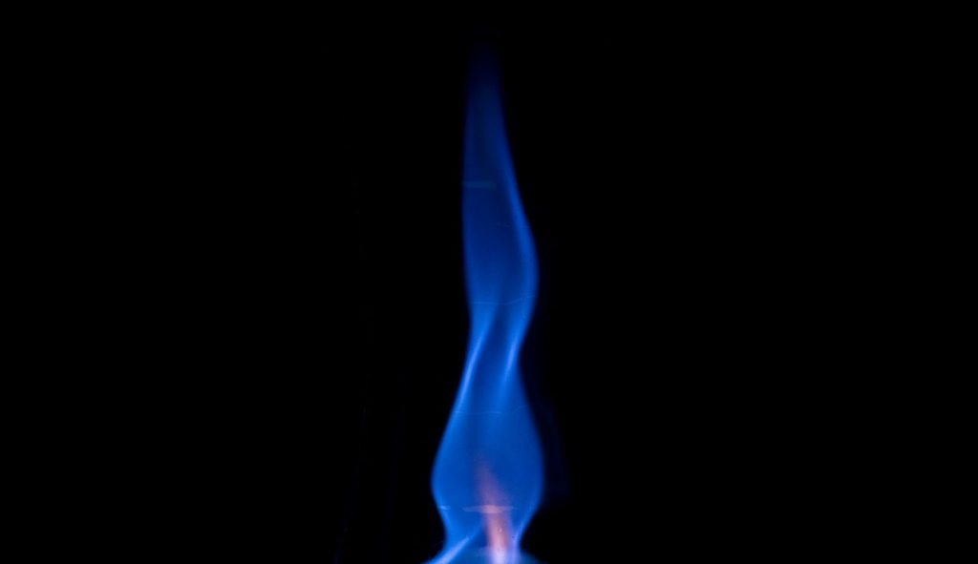
Works Cited
English, Trevor. “The Physics of Fire Tornadoes.” The Short Sleeve and Tie Club, 24 Oct. 2017, shortsleeveandtieclub.com/the-physics-of-fire-tornadoes/.
Libretexts. “15.4: Chemical Reactions of Alcohols. Reactions Involving the O-H Bond.” Chemistry LibreTexts, Libretexts, 23 June 2017, chem.libretexts.org/Textbook_Maps/Organic_Chemistry/Book%3A_Basic_Principles_of_Organic_Chemistry_(Roberts_and_Caserio)/15%3A_Alcohols_and_Ethers/15.04%3A_Chemical_Reactions_of_Alcohols_involving_OH_bonds_wtih_Acidic_Properties.

