Clouds Report 1- 2018
Peilin Yang
MCEN 5151
2018
Image Context
The aim of this Clouds image was to record the interesting cloud phenomena in the versatile weather of Colorado. Saturated colors were expected to reflect the phenomena in a vividly as well as aesthetic way. I chose sunset as the time of photography because the setting sun was so magnificent during the autumn that added a brilliant touch to most daily scene.

Flow Apparatus
I found a public-accessible roof at the intersection of college avenue and 28th street where allowed me to have a pleasant view of the clouds accompanied by the shadow of the Engineering Center echoing by the Flatiron Mountain.
According to the Skew-T diagram, the atmosphere on September Cirrus clouds in the image is stable due to the fact that the CAPE(Convective Available Potential Energy, J/kg) equal to 0.
$$CAPE=GRAVTY * SUMP ( DELZ * ( TP - TE ) / TE )$$
SUMP = sum over sounding layers from LFCT to EQLV for which ( TP - TE ) is greater than zero
DELZ = incremental depth
TP = temperature of a parcel from the lowest 500 m of the atmosphere, raised dry adiabatically to the LCL and moist adiabatically thereafter
TE = temperature of the environment
In the figure 1, the narrowest gap between dew-point line and temperature line which indicating that the height of the clouds is around 2800 meter from the sea level.
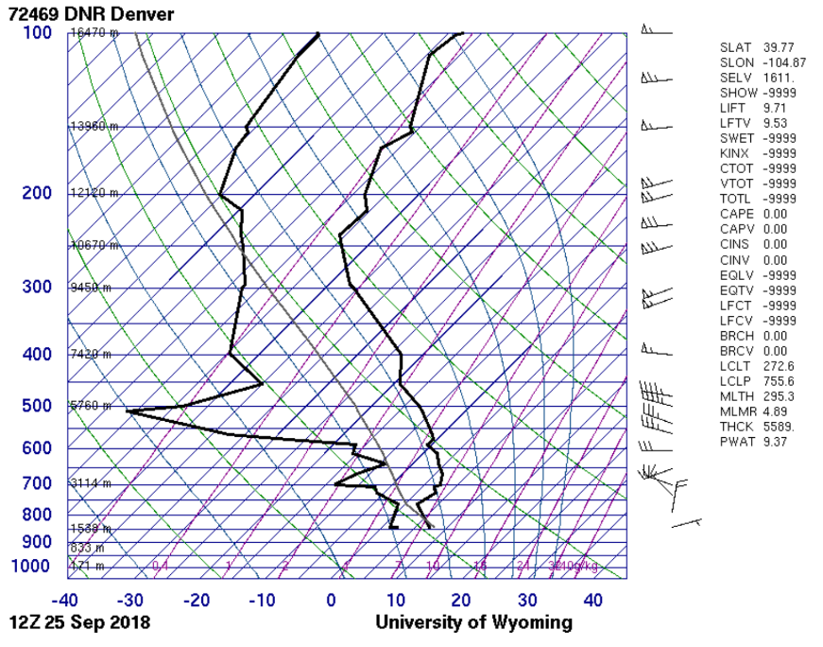
Figure 1 Skew-T
However, based on Dr. Fu’s research, the thin and wispy Cirrus clouds in the image usually exists at the height bigger than six thousand meters. This kind of low-height cirrus clouds was unique.
The glaciation process consisted of the cirrus clouds. Ice and snow were composed among these “finger-like” clouds. The strength of wind and the falling speed of the ice crystals decided the shape of the cirrus clouds.
Visualization technique
For the lighting control, I chose the backlight situation to make more contrast between the showy clouds and the silent mountains, which makes audience put more emphasis on the magnificent clouds.

Photographic technique
The shutter speed is 1/177 second of an iPhone XS camera. The aperture value is f/2.4 to allow enough light come into CMOS. The focal lens of the camera is at 6 mm. Due to sufficient exposure to the sunlight, the ISO was set at 16 to lower the noise. For the photoshop work, I crop the image to remove the distractive part. Then I adjust the contrast and the curve of the whole image to sharp the color.
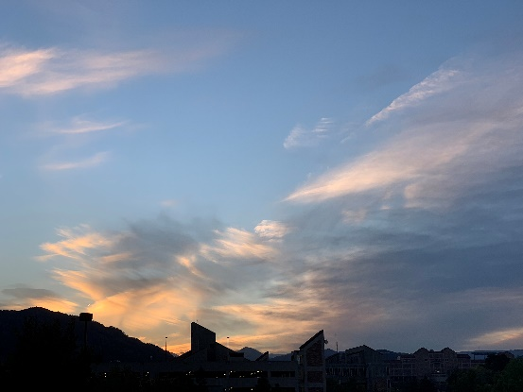  Figure 2 Original Image  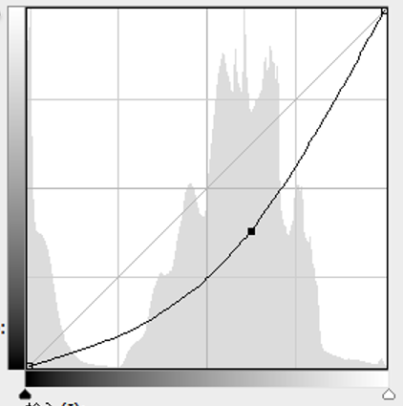  Figure 4 Curve in PS | 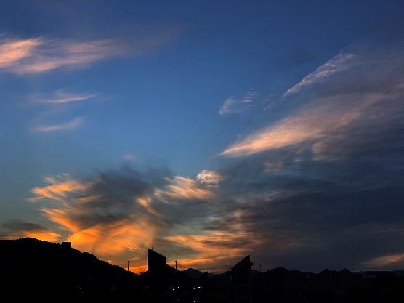  Figure 3 Final edited Image
Image reveals
The golden color in the bottom of the image was my favorite part. It illustrates the cirrus clouds in a clear method as well as lifts the aesthetic sense of the image. Besides, the engineering center skyline was a nice touch.

Soundings from Department of Atmospheric Science University of Wyoming http://weather.uwyo.edu/upperair/sounding.html
Fu, Q., & Liou, K. N. (1993). Parameterization of the radiative properties of cirrus clouds. Journal of the Atmospheric Sciences, 50(13), 2008-2025.

