Clouds First Fall 2018
MCEN 4151
Chase Cleveland
Alto-Stratus, 10/2/2018, 7:00 am, Mt. Sanitas Peak, Boulder, CO

My first cloud assignment image was taken on a sunrise hike up Mt. Sanitas. I aimed to capture the sun rising through a layer of alto-stratus clouds and the coloring that results. Although many shots were taken at sunrise, I settled on this one since I liked the up-close look at the sunrise and the lighting of the sun rays as they dissipate through various cloud layers. I also like the colors achieved in this image.
The image was taken in Boulder, Colorado at the peak of Mt. Sanitas, bordering the front range. At 1,343 ft tall, Mt. Sanitas allowed for a high-altitude shot of the sunrise including ground level to about 20,000 ft. The center of the shot was angled about horizontal to ground level. The image was taken at 7:00AM as the sun was rising and the camera was pointed eastward during the shot.
Altostratus clouds are featured in the image as well as some lower stratus clouds. The rest of the sky had some stable cirrus clouds above, but out of frame. There was a warm front approaching as there had been rain the day before and the atmosphere was now stable. However, it did not rain a few hours within taking the photo nor was it windy. The screw-T plot below shows a CAPE of 0, demonstrating a fully stable atmosphere, and has the temperature profile and dew point line closest in the 3500 m and 9000 m range in which altostratus clouds exist. These cloud formations agree with my observation of lower stratus and higher altostratus clouds. Stratus clouds also reflect a stable atmosphere which is evident in the skew-T plot [1]. Overall, the clouds pictured represent the remnants of a storm from the day before turning stable.
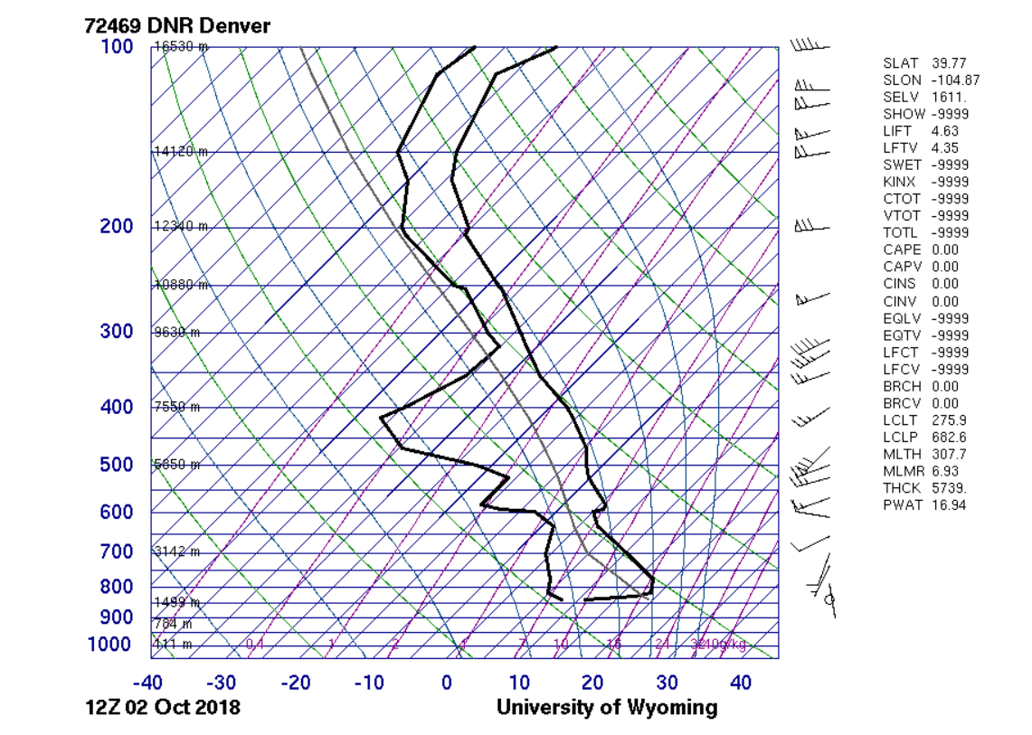

The photo was taken using a Canon T6i DSLR with a lens at a focal length of 35 mm. The field of view in the edited image is approximately 10 mi wide and 4 mi high. The original image had the dimension of 6000 x 4000 pixels and was cropped to 6000 x 3211 pixels. An aperture of f/5.6 was used with an ISO of 400 to capture the clarity of the cloud formations as well as the variation in light and contrast. The shutter speed was 1/1600 sec which gave the shot stability with no blur. The photo was edited using digital photo professional where the tone curve was adjusted to enhance the natural colors while providing more even lighting and better contrast throughout the image. The original, unedited image is shown below.
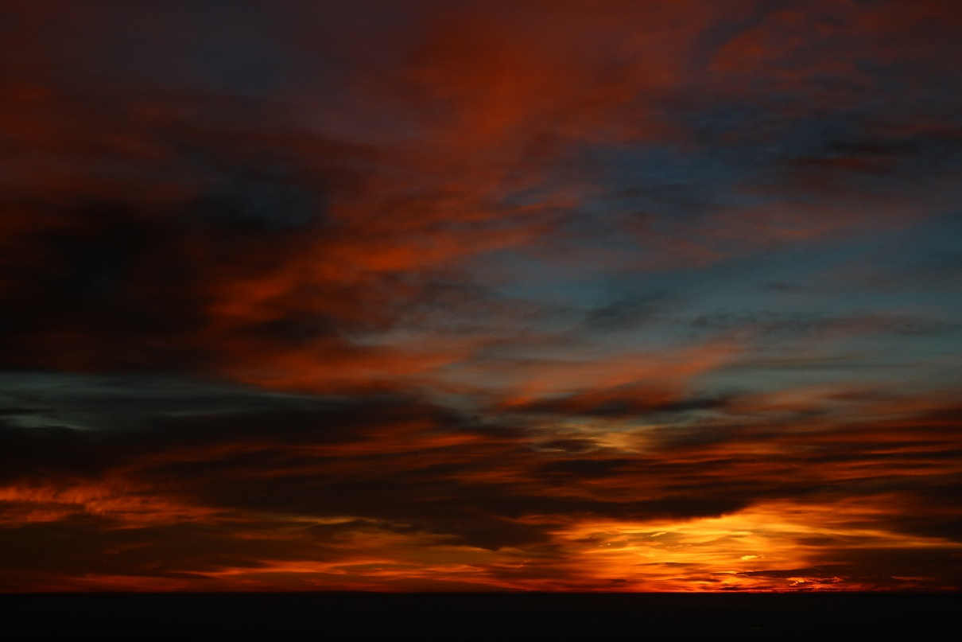
The image reveals the beautiful variation in colors present in a sunrise seen through stratus and altostratus clouds. The distant beauty is emphasized by a wide range of colors from the yellows of the sun, orange of its reflection, and natural blue of the sky above. I would have liked to better capture the details of the sun as seen through clouds by using a telephoto lens and getting better detail in the yellow section of the image up close. I wonder what the image would look like from the same point of view but at sunset. Overall, my intent of capturing a sunrise through stratus clouds was achieved. Further development of this image would include using a zoom lens with a lesser focal length, thus bringing out the detailed yellows of the refracted sun rays.

References
[1] Atmospheric Soundings, weather.uwyo.edu/upperair/sounding.html.

