Third Team Image Report

Brent Eckles

MCEN 4151-001

11-Dec-18

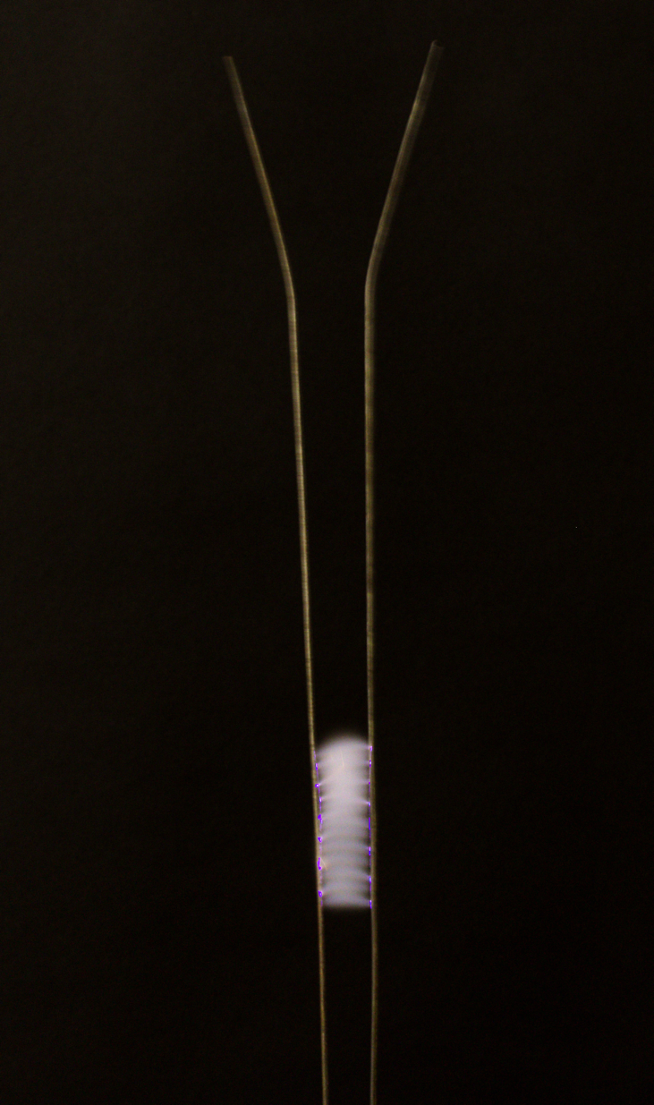

Introduction:
This image was produced in response to the third team project assignment for Flow Visualization as the last opportunity to work as a group and presented the opportunity to further improve image capturing techniques. The idea for this project came from on of the team members being apart of the Tinker Mill in Longmont, Co. The team member was aware of the Jacob’s Ladder that was in their possession and believed it would be interesting to take a picture of. The remainder of the team was excited at this opportunity and was interested in learning more about the phenomenon.

Experimental Setup:
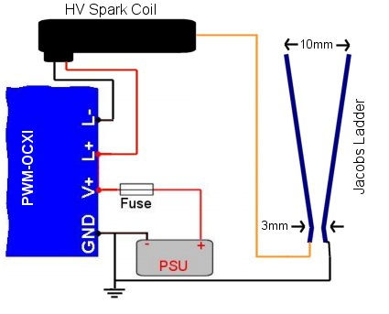
The materials used in this project were a Canon CR2 camera, a black sheet of background paper, a Jacobs Ladder device, and a stool. The Jacobs Ladder was already constructed and was placed upon a stool to increase the visibility on the device. The black paper was hung behind the Jacob’s Ladder in order to increase the contrast between the light produced and the background. The camera was placed directly in front of the device placed upon a stand to hold the camera firm. The device was then plugged in and the camera was used to take pictures of the result. A depiction of a Jacob’s Ladder can be can be seen in Figure 1.
Figure 1

Flow Analysis:
A Jacobs Ladder is the visualization of an electric spark jumping between two parallel wires, climbing up the ladder. A transformer at the bottom creates a potential difference between the wires. The electrons repel each other each other, so they jump from one wire to try and get as far apart as possible. The spark heats up the surrounding air and hot air rises, so the spark rises with it. When the spark gets to the top of the wires, it dies and a new one starts at the bottom. (UW Madison) The spark is what can be seen as a deep purple and blue with its path being a trail of lighter smoke looking debris.

Camera Specs & Photo Editing
This image was captured using a Canon CR2 camera with an 18-55 mm lens. The exposure time was 1/8 seconds with an f-stop of f/8. The camera lens was located about three and a half feet from the Jacob’s Ladder. The original photo was 5184 X 3456 pixels before being cropped to the image in Figure 3. After capturing the large quantities of photos they had to be sorted through in order to select the perfect image. This image displayed two main characteristics, a detailed image in focus as well as one that captured the events partaking in the photo. Once this photo was selected it then had to be edited allowing for the optimization of the photo. The image was uploaded into gimp, an editing software with several image editing options. Two main things happened to the photo, one it was cropped and two the color curve was adjusted. As can be seen from Figure 3 the original photo captured a much larger area, with the main events of the picture not in the center of the photo. The picture was cropped to reduce the amount of unnecessary background and place the Jacob’s Ladder in the middle of the photo.

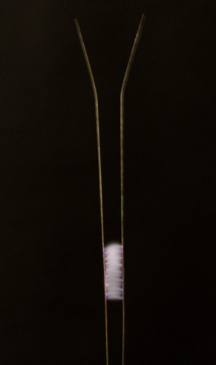
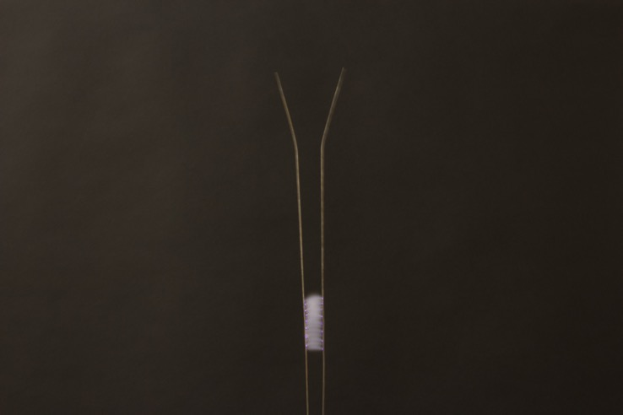

Figure 3
Figure 3 also shows the changes made to the coloring of the photo. The goal of the editing was to make the sparks captured the main focus of the photograph. To do this the darker colors in the image were made much darker without effecting the lighter colors. This created a larger contrast between the background and the sparks. The adjustment of the color curve is contained in figure 4 below.
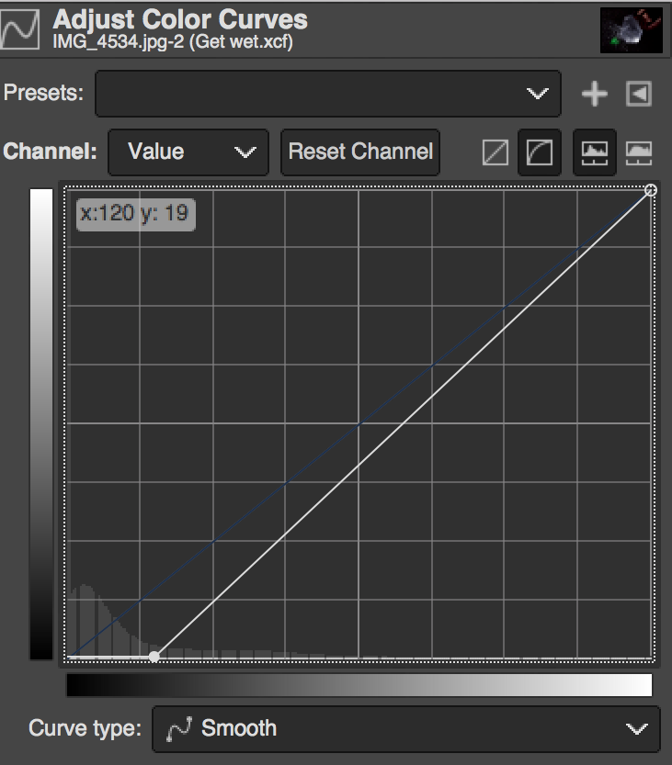

Figure 4
Conclusion:
The third team project gave the last opportunity to capture flow for the class Flow Visualization and was a nice capstone to end the class. You could tell the progression we had as a team as the team came prepared and was efficient in taking our shots. The overall image produced was one to be proud of and showed an interesting phenomenon. The purple sparks offer a unique intertwining of science and art as they were exciting to look at.

