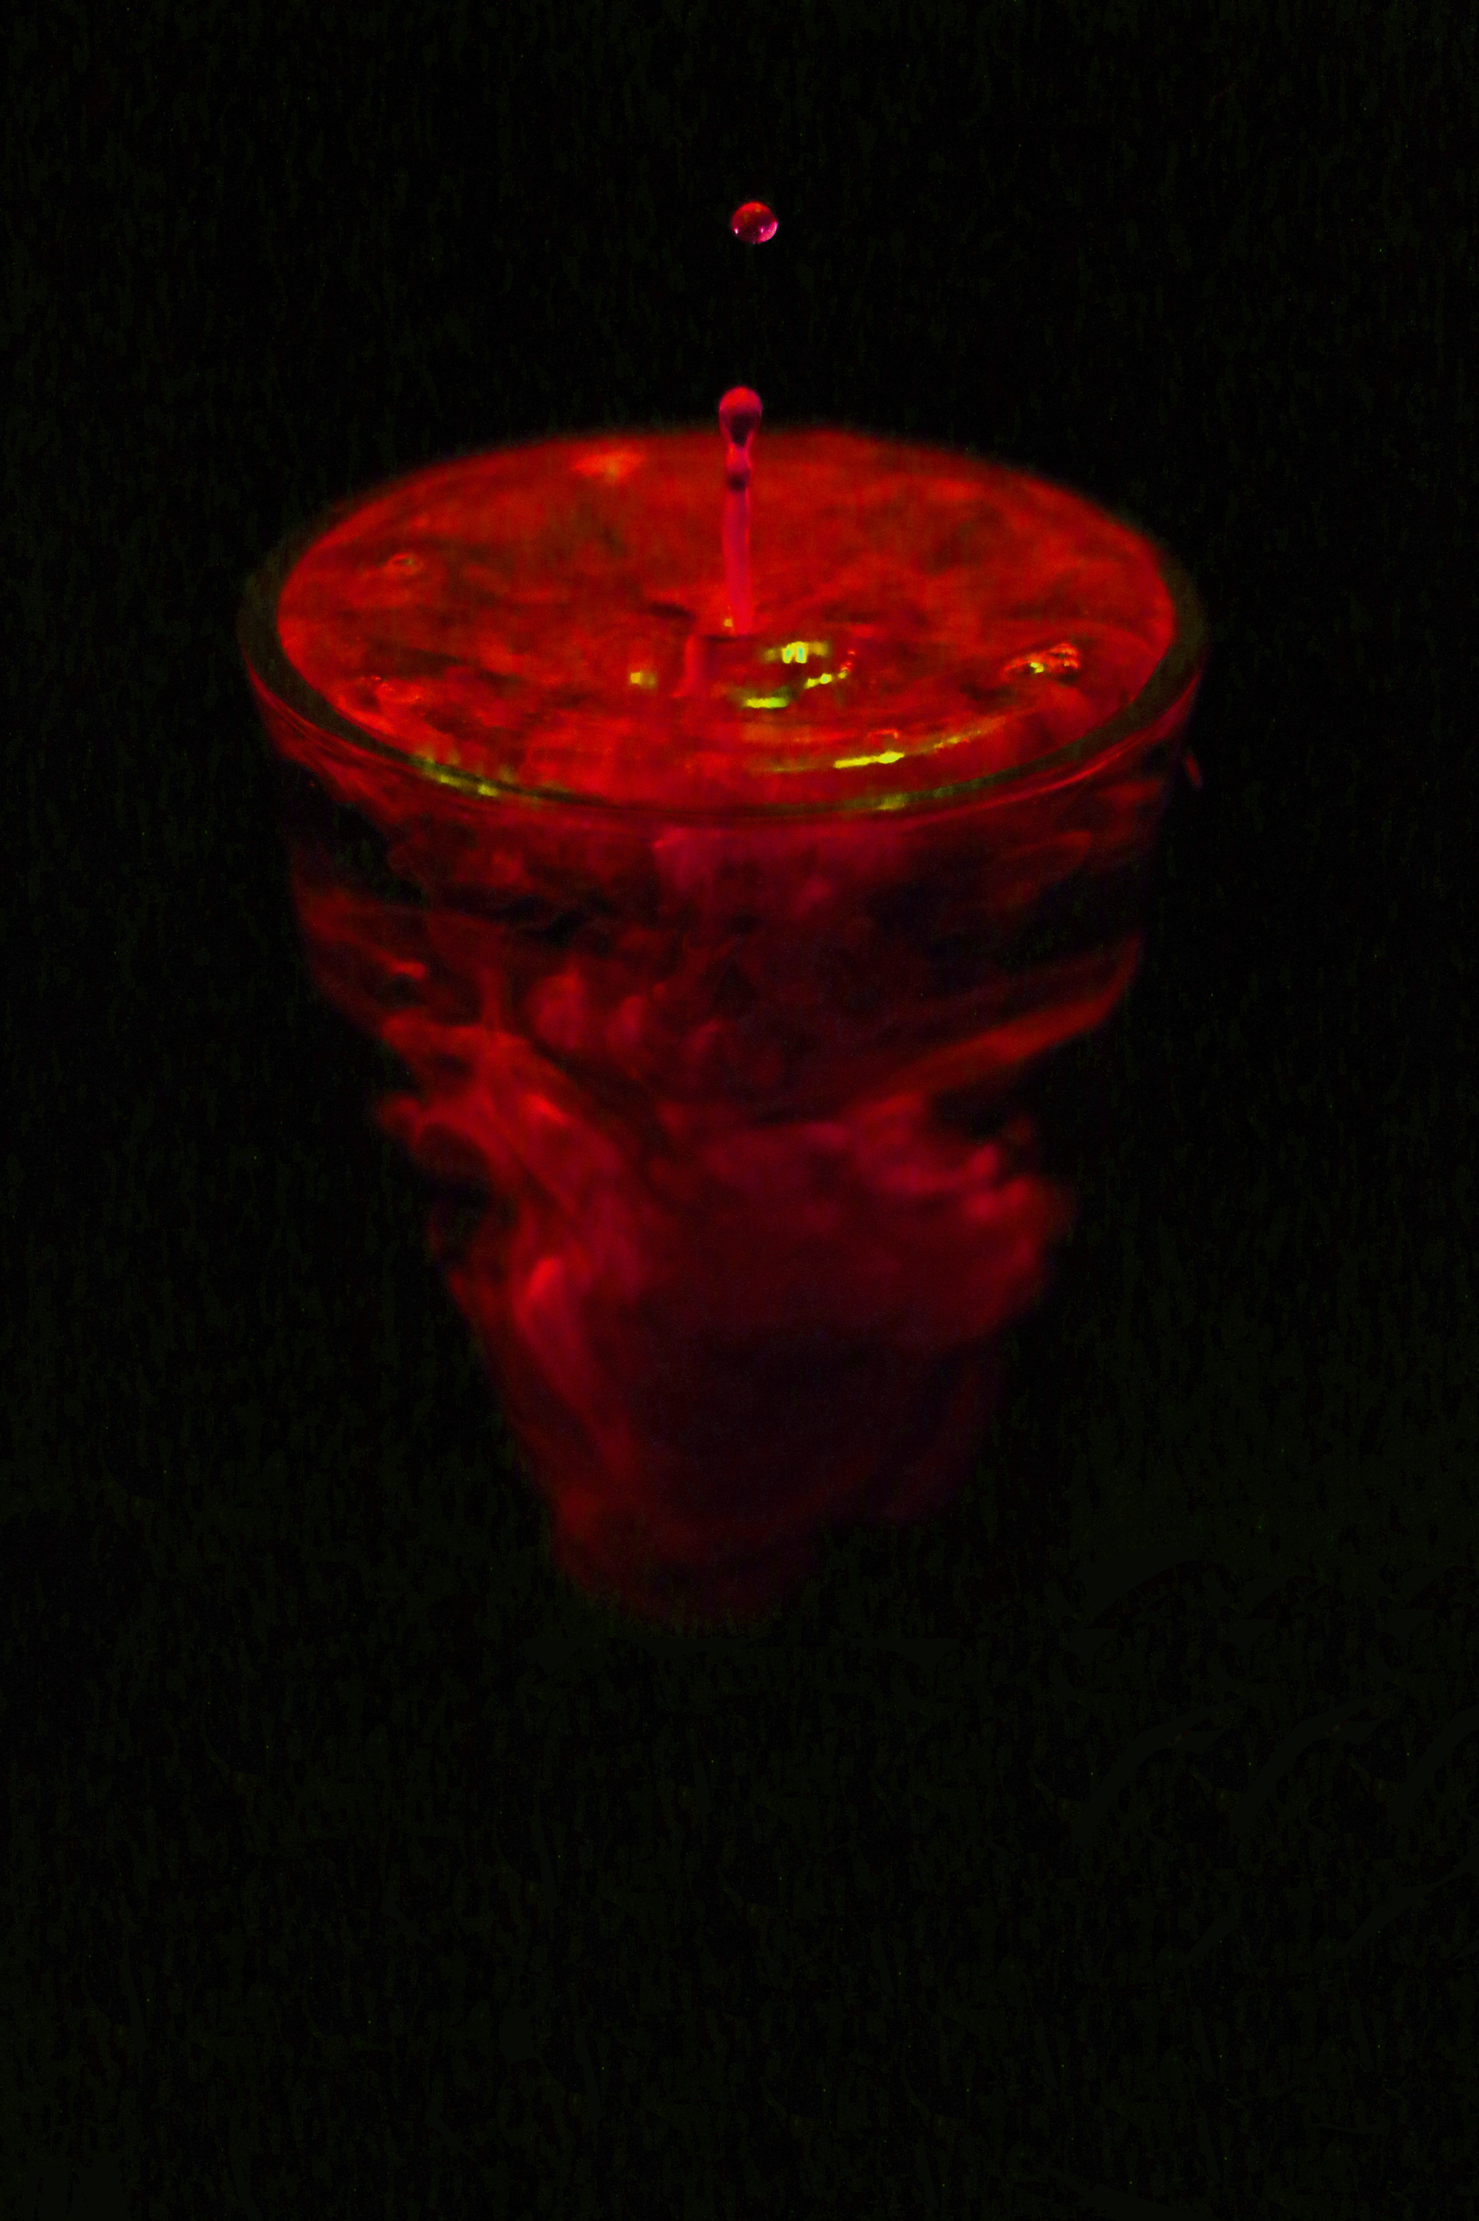
Fluorescent Worthington Jet
MCEN 4041 – TEam first photo
Jeremiah Chen
Fall 2016

Purpose

The purpose of this assignment, titled “Team Photo #1”, was to work in a team to create a display of fluid phenomenon for the MCEN 4151 Flow Visualization course held by Professor Hertzberg. The image captured should be both visually appealing and show fluid dynamics.

Introduction

Originally, the plan for this image was to utilize a large fish tank provided by Professor Hertzberg to capture von Karman vortices. The tank had an inlet and outlet hole for water to be pumped through and a pipe was to be placed in the path of the fluid flow so that the vortices could form. However, the flow apparatus was not able to provide a laminar flow so this plan was abandoned. Instead, fluorescein dye from highlighter markers from put into a glass of water inside a dark room and the resultant flow was used for images.

Procedure

The procedure is rather simple: Using the ink taken from approximately 15 highlighter markers and putting it into a syringe, the dye was dropped into a glass of water. The syringe was held at approximately 8 inches above the top of the glass. The glass was located in a bathroom with all lights completely off with a black back drop. Multiple drops of dye were dropped into the water with the camera taking multiple shots during the entire process.

Team

- Daniel Bateman
- Mark Noel
- Jason Savath
- Jeremiah Chen

Pipette

8 inch

Glass of water

Figure 1. Apparatus set up showing water glass and pipette.

Fluid Physics

The Worthington jet is a commonly seen fluid phenomenon. The jet forms during a splash impact when a moving liquid object collides with a stagnant liquid surface. When the splash occurs, the falling droplet creates a crater in the liquid. The crater quickly collapses and the energy leftover forms a jet of liquid shooting straight up.¹ This jet is called the Worthington jet. Nonetheless, the physics behind it can get quite complicated as there are many factors involved in the formation of a Worthington jet. However, the scope of this report will limit the fluid calculations to more elementary math. Given the size of the glass, and treating it as a perfect cylinder, the potential, kinetic energy and Reynolds number of the jet can be estimated.²

The kinetic energy of the droplet is calculated using the equations for linear motion and kinetic energy. Linear motion may be used because the droplet is so small that all other forces besides gravity may be neglected. The droplet is also considered a sphere with a diameter of 0.5 mm and is dropped at a height of 8 inches or 0.2032 m. In reality, droplets are not perfect spheres and will constantly be changing shape as it falls.³
$${v_{f}}^{2}={v_{0}}^{2}+2*g*d=0+2*9.8 \frac{m}{s^{2}}*0.2032 m=3.98 \frac{m^{2}}{s^{2}}$$
$$v_{f}= 2.00 \frac{m}{s}$$
$$KE= \frac{1}{2}mv^{2}= \frac{1}{2}*ρ*\frac{1}{6}*π*d^{3}*v^{2}= \frac{1}{12}*π*1000 \frac{kg}{m^{3}}*{(0.0005)}^{3} m^{3}*3.98 \frac{m^{2}}{s^{2}}=0.26 mJ$$

The equation for gravitational potential energy is: $U=mgh= ρ*V*g*h= ρ*\frac{1}{4}*π*{g*d}^{2}*h^{2}$. This equation simplifies the shape of the jet into a cylinder. The value of density can be assumed to be that of water as it almost completely makes up the mixture. Additionally, the diameter is assumed to be the same as the droplet that came from the pipette; that is, the average diameter of a droplet of water when it first begins falling.

Given the size of the glass of water and the distance of the jet from the lens, the height of the jet can be estimated to be about 3 inches or 76.2 mm.

3 inches

Figure 2. The Worthington jet is estimated to be about 3 inches in height.

$$ρ=1000 \frac{kg}{m^{3}}$$
$$h=76.2 mm=0.0762 m$$
$$d=0.5 mm=0.0005 m$$
$$U_{g}=1000 \frac{kg}{m^{3}}*\frac{1}{4}*π*{9.8 \frac{m}{s^{2}}\left(0.0005\right)}^{2} m^{2}*{\left(0.0762\right)}^{2} m^{2}= 0.011 mJ$$

Lastly, the Reynolds number is calculated using the final velocity of the droplet right before it hits the water and the kinematic viscosity of dry air:

$$Re= \frac{UD}{ν}= \frac{2.00 \frac{m}{s}*0.0005 m}{1.568 x {10}^{-5} \frac{m^{2}}{s}}=63.78$$

From the Reynolds number, it is seen that the flow of the droplet through air is laminar and this makes sense as the droplet was not falling at very high speed and the resulting splash did not have a huge impact.

When comparing the kinetic energy of the droplet and the gravitational potential energy of the jet, it is noted that the potential energy is significantly smaller than the kinetic energy. Thus, the surface of the water must absorb the majority of the energy from the falling droplet during the impact of the splash. Specifically, the energy not absorbed by the surface is about:

$$\frac{U_{g}}{KE }= \frac{0.011 mJ}{0.26 mJ}=0.0423=4.23\%$$

The surface of the water takes in about 96% of the energy from the fall. This value could very much change when other factors are changed though. If the droplet fell longer, or was bigger in size, then the surface of the water might not be able to dissipate all that energy.

Photographic Technique

For this image, the Canon Rebel equipped with a EF50 mm f/1.8 lens was used. The ISO was set to 3200 due to the black room setting that the image was shot in. Exposure time was quick at 1/256 s with an aperture at f/1.8. The focal length was 50 mm and the lens was located approximate 1 foot away from the glass of water. The field of view was approximate 6 inches by 12 inches. The original image had a resolution of 3648 x 5472 pixels for a DPI of 72. During post processing, the color of the fluorescein was changed from lime green to red. Levels were adjusted in order to make the color of the dye brighter and more vibrant. Additionally, the bottom of the glass was blackened out to match the background as the reflection from the bottom of the glass was distracting. The final image was not cropped as there was nothing in the background to distract from the main image.

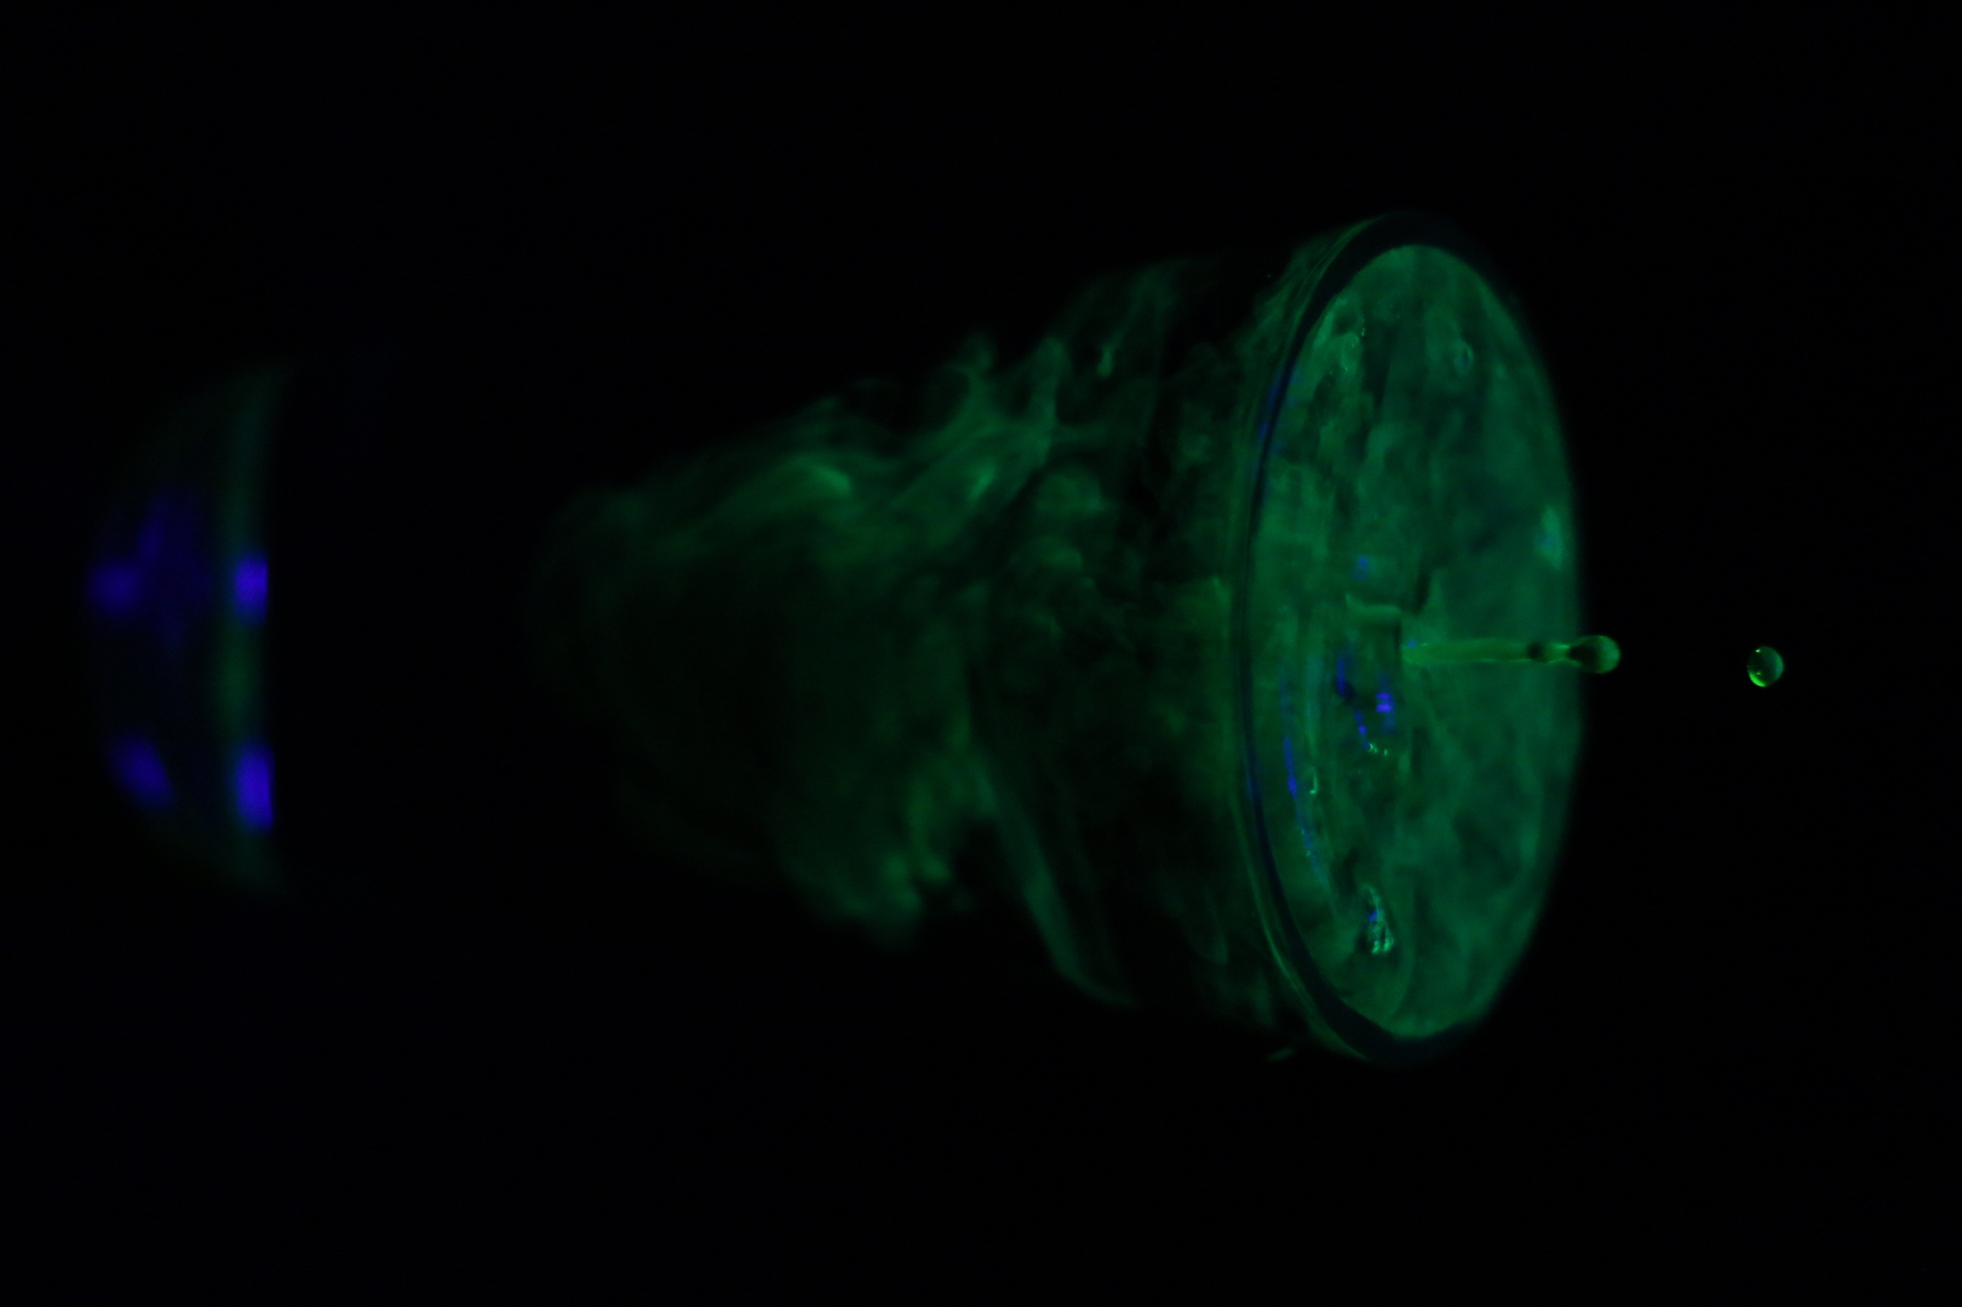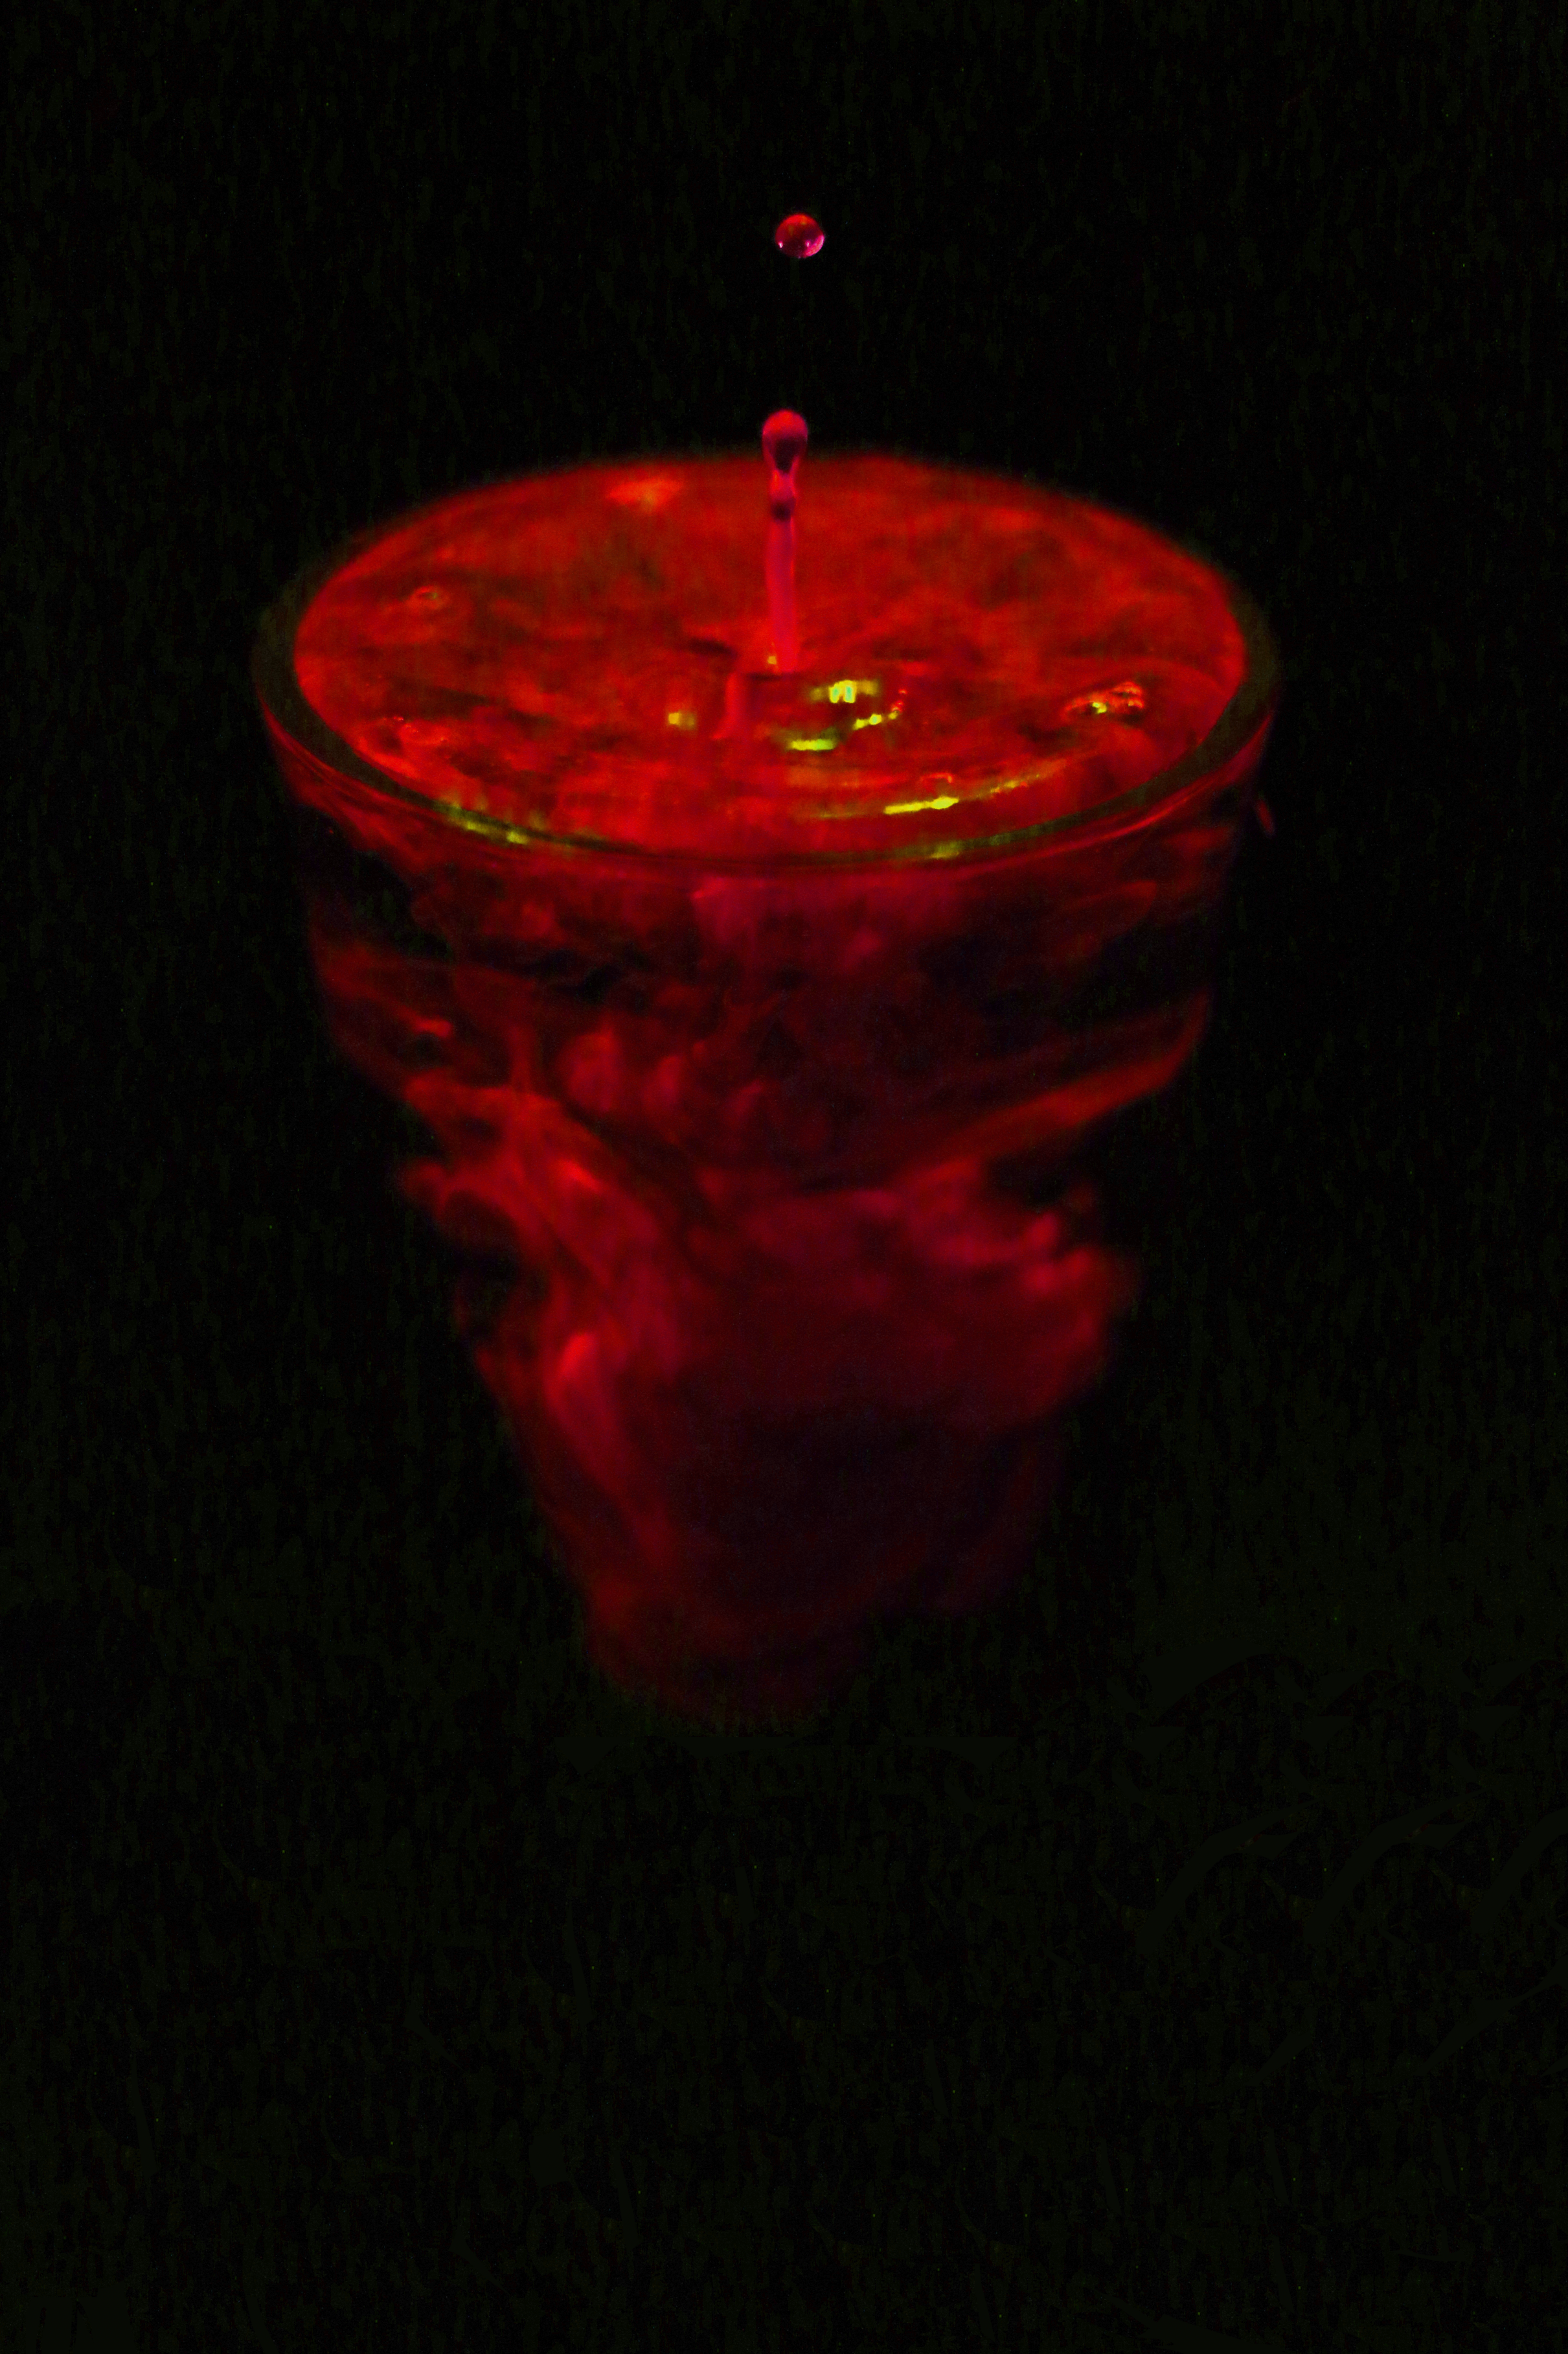
Figure 3. The original image (left) as compared to the final image (right).

Conclusion

Overall, the image was very appealing as it showcased the fluorescein dye dissipating through the glass of water as well as the splash impact of dropping the dye into the glass. The vibrance of the color of the dye draws the viewer’s interest with the splash impact makes the viewer want to know more about the physics. While the original plan of the team did not come to fruition, the secondary plan still provided sufficient results. For future experiments, it would be interesting to vary the height of the falling droplet as well as vary the size of the droplet in order to see how different factors would affect the splash impact.

Works Cited

1. Liu, Jie. “Splashing Phenomena During Liquid Droplet Impact.” Department of Mechanical Engineering, University of California – Riverside (2009): 297-298.

2. Ogawa, Akira, et al. "Morphological study of cavity and Worthington jet formations for newtonian and non-newtonian liquids." Particulate science and technology 24.2 (2006): 181-225.

3. Magono, Chiji. "On the shape of water drops falling in stagnant air." Journal of Meteorology 11.1 (1954): 77-79.

