Team Second Image
The Kaye Effect
Flow Visualization
Team 10
Maxfield Scrimgeour
With Joseph Straccia and Jeremy Parsons

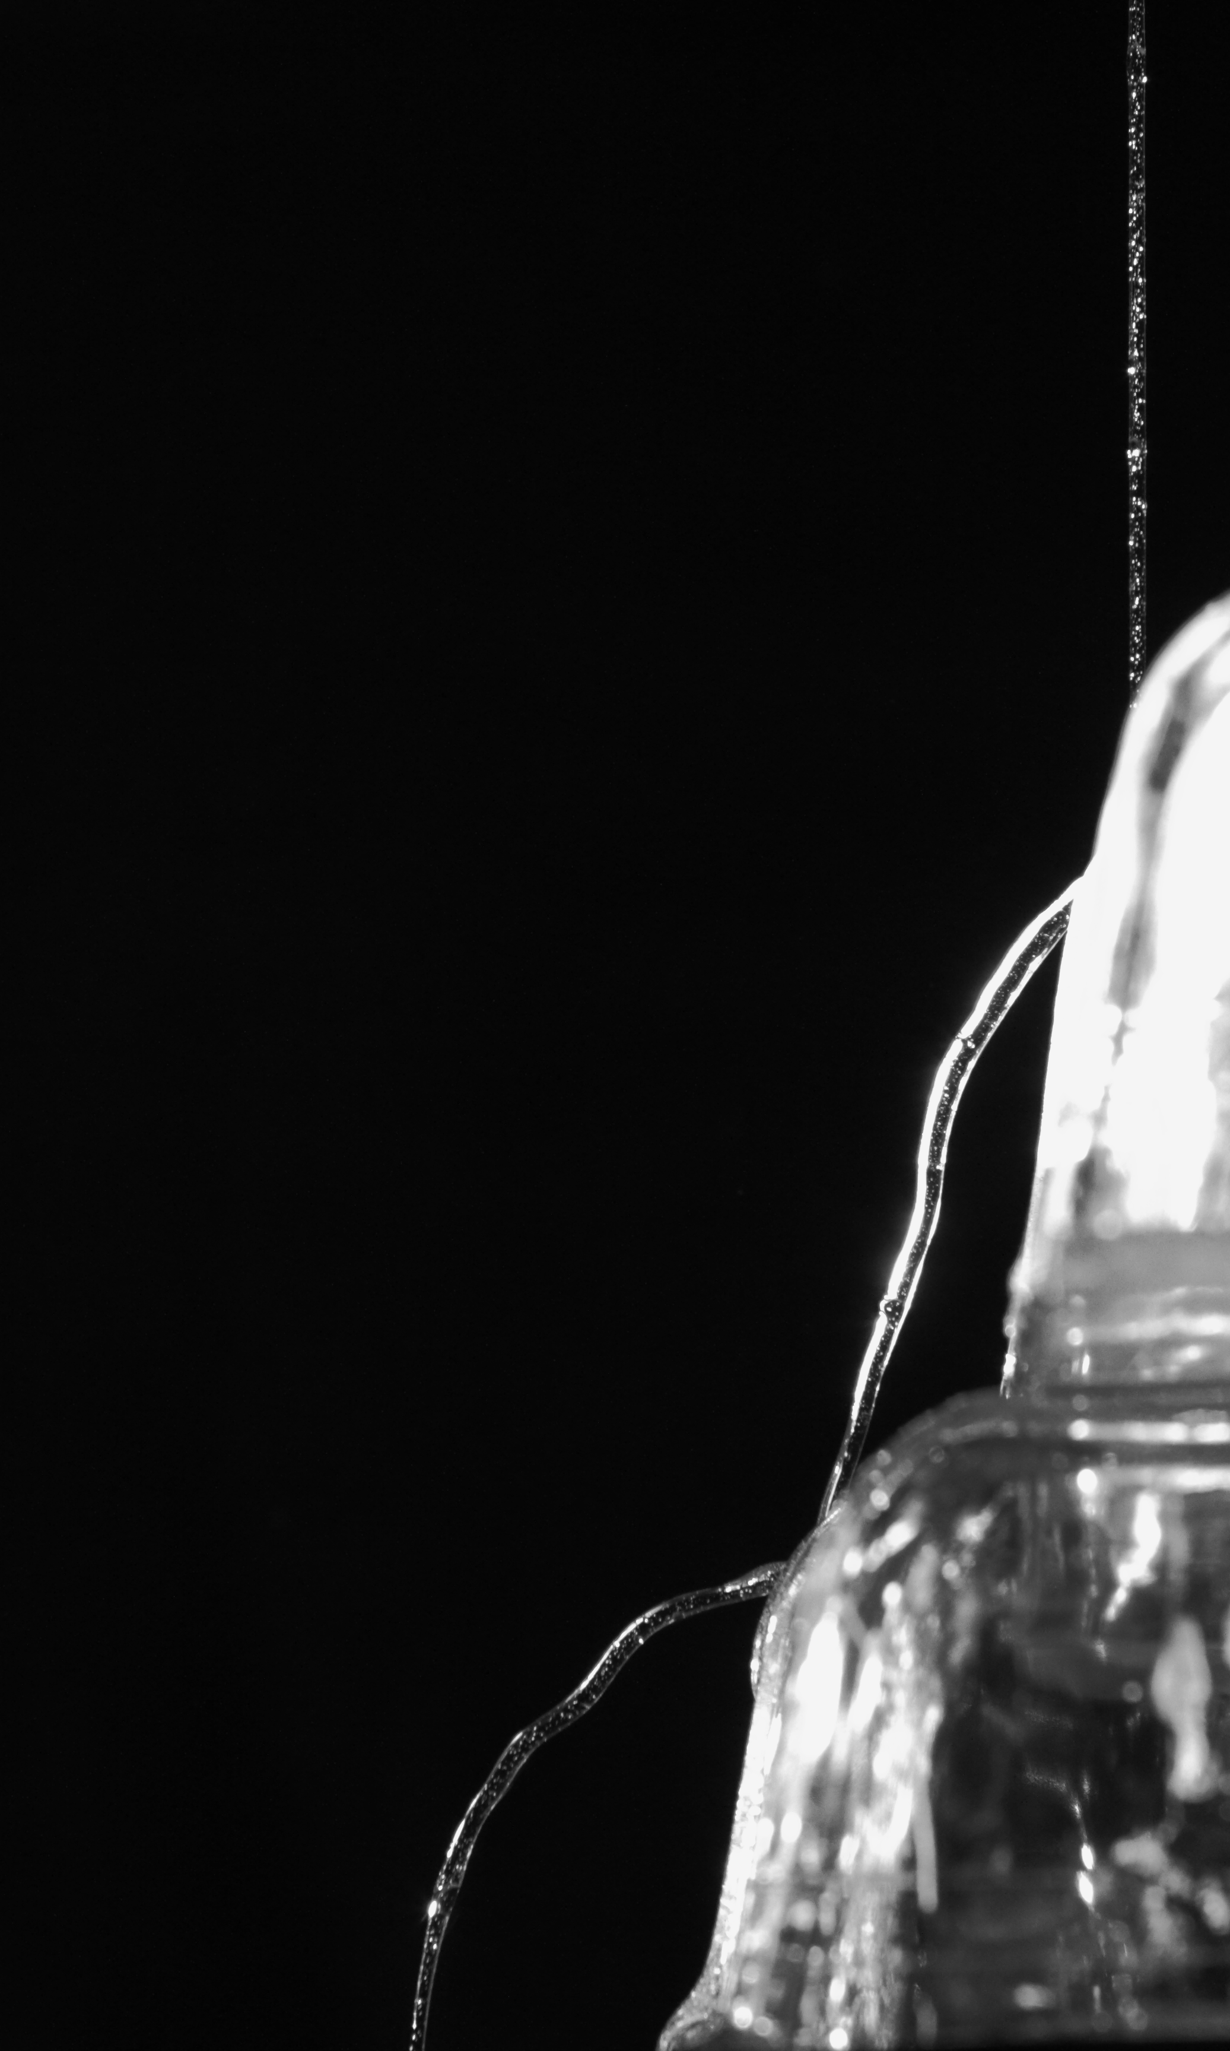

The intent of this project was to produce and capture the Kaye effect. The Kaye effect is something that can happen with everyday materials in regular circumstances. The Kaye effect can be noticed from pouring shampoo out of a bottle to emptying soap into a washing machine. There are many different examples of the Kaye effect and each seems to be individual and unique occurrences. This report will explain the situation of the Kaye effect that can be seen in the above image as well as the driving forces behind the motion of the fluid.

In order to capture the image above several sets of hands were required all at once. Before each sequence of shooting one team member would be prepping the location of the flow with the soap above. Another would be focusing the camera while the third held their hand at the depth of focus to assist with focusing the camera. The flow itself was hand soap, which was being slowly poured out of a large container above where the image was captured. In the Image Pyrex dishes can bee seen as the surface in which the flow contacts to help direct the effect. The image below gives a birds eye view of the setup, which was used to take this image. Below where the image was taken is a black fabric that was used as a background.

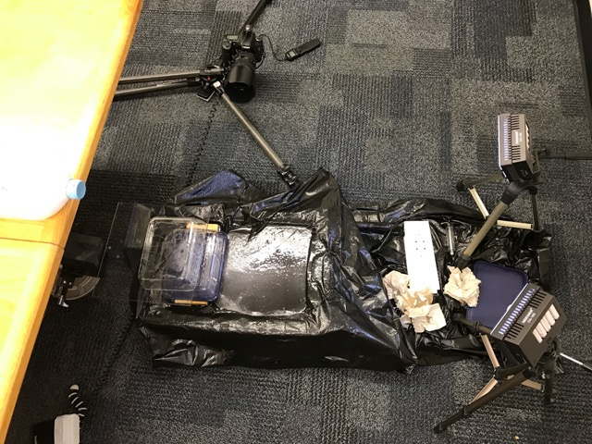

Figure 1: Set up

Figure 1 shows the black background with 2 led panel lights at the side. This also shows the flash behind the Pyrex dishes. The dishes can be seen as the white squares that the flow is bouncing off of. The purple bottle of soap is the beginning g point for the flow.

The Kaye effect can be observed in sheer thinning non-Newtonian fluids such as the liquid hand soap, which was used for this experiment. The viscous fluid will pile up upon itself as could be witnessed with the soap on the radius of the Pyrex dish. When the fluid below hits a favorable geometry the incoming fluid will create a dimple in the below fluid which directs the incoming jet back out in a new direction (J. Stat. Mech). From the image it can bee seen that the outgoing jet is much thicker than the initial jet, which translates, to a lower exit velocity compared to the initial jet. This can be seen with the continuity equation below. Due to the lack of knowledge on stream diameter it is very difficult to know what the input velocity is, however, the relationship between input velocity and output can still be considered.

$$V_{in}R_{in}^{2}=V_{out}R_{out}^{2}$$

Since the Kaye effect is a shear thinning fluid the higher the velocity that comes into the flow the more shearing there will be. The Kaye effect occurs at an ideal shear rate, which can be approximated by the following equation.

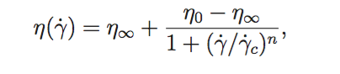

Since the above equation approximates for the ideal shear rate on a flat surface there may be some slight discrepancies due to the fact that the Kaye effect in the experiment talked about here occurred on a curved surface which could alter the ideal shear and viscosity values that are required to achieve the Kaye effect. In the above equation $η_{0}$ = zero shear rate and $η_{∞}$ = infinite shear rate (J. Stat. Mech.). The geometry of the fluid below, the orientation of the contact surface and the velocity all have an effect on the flow where each scenario needs to line up for the incoming jet to push the below fluid out of the way and create a pocket to redirect itself. A tilted surface will allow the effect to remain continuous, as the jet in this scenario will not come in contact with itself.

As was stated above in the report the flow is just simple clear hand soap, which is being poured out of a liter container. The incoming stream has a high concentration of bubbles contained within which is due to the fact that this was captured on the third round through the soap bottle. In order to refill the soap bottle syringes were used to refill them, which introduced many air bubbles into the soap reservoir. In order to light the soap two LED panel lights were used as well as a remote flash. The Panel lights were pointed from the left side of the image towards the flow while the flash was bounced off a wall behind the lights and back towards the flow to add more light to the image. The room was completely dark other than the lighting that was being used for the image.

The image picoted above has a field of view of approximately 10 inches tall by 6 inches wide. The camera in this image was about 3 feet back from where the jet was striking the dish. The camera and photo details are given below.
Camera: Cannon EOS 7D Mark 1 DSLR
Lens: Cannon 24-70mm f/2.4
ISO: 640
Focal Length: 54mm
Aperture: f/6.3
Shutter: 1/200
Original Image size: 5184 x 3456
Minimal post processing was done to the image and includes cropping and converting the image to black and white. Both the cropping and black and white post processing are purely for artistic effect and not to enhance the flow. The original image pre editing is included below.

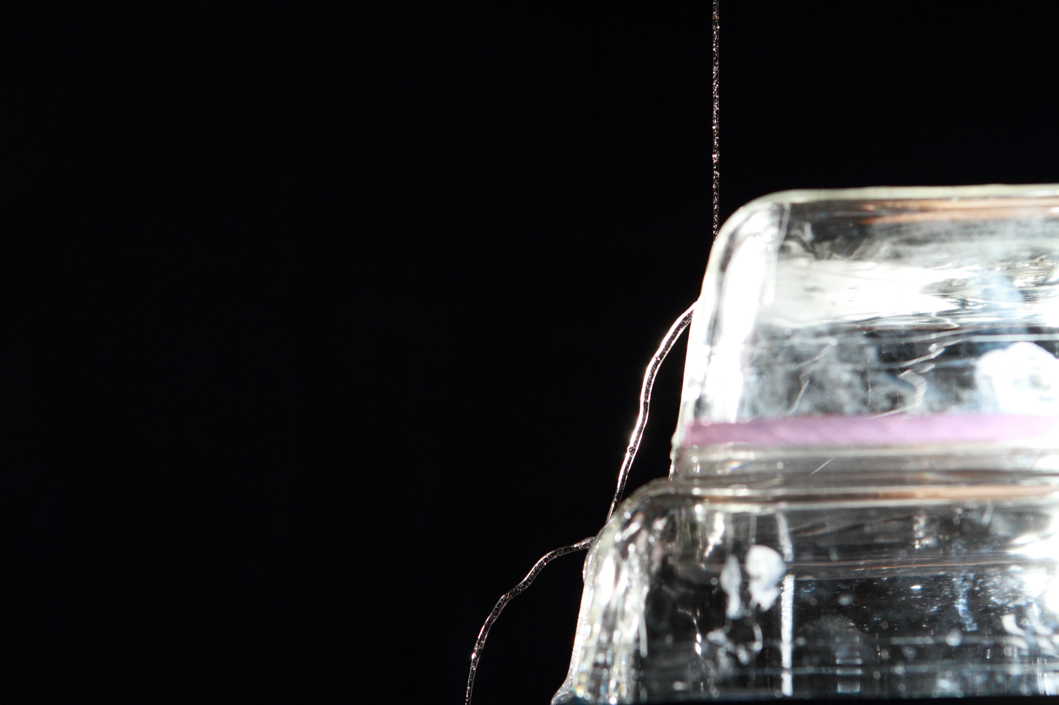

This image and experiment revealed the mysterious phenomenon behind the Kaye effect. When carrying out this experiment I was completely mystified by how the fluid seemed to lift off of the other fluid it was in contact with. I really like the crisp lines of the image and I feel that the contrast is excellent in the photo. If I could take the image again I would set the camera up slightly more left of the current position so that the impact and crater section of the effect could be more easily seen. I would like to see this done with other objects and a more stable effect for the image, which can be, don’t with a flat inclined surface. Overall I am happy the way this image turned out and thrilled that I have learned about a new phenomenon that I encounter on a frequent basis in my everyday life.

References:

"Leaping Shampoo and the Stable Kaye Effect." Journal of Statistical Mechanics: Theory and Experiment (2006): 1-12. Iopscience.iop.org. Web. 07 Nov. 2016.

