Stephen Morton
Get Wet Report
MCEN-5151
February 14, 2018

This image was taken in an effort to demonstrate the marangoni effect. The marangoni effect is the movement of fluid along the interface with another fluid due to the difference in surface tension. In this image, a thin layer of milk, about half a centimeter, was poured onto a plate. Three drops each of green, yellow, and red food coloring were dropped into the center of the milk. The last step is to swab a Q-tip in dish soap, and touch it to the milk where the food coloring was dropped in. All the ingredients for this experiment were found at Kings Soopers. The milk was 1% fat, the food coloring was Kroger brand. The dish soap was Dawn Ultra Original Scent Dishwashing Liquid. This is a fairly common experiment, and blue food coloring is often used as well. Originally, I attempted to use all four colors, but the blue was so much darker than the other colors, and it seemed to take over the image too much, so for the final image, only green, yellow, and red were used.

Surface tension is the tendency of a fluid to shape itself to have the smallest surface area possible. A liquid with high surface tension pulls on a neighboring liquid more strongly than a liquid with low surface tension. A gradient in surface tension causes liquid to flow from low to high. A surfactant is a compound that lowers the surface tension of a fluid that they are added to [1]. The addition of a surfactant causes a gradient in the surface tension, which causes the fluid to flow. Two of the most common surfactants are soap and oil. Surfactants are characterized by their hydrophilic (attracted to water) head and hydrophobic (repelled by water) tails. This polarity of the soap molecule causes the fat and water in the milk to separate, and decreases the surface tension. As the soap dissipates through the milk, the different in surface tension occurs at the radius which the soap has reached. As the soap spreads out further from the Q-tip, the milk, and therefore the food coloring, flows outward with it [2]. Figure 2 shows this at one instant in time, and the unedited image taken is shown in figure 3.

As stated earlier, only red, green, and yellow food coloring was used in order to get rid of the dominance of the much darker blue in the image. The exact materials used can be seen in table 1 below. Three drops each of the food coloring were used, and the Q-tip was covered in dish soap before it was dipped in the milk. The lighting used in this setup was all natural. While done inside, it was performed right next to a large window, around noon on a very bright day. A camera flash would have reflected off of the milk, and distracted from the rest of the uncropped image.

Ingredient/Material | Brand
Q-tip | Kroger Cotton Swabs
Dish Soap | Dawn Ultra Original Scent Dishwashing Liquid
Food Coloring | Kroger Assorted Food Coloring Kit
Milk | Colorado Proud, 1% Low Fat
Table 1: Ingredients/Materials Used

The original, unedited photograph shows almost the full plate of milk. This was done with the intent of cropping down to a more interesting section afterwards, as shown in figure 4. This flow, and therefore the coloring is almost never uniform, so a more interesting final image could be created from cropping down during the editing phase. Other than cropping, there were no manipulations to the image, as I wanted all the natural colors. The plate used was approximately 6 inches across. The photo was taken from a height of about 6 inches. The digital camera used was a Nikon CoolPix 4600.

The final image does a pretty good job showing the marangoni effect of this experiment. The cropped photo is a little bit blurry however. I think another way to improve this would be to use a slow-motion camera to capture the movement of the fluid, instead of the aftermath of the movement.

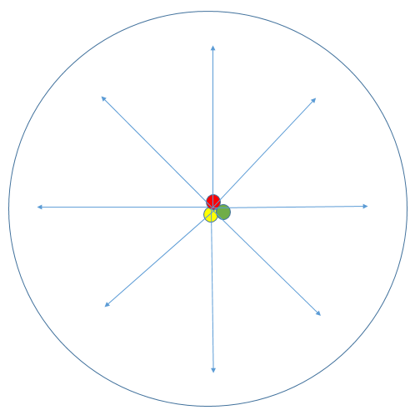
Figure 1: Flow of Food Coloring in Plate of Milk

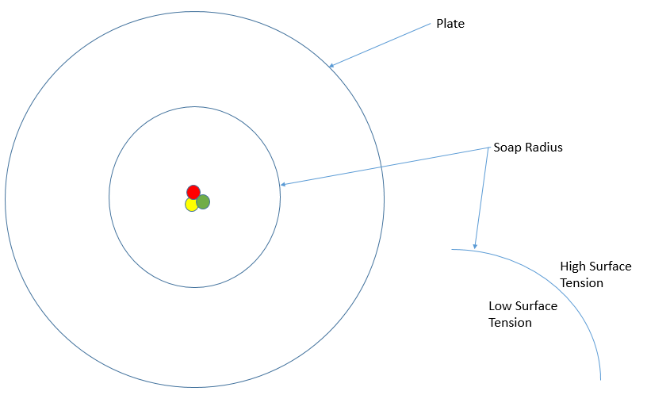
Figure 2: Surface Tension Gradient in Milk

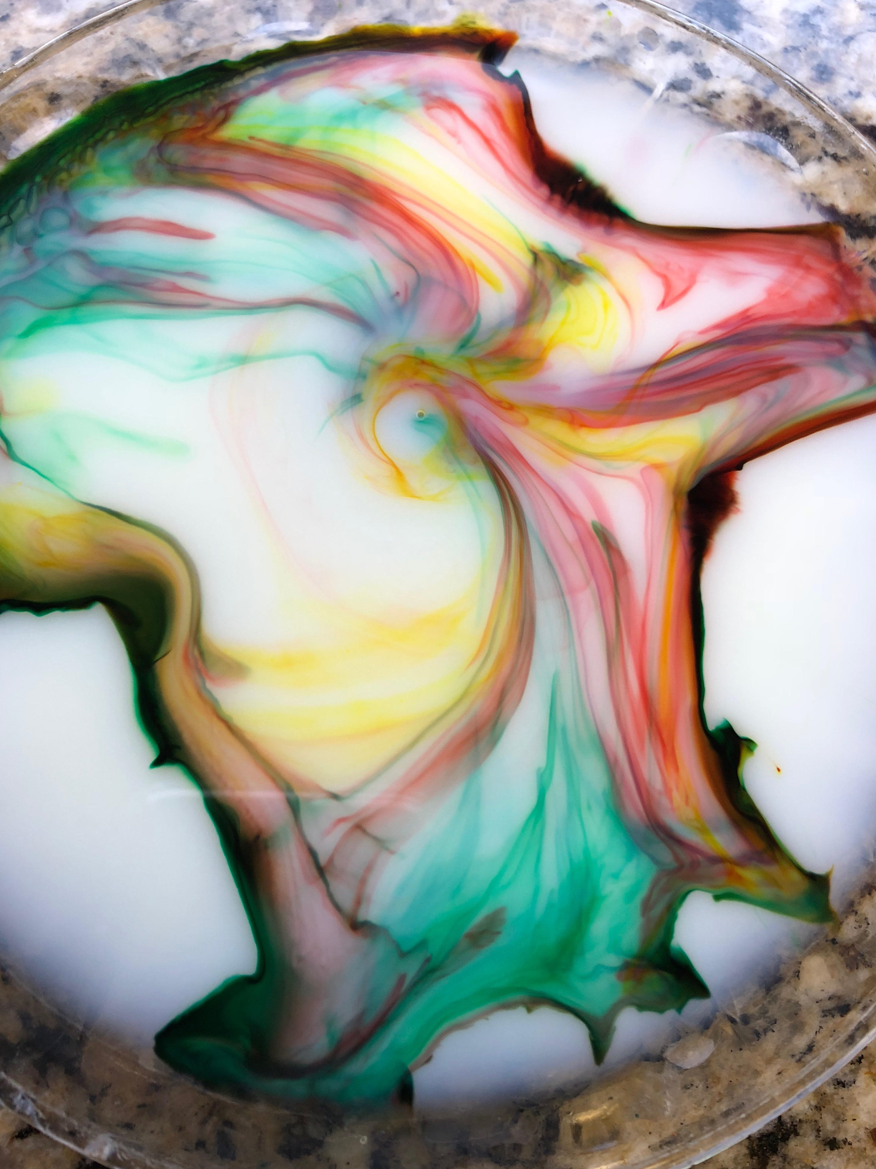
Figure 3: Unedited Photograph
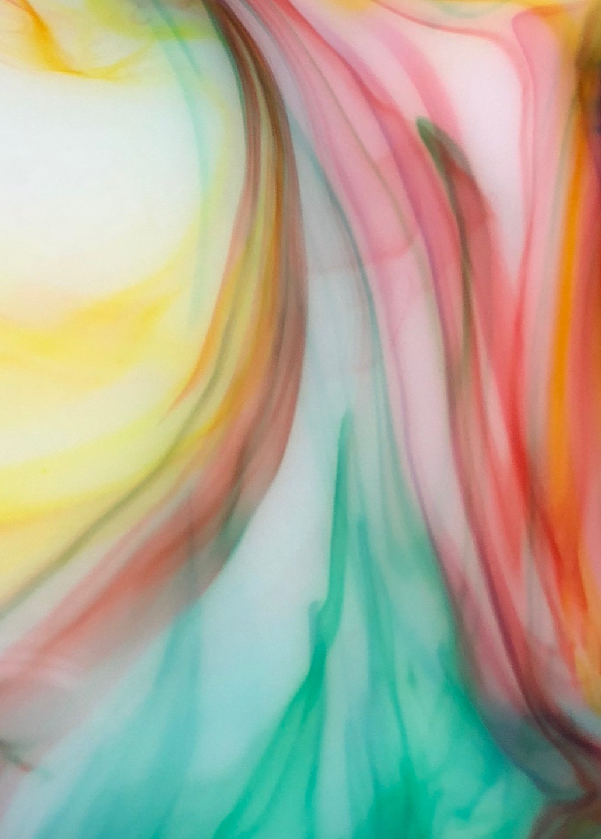
Figure 4: Cropped, Final Image
[1] “Lecture 4: Marangoni Flows.” MIT, pp. 1–5. http://web.mit.edu/2.21/www/Lec-notes/Surfacetension/Lecture4.pdf

[2] Buddies, Science. “Surfactant Science: Make a Milk Rainbow.” Scientific American, 13 Mar. 2014, www.scientificamerican.com/article/surfactant-science-make-a-milk-rainbow/.

