Professor Jean Hertzberg

Clouds - First
MCEN 4151 – Fall 2016
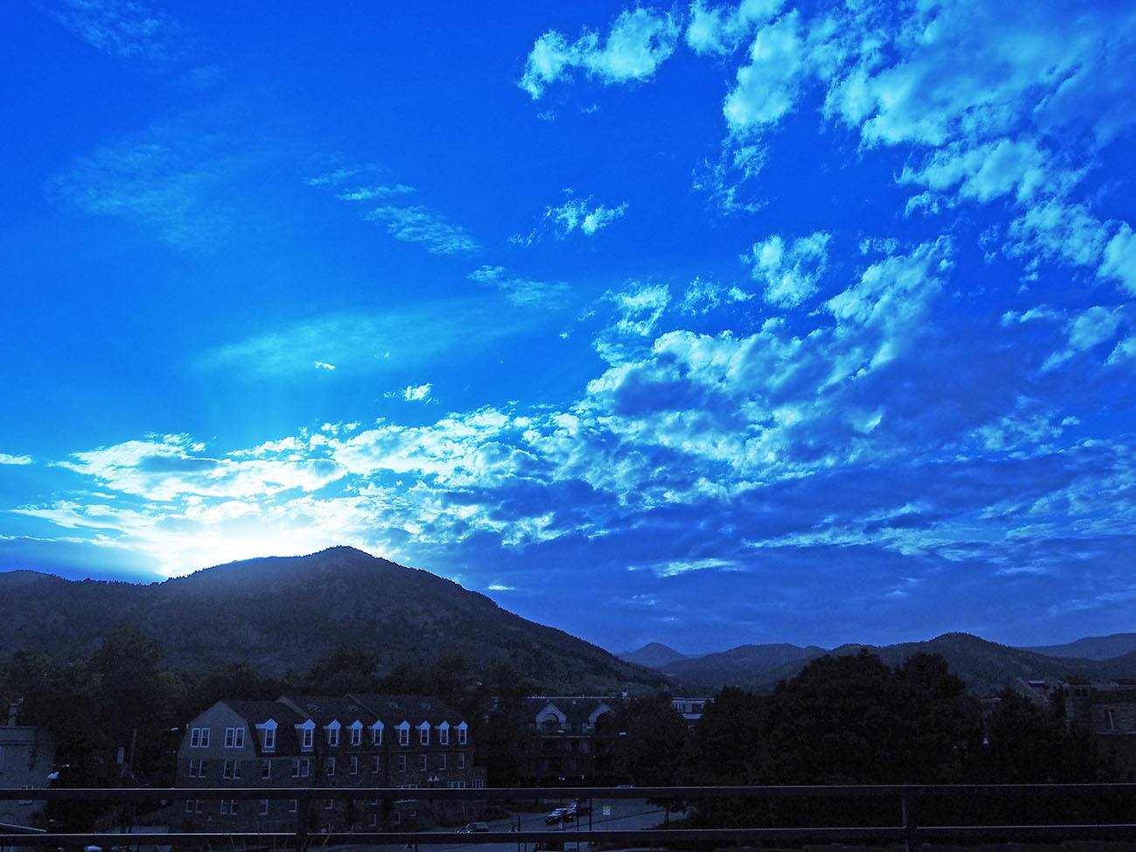
Jeremiah Chen

Introduction
When discussing fluid flow, one often thinks about water moving through a pipe or things distilling inside a liquid. However, fluid flow can refer to both liquids and gases. Clouds are constantly subject to fluid dynamics as the atmosphere around the earth is constantly moving. An analysis of cloud structures and their movement provides good insight into how the atmosphere is at a specific time and location.

Purpose

The purpose of this image was to capture the flow phenomenon of clouds so that their characteristics could be analyzed. A day where cloud cover was significant was chosen in order to see differences in cloud structures at different altitudes and locations. It was taken for Professor Hertzberg’s MCEN 4151 Flow Visualization - Mechanical Engineering course at CU Boulder.

Image Conditions

The image was taken on the 5th floor of the University Memorial Center on the CU Boulder campus while facing West Northwest at approximately 6:02 pm on September 29, 2016. The weather conditions were fair at this time with a high of 68 and low of 64. The humidity was at 34% with a barometric pressure of 30.26 in Hg ( = 771.4 mm Hg) with a wind speed of 5.593 mph going NNW [1]. The image was taken about 5 degrees upwards with respect to the horizon.

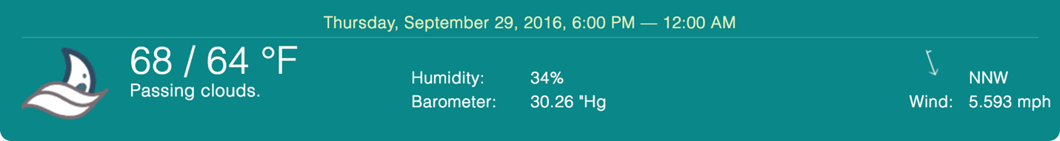
Figure 1. Weather information for the date and time the image was taken. [1]

Cloud Analysis
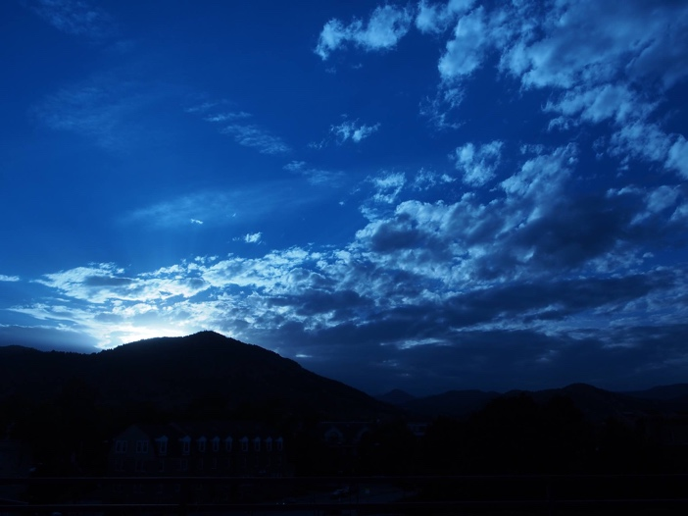
Figure 2. Final, edited cloud image (left) and original image (right)

The image was taken while a cold front was moving in. The sky immediately above the camera was relatively clear, but the sky seen in the background of the image is significantly covered by clouds. Due to this, there are a variety of cloud structures are present in the image. When looking at a graph of the barometric pressure throughout the day, there is a clear trend in the pressure dropping [2]. When air pressure drops, the weather usually becomes cloudy and rainy. Indeed, the image does show clouds moving into the city of Boulder and not too long after, a small drizzle had begun. The wind is coming from north-northwest bearing south-southeast, which is also revealed within the image.

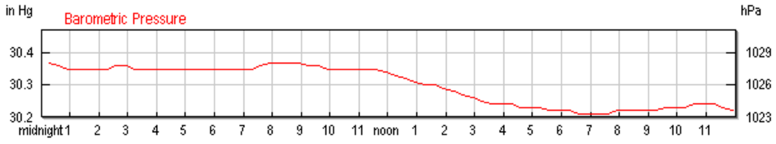
Figure 3. Barometric pressure throughout the day on September 29, 2016. [2]

When examining both skew-T graphs for both 6 am and 6 pm of September 29, the clear difference is in the CAPE values. At 6 in the morning, CAPE is at 0.00, indicating a very stable atmosphere [4]. However, the skew-T at 6 in the afternoon shows CAPE being 27.96 [3]. The image was taken approximately at the same time as the 2nd skew-T diagram; therefore, the skew-T of September 30, 2016 00Z is a pretty accurate representation of the weather at that time.

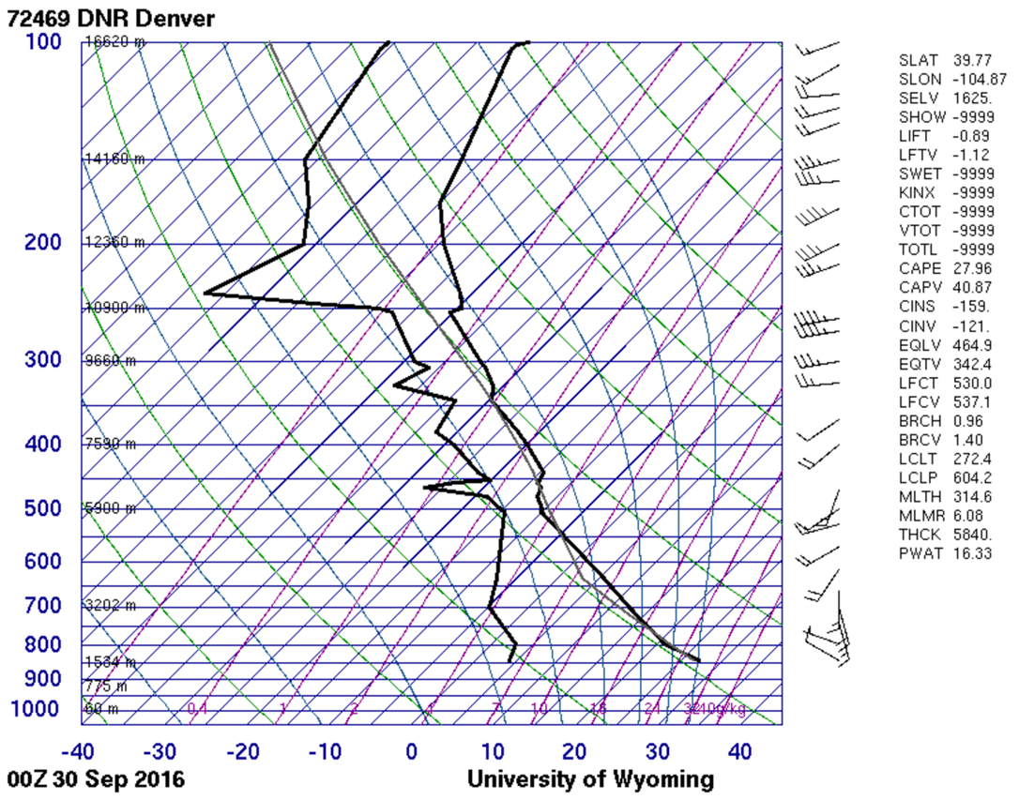
Figure 4. Skew-T diagram of the time the image was taken. [3]

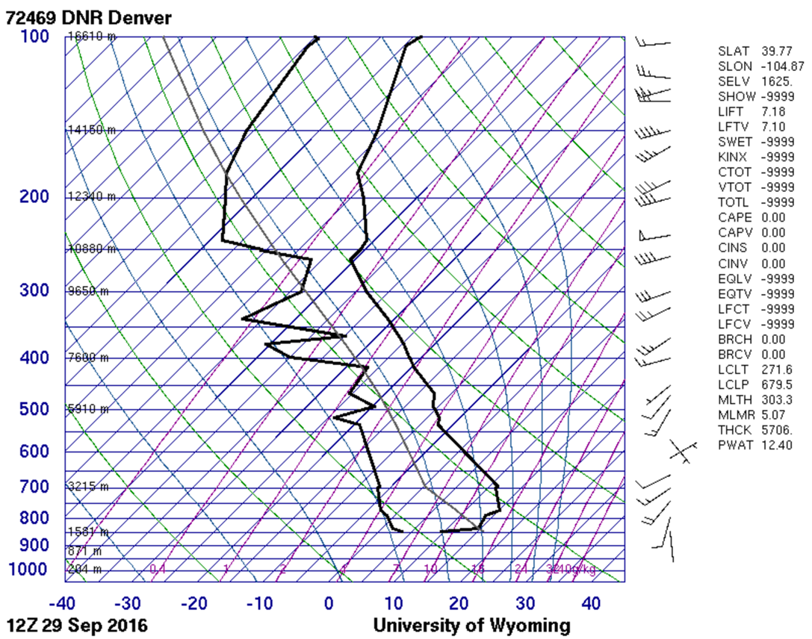
Figure 5. Skew-T diagram of the weather at 6 am earlier in the day. [3]

Given that the atmosphere had become unstable at the time, altocumulus clouds and altostratus would be expected. Altostratus clouds usually cover the whole sky and they are usually followed by a storm according to UCAR Center for Science Education [4]. Also present are altocumulus clouds which are mid-level and about 1 km thick. Both altostratus and altocumulus clouds occur from 6,000 - 20,000 feet. The majority of the altocumulus clouds seem to be moving away towards the east.

When comparing the skew-T diagram and the characteristics of the cloud structures, their cloud height can be predicted. Clouds will usually form when the dew point line is closest to the environmental sounding line. The point where the two are closest is at about 5900 m or 20,000 feet [3]. This is consistent with what is seen in the image as most of the clouds are altocumulus and altostratus clouds.

The incoming front can be said to be the main cause of the clouds seen in the image as their existence points to an impending storm.

Photographic Techniques

The camera used for this image was an Olympus OM-D E-M5 mirrorless camera with a 12-50 mm lens. To reduce the noise in the image as much as possible, ISO was set to 200 with a shutter speed of 1/1250 s. Aperture was set to an f-stop of f/9.0 and the focal length was 15 mm. The high f-stop number was so that depth of field could be as large as possible so that much of the background is in focus. Given the size of most mountains, the field of view is estimated to be about 5 miles across with the distance from the lens to the nearest clouds about 2 miles.

During post-processing, edits were made to the image to make all the subjects more visible. Contrast was decreased in order to bring out the blue in the sky. Shadows were also deleted in order to brighten the image. Saturation was increased in order to bring out the vibrant colors in the sky. The original and edited image had the same resolution at 4608 x 3456 pixels.

Conclusion

Overall, the image was unique in that it was captured at a time where the atmosphere was changing. Earlier in the day, the weather was more stable and later, a storm began rolling in. This allowed viewers to see a variety of cloud structures. If this image were to be recreated, post-processing would be changed. Less contrast would be used and saturation would be decreased as well. This would decrease the blue in the image to make it seem more realistic. Additionally, the foreground would be cropped more so that distractions from the cloud structures could be minimalized. Additionally, a time lapse of the storm moving in would yield some great results as well.

Appendix
[1] Time and Date, “Past Weather in Boulder, CO,” October 12, 2016. [Online]. Available: http://www.timeanddate.com/weather/usa/boulder/historic [Accessed 13 October 2016].

[2] Weather History for Boulder, CO, “Daily Weather History Graph,” September 29, 2016. [Online]. Available: https://www.wunderground.com/history/airport/KBDU/2016/9/29/DailyHistory.html?req_city=Boulder&req_state=CO&req_statename=Colorado&reqdb.zip=80301&reqdb.magic=1&reqdb.wmo=99999&MR=1 [Accessed 13 October 2016].

[3] University of Wyoming, "Department of Atmospheric Science," 29 September 2016. [Online]. Available: http://weather.uwyo.edu/upperair/sounding.html. [Accessed 13 October 2016].

[4] UCAR Center for Science Eduation, “Cloud Types,” 2012. [Online]. Available: http://scied.ucar.edu/webweather/clouds/cloud-types [Accessed 13 October 2016].

