Jeremiah Chen – MCEN 4151 | Flow Visualization
Professor Jean Hertzberg | November 9, 2016
Team 2nd PHOTO: Champagne popping in slow motion
MCEN 4151 – FLOW VISUALIZATION

Purpose

The purpose of this assignment, titled “Team Photo #2”, was to work in a team to create a display of fluid phenomenon for the MCEN 4151 Flow Visualization course held by Professor Hertzberg. The image captured should be both visually appealing and show fluid dynamics.

Introduction

The concept for this image was chosen due to the availability of a high speed camera, the Vision Research Phantom 2512, brought in by Professor Truscott, a visiting professor from the University of Utah. The camera allows for a high framerate video to be recorded and the team felt this would be a good way to view the physics behind the popping of a champagne bottle. Champagne popping is a common occurrence at holiday gatherings, parties, and other events of celebration; therefore, it would be beneficial to understand what goes on behind the scenes.

Procedure

There is no real apparatus for this photo as the only requirement was only to have a champagne bottle. Four different bottles of Krug Brut champagne were used in different lighting and focus settings to give different views of the champagne. A towel was placed on the opposite side of the champagne bottle trajectory to prevent the cork from flying away. Both backlighting and front lighting were used for a variety of different videos. Wide and close shots allowed for different views of the physics behind the popping of the champagne bottle.

Team
- Jeremiah Chen
- Daniel Bateman
- Jason Savath
- Mark Noel

Fluid Physics

Champagne bottles are constantly under pressure due to the carbon dioxide contained inside them. “The carbon dioxide creates internal pressure that pushes on the cork” [1]. Normally, all the forces from the actual champagne are balanced by the bottle, the cork (and possibly the cork net, if present). Even when the bottle is shaken, the bottle and cork are still able to keep the forces in equilibrium. One common perception is that shaking the bottle causes the internal pressure to increase and therefore, the cork will be forced out of the bottle and the champagne will pop. However, a study showed that the main result of “shaking is that the pressure inside the bottle does not change ‘much’” [2]. That is, there is not a significant change in the internal pressure to force the cork off. Rather, when popping champagne, the cork must be slightly moved. This movement illustrates the friction between the cork and the bottle to move from static friction to kinetic friction. Kinetic friction is smaller in value than static friction which causes the force balance of the champagne bottle to fall out of equilibrium. Once this occurs, the cork will be accelerated out of the bottle along with the champagne.
Figure 1. Forces in equilibrium on the champagne bottle with internal forces shown in blue and the forces from the bottle and cork shown in red.
v

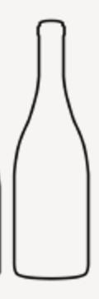

Additionally, the exit speed of the cork can be calculated based on the frame rate of the video as well as the size of the cork. Given the length of the cork was about 2 inches and the video being used for reference was recorded at 25000 frames per second, the speed of the cork can be calculated based on how long it takes it to travel the length of the cork from rest.

$$Time= \frac{Number of Frames}{Frame Rate}= \frac{154 Frames}{25000\frac{Frames}{Second}}=0.0062 seconds$$
$$Speed=\frac{Distance}{Time}= \frac{2 inches}{0.0088 seconds}=322.58 \frac{in}{s}=8.19 \frac{m}{s}=18.32 mph$$

Based on what is seen in the video, the cork was forced out of the champagne bottle at about 13 mph. If the velocity and time duration are known, then the average acceleration can be found.

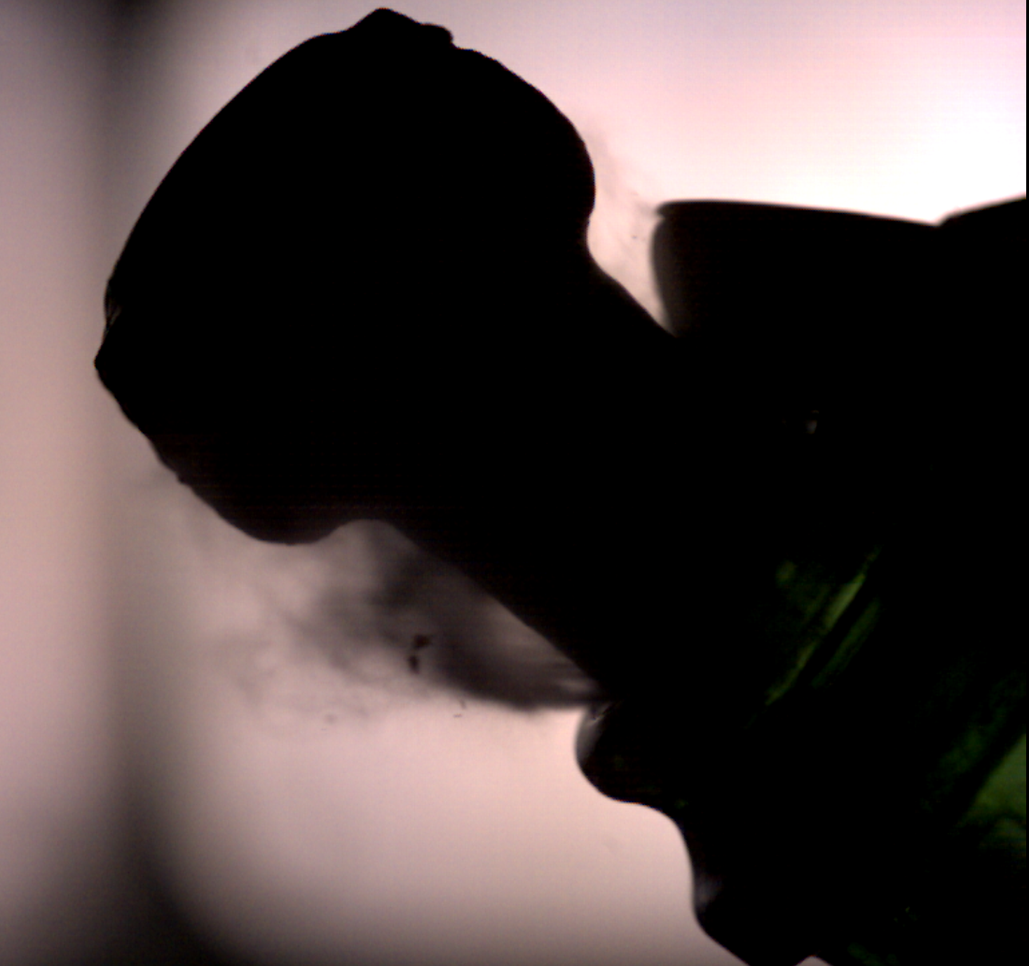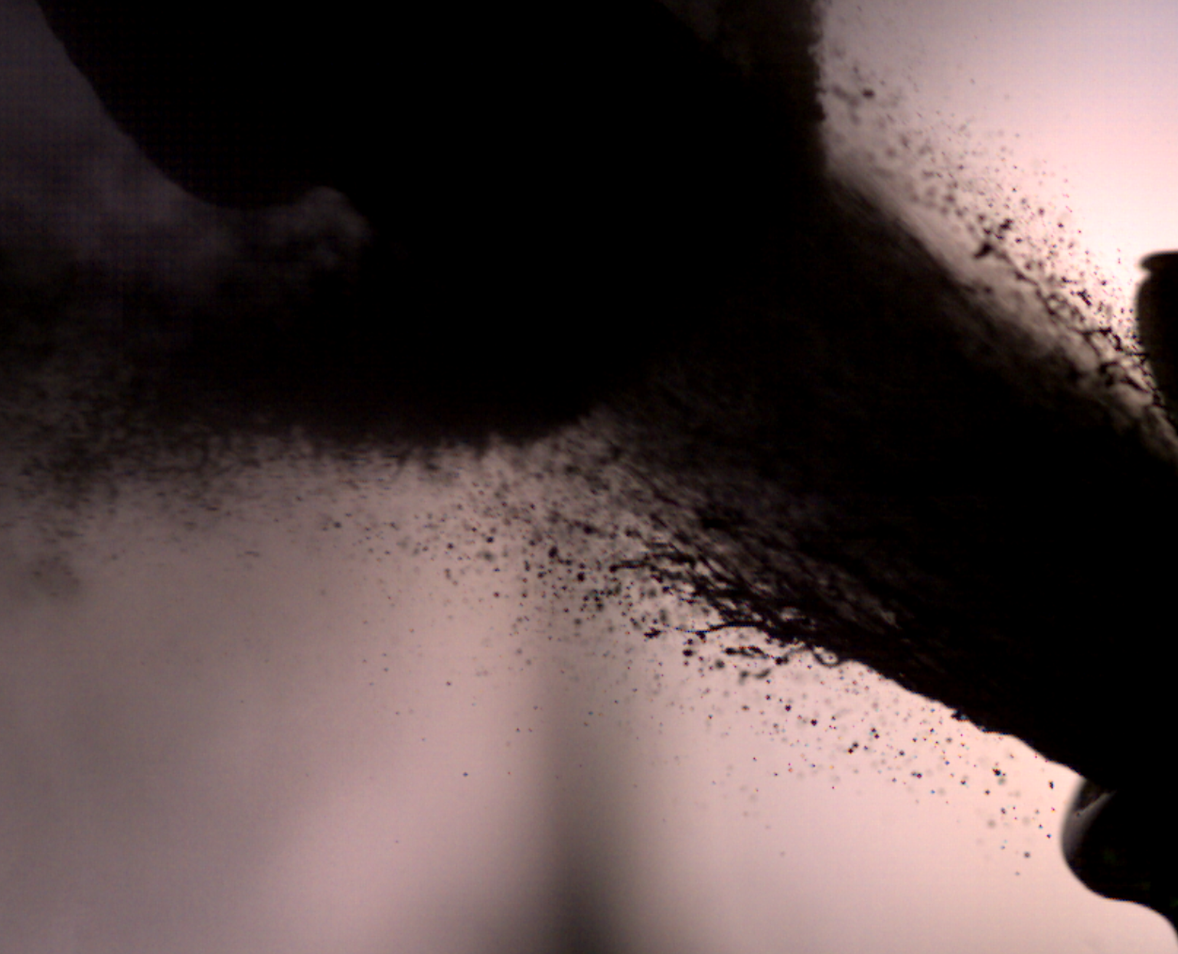
Figure 2. The two points of reference used to find the speed of the cork. The distance between the two arrows is approximately 2 inches.

This acceleration can be used to find how much force the champagne generated using Newton’s 2nd law. The mass of the cork is about 9.1 g.
$$Acceleration= \frac{Velocity Change}{Time Duration}= \frac{8.19\frac{m}{s}-0}{0.0062 s}=1321 \frac{m}{s^{2}}$$

$$Force=ma=9.1 x {10}^{-3} kg x 1321 \frac{m}{s^{2}}=12.03 N=2.7 lbf$$

From these calculations, the cork was ejected from the bottle at almost 20 mph with a force of about 12 N or 2.7 lb.

Photographic Technique

The photographic technique for this project was to use different types of lighting and different fields of view. For the first two videos, the camera was placed farther away from the champagne popping. A black background with front lighting was utilized in the first video while the second changed to a white background. A 50 mm lens was used for both these videos with recording set at 8000 frames per second.

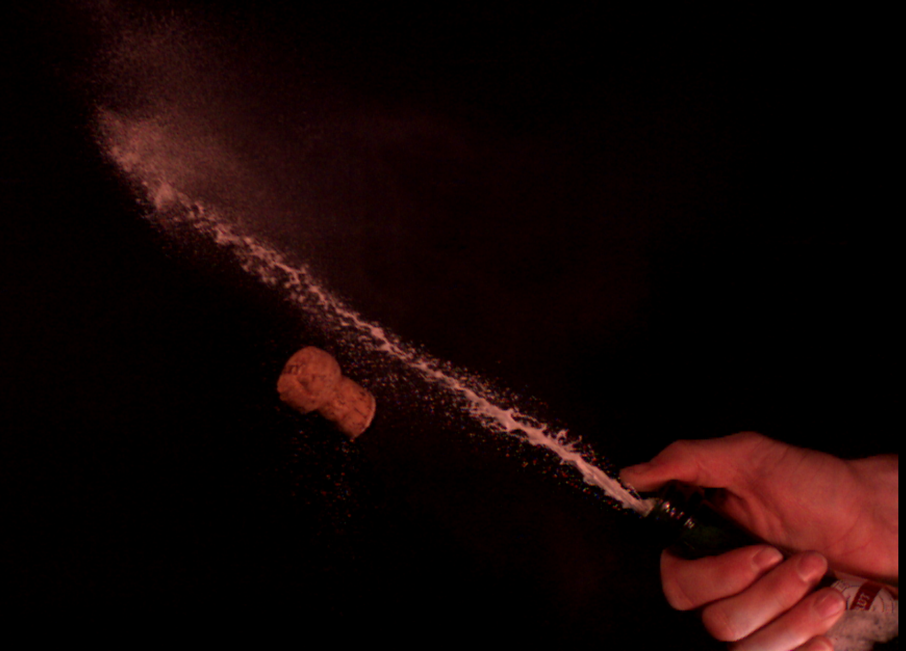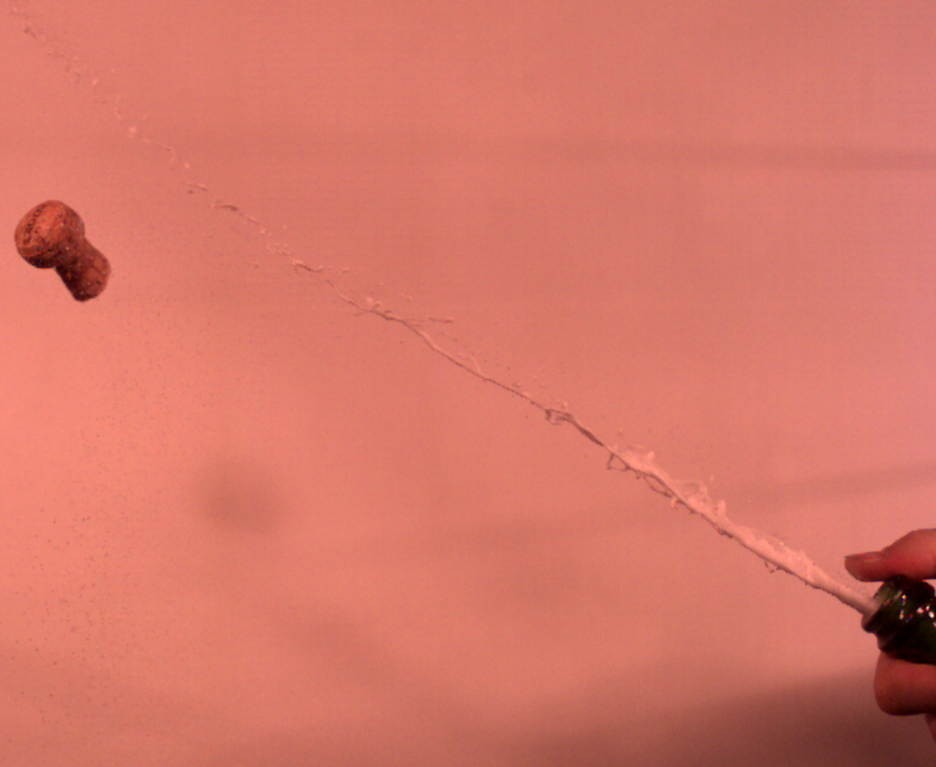
Figure 3. Lighting comparison of the first and second champagne popping videos.

For the third video, the lens was switched to a 105 mm macro one and a diffused back lighting was used against a white background. This allowed for a very in depth look at the flow physics.

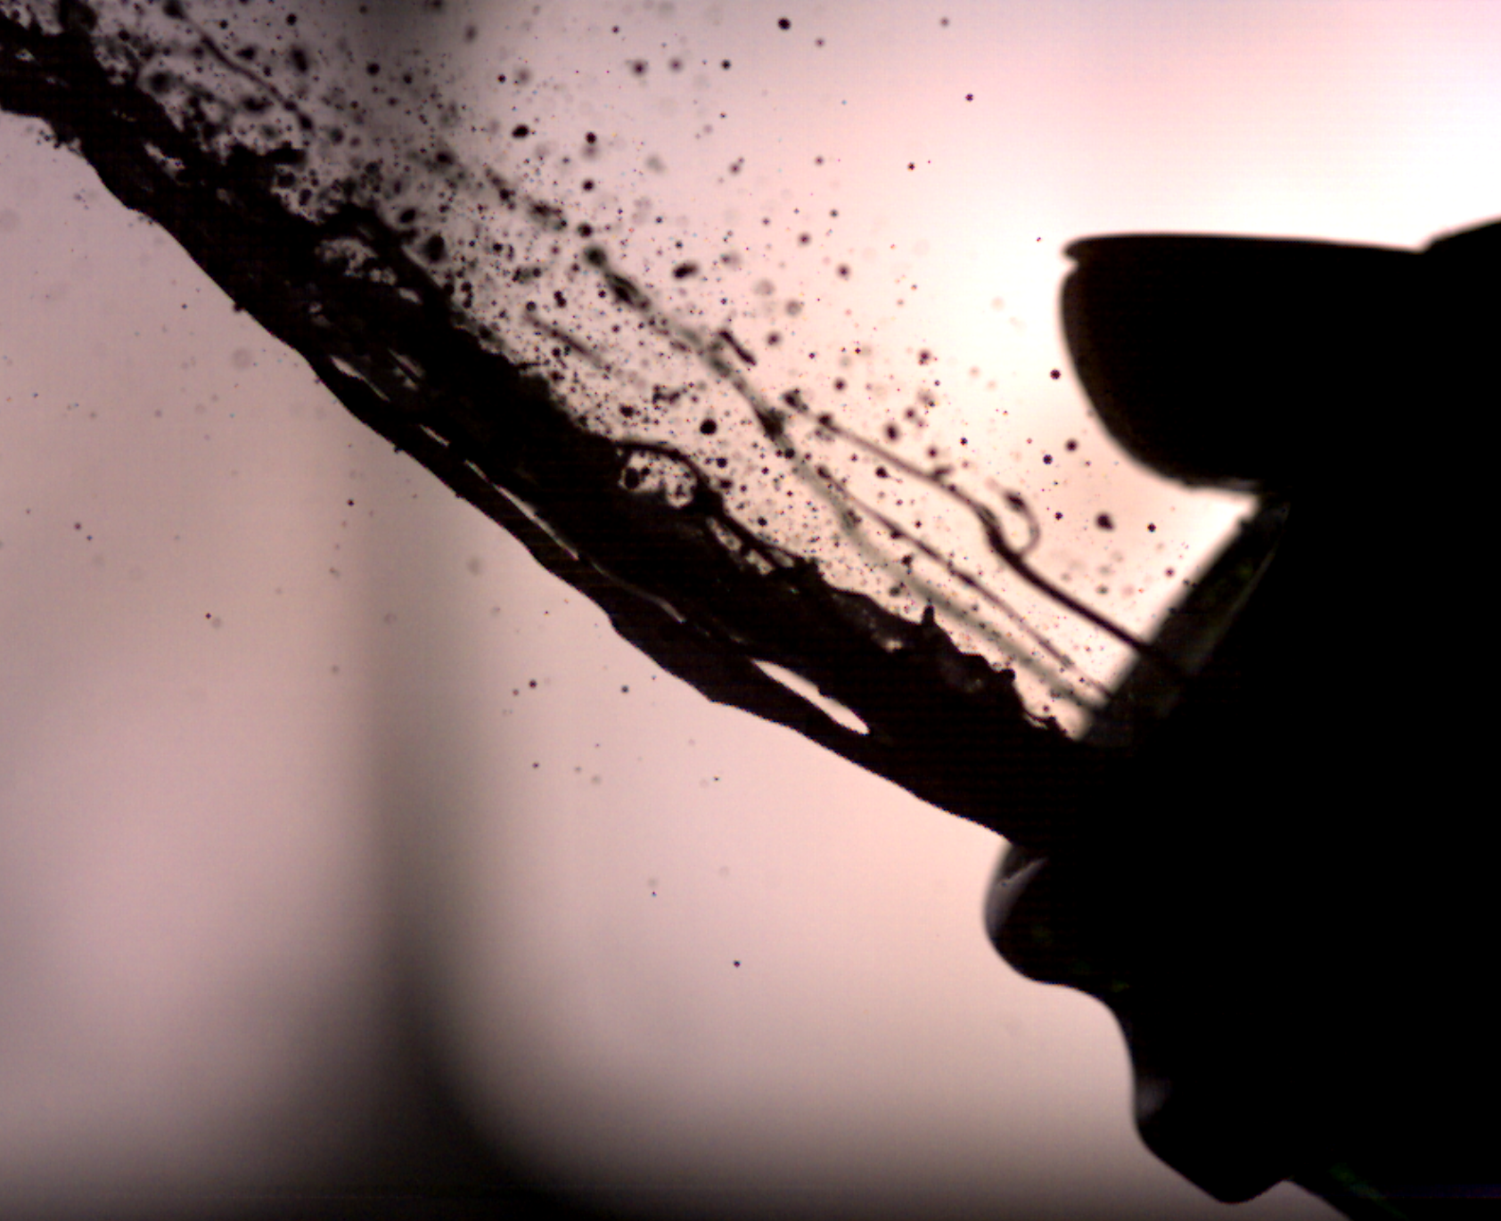
Figure 4. The third video used diffuse backlighting and a macro shot.

On the last video, the lens was switched back to 50 mm and a black background. Back lighting was still utilized. The third and fourth videos both were recorded at 25000 frames per second.

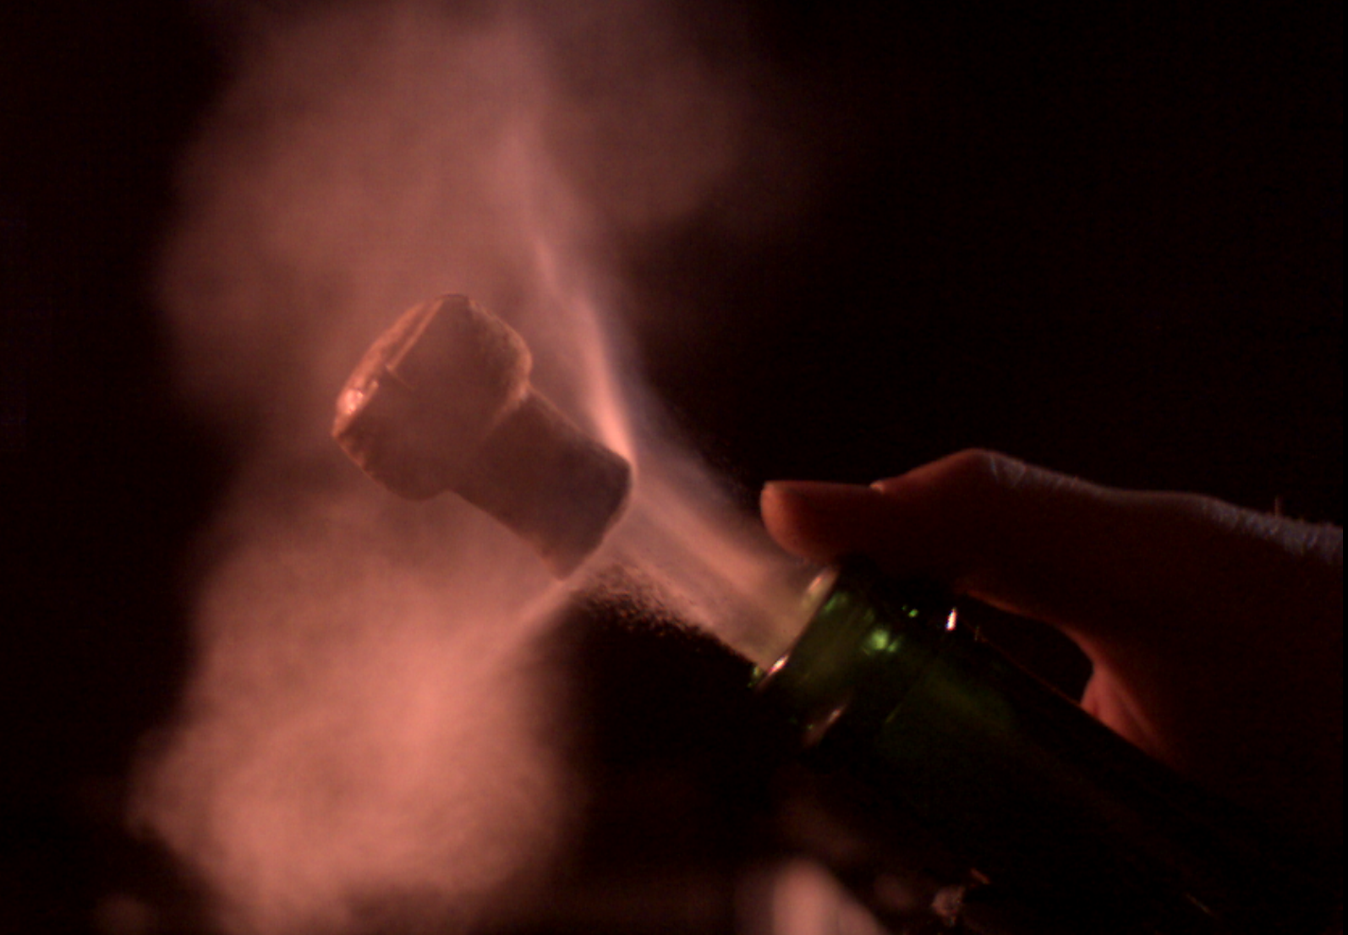
Figure 5. The final video lighting.

The distance from the lens to the champagne bottle was approximately one yard for the first and second videos, and about one foot for the third and fourth videos.

For the final, edited video, the first and third champagne bottles were spliced together to show both a close up and wide scale view of the cork popping off. This way, the viewer could gain a deeper perspective of what all is going on during this event.

Conclusion

The results of this project were splendid. The capabilities of the Phantom camera allowed for high quality viewing of a process that is not often thought about in an in-depth way. It was able to capture minute details of the process that cannot be seen with the naked eye. The overall process was captivating and interesting to watch. For future projects, a possibility would be to pop different kinds of carbonated beverages to see if the type of liquid will affect the flow physics.

Works Cited

- Allain, Rhett. “The Physics Behind Popping Champagne Bottles.” Wired.com (2015, Dec. 30).
- Pouligny, Bernard. “Does shaking increase the pressure inside a bottle of champagne?” Journal of Colloid and Interface Science (2015, Feb.) – 50 – 51.

