Flow Vis
Team Report # 2
Preston Marcoux

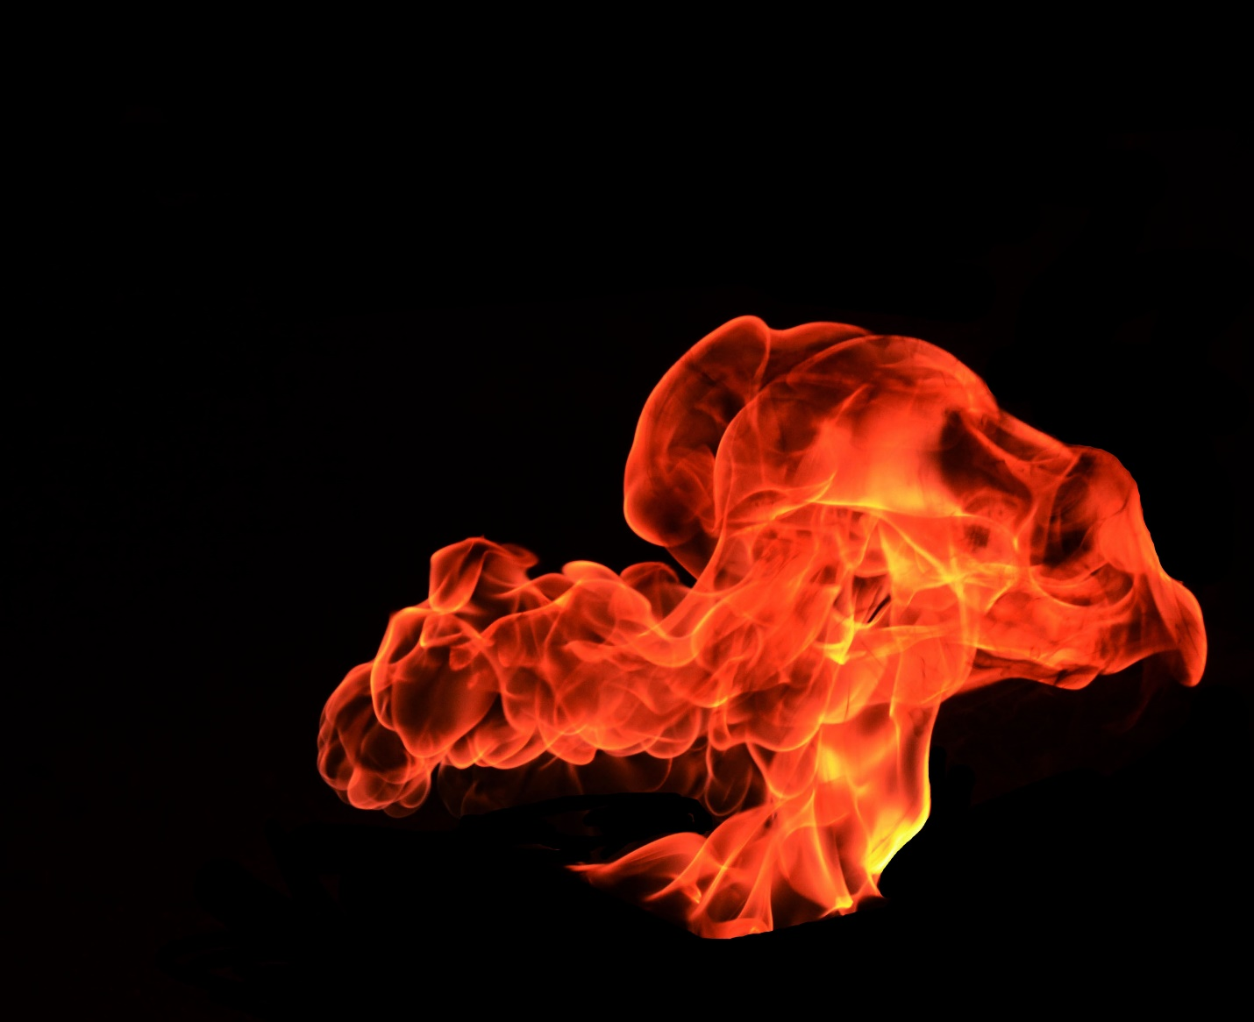

Introduction
As walking sacks of water, many people are naturally drawn to fluid flows. For good reason too, fluid flows can be absolutely stunning. I personally have always been enamored with manipulating flows such as fire. For this reason, I began juggling fire a couple years back. During my juggling career I have come to a realization, often times people do not see the true beauty of fire. Fire is incredibly dangerous, and has the capability of ruining anything it touches. However, it is an incredibly beautiful fluid flow. For this project I intended to portray the beauty of fire by displaying the rhythmic dancing in the flames.

Set Up
The experiment was fairly easy to set up, I had help from Alex Rosenberry, Branden Goldenberg, and Katherine Yarnell. The materials used were three classic juggling torches, fire poi, kerosene, an aluminum container, and a lighter. Originally the group was interested in capturing the flame as it interacted through fire juggling, and fire spinning. It was difficult to get an image that truly portrayed the beauty of the fire. Figure 2 shows me juggling a cascade, but the long shutter made it look like I was on fire. So instead in figure 3 we see one torch thrown across the screen, and though this is very cool it didn’t capture the danger and beauty of fire I was hoping to achieve.
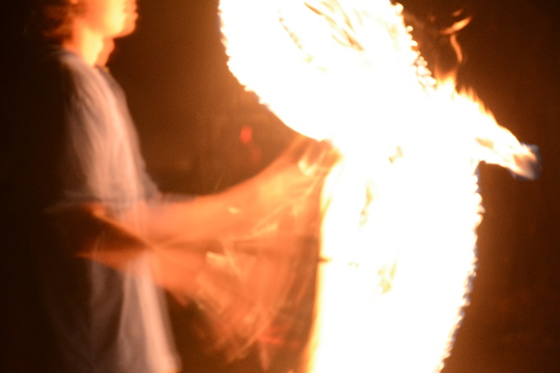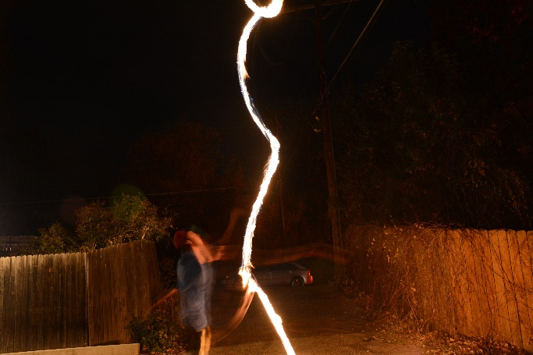
Figure 2 Figure 3
In a last effort to save the experiment, we figured we could light the remaining kerosene on fire that was used to lite the torches and poi. As the flames grew a beautiful wave began to occur within the aluminum bowl, and though the final image doesn’t show the wave the image shows a beautiful array of different colors and a vibrant flame.

Deciphering the Image:
In order to understand the image and what was captured please refer to figure 4. The image was taken place in an alley at approximately 8PM, the alley had a slight breeze coming through which resulted in creating a small disturbance in the fire. To give a relative size on the fire, Figure 4 shows the approximate dimensions of the bin, which allows us to decipher how big the fire is. The fire is at most 2 feet off the ground. You can also see the direction of the wind as it crosses over the fire. This wind creates this vortex effect that can be seen at location A where the flame recoils to the edge label B and moves with the wind towards A.
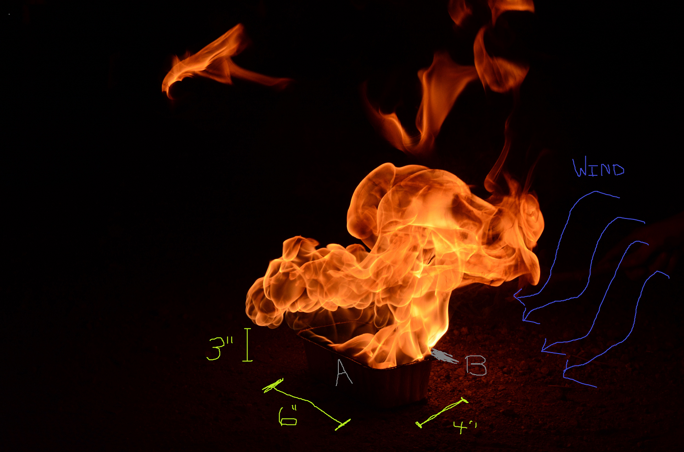
Figure 4

Flow Physics
Fire results in a chemical reaction consisting of carbon dioxide, water vapor, oxygen and nitrogen. From this reaction, heat and light are created. (Equation 1) The formula for combustion is provided in Equation2.
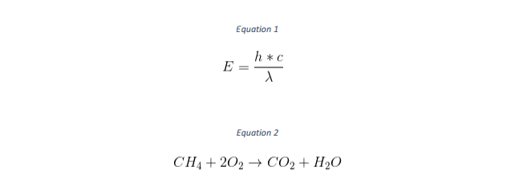
In order to create the best image, we went to an alley where no other light could be seen by the camera. Luckily it was a slightly clouded evening and the moon played no role in our images. We also used trees to make sure no headlights from cars could be seen during the photoshoot. The visualization techniques used were all natural, the photo is based on the light given off by the fire. This makes the image unique, instead of using lighting techniques to capture the flow, the flow is the light. The camera was about 6 feet from the aluminum base lit on fire and was set to an ISO of 800 an F 13 aperture, and a 1/640 exposure time. We chose about 6 feet from the flame so it could catch all of the flames. The camera used was a NIKON D7100 with a 52mm focal length lens. A tripod was used for stabilization. All of these settings can be seen on Figure 6.
The picture had dimensions of 3621x2952 pixels, this can be seen clearly in Figure 5.

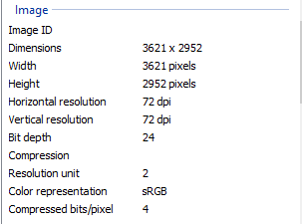
Figure 5
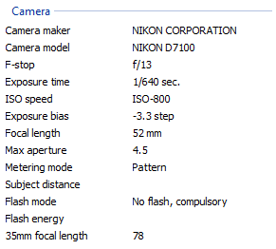
Figure 6

Post Processing:
The most work that was put in on this project was in Photoshop, after cropping the image to its preferred size I decided that taking out the aluminum bowl and any distracting elements would enhance the photo. This included taking out the ground, and some of the errant flames in the photo. Personally, I like the resulting image. However, it would be incredibly difficult to recreate especially with the slow wind resulting in the alley way. I used the editing curves in Adobe Photoshop to bring out some of the flame and enhance the yellow on the right side of the photo. I used the paint tool within Adobe photo to edit the pixels near the fire to create a crisp boundary layer on the flame. Figure 7 and 8 on the next page show the before and after images.

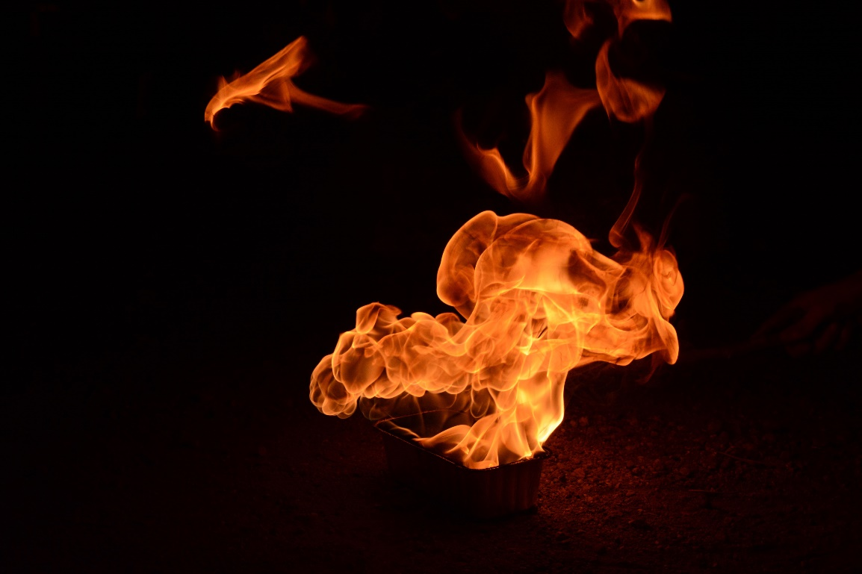
Figure 7: Before
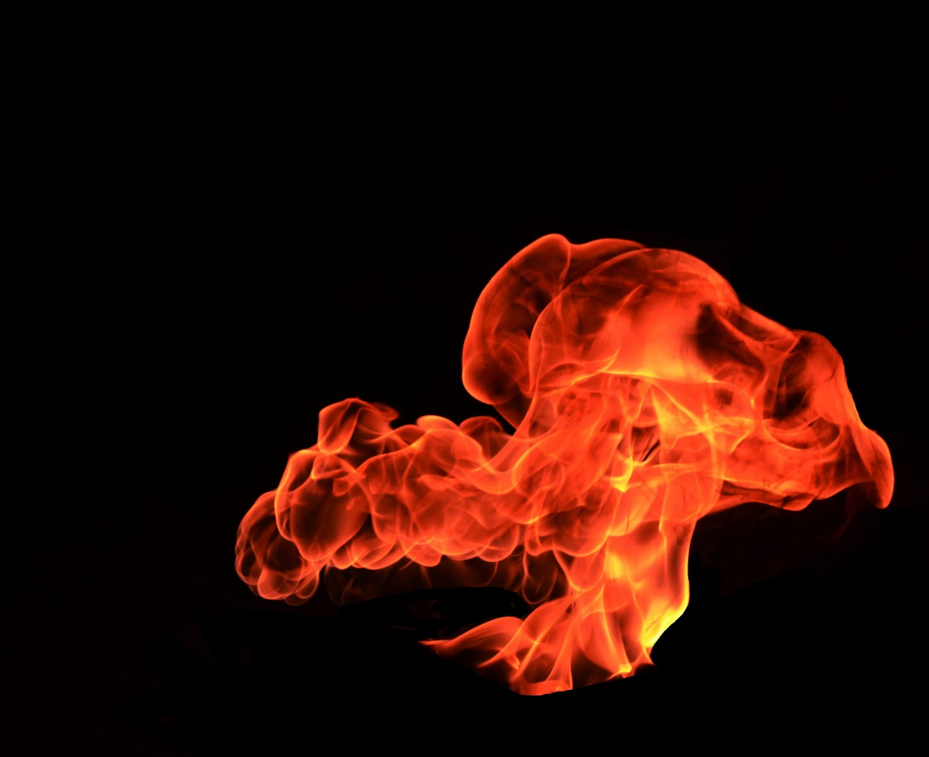
Figure 8: After

Conclusion:
I believe that the image displays the true beauty and power of fire. Hopefully this image entices people to splendor in everything around them. I personally like the way the image is centered, I like that the fire isn’t centered and that there is some room for the black to drown out the fire. I also really like the way the fire trail looks, especially in the left sides where the flow is turbulent. One thing I don’t like about my image is that in order to edit out the aluminum tin some of the flames were taken out as well. In order to solve my problem, I will need to look further into Photoshop. I definitely fulfilled my intent and look to improve on setting up the photo sessions better. With a little research I could have quickly narrowed down that sex second shutters would only result in images like Figure 2. In order to develop my preparation, I will continue to take pictures and investigate the reactions of shutter speed and light.

