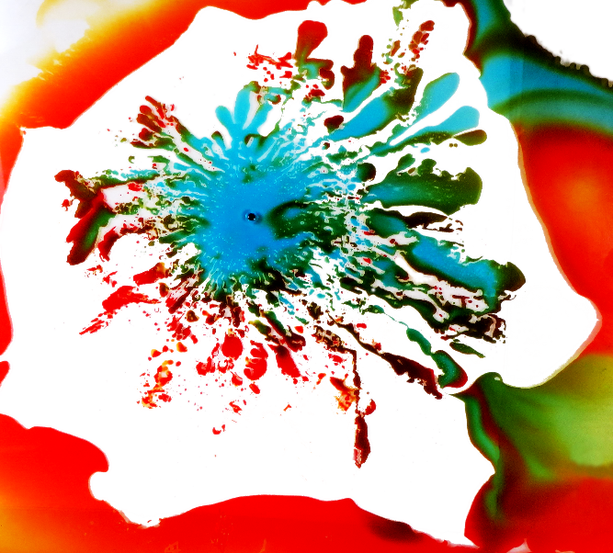
I was really excited to be creating a Hele-Shaw cell because working with fluids like this gave me the opportunity to implement a lot of colors. The instability that creates this Hele-Shaw cell is called the Saffman Taylor instability. By the time this photo was captured a lot of the initial fingering created by the instability had gone away because the pressure between the two plates had been lifted. My teammates who helped me create this image are Matthew Beckemeier, Tianzhu Fan and Yadira Valdez.
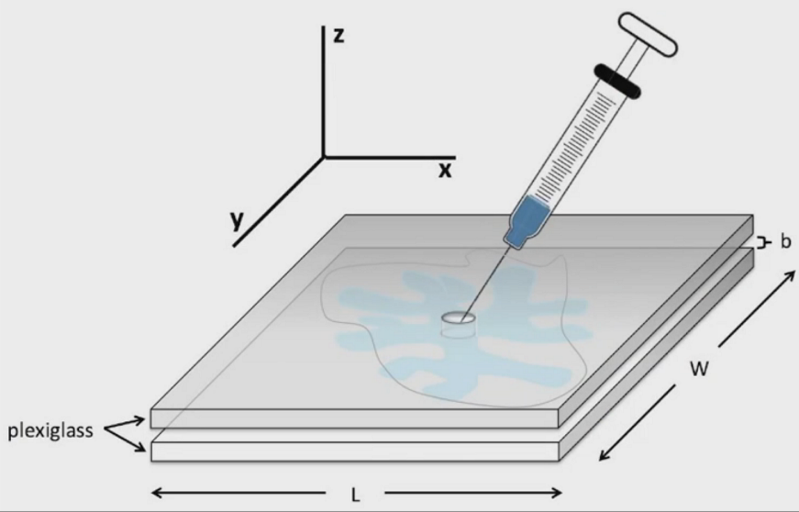
This is the basic set up that you need to create a Hele-Shaw cell. It requires two sheets of plexiglass, one having a hole drilled through the center, and a syringe. The cell is created when you inject a low viscous fluid into a high viscous fluid. In our photo, we used water mixed with food coloring for the low viscous and vegetable oil for the high viscous fluid. The plexiglass sheets we used were 11x14 inches and the syringe was a cooking syringe purchased from Target.
To emphasize the Hele-Shaw cell we used blue food coloring in the water. Since the food coloring is water based, it did not mix well with the oil. Even so, we put oil into a small cups and added the droplets of dye in it and stirred it so there would be a lot of small beads of dye. When the water would hit the beads, there was beautiful color interactions. We used just the lighting in the room for this image, any flash would have caused a glare. Even the ceiling lights were causing a bit of glare but we just had to move the apparatus so that it was not directly beneath the light to fix that issue.
I used a Canon PowerShot to take this image. My f-stop was at a 4, my shutter speed was at 1/30 of a second, my ISO was 160 and my focal length was 6 mm. I chose these setting because I was trying to get as clear of an image possible, with a focus on the bright colors. Using Gimp, I chose a color selector tool which allowed me to select all of the background and make it a bright white. I did this to have more focus on the colors and give it a nice contrast. Additionally, I boosted the contrast to make the colors pop even more. I also decided to rotate the image because I like seeing the fluid flow go left to right. Lastly, I used the clone stamp tool to get rid of the line going across the left side of the image and to get rid of some of the extra splatter. Below is the original image.
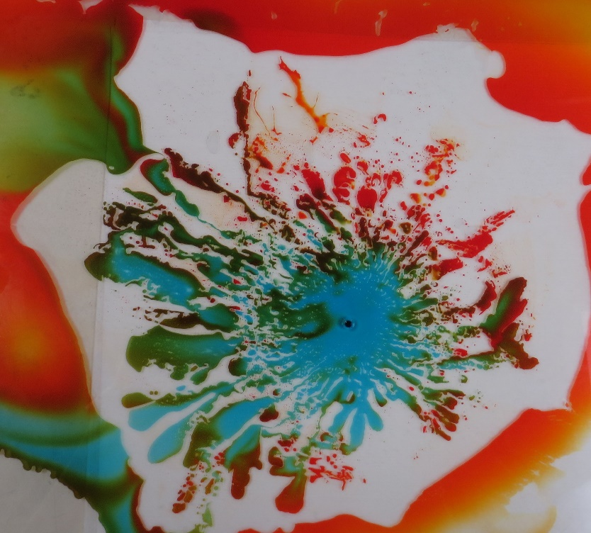
This image reveals the viscous fingering associated with the Saffman-Taylor instability. What I wanted to reveal in my image was a beautiful combination of colors intermingling during this instability. If I could change things I would want to have a sharper image, better light and capturing the instability before the pressure came off. What I really do love is the color mixes we were able to achieve and how there is a white circular border around where the fingering was happening. I think it is very aesthetically appealing. I also like that this photo has a messy, wild feel to it.

