Team First Report
By Ryan Walker
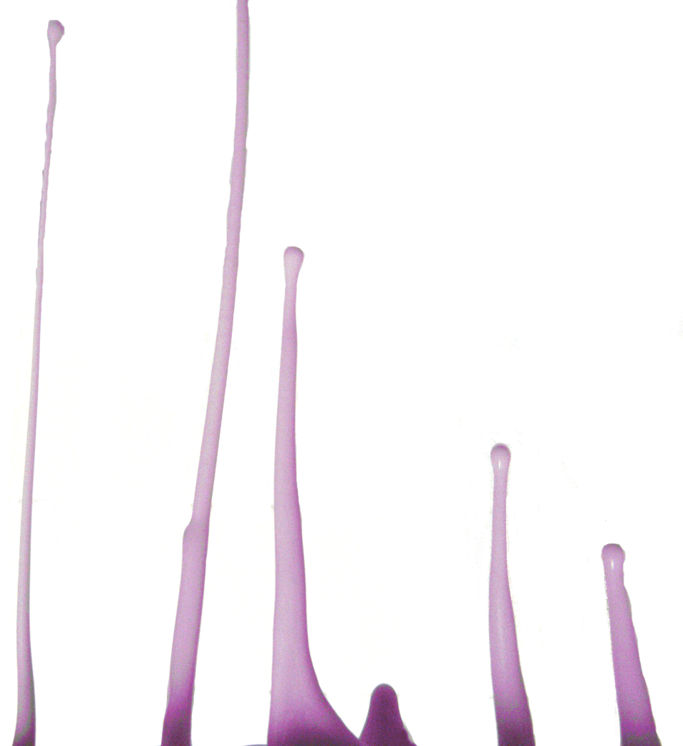

This is the first team photo. In this setup I was photographing oobleck falling through a kitchen strainer. The main purpose of this image was to show the shear thickening properties of oobleck, as shear on the oobleck increases, so does its viscosity. I was not able to meet with teammates for this project, so the setup and photo were done individually.
In order to illustrate the shear straining properties of oobleck I decided to pour the oobleck through a strainer from my kitchen. I setup my camera on a tripod about a foot away from where I was pouring the oobleck and played around with the timer on my camera to get a good photo. This setup can be seen from the top down view below:
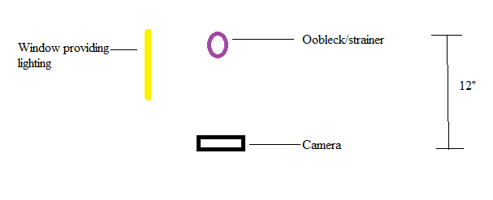
Figure 1 Setup
The flow I was able to capture shows prolonged droplets of a shear thickening fluid. The oobleck is liquid with a low viscosity when first poured into the strainer, but as it comes through the strainer its viscosity is increased due to its shear thickening properties. This causes it to behave more like a solid right as it exits the strainer and it moves very slowly. The further it gets from the strainer the more its viscosity starts to decrease, causing it to behave more like a liquid again. This is why the long drawn out droplets in the picture are formed. These droplets were approximately 5” in length. This flow is being driven purely by gravity, I’ve just inverted the photo in my final image. It is difficult to calculate a Reynolds number for this flow with the data that I have because viscosity is a function of time. This is a laminar flow with the highest Reynolds number at the bottom of the droplets where the flow has the highest velocity and lowest viscosity. The lowest Reynolds number in the droplets can be found right as the oobleck exits the strainer due to the high viscosity and low velocity.
To color the oobleck I used a purple food dye that I had lying around. When mixed with the white oobleck, this made a light purple color. I thought that this would make it easier to stand out against the white background of where I was taking the photo, but the purple color of the oobleck failed to come through in my image. I had to add the coloring back into the oobleck during post processing. This was probably due to the lighting that I used for the image. The only source of lighting was sunshine coming in through a window that was about a foot away from the oobleck and the camera, however, the window was significantly higher than the oobleck so there was no direct lighting.
In this picture the camera was roughly 12 inches away from the oobleck. The field of view is about 6” by 6”. The focal length in this particular photo was 5mm. This picture was taken on a digital Panasonic DMC-FZ35 camera. My original image had a width of 4016 pixels and height of 3016 pixels while my final image was 2520 pixels by 2728 pixels. I used an aperture of f/2.8, a shutter time of 1/30, and an ISO speed of ISO-100. This aperture was necessary because it was a relatively low light situation. A lot of work was needed once I got the image into GIMP. I was planning on simply using the color selector to select the white background and edit it to make it less distracting, however the contrast between the purple oobleck and white background was not enough because the oobleck came out as grey instead of purple. Ultimately I was able to use a variety of selection tools to isolate the background from the oobleck so that I could eliminate distracting elements in the background, and then add the color back into the oobleck. A before and after image can be seen below:
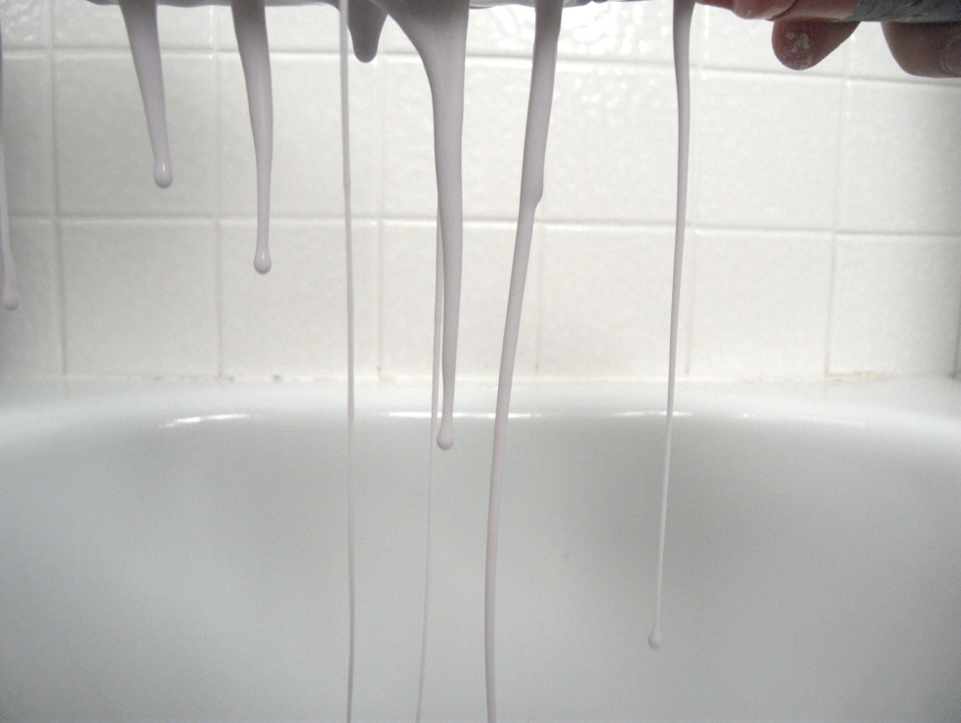
Figure 2 Before
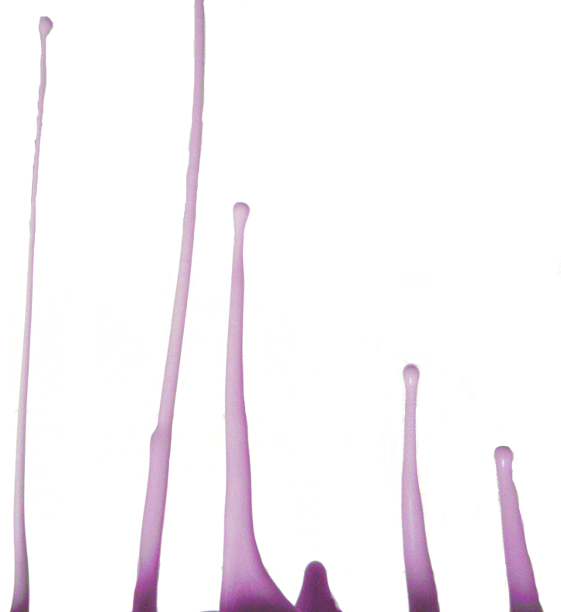
Figure 3 After

I think this image does a good job of revealing the changing viscosity of a shear thickening fluid. In this aspect I fulfilled my intent for the image. If I had to change something, I would have used more dye and better lighting so that the color of the oobleck would have stood out better and had more contrast from the background. This would have made editing the image a lot easier, as well as given me more flexibility with what I could do with editing the image.
Sources
- http://science.howstuffworks.com/liquid-body-armor1.htm

