Marco Gardi Team 1st

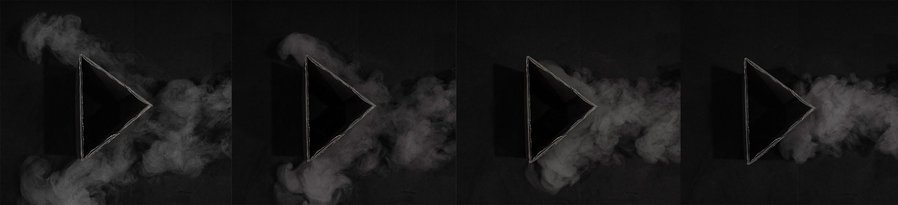
I took this image for the Team 1st assignment in the Flow Visualization class at CU Boulder. The goal for this assignment was to capture the behaviour of a jet of fog as it interacts with a solid obstacle. Thanks to Professor Jean Hertzberg for allowing Team 5 to use her fog machine.

Fog maker

For this assignment I used an inexpensive fog generator such as the ones for sale around Halloween at Target. The machine uses water and a glycerol solution to make the fog and expels it at the push of a button on the remote. In order to produce a jet of fog that is dense and does not rise immediately it is necessary to place some kind of cooling in a designated in the machine; I used a ziplock bag filled with ice but dry ice can also be used. It’s also important to note that to produce a thick jet of fog it’s necessary to build up fog in the cooling chamber with one press of the actuator button. Then a second shorter press of the button will expel the fog that has cooled in the chamber. The Reynolds number for the flow in this image can be approximated will the following equation.

$Re = \frac{ud}{v} =\frac{0.5m/s*0.1m}{15.68*{10}^{-6}m^{2}/s}≈3188$

The high reynolds number indicates the flow is turbulent. The main observable characteristic of the flow is that when the flow meets the barrier, it diverges into two portions at the point of the triangle, and then each portion maintains the direction of the side of the obstacle it flows along, even after it passes the obstacle. This is a characteristic of an impinging jet because the particles are momentum driven and therefore maintain their direction instead of trying to converge again after they pass the obstacle.

I set up the apparatus on the floor of my bedroom, using a black piece of cardboard as a backdrop. Initially I tried shooting with all the lights off and illuminating the scene with the built in flash on my camera. This method of lighting proved to be highly ineffective; the fog was hardly visible at all. My next attempt was to leave some of the lights in the bedroom on, providing a minimal amount of diffused background illumination and shooting at a high aperture to properly expose the image. This way I was able to capture the jet of fog.

The camera I shot with was a Nikon D3100 mounted with a 35mm prime lens. The shutter speed was 1/100, aperture f3.5, ISO 800 and automatic white balance. My distance from the triangular obstacle and the fog was 3 feet. Editing the original images proved to be a little challenging because it was hard to maintain the fine details in the fog while increasing the contrast and modifying the colors. Eventually I had to balance a modification of the curves with a brightness layer, and I applied a high pass filter to sharpen things up a little. I used the clone stamp tool to remove the lens cap from all four images. In another set of layers I completely desaturated the images to make them black and white. Finally to patch the images together I had to extend the canvas size horizontally in one image and drop the other three onto it as separate layers. One problem with this method is that I edited each image separately which means they were all slightly different; when I initially patched them together it was too obvious so I had to modify them slightly to get the colors to match better.

By patching four images together my intent was to produce an interesting progression of images that gave the viewer a more dynamic sense of the phenomenon. In my final image the time progression goes from right to left which is fairly unusual; perhaps I should have inverted the image for a more conventional look. However, the triangular obstacles look like arrows pointing left to right which unintentionally contrasts the direction of time; I think this contrast adds a layer of interest and mystery to the image. People also pointed out that the obstacle resembles a play button found on everyday electronics. One could interpret the frozen images as the paused screen of a video; if someone pressed the play button the fog would resume its flow.

References:
Air absolute and kinematic viscosity. (2016). Retrieved from http://www.engineeringtoolbox.com/air-absolute-kinematic-viscosity-d_601.html

