Team Assignment 1
Group 5
Harrison Lien
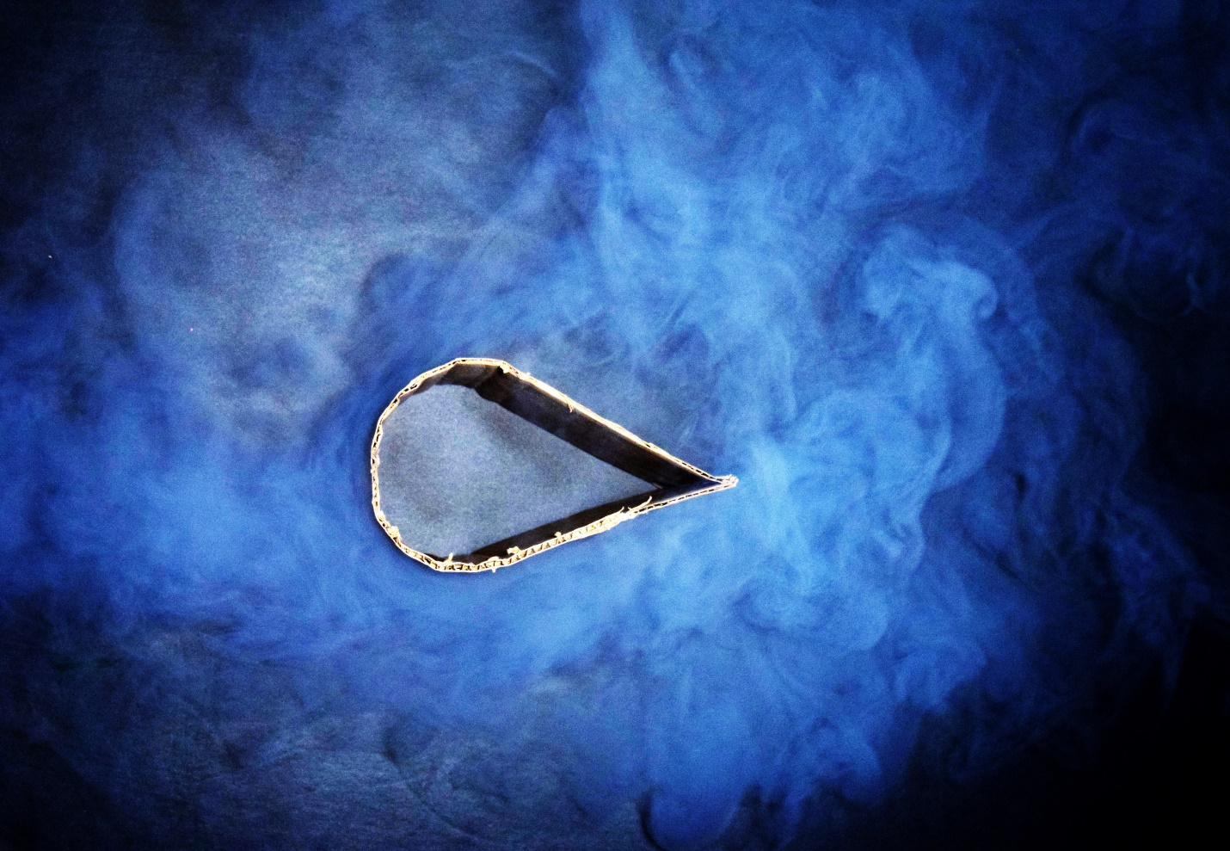
Figure 1: Fog flowing past an airfoil shape

The use of particulate seeding in air can be an effective technique to help visualize air flow. While it is fairly common practice in modern air flow analysis, it is not necessarily a trivial technique. There are several factors in successfully capturing a flow around the studied object, which will be discussed later. The experiment performed to produce the image in figure 1 used both fog and airflow produced by a fog machine. The flow goes from the left to the right, as well as moving slightly upward. The fog machine was set on the floor next to a black poster board, the fog machine produced fog using water and glycerin, and the fog was cooled by ice cubes before leaving the machine. On the poster board, the shape was set in the middle, and the fog flowed over it. The walls of the board were folded up to help direct the flow. Harrison stood above the shape, held the lighting, and took this picture, while James Julian operated the throttle on the fog machine. The camera body used was a Nikon D3300, the lens used has a focal range of 18mm – 55 mm, and was set to manual focus. The settings on the camera were as follows: shutter speed of 1/40 sec., aperture of f/4.8, ISO of 1600, and a focal length of 40 mm. The shutter speed was perhaps a little short, however the depth of field was adequate, and grain produced by the high ISO is not distracting.
Because smoke or fog is almost always white, it is common to employ methods of light scattering off of the particles in order to depict them clearly. When light scattering is used to highlight the seeded fog in the air, it is then useful to get a hard contrast for the background behind the fluid flow. For this setup, the background was a matte black poster board. The setup also used lighting from behind the camera to try and avoid shadows from appearing off of the shape, hiding the fluid flow. Given the lighting conditions and the non-ideality of the poster board’s finish reflecting too much light, there was a significant struggle to get a clear distinction between the fog and the background.
The fog machine used also had very little control over the direction, speed, and thickness of the fog coming out of it, so in an attempt to get a flow going straight at the shape, the fluid ended up coming from the bottom edge of the shape. Although this was not the intended flow for this experiment, the fluid flow used is still an important thing that can be studied. As can be seen, the fog follows the bottom edge of the shape and then starts to curl upward after the shape has ended. The fog also leaves an empty spot above the shape where there is no flow. It could be said that the fog is impinging onto the shape in a jet along the bottom edge. It can also be seen from the image in figure 1 that the flow appears to increase in turbulence as it passes the shape, which could be expected given a flow like this.

