Michael Johnson
Assisted by JT Balling
Professor Hertzberg
MCEN Flow Vis
February 16, 2018
Get Wet Report
This image was for the Get Wet assignment and is an image that uses surface tension of water to keep a bubble of water on top of a watch face. It took a few tries to get this right, I kept putting too much water on the watch face, so it kept spilling over the edge. Using the help of JT Balling I finally got the final image. JT helped me by holding two iPhone’s above the watch face and used their flashlights to give me the lighting that you see in the final image. He also let me borrow his camera to capture the image.
In the image you see a watch with a bubble of water on top of the watch face. To get the correct amount of water on the watch face I used a disposable pipet to slowly, and methodically add water until I had covered the entire watch face. The reason that the water created a bubble on top of the watch as opposed to just spilling off is because the water was holding itself together using it’s surface tension. The surface tension force causes the water molecules to want to stay together rather than flow away from one another. This cohesion of water molecules means that they are more attracted to other water molecules than they are to the air molecules in the air surrounding the surface of the water. This lack of water molecules surrounding other water molecules causes the water molecules at the surface to create stronger bonds with other surface molecules. This cohesive force causes the water to form a bubble on the top of the watch face.
To capture this image, I used two iPhone lights directly above the watch and a black background to try to make the image stand out. I also did my best to make sure that the watch face was in the center of the shot so that the image would be symmetrical. The watch used in this image is manufactured by a company named Aulta and is The Leeway model. The water used was from a drinking fountain in the Fleming building on campus. When taking the picture, I used the camera flash as well as then two iPhone lights mentioned above.
To capture this image, I borrowed JT’s Canon E80D. For this image the field of view was approximately 4 inches across. The reason I decided to do this was because I didn’t want the watch clasp to be in the photograph, because I felt that it would distract from the watch face which is the image that I was trying to capture. The lens was approximately 6 – 8 inches from the watch face. I felt that this was a good distance because it allowed a good level of focus as well as enabled me to get the watch and part of the band in the picture while keeping the clasp out of the picture. I also used the monochrome feature on the camera to make the colors look cooler. Once I had the picture I just used “Mono” filter on my iPhone to create the image that I ended up submitting for this project, I thought that this filter looked better than the filter that I had applied on the camera.
The image does a good job of showing how surface tension holds water together when it would otherwise just spill everywhere. You can also slightly see the refraction properties of the water if you look at the markings on the watch face. They seem to curve even though in reality they are straight lines. I like the lighting and overall look of the picture. I think the bubble of water looks cool especially once you notice that the light is refracting through the water. A few things that I dislike about the picture are the dust particles that are apparent in the foreground of the picture, as well as I wish that the refraction of the watch face had been more apparent to the casual observer. I think for the most part I fulfilled my intent, but if I were to take this image again I would try and make the refraction aspect of the fluid physics more pronounced. Moving forward I think it would be cool to run this experiment on a larger scale to try and illustrate how strong the surface tension forces can really be.

Original Image:
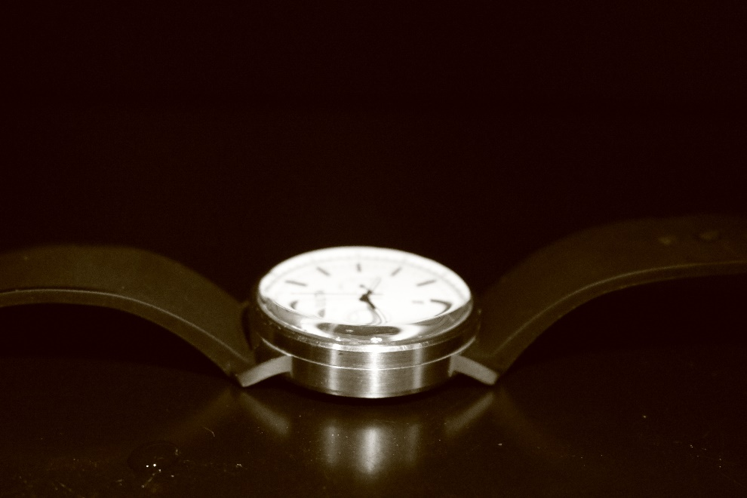
Submitted Image:
