Team Second Photo

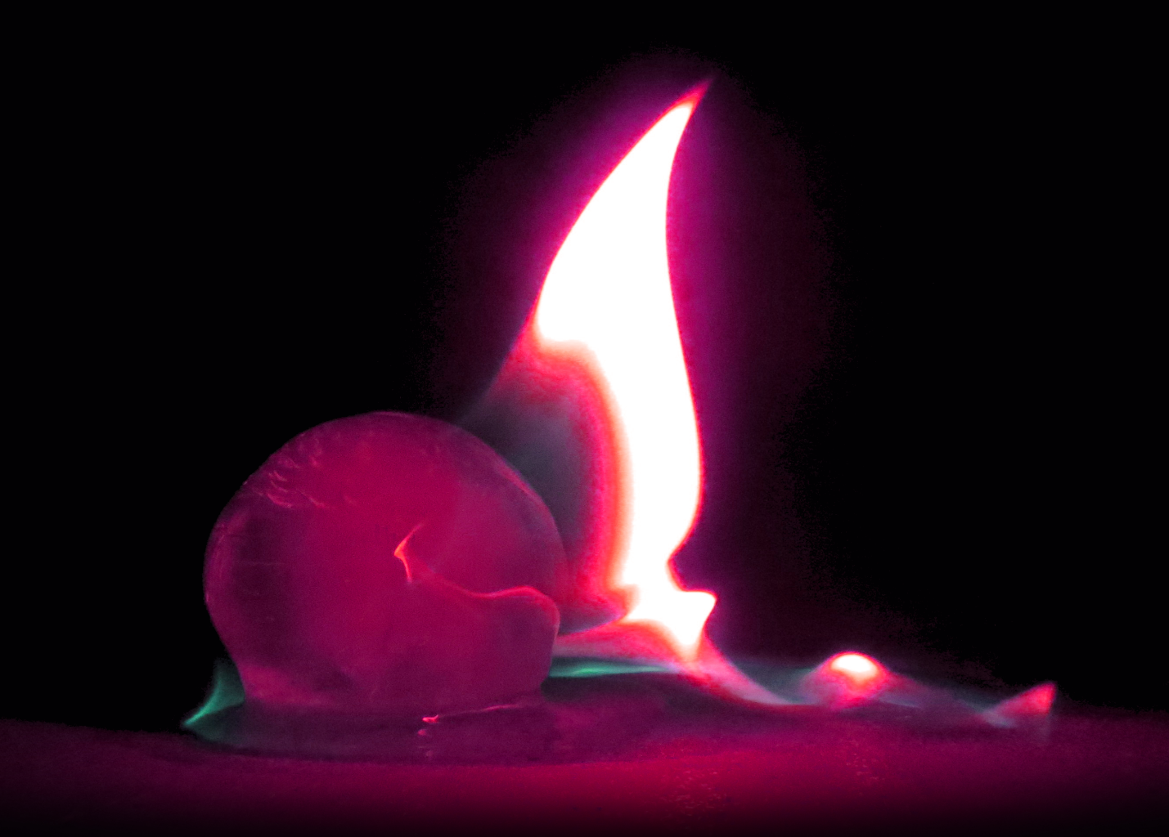

Casey Cooter
MCEN 4151: Flow Visualization Spring 2018
11 April 2018

Introduction
This image was taken for the “Team Second” assignment of the 2018 spring semester course “flow visualization” at the University of Colorado at Boulder. The assignment observed lighter fluid after it was ignited, using an ice sphere to create a contrast between “fire and ice.” The ice was covered in lighter fluid, ignited, and observed over a short burning period. During the experiment, the team attempted to change the flame color by using potassium chloride. However, the flame did not burn long enough to be affected by the addition of the salt, so the flame was taken in its natural color. The inspiration for a distinct color however drove the post-processing that was done on the photo.

Contributors
For this assignment, team eta collaborated to capture multiple shots at multiple angles. The other contributors were: Sam Oliver, Steve Rothbart, Brent Bauer, and Jacob Chapin. The team collaborated to produce the photos as well as providing materials necessary for the photo.

Materials
The materials used in this visualization are all easily obtainable materials, making it relatively straightforward to replicate. The following materials are necessary to recreate this experiment:
- Round ball of ice (made from ice mold of 2.5 inches in diameter)
- Ronsonol (contains light petroleum distillate, enough to cover ice ball + small ring on ground)
- Lighter
- Bucket of Water (to extinguish flames)
- Canon SC260 HS

Procedure
The ice ball was prepped in advance prior to the shoot, and was created using water frozen in a spherical mold. The spherical ball was placed onto a concrete ground, free from any obstructions or potentially flammable materials to ensure safety in shooting of all parties involved. Following this, the lighter fluid (Ronsonol) was squirted on the ice ball. Prior to this, the potassium chloride was also placed in a ring around the ball. The lighter fluid was also squirted in a ring around the ball to soak the potassium chloride, but ultimately the potassium chloride had no effect. This created a ring of lighter fluid around the ball, as well as covering the ball itself in lighter fluid. The ice ball was then ignited with a lighter, and then those who were near it distanced themselves to take photos. The ice ball burned for approximately 1-2 minutes before the lighter fluid burned up and the flames disappeared.
The ice ball was placed onto the ground, and to achieve this shot, the camera was placed on the ground as well. The camera was placed approximately two and a half feet away from the ice ball in this photo, and then focused in with the zoom. The flame had been burning for around 20 seconds in this shot. A diagram can be found in figure 1:
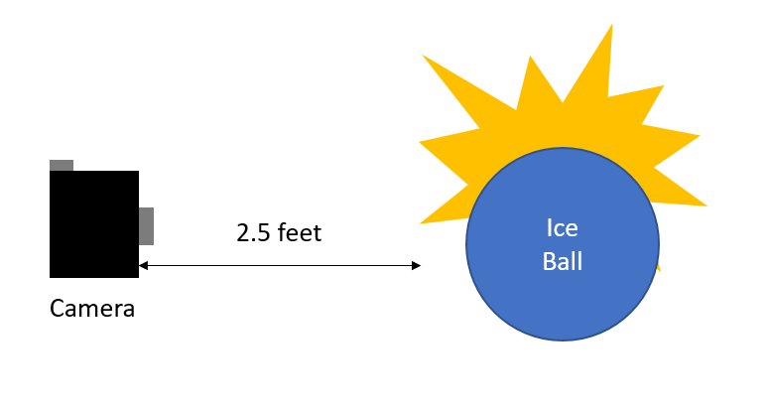
Figure 1: Diagram of Setup
This angle provided a unique view on the ice ball, and allowed the flame to be captured in high detail.

Fluid Dynamics
The speed of fire is a bit difficult to determine. In one study, a group found that the fire they measured was around 6 feet per second, or 1.8 m/s. [1] The speed of the flame depends on may factors of course, but this is a reasonable approximation. The characteristic is the diameter in which the flame was burning, which is the diameter of the sphere (2.5 inches, or 0.0635 meters). Assuming the temperature of fire is around 527 degrees Celsius (or 800 K), the kinematic viscosity of air at this temperature would be 8.214 x 10⁻⁵ m²/s. [2] Given this information, the Reynold’s number for fire would be:
$$Re=\frac{vD}{ν}=\frac{(1.8 m/s)(0.0635 m)}{8.214 ×{10}^{-5} {m^{2}}/s}=1391$$
A Reynolds number of 1391 implies the flame is laminar. As the fire was extremely smooth and had well defined edges, this is a reasonable calculation. If the flame was burning in a more violent way, invoking crackling, it would be more likely to be in the turbulent region.

Imaging Technique
The photo was taken on a Canon SX260HS camera, a digital point and shoot camera. The image was taken 2 feet away from the subject, and gives a field of view of approximately 6 inches x 4.5 inches, with a resolution of 4000 x 3000 pixels. The photo was taken with a f-stop of f/4, an exposure time of 1/125 of a second, and an ISO of 1600. The focal length was 10 mm. The ISO and exposure settings were chosen to capture the flame with minimal blur. No flash was necessary, as the flame produced more than enough light to illuminate the subject, so the time resolution of 1/125 of a second seems like an appropriate time resolution. If the exposure time was decreased even further, it might have become difficult to capture the ice ball, which did not produce its own light. The original photo can be seen in the following figure:
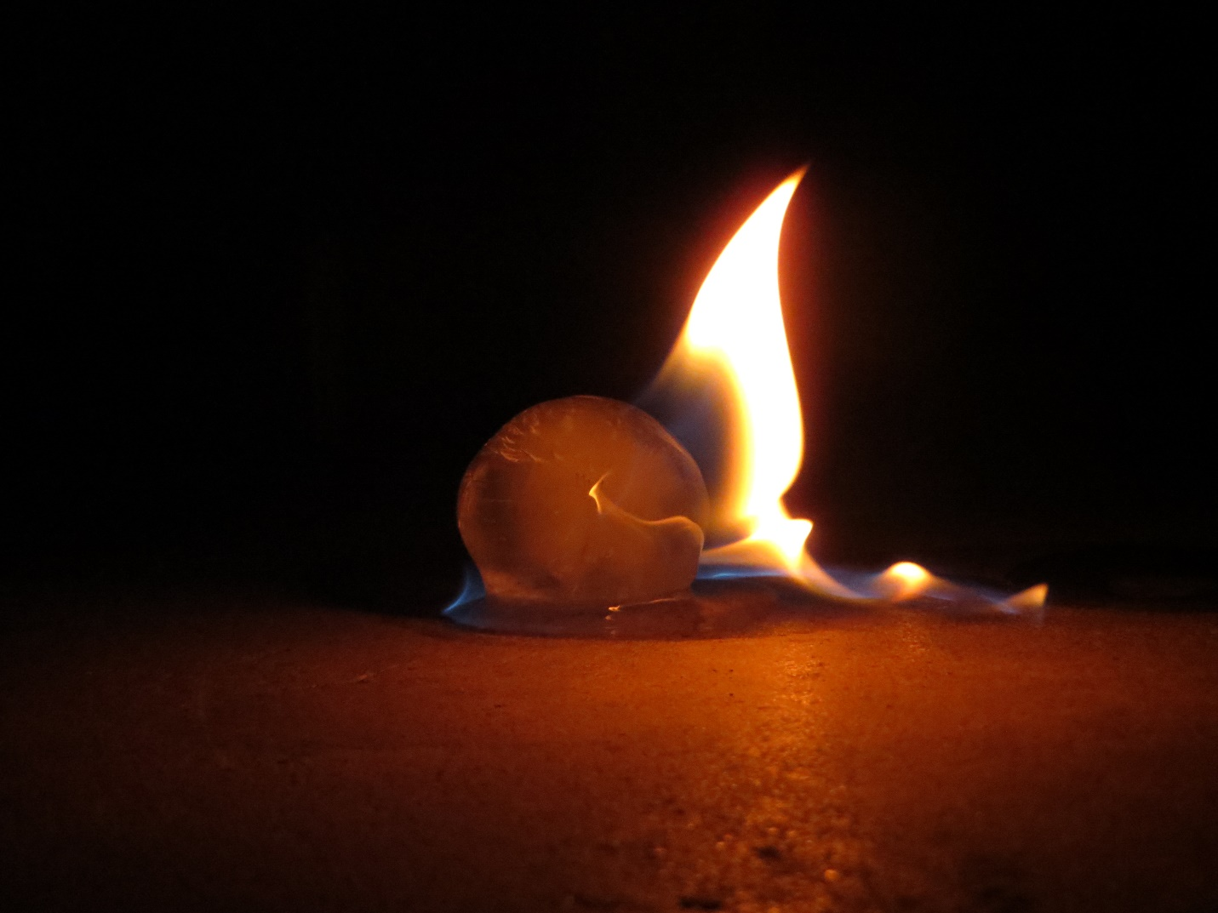
Figure 2: Original, unedited image.
The photo-processing package GIMP was used to enhance the image beyond what was taken. The original image introduces some slight graininess in areas where it is otherwise black. All the darkness that surrounds the orange glow was selected and changed to a flat black. This improves the focus of the flame while also allowing the image to have the contrast freely changed without creating noise in the darkness. The image was first cropped to focus the subject matter in the center of the image, to a final resolution of 2664 x 1908 pixels. The floor was also quite distracting in the image. Instead of doing a simple crop, a slight fade effect was applied in a circular pattern to the bottom floor. This helped to give more focus to the subject of the image in a more natural way since the ball was essentially glowing.
After the image was properly cropped and focused, the colors were changed to create a purple flame by adjusting the hue balance for the whole image as opposed to just shifting the oranges and reds. By shifting the oranges to purples, the blues in the image were shifted to green, which creates a nice contrast between the purple and blackness. The image also underwent a slight sharpening to clean up some noise that was missed in a prior step. Finally, the contrast curves were modified slightly to bring out purples that were initially quite dark.

Conclusion
Overall, I am quite content with the final image that was produced. It was a fantastic opportunity to experiment with image processing in ways I had never explored yet. Some may prefer the coloring of the original image, but it didn’t feel “unique” to me, so this was the avenue I used to give the image my own personal spin. One thing I did learn from this image however is that focus and exposure time are extremely difficult to manage when shooting fire. While not immediately obvious, the image is still slightly grainy in spots and some parts are less focused than others. This isn’t apparent unless one inspects the image up close, but it can still be detracting. Despite this, the post-processing otherwise enhances the effect of the image, and the original effect I wanted to create was achieved.

[1] http://astrocampschool.org/fire-speed/
[2] https://www.engineeringtoolbox.com/dry-air-properties-d_973.html

Image Assessment Form
Flow Visualization
Spring 2013

Name(s)

Assignment: Date:
Scale: +, ! = excellent √ = meets expectations; good. ~ = Ok, could be better. X = needs work. NA = not applicable
Art | Your assessment | Comments
Intent was realized | √
Effective | !
Impact | !
Interesting | !
Beautiful | !
Dramatic | !
Feel/texture | √
No distracting elements | !
Framing/cropping enhances image | !

Flow | Your assessment | Comments
Clearly illustrates phenomena | !
Flow is understandable | !
Physics revealed | !
Details visible | !
Flow is reproducible | !
Flow is controlled | ! | Proper protocol for fire
Creative flow or technique | !
Publishable quality | √

Photographic/video technique | Your assessment | Comments
Exposure: highlights detailed | !
Exposure: shadows detailed | !
Full contrast range | !
Focus | !
Depth of field | !
Time resolved | !
Spatially resolved | !
Photoshop/ post-processing enhances intent | !
Photoshop/ post-processing does not decrease important information | !

Report |  |  | Your assessment | Comments
Collaborators acknowledged |  |  | !
Describes intent | Artistic |  | !
 | Scientific |  | √
Describes fluid phenomena |  |  | !
Estimates appropriate scales | Reynolds number etc. |  | !
Calculation of time resolution etc. | How far did flow move during exposure? |  | !
References: | Web level |  | !
 | Refereed journal level |  | N/A
Clearly written |  |  | !
Information is organized |  |  | !
Good spelling and grammar |  |  | !
Professional language (publishable) |  |  | !
Provides information needed for reproducing flow |  | Fluid data, flow rates | !
 |  | geometry | !
 |  | timing | !
Provides information needed for reproducing vis technique |  | Method | √
 |  | dilution | √
 |  | injection speed | √
 |  | settings | √
lighting type |  | (strobe/tungsten, watts, number) | N/A
 |  | light position, distance | N/A
Provides information for reproducing image |  | Camera type and model | !
 |  | Camera-subject distance | !
 |  | Field of view | !
 |  | Focal length | !
 |  | aperture | !
 |  | shutter speed | !
 |  | Frame rate, playback rate | N/A
 |  | ISO setting | !
 |  | # pixels (width X ht) | !
 |  | Photoshop and post-processing techniques | !
 |  | "before" Photoshop image | !

