Jacob Chapin
Cloud Second Report
Flow Visualization
Jefferson, CO
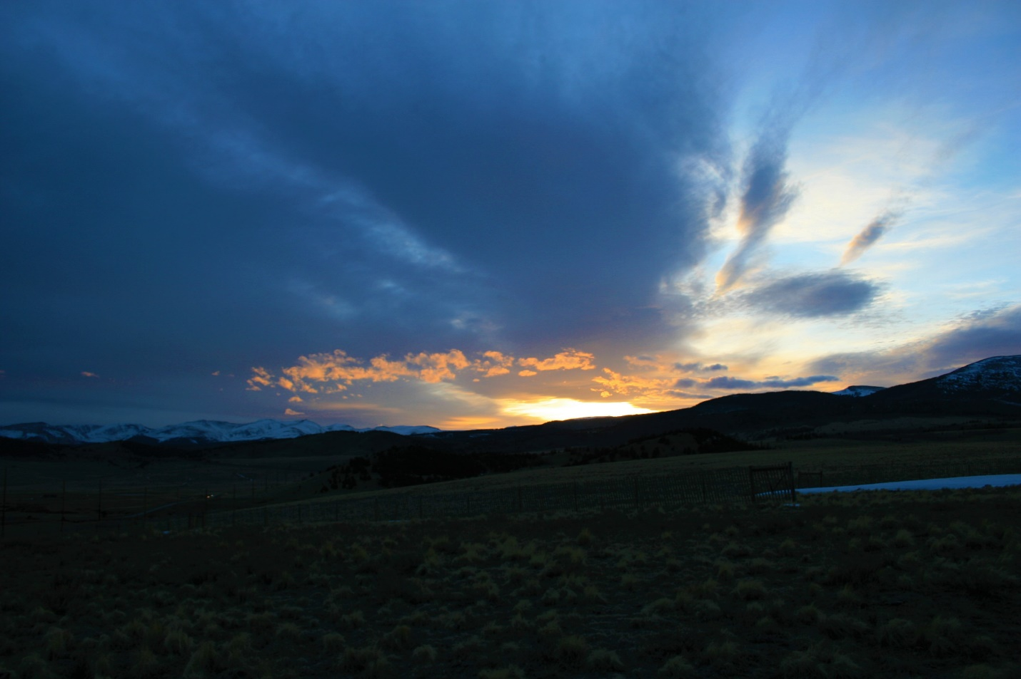
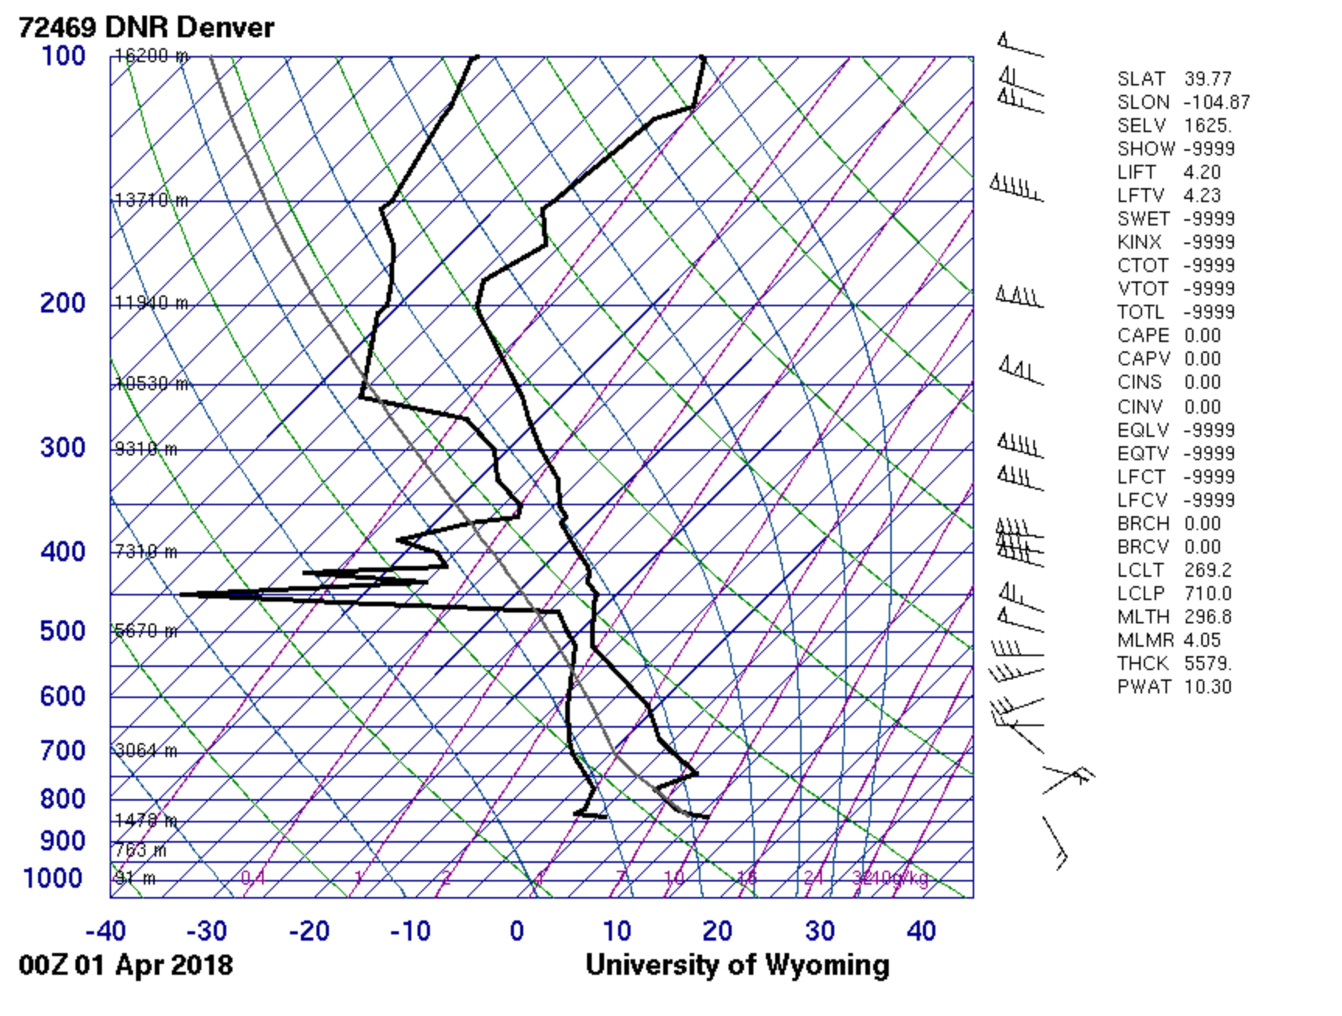

My intent while shooting the image was to capture how isolated I felt while driving through this valley. I also wanted to capture the sunset and the intense orange glow. This cloud formation and coloring was far more elaborate than any of my other cloud images I shot for this assignment.
When I shot this image, it was Saturday evening (March 31st) at approximately 7:30PM. I was driving back from a weekend of skiing at Crested Butte Mountain Resort. I am standing on a hill just outside Jefferson, CO facing SSW. The camera is positioned even with the horizon. While I was driving back to Boulder via 285N, I noticed a string of clouds that had formed above the mountains. As I continued to drive, the colors became more and more vivid until I decided to stop. This is the resulting image.

After examining the skew-T diagram for this location on this particular location, I believe that the orange clouds in the front of the image are Altocumulus while the darker clouds in the background are Nimbostratus. The weather on this day was very clear, however, I believe there was a storm that was supposed to move into the area by the evening. The atmosphere on this day was also stable. I estimated the clouds to be at about 9000-10,000 feet.
The technique I used when shooting this photo was based on trying to capture the clouds, mountains, and foreground all at the same time while having the clouds be the focal point of the image. I wanted to show the beautiful foreground with the subtle vegetation as well as the rolling hills leading to the mountains. I also wanted capture the length of the mountain range extending along the left side of the image. I used my digital Canon 30D DSLR to shoot this image. I am not positive but I believe I was shooting in the preset landscape mode.
This image fulfills my original intent. It reveals how majestic and angry mother nature can be. I like this image because of the dark colors surrounding the bright orange clouds. It would be cool to try and some time lapse shots of clouds going forward.

