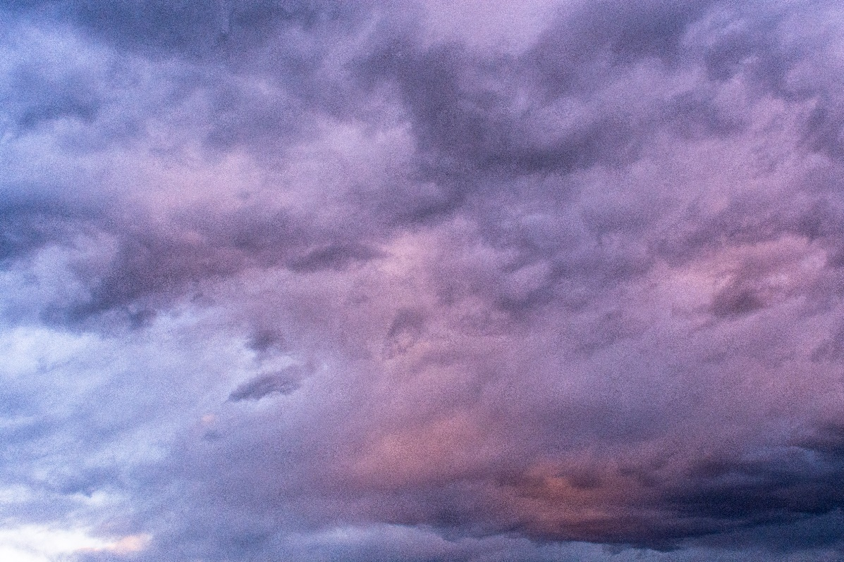

Storm Clouds on the Flatirons
  - Clouds first report
Cyron Completo | ATLS 4151 | March 19, 2018

Context
This image was taken for the Clouds First project and was taken by Cyron Completo on March 4, 2018 at 5:56 PM. The intention was to capture mountain wave clouds during an advancing cold front while bringing out all the textures and colors seen in person. The photograph was taken at a scenic lookout at 2511-2923 S Foothills Hwy, Boulder, CO 80303, facing northwest.

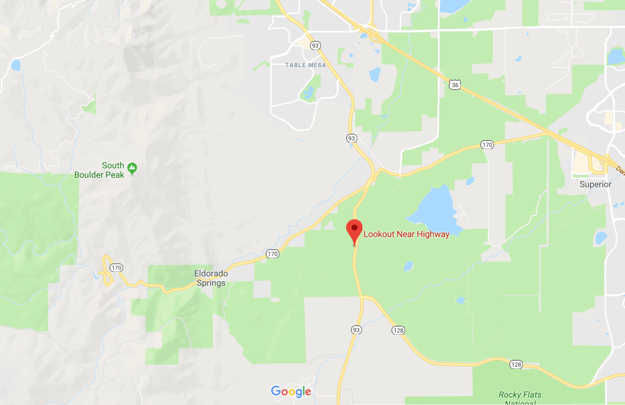
Figure 1: Location of Photograph

Flow Discussion
The cloud appears this way due to the presence of a cold front. Since the cloud appears to occupy a large distance, the weather was especially windy, and the fact there was different layers of the cloud present, that means there was presence of wind shear [1]. The cloud was moving with time due to the presence of wind in the area. To replicate this image, you must photograph towards a mountain during sunset with low-lying stratus clouds in the area. You must also capture the cloud during an advancing cold front and find a skew-T diagram that has characteristics matching that of March 4, 2018.

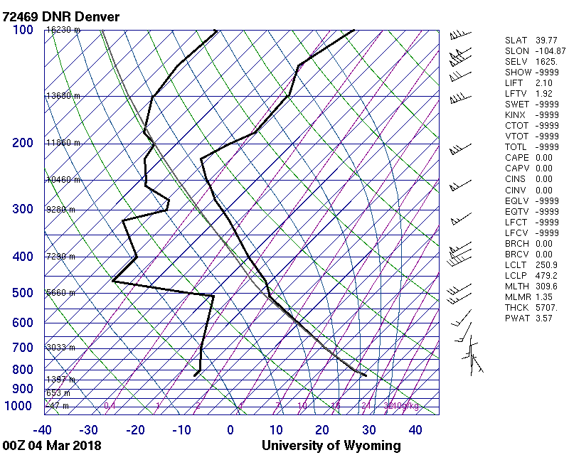
Figure 2: Skew-T Diagram of March 4, 2018
Since the CAPE value of this day was at 0 when the skew-T diagram was recorded, it leads me to believe that there was a passing cold front during the evening.

Visualization Technique
I used natural sunlight as my source of lighting for this scene. Any foreground elements that could be in the way of the clouds being framed were not framed in the image. I did not use any physical filters on my camera to capture this.

Photographic Technique
I used a Nikon D5200 to take this photograph. The original photograph had dimensions of 6000 x 4000. The final image had the same resolution: an uncompressed 6000 x 4000 but at 240 dpi with a bit depth of 48. The cloud captured was roughly 5600 feet in the air (derived from the skew-T diagram at 00Z). I used an aperture of f/10 to capture a wide depth of field without sacrificing my lighting conditions too much, an exposure time of 1/160 seconds to reduce motion blur while capturing as much light as possible, manual focus to eliminate the need for automatic focus bias, no flash, a focal length of 18 mm to capture the widest frame possible, and an ISO speed of ISO-2016 to capture the light as accurately as possible while anticipating for some image noise. In terms of post-processing, I made use of Adobe Lightroom to bring out latent lavender colors of the clouds as well as the colors of the sunset behind the clouds. I raised the temperature of the white balance as well as the white balance’s tint to bring out those lavender colors, I raised the exposure of the tone curve, reduced the tone highlights, increased the shadows and the whites, reduced the tone of the blacks, increased the presence of vibrance and saturation, adjusted the tone curve to increase highlights and lights while bringing down the darks, adjusted the hue and saturation in favor of cooler colors, and enabled lens profile correction for the Nikon Nikkor lens.
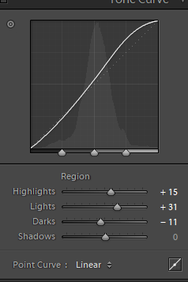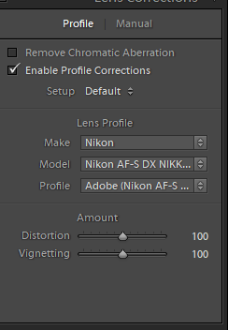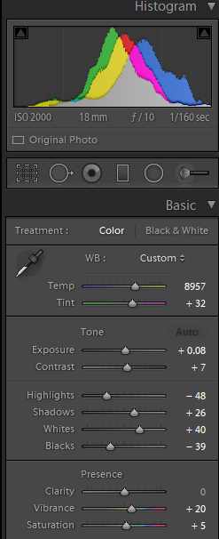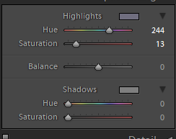
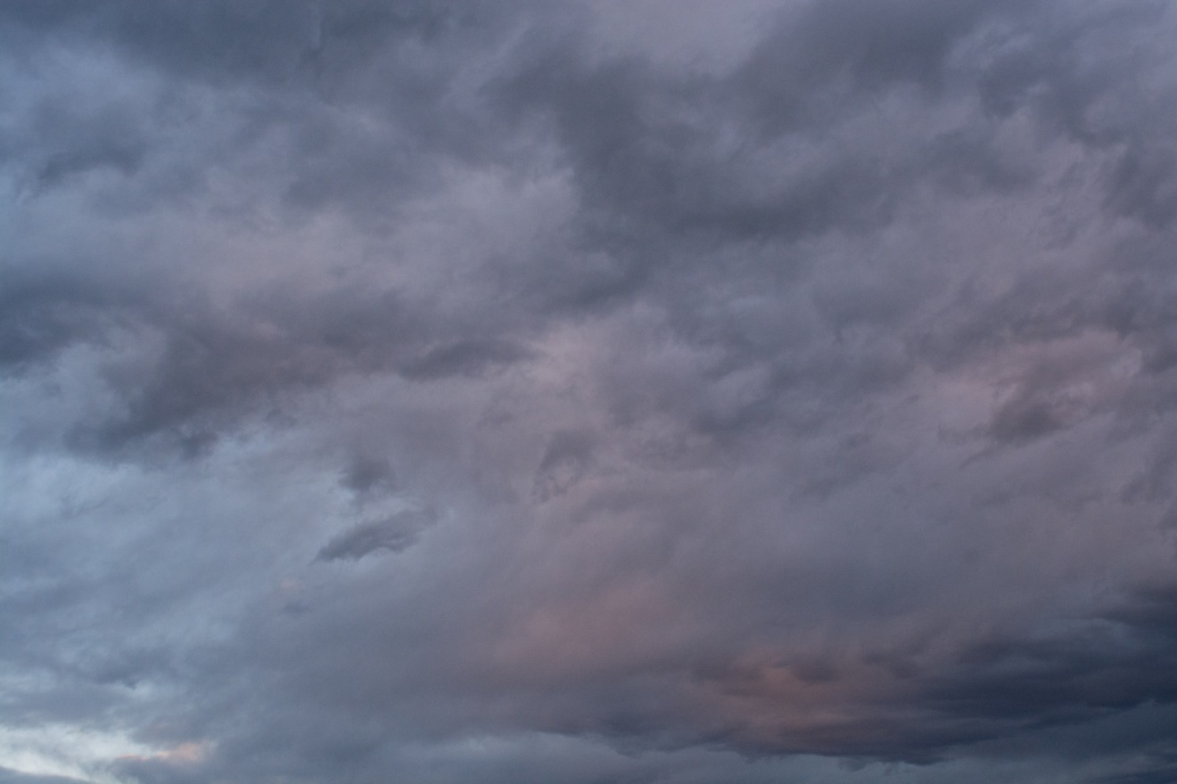
Figure 3: Original image

Closing Remarks
The image shows a large, stormy mountain wave cloud during the height of windiness on March 4th and during the sunset of that day. Due to all the colors and textures at play in the image, I satisfied my intent with my result. I like that the colors of my image complement each other well and that my adjustments of lighting during the shoot and at post-production work to bring out the textures that I witnessed in person. My original image could not do justice to all the textures and colors of the scene that I witnessed with my eyes, so I did the best that I could in post-processing.
By bringing out the colors and textures in post-production, accurately capturing the scene by maximizing the lighting my camera could take and by widening the depth of field to capture more of the scene, I successfully satisfied my intent. In the future, I hope to capture more isolated clouds that are less horizontally developed (cumulus clouds) to provide more visual context in the sky and to provide a greater sense of scale.

References
[1] Lee M. Grenci; Jon M. Nese (2001). A World of Weather: Fundamentals of Meteorology: A Text / Laboratory Manual (3 ed.). Kendall/Hunt Publishing Company. pp. 207–212. ISBN 978-0-7872-7716-1. OCLC 51160155

