Team Second: Soap Bubble
Alexandra Grace Wilson
ATLS 4151
With Group members Lea Mattson, John (JJ) Monahan, Chi Liu, and Youngwoong Kim

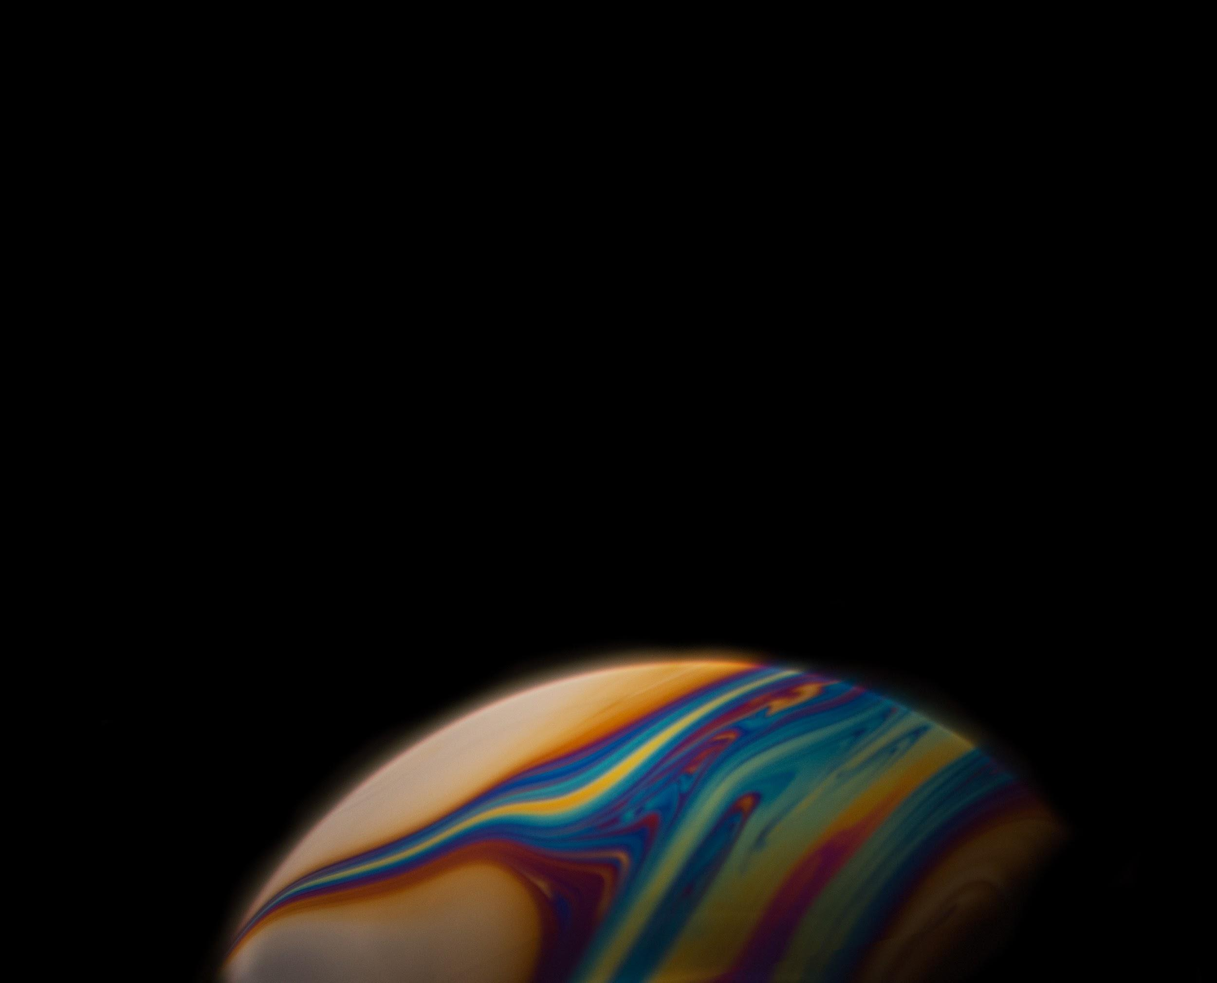

This image is a soap bubble that we captured for our second group project. We wanted to capture the planet-like, magical iridescence of a soap bubble up-close. I set up the camera on the tripod, everyone helped build a softbox out of studio lights. Chi and Youngwoong were holding the background straight, while Lea blew into a pipe of connected straws that culminated in a plastic wine glass that she had dipped in a film of bubble-liquid held by JJ. It was absolutely a team effort and could not have been done without everyone’s essential work and clever ideas.

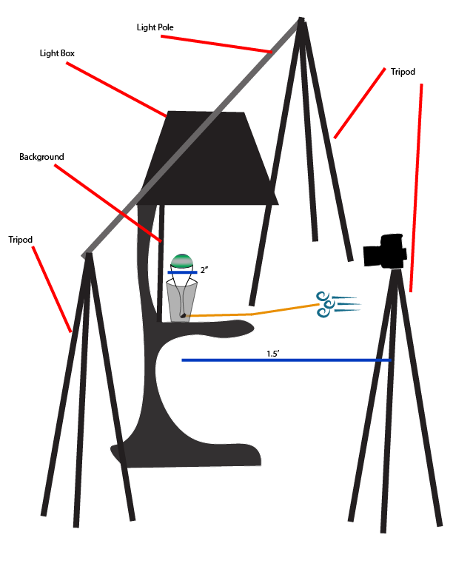
This diagram shows the basic setup of the apparatus used. Someone manned the camera, someone rimmed the glass with soap and then someone else blew through the straw. We set up the light scenario because it was the closed we could come to a softbox with the equipment that we had. We used Ramakant Sharda’s guide, How to Photograph the Sheer Beauty of Soap Bubbles from Digital Photography School as a guide, which is how we knew to set up a light box. We also had to turn off the room lights in order to get enough of a rainbow to be happy with. The flow is the the reflection and refraction of light from the surroundings. It’s actually a fascinating phenomena. When you see those rivers of changing light, that’s showing the thinner and thicker parts of the bubble. The thickness of the bubble determines what light frequencies can and cannot bounce off of the variable layers, a phenomenon known as interference. This was explained to me by group member, Lea Mattson, whose fantastic lab report and additional references can be found here. A the flow of the soap bubble changes, and everything becomes thinner, the colors become much less vibrant, shrinking into dull greys and browns, and then it pops!

The visualization of the flow was created through light reflecting off of a soap film. the soap used was Pustefix Premium Bubbles, I believe, and it was undiluted. The lighting was completely artificial softbox light, using a constant light source and no flash. The bubbles were blown through a pipe of roughy 1.5 feet of plastic drinking straws with bendable ends fastened into one another and secured with black gaffer’s tape to eliminate as much air leakage as possible. The air ended up in a small plastic champagne flute with the end broken off so as to allow the air through the straws into the flute of the glass. The glass was 2 inches in diameter, and was held up by a plastic drinking cup, approx. 12 oz. size.

The photographic technique revolved around finding the correct distance from cup to camera. I found out later that one of the reasons our photo was gauzy around the end was that I was using an F-stop, at 1/1.4, too low to truly capture the sharp edges of the film. The camera was my own, a Canon EOS Rebel SL1 with my prime 50-mm lens. my ISO was down at 100 to try for as much sharpness as could be found. I shot at 1/125 seconds to try to balance a “still” object’s lack of motion blur and the rather rapid cycle of growing and popping. The editing process was fairly straight-forward. I increased the highlights slightly and masked out the not-perfectly black background to make it cleaner, and cropped the image as a whole.
Original:
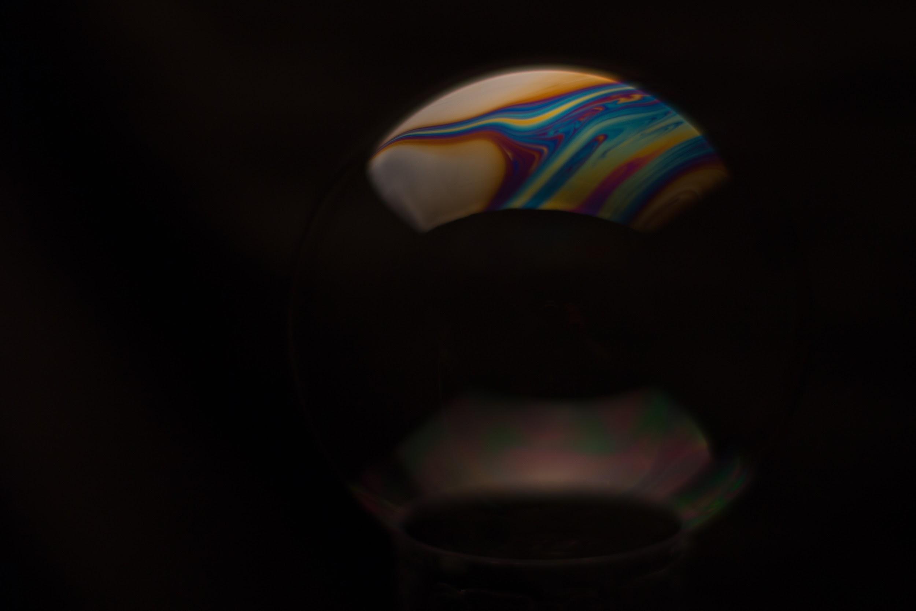

The image reveals the beautiful qualities of light when reacting with semi-light-permeable liquids like soap. It’s fascinating to see the rivers of light running through the seemingly most mundane of objects. I love this image because I feel it to be emblematic of the importance of flow visualization as an art. I dislike that the edge isn’t crisp. It’s a nice, “atmospheric” effect for sure, but learning that f/1.4 is just not satisfactory for sharp macro images with my lense is a bit of a bummer. I think the physics are well shown, though some explaining is necessary. I wonder if there could be a way to make a bubble density uniform, and if that would cause a uniform color, or if it’s just not humanly possible. in that case, can we use bubbles as ciphers? Like the lava lamps? I think we as a team did a good job of following through. My many thanks to Lea for finding this fascinating subject! I would love to improve the sharpness and the quality of our lighting to be brighter and more uniform. I could take this further by selling huge prints of the soap planets to raise money for the cube-sats!

