Stephen Morton
Team First Report
MCEN-5151
March 1, 2018

This image was taken to demonstrate turbulent flow. Flow of a fluid is considered turbulent when the Reynolds number is larger than 4000 [1]. The Reynolds number is the ratio of inertial force (density*velocity*characteristic length) to the viscous force [2]. The equation for the Reynolds number can be seen in equation 1 below. The setup of this experiment was fairly simple. Two fog machines were set up about 18” away from a half cylinder, with a laser at the bottom. The laser light circles very quickly which makes a conical shaped laser light. A top view schematic of the setup is shown in figure 2. At any one time, only one of the two fog machines was used. With all lights in the room turned off except for the laser, one of the fog machines would be turned on for about 1 second, until the semi-cylinder filled up with smoke. Then, as the fog dispersed a bit, the conical shape of the laser light brought more and more of the focus to the swirls of the fog.

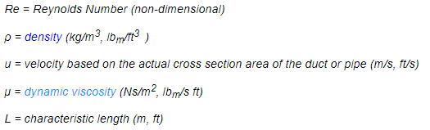
Equation 1: Reynolds Number [2]

Due to the many unknowns of the fog machine, the Reynolds number has not been estimated. The exit velocity of the fog from the fog machine, and the dynamic viscosity of the fog are unknown. The difference between turbulent and laminar flow however, can be visualized in figure 1 below. In addition to this, the image taken does not reflect the flow of the fog just after exiting the fog machine. In fact, the flow could be laminar until it hits the semi-cylinder, which causes it to spread out and become turbulent.
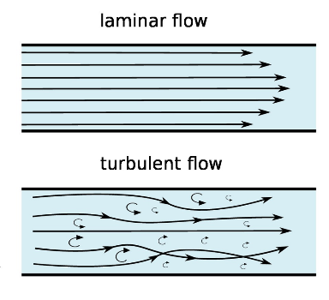
Figure 1: Laminar vs. Turbulent Flow [3]

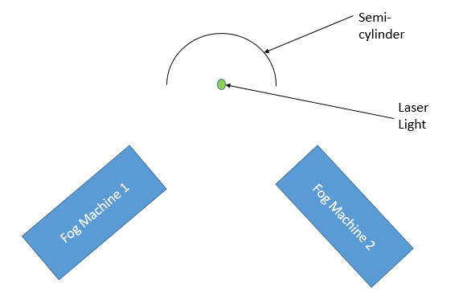
Figure 2: Image Setup

The uncropped image shown in figure 3 below shows the true shape of the fog after hitting the half-cylinder and rising. The conical shape can be clearly seen. The base of the cone is approximately 8 inches in diameter, and the cone in this image is about 18 inches tall. There is also some fog seen outside of the cone, which is a result of the laser light diffraction. An Iphone8 was used to capture this image, and the camera specs can be seen below in table 1. A standard zoom of 1x was used to take the original image, and it was taken from a distance of about 18 inches.

Camera | 12 MP
Aperture | f/1.8
Zoom | 1-5x
Table 1: Camera Specs

The only edits to this image was cropping, to focus the final image on the turbulence of the fog. The final image shows some of the main “swirls” that result from turbulent flow, and can be seen in figure 4.

This image does a pretty good job showing what turbulent flow can look like, as described in figure 1. Another way to visualize this would be to use a slow motion camera to show the fog as it flows upwards through these swirls and eddies.

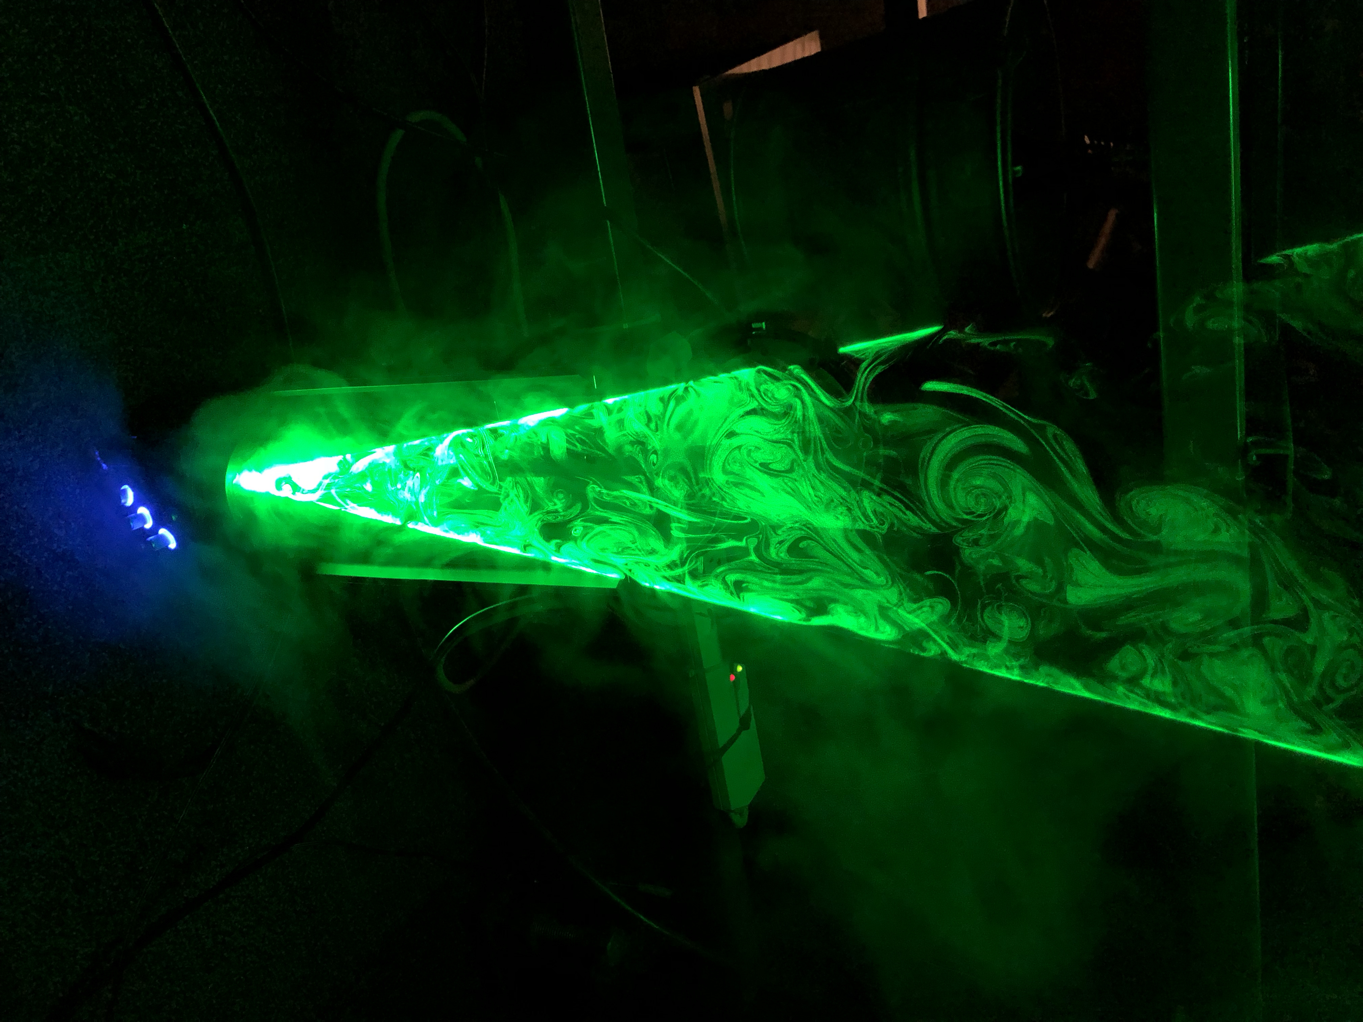
Figure 3: Original, Uncropped Image

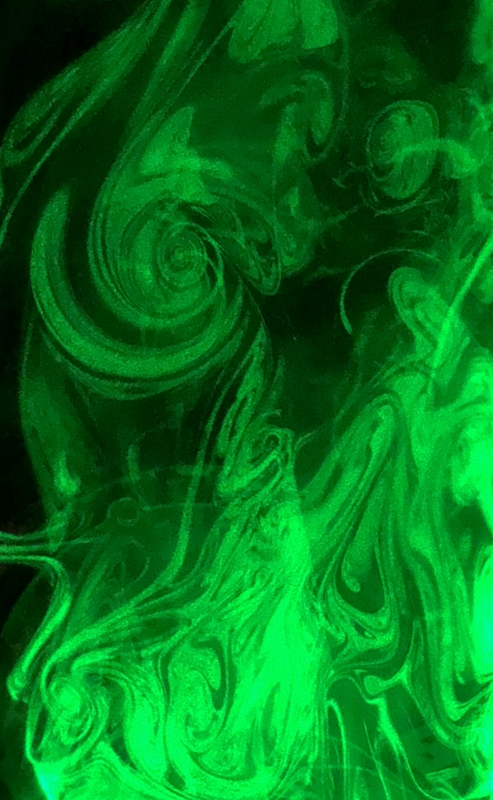
Figure 4: Cropped Image

[1] Engineering ToolBox, (2004). Laminar, Transitional or Turbulent Flow. [online] Available at: https://www.engineeringtoolbox.com/laminar-transitional-turbulent-flow-d_577.html
[2] Engineering ToolBox, (2003). Reynolds Number. [online] Available at: https://www.engineeringtoolbox.com/reynolds-number-d_237.html
[3] https://www.cfdsupport.com/OpenFOAM-Training-by-CFD-Support/node275.html

