Cloud First
MCEN 5151
Chi Liu
March 1st, 2018, 5:30PM
Location: Idea Forge

Introduction

This is taking in front of idea forge at afternoon, which is amazing that the cloud is turned into red because of the sunlight. This is extremely beautiful at that moment, so I took this picture, as shown in figure 1, and decided to use it as my cloud first assignment.
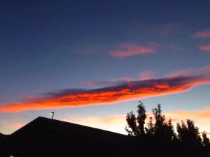
Figure 1 Cloud

Location

The picture is taking in front of idea forge in the afternoon. I was facing north, the same direction toward flatiron mountain. The angle is about 45 degrees above the horizontal, and the elevation of this picture is about the same as boulder’s elevation, 5430 feet over sea level. I took this image after class about 5:30 pm, and at March 1st. It was a sunny day, and not much clouds on the sky.

Cloud

The cloud is either stratocumulus or Stratus, because it looks low at that moment. And the sky is very clear, there is no signal for raining or snowing, the wind speed is also very slow. As shown in figure 2, the cloud types are specified in this figure.
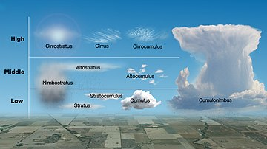
Figure 2 List of Cloud Types^{[1]}
The expected weather is shown in figure 3, which shows a clear day but with a little bit clouds on the sky. There is no raining chance on that day, so this proved this cloud is stable.
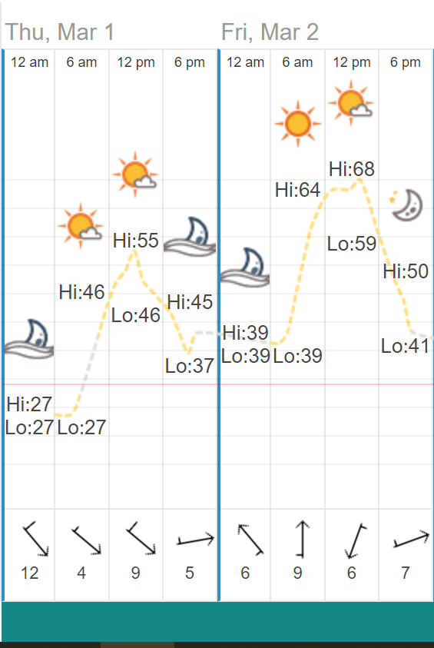
Figure 3 Weather Broadcast^{[2]}

Because it is about 6 PM on March 1st, so Skew T diagram on March 2nd would be more accurate for this clouds analysis, Skew T diagram is shown in figure 4.
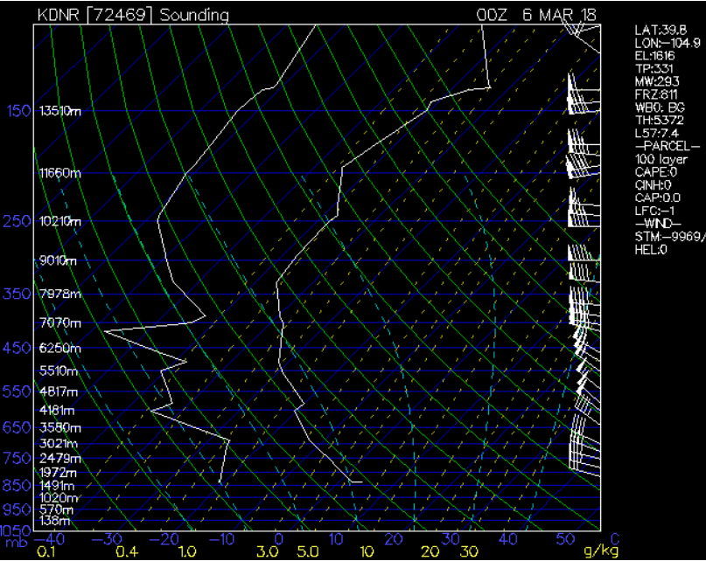
Figure 4 Skew T Diagram
This shows a stable weather on both low and high altitude. The cloud would be 1000 feet from boulder, so it would be about 7000 feet from sea level, and from skew-T plot, it shows stable weather for this cloud location.

Photographic

The original image is shown in figure 5, which is took by iPhone.
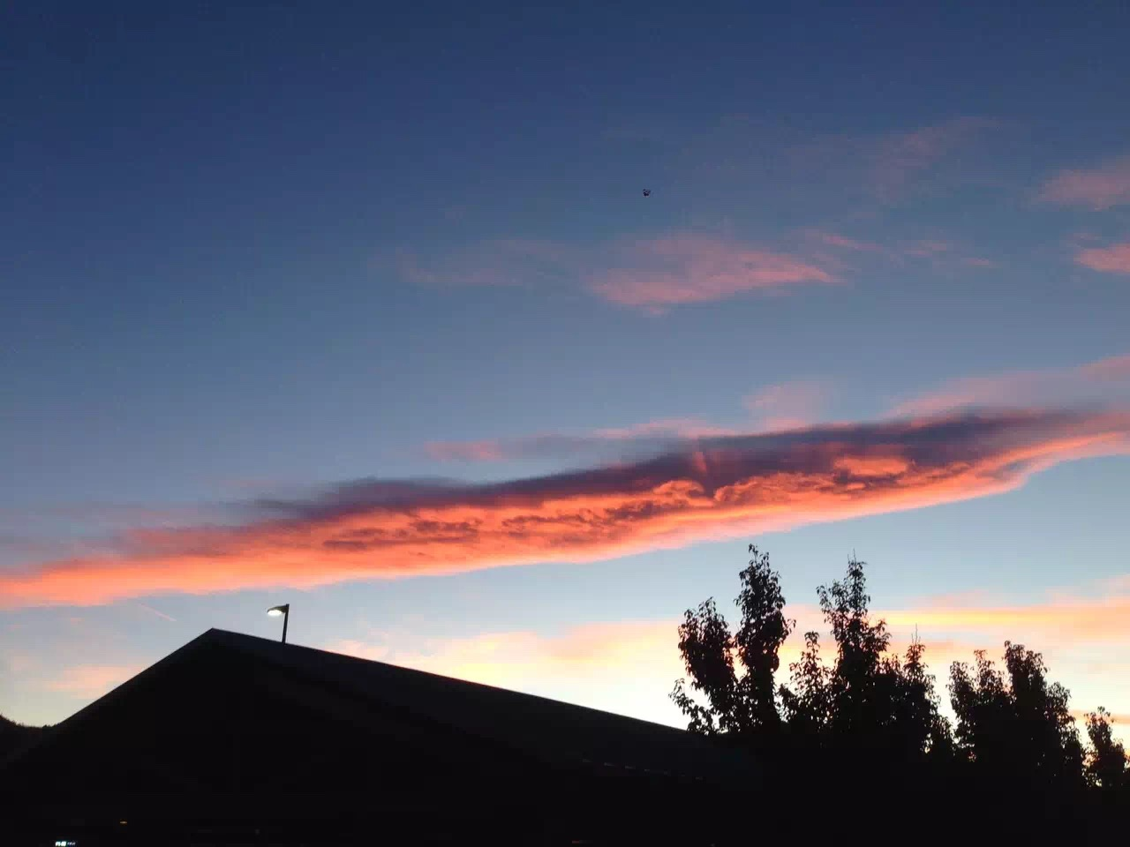
Figure 5 Original Image
I used default settings on my phone and the estimate size of field of view would be 2000 feet x 1500 feet. Distance from object to lens would be 1000 feet. The iPhone was iPhone 7, and the ISO setting was 250 ISO. The photoshop is used for this image, I increase the saturation of the image and change the light of the picture. So, after photoshop, it become redder on clouds butter looks little bit darker in the image.

Conclusion

My favorite part of this cloud is its color, this is the main reason I choose this image as my assignment. The dislike part would be the resolution of the image, this might because of the shaking when I took the picture. The improvement for this image would use a better camera, more photoshop to get ride of some noise from the image.

Reference
[1] List of cloud types – Wikipedia URL: https://en.wikipedia.org/wiki/List_of_cloud_types, 2018
[2] Past Weather in Boulder, CO – time and date URL: https://www.timeanddate.com/weather/usa/boulder/historic, 2018

