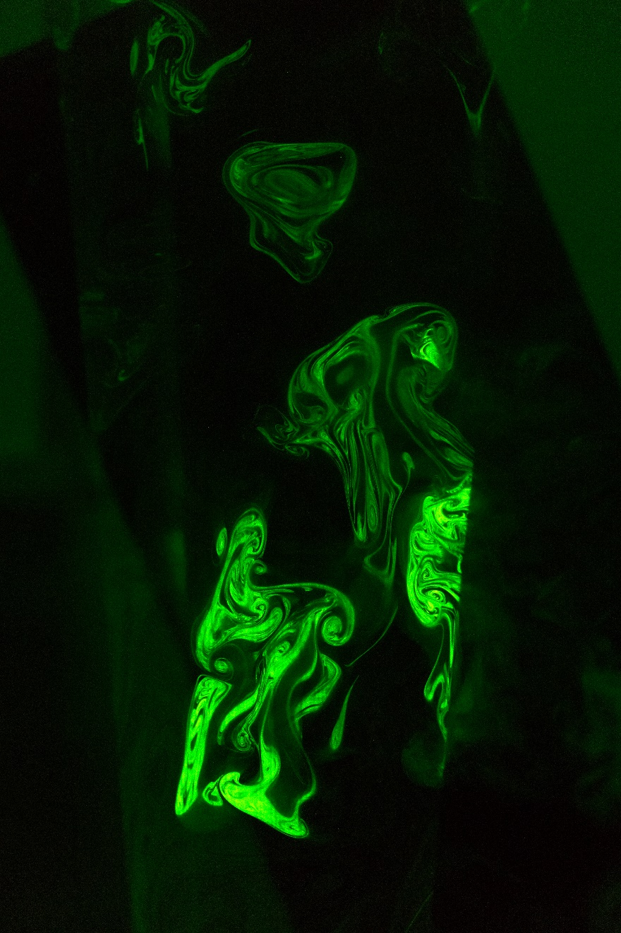

Turbulent Fog Visualization
  - Team Third Report
Cyron Completo | ATLS 4151 | May 7, 2018
Photograph taken: April 23, 2018
With assistance from: Galen Melchert and Kevin Oh

Context
This photograph was taken by Team 9 in the Flow Visualization class of 2018, with the participating members being Cyron Completo, Galen Melchert, and Kevin Oh. The intent of the photograph is to capture the variations of air fog as it is being perturbed by turbulent air flow while illuminating the fog with a laser that moves in the direction of a circle. Cyron Completo post-processed the image and set up the scene by positioning the laser, fog machine, by directing the position of the photograph/framing, Galen Melchert adjusted the camera settings and took the photograph, and Kevin Oh perturbed the fog airflow by fanning air using a rectangular black board.

Flow Discussion
The flow shown is fog generated by a fog machine pushed in the direction of a circular laser after being perturbed by a black board. The turbulence generated by both the fog machine and the board result in elongated flow patterns that have some vortices. The flow generated by the black board resulted in upward lift, hence why there are blobs of the fog that appear to be going upwards. The shape of the flow is affected by the force of the fog machine, gas density, the force of the black board’s movement, gravity, and the temperature of the room. The temperature of the room was approximately 70 degrees Fahrenheit.
To reproduce this image for artistic use, fill a small-sized fog machine with a water-glycerin mixture and then place it near the edge of a table that is about 30 inches high. Then, place a laser apparatus that can shine a laser in a circular formation on the floor, adjacent to the edge of the table. Make sure that the room is completely dark, then turn on the laser apparatus. Run the fog machine for approximately 10 seconds, then shut it off. At the tail end of the operation, wave a rectangular foam board that is approximately 7 inches wide, 2 feet tall, and half an inch thick at a slight angle from the ground, about 15 degrees. Due to the angle of the board, the motion will generate lift and cause the fog to move upwards.

Visualization Technique
The fog machine used can be of any make and model if it is small (7 inches wide, 1.5 feet long) and is filled with a water-glycerin mixture. The only lighting results from the circular laser apparatus. To replicate the lighting, you must find a room that has very little to no lighting and use the laser to light the scene. The camera flash was not used at all, and manual focus mode was engaged to prevent the usage of the focus light.

Photographic Technique
The photograph was taken with a Sony ILCE-5100. The camera settings were an F-stop of f/1.8 in order to gain a shallow depth of view while maximizing the amount of light in the scene, exposure time of 1/80 seconds in order to maximize the amount of light while reaching a limit of image blur (the image still remained sharp at this shutter speed), an ISO speed of ISO-2500 in order to maximize light, a focal length of 50 mm to get the subject distance and focal distance balanced, and a subject distance of about one meter as it was comfortable to take the photo at that distance. The final resolution was at 4000 x 6000 pixels at 240 dpi and a bit depth of 48, uncompressed, all to maximize quality with a decent original file size of ~25 megabytes. As for post-processing, I raised the image temperature to make the image less cold, increased the exposure and contrast to bring out the fog shapes, decreased the presence of shadows and whites while bumping up the highlights and blacks as the tones were biased towards overexposed whites and underexposed areas that rendered as shadows, I then adjusted the clarity of the image as the image needed some sharpness to bring out the edges of the fog shapes, then I adjusted the tone curve to prioritize the outlines of the fog shapes.

Closing Remarks
The image reveals that a cool fog appears to form slight vortices and elongates when perturbed by two directions of air flow, horizontal and vertical. I like that the flow appears in various shapes and patterns, with a surprising amount of variation of green light from the laser. I think that the magnitude of green light depends on the amount of fog in the area illuminated, as there is more surface area to reflect the light. The flow physics are revealed due to this image and the process of setting up the image, helping capture it, and post-processing improve upon my understanding of air flows. To improve this image, I could choose to use different colors by adjusting the clarity and vibrance to create a more artistically intriguing scene. Nonetheless, I am satisfied by the outcome as it is clear what the physics are.
I fulfilled my intent with the result of this project: to capture a turbulent fog with a circular laser light, agitated by two different directions of force and to enhance my understanding of air flows. For the future, I hope to create a video that shows the same physics at different angles and in slow motion.

