Clouds 1
Alexandra Grace Wilson
ATLS 4151
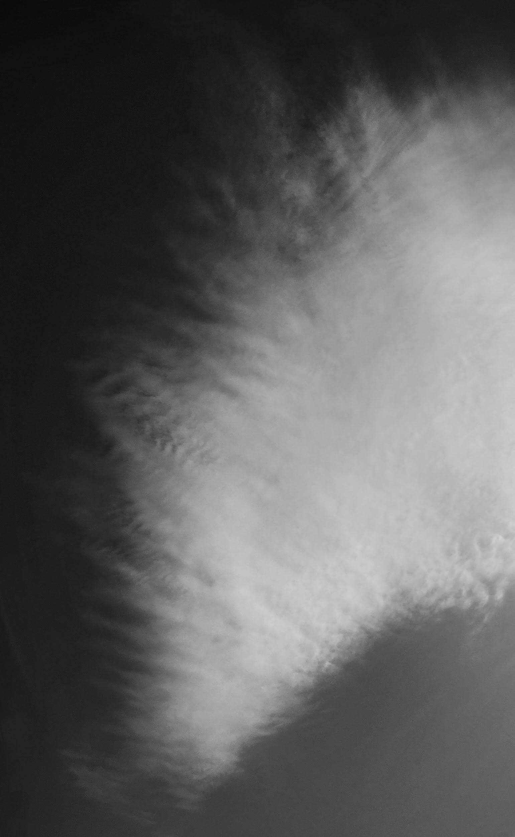
About the cloud:
This is an altocumulus lenticularus undulatus in a stable atmosphere.

This was for the first cloud assignment. I wanted to capture the beautiful ripples I was seeing above me and not have a picture with any distracting elements like buildings, trees, or wires.

This is an altocumulus lenticularus undulatus in a stable atmosphere, It was taken fairly directly overhead facing the engineering center at 91 Deg. East on February the 14th at 10:19 AM and at roughly 40 Degrees, 25″ North and 105 Degrees, 15’50” West (using my Iphone 6S compass and GPS)

The cloud in this image is an altocumulus lenticularus undulatus in a stable atmosphere. I can say this because it was at a relatively high in elevation and on a not chaotic day (altocumulus), the sides are smooth in their feathering (lenticularus) and you can see small wave patterns in the cloud (undulatus). The Skew T generated on this day supports the claim of a stable atmosphere, as the CAPE, a measurement of atmospheric instability, was zero. The rest of the sky was mostly clear, and the weather had been calm for at least two days. There was no large front expected. No drastic changes happened for the rest of the day, though there was some mild to moderate wind.
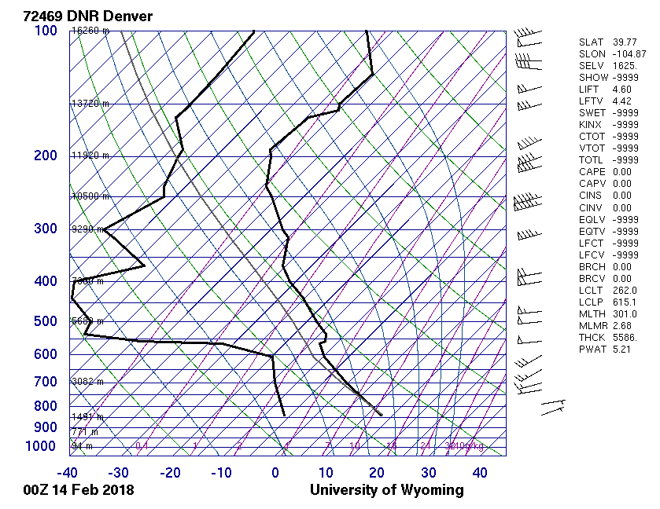

I took a photo with my iPhone 6 looking straight up, and using a wide open path in order to limit the possibility of distractions in the image. I would estimate the field of view to be larger than I can put a proper number on, but at least 500 feet.
In file info, these were the settings given to me by the metadata-reader:
f-stop: 1/2.2
Exposure time: 1/5917 sec
ISO-speed: ISO-25
focal length: 4 mm
35-mm focal length: 29 mm
Original size (in pixels): 3024 x 4032 px
I did edit the photo in Photoshop. I increased the Dynamic range through contrast and exposure, and I used a combination of cropping and the stamp tool to get rid of the small bits of building in the background. The original photo (below) also had a large amount of reflection from the cloud itself, and making that glare less intense took a feathered low opacity mask of that area being manipulated with curves.I made it black and white to focus more on the cloud
structure.
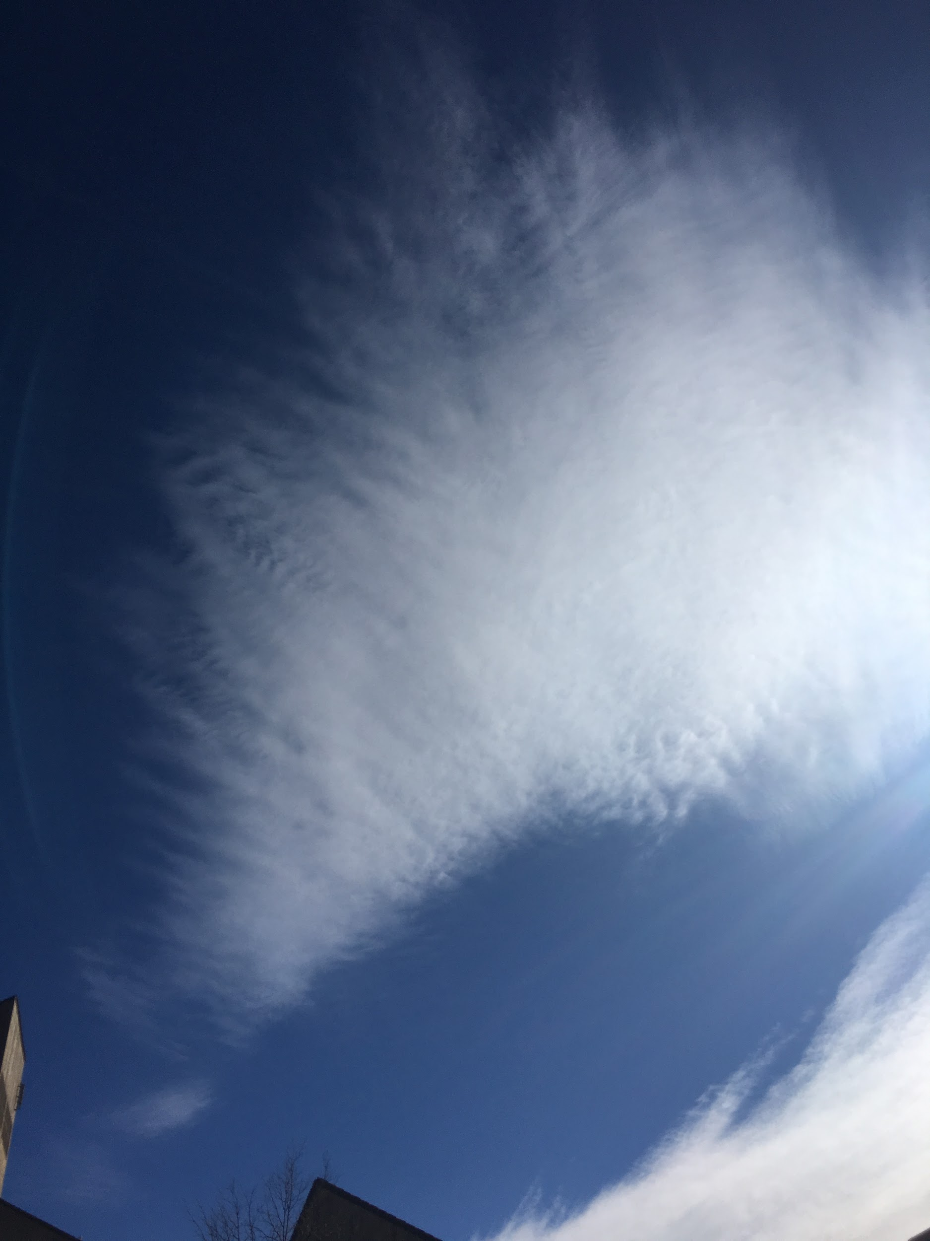.
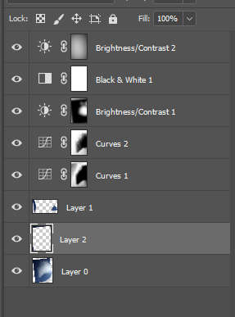
I feel the image reveals wind patterns and flow fragility in interesting ways. I also really love the wave pattern. I dislike the sun-glare from the cloud. The fluid physics are ell shown, but I wonder how you could use the stretch over time to give you more insight into the force of the wind. I feel my intent was realized, but I’d like to learn more about how to manipulate the iphone’s focusing ability. I could try to find a similar cloud with a real camera to see if I could capture the phenomena better.

