Get Wet Report

Brent Eckles

MCEN 4151-001

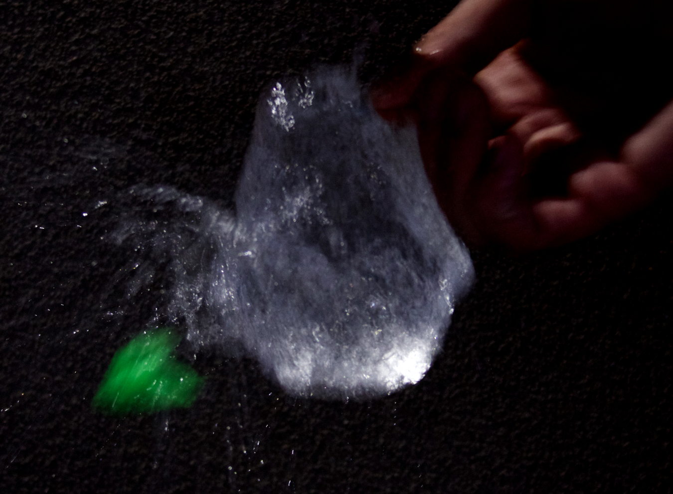
20-Sep-18

Introduction:
This image was first generated in response to the Get Wet assignment for Flow Visualization as the initial photography assignment. The inspiration came from the excitement of purchasing a new camera with the continuous photo setting recommended by the camera salesman. After conducting some research, it seemed fairly plausible to capture the explosion of a water balloon just after the balloon had been pierced. This occurrence had several flow applications and would give the opportunity to practice the art of capturing the right photo. Staging was also practiced to first get a good angle of the event as well as how to act in unison with the person popping the balloon to capture the right picture.

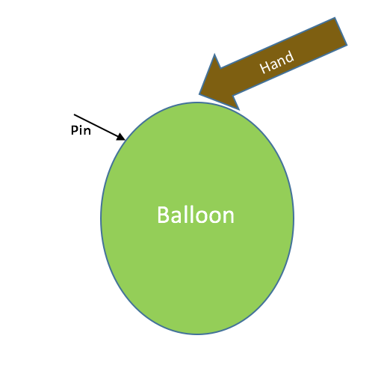
Experimental Setup:
The required materials for this experiment included a water balloon, a water balloon nozzle, a sharp pin, a volunteer, and a Canon Camera (Figure1). First several balloons were filled up by connecting the balloons to the purchased nozzle connected to the spicket. The balloons were filled until a substantial stretching of the balloon could be seen, once filled the balloon was tied off. The Cannon camera was set to the continuous shooting Drive setting, a setting which takes 4.5 pictures per second. The balloon was then held up by a volunteer holding the pin. On a designated count the cameraman began to take pictures while the volunteer pierced the balloon. This process was repeated several times capturing bursts of images for each attempt.
Figure 1

Flow Analysis
The events that lead up to the balloon being popped and its eventual release of the water are characterized by both the forces of pressure and gravity. Due to the elastic characteristics of the balloon its volume is not constant and can be increased or decreased due to the amount of fluid captured in the balloon. As more water is added to the balloon it stretches the rubber material and expands the the volume of the balloon. As this volume increases, the elastic material begins to push more and more inward toward the contents of the balloon. However, due to the elastic material pushing on the water, the water responds by pushing outward with the same amount of force, this force is called pressure. This pressure remains constant once the balloon has stopped being filled and is contained within both the balloon and water. The experiment is done by pressing a pin into the side of the balloon. This piercing of the balloon immediately releases the pressure from within the balloon, however the force still instantaneously acts on the water within. This pressure force acts perpendicular to the wall of the balloon on the water particles. This is what causes the exploding affect which can be seen, pressure instantaneously acting on the water within without the balloon material pushing back. This phenomenon happens very quickly which is why a camera taking continuous photo’s must be used. The other force which acts on the balloon and its contents is gravity. This force is always acting on both the water and balloon. However, upon the popping of the balloon there is no force from the balloon to hold the water up. Due to this force imbalance the force of gravity takes over and pulls the water down to the ground splattering the water. The forces acting on the balloon can be seen in Figure 2.

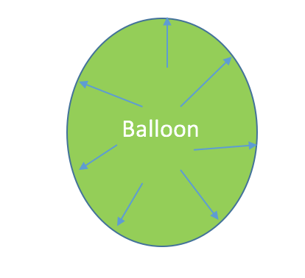
Gravity

Figure 2 shows the force the water is applying to the surface of the balloon as well as the force of gravity acting on the water and balloon.

Camera Specs & Photo Editing:
This image was captured using a Canon EOS 70D camera with an 18-55 mm lens. The exposure time was 1/80 seconds with an f-stop of f/5.6 and ISO2000. The camera lens was located about a foot and a half from the balloon explosion. The original photo was 5472 X 3648 pixels before being cropped to the image in Figure 3. After capturing the large quantities of photos they had to be sorted through in order to select the perfect image. This image displayed two main characteristics, a detailed image in focus, as well as one that captured the initial event of the balloon popping as best as possible. Once this photo was selected it then had to be edited allowing for the optimization of the photo. The image was uploaded into gimp, an editing software with several image editing options. Two main things happened to the photo, one it was cropped and two the color curve was adjusted. As can be seen from Figure 3 the original photo captured a much larger area, with the main events of the picture not in the center of the photo. The picture was cropped to place the balloon in the middle of the photo but also allowed for both the hand and the balloon residual to be captured in nice corners of the photo.
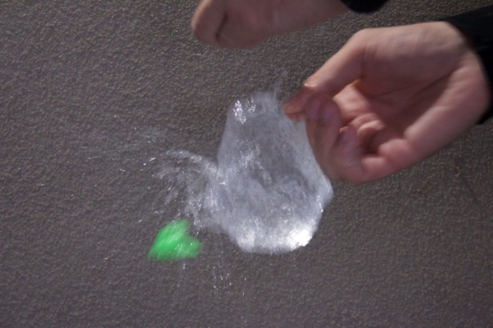
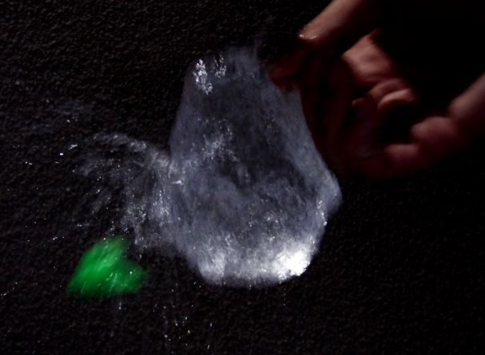

Figure 3
Figure 3 also shows the changes made to the coloring of the photo. The goal of the editing was to make the water captured the main focus of the photograph. To do this the darker colors in the image were made much darker without effecting the lighter colors. This created a larger contrast between the wall and the water. Additionally, this took the brightness out of the hand giving the hand warm characteristics. The adjustment of the color curve is contained in figure 4 below.
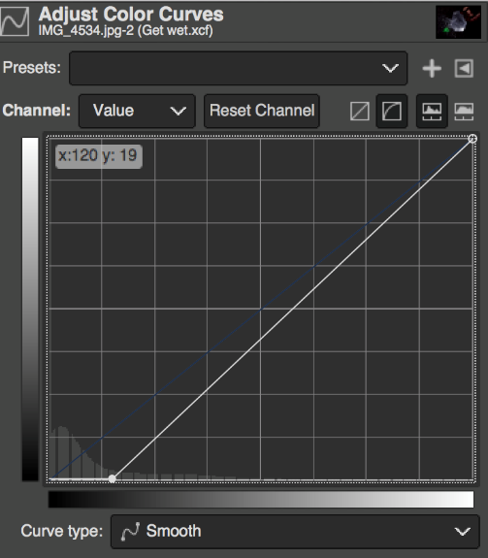

Figure 4

Conclusion
The get wet assignment did exactly as the name states, it gets the participant a good understanding of the process of performing an experiment with the intention of analyzing both the physics and beauty of the event. The final photo has redeeming qualities as it captures the physics and has an artistic sense. The photo utilizes a diagonal pattern of points of interest with the hand, water, and balloon all lined in a diagonal position. The water adds the point of focus and physics involved, but the balloon and hand certainly add to the photo. The hand has a bit of a warming effect, while the neon green color of the balloon adds excitement to the photo. The only point of improvement would be to find a way to make the background a pitch black without removing some of the other colors from the photo.

