Team First Image Write Up
Michael Karns
Assisted By: Jeremy Aparicio
Flow Visualization: MCEN 4151-001
10/10/18

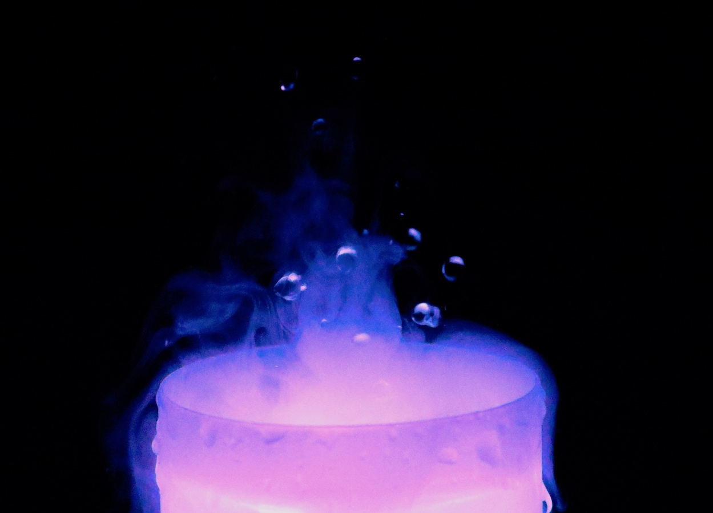

This image was for the team first image assignment. My group included Jeremy Aparicio, Max Rodgers, Charles Keeley, and myself. As a group we decided to have a theme of vapor. Because of schedule conflicts and with the due date much sooner than we realized, we had three different setups. In the future as a group we are going to plan better and share the same set up. For this project however, Jeremy and I worked together to make a setup and shoot the pictures. The main piece of equipment that Jeremy and I used to make the water vapor was a small ultrasonic humidifier. This humidifier created a vapor plume that formed various shapes and then rolled over the edges of the cup containing the water. As a side effect, the humidifier shot up water droplets in the air. Our goal was to capture the vapor plume as it rose into the air and the water droplets while they were midair.
The flow apparatus that was used was an InnoGear Ultrasonic Diffuser Cool Mist Humidifier to create the vapor. The ultrasonic transistor was at the bottom of the cup where the water was sitting. The following Figure 1 shows a schematic of the set up.
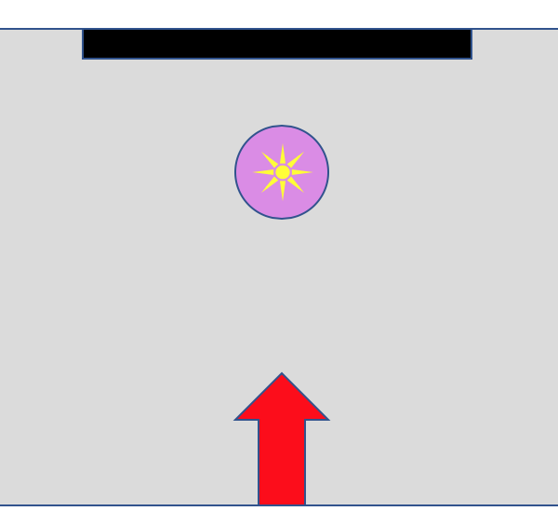
Figure 1: A schematic of the experiment setup.
The grey square represents the desk that everything was resting on. The purple circle and yellow sun represent the humidifier and the location of the light source respectively. The light source were three LEDs that were located in the base of the humidifier. The black rectangle represents the black seat cushion that was used to have a black background. The red arrow represents the camera. The camera was just above the brim and slightly looking down at the humidifier.
The flow of the vapor down the edges of the cup was a stable downward flow. This was caused by a density difference between the air around it and the colder vapor. The flow of vapor over the sides of the cup was random but does not change much with time in terms of amount of vapor flowing over the edge. The most applicable nondimensionalized scale is the Grashof number [1]. This scale is used to determine the motion of fluids due to difference in densities. The root cause of the fluid motion is due to a difference in temperature because the temperature causes the difference in densities. Therefore,
$$Gr_{L}=\frac{\left(gβ\left(T_{s}-T_{∞}\right)L^{3}\right)}{ν^{2}}$$
where $g, β, T_{s}, T_{∞}, L$and $ν$ are the gravity, coefficient of thermal expansion, vapor temperature, bulk temperature, vertical length of cup wall, and the kinematic viscosity respectively. Plugging in the values yields,
$$Gr_{L}=\frac{9.8\frac{m}{s^{2}}*400*{10}^{-6}\frac{1}{K}\left(293 K-290 K\right)*0.1 m}{10.5*{10}^{-6}\frac{m^{2}}{s}}$$
$$Gr_{L}=112$$
The Grashof number is small, which is expected because the fog is a laminar flow.
The setup for this image was straightforward along with the visualization techniques. We did not use any water colors, we just relied on the LEDs that were inside the humidifier shining from the bottom up. In order to have a black background, a black seat cushion was set up against the wall. We took the image in a room where the only light was coming from the humidifier, and the flash on the camera was not used.
Different angles were attempted to capture the best shots, but the angle that produced the best images was when the camera was level with the humidifier looking straight at the vapor plume. Figure 2 shows a photo of the setup.
Figure 2: Picture of the set up in order to get a feel for the size of the humidifier compared to a standard DSLR camera.
The diameter of the humidifier cup is four inches, so the size of the field of view of the final edited image is six inches across the frame. I wanted most of the frame to be taken up by the brim of the humidifier and this field of view gave me the best results. As seen in Figure 2, the distance from the object to the lens was about a foot and a half. I had this distance because I wanted to fully zoom in on the vapor plume in order to get a narrower field of view in relation to the background. This resulted in a lens focal length of 49 mm. The original size of the image was 6000 × 4000 pixels and the edited image was 4365 × 3145 pixels. I used a digital Canon EOS Rebel T6i camera with a 18-55 mm lens. The aperture was set to 5.6, the shutter speed was 1/800 seconds, and the ISO was 12800. I had the highest ISO my camera could do because I needed a quick shutter speed to capture the water droplets in midair. Figure 3 shows the original image before post processing.

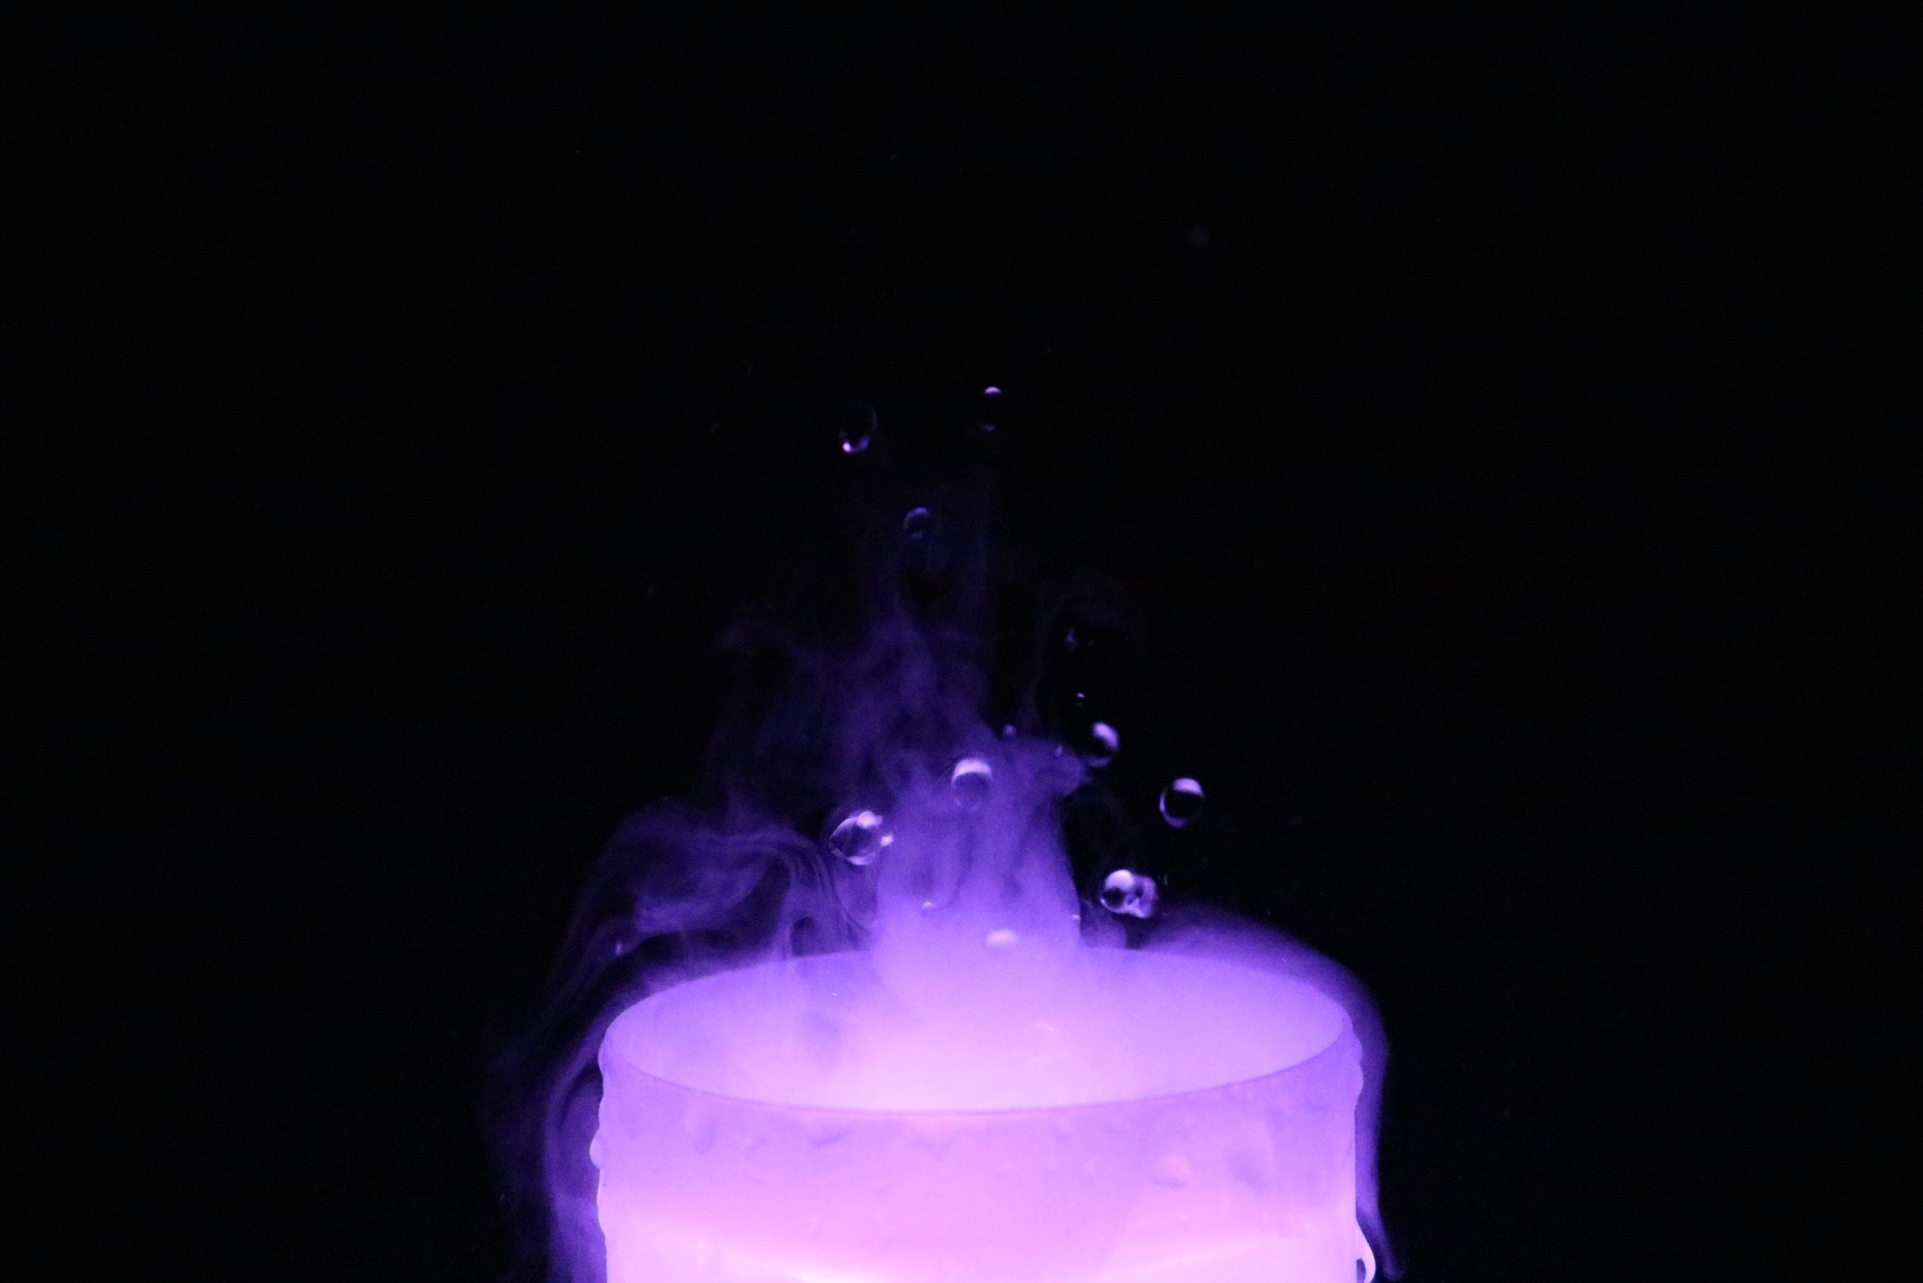
Figure 3: The original image before post processing.
For post processing I used iPhotos. I slightly increased the brightness and color, and I changed the transfer function curve to have more white as seen in Figure 4.

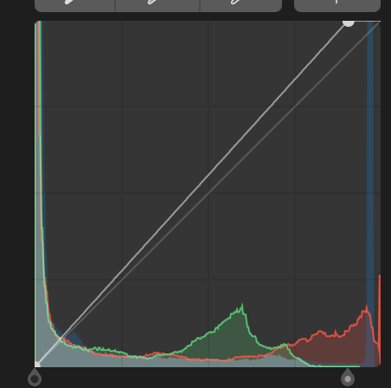
Figure 4: Image of the transfer function of the edited image.
Lastly, I increased the selective color for blue to make the vapor plume more visible by making it appear blue.
This image reveals what happens in the background when a ultrasonic humidifier creates vapor. In this image I like the contrast between the bright humidifier and the black background. I was able to capture the water droplets in midair, which adds a nice touch to the image. I do not like how there is a little bit of motion blur of the water droplets. I could not set a fast-enough shutter speed because there was not enough light. The fluid physics is shown well because the viewer can see the vapor falling down the edge of the cup. I fulfilled my intent of capturing the vapor being created with the water droplets in midair, so I am happy with my image. In the future I would like to have better lighting, so I could have a faster shutter speed and reduce the ISO number to reduce the graininess. To develop this idea further it would be interesting to use a larger humidifier, and if this would result in larger water droplets being shot up in the air.

References

- Grashof number. (2018, March 21). Retrieved from https://en.wikipedia.org/wiki/Grashof_number

